1[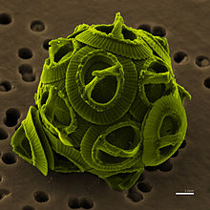](https://en.wikipedia.org/wiki/File:Gephyrocapsa_oceanica_color.jpg) 2 [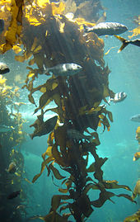](https://en.wikipedia.org/wiki/File:Kelp-forest-Monterey.jpg) 3 [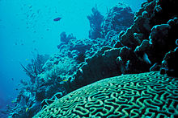](https://en.wikipedia.org/wiki/File:Coral_Reef.jpg)

4[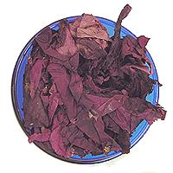](https://en.wikipedia.org/wiki/File:Dulse.JPG)5 [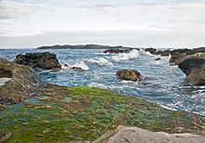](https://en.wikipedia.org/wiki/File:Taiwan_2009_East_Coast_ShihTiPing_Giant_Stone_Steps_Algae_FRD_6581.jpg)

[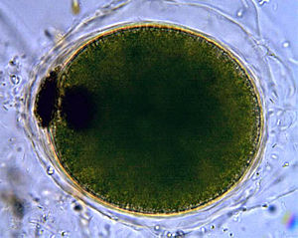](https://en.wikipedia.org/wiki/File:Dileptus_viridis_cyst.jpg)6[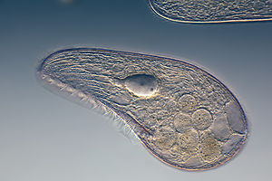](https://en.wikipedia.org/wiki/File:Mikrofoto.de-Blepharisma_japonicum_15.jpg)

7

8[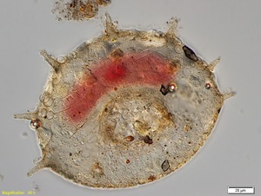](https://en.wikipedia.org/wiki/File:Collection_P%C3%A9nard_MHNG_Specimen_88-4-4.tif) 9