   
**Translation** is the process of translating the sequence of a messenger RNA (mRNA) molecule to a sequence of amino acids during protein synthesis. The genetic code describes the relationship between the sequence of base pairs in a gene and the corresponding amino acid sequence that it encodes. In the cell cytoplasm, the ribosome reads the sequence of the mRNA in groups of three bases to assemble the protein. Here is a more complete definition of translation:[**Translation**](http://www.genome.gov/Glossary/index.cfm?id=200)

### Translation

The mRNA formed in transcription is transported out of the nucleus, into the cytoplasm, to the ribosome (the cell's protein synthesis factory). Here, it directs protein synthesis. Messenger RNA is not directly involved in protein synthesis − transfer RNA (tRNA) is required for this. The process by which mRNA directs protein synthesis with the assistance of tRNA is called translation.

The ribosome is a very large complex of RNA and protein molecules. Each three-base stretch of mRNA (triplet) is known as a codon, and one codon contains the information for a specific amino acid. As the mRNA passes through the ribosome, each codon interacts with the anticodon of a specific transfer RNA (tRNA) molecule by Watson-Crick base pairing. This tRNA molecule carries an amino acid at its 3′-terminus, which is incorporated into the growing protein chain. The tRNA is then expelled from the ribosome. [Figure 7](http://www.atdbio.com/content/14/Transcription-Translation-and-Replication#figure-translation) shows the steps involved in protein synthesis.

[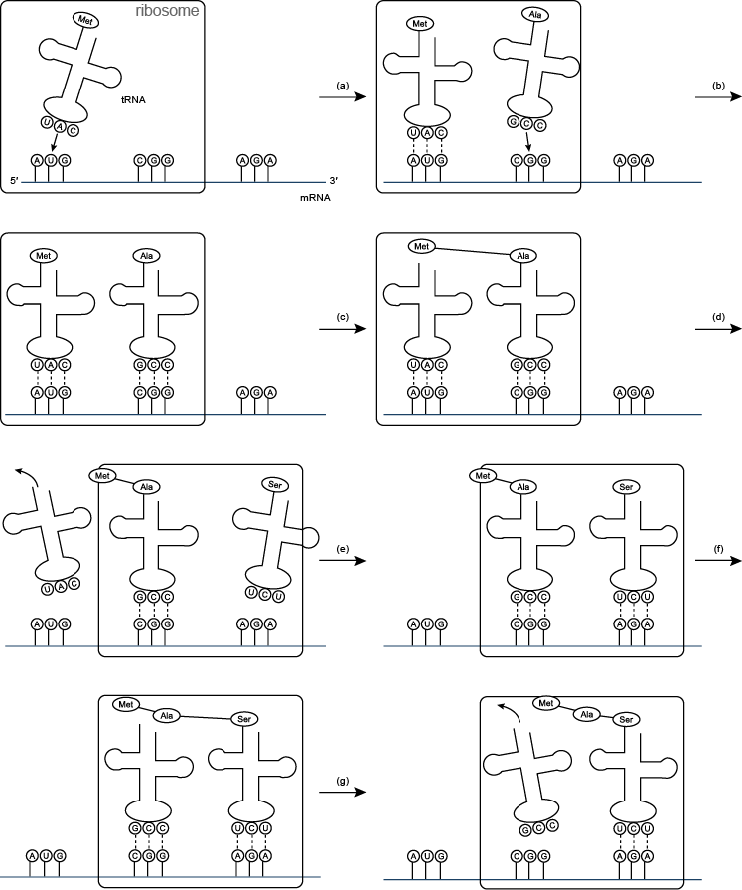](http://www.atdbio.com/img/articles/translation-large.png)

Figure 7 | Translation(a) and (b) tRNA molecules bind to the two binding sites of the ribosome, and by hydrogen bonding to the mRNA; (c) a peptide bond forms between the two amino acids to make a dipeptide, while the tRNA molecule is left uncharged; (d) the uncharged tRNA molecule leaves the ribosome, while the ribosome moves one codon to the right (the dipeptide is translocated from one binding site to the other); (e) another tRNA molecule binds; (f) a peptide bond forms between the two amino acids to make a tripeptide; (g) the uncharged tRNA molecule leaves the ribosome

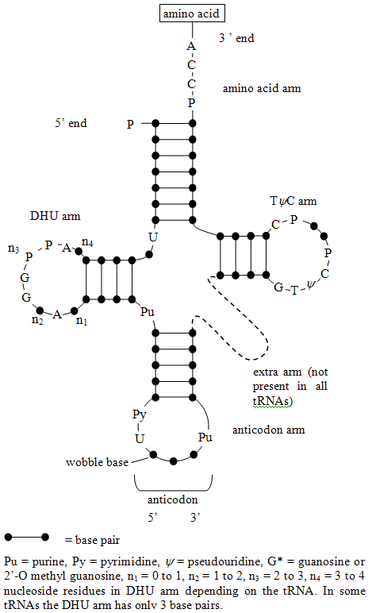

Figure 8 | Two-dimensional structures of tRNA (transfer RNA)In some tRNAs the DHU arm has only three base pairs.

Each amino acid has its own special tRNA (or set of tRNAs). For example, the tRNA for phenylalanine (tRNAPhe) is different from that for histidine (tRNAHis). Each amino acid is attached to its tRNA through the 3′-OH group to form an ester which reacts with the α-amino group of the terminal amino-acid of the growing protein chain to form a new amide bond (peptide bond) during protein synthesis ([Figure 9](http://www.atdbio.com/content/14/Transcription-Translation-and-Replication#figure-protein-synthesis-tRNA)). The reaction of esters with amines is generally favourable but the rate of reaction is increased greatly in the ribosome.

[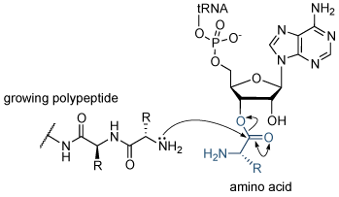](http://www.atdbio.com/img/articles/protein-synthesis-tRNA-large.png)

Figure 9 | Protein synthesisReaction of the growing polypeptide chain with the 3′-end of the charged tRNA. The amino acid is transferred from the tRNA molecule to the protein.

Each transfer RNA molecule has a well defined tertiary structure that is recognized by the enzyme aminoacyl tRNA synthetase, which adds the correct amino acid to the 3′-end of the uncharged tRNA. The presence of modified nucleosides is important in stabilizing the tRNA structure. Some of these modifications are shown in [Figure 10](http://www.atdbio.com/content/14/Transcription-Translation-and-Replication#figure-tRNA-modified-bases).

[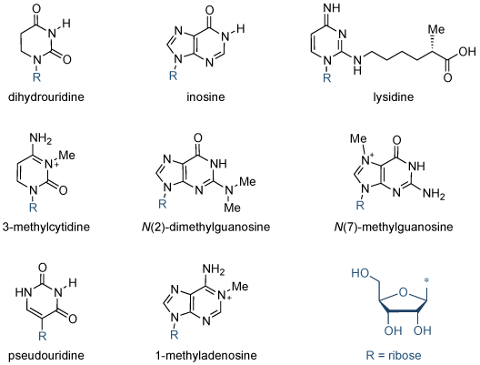](http://www.atdbio.com/img/articles/tRNA-modified-bases-large.png)

Figure 10 | Modified bases in tRNAStructures of some of the modified bases found in tRNA.

# Translation

The genetic information stored in DNA is a living archive of instructions that cells use to accomplish the functions of life. Inside each cell, catalysts seek out the appropriate information from this archive and use it to build new proteins — proteins that make up the structures of the cell, run the biochemical reactions in the cell, and are sometimes manufactured for export. Although all of the cells that make up a multicellular organism contain identical genetic information, functionally different cells within the organism use different sets of catalysts to express only specific portions of these instructions to accomplish the functions of life.

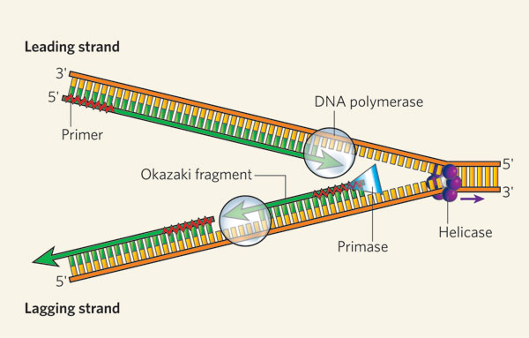

Figure 1: DNA replication of the leading and lagging strand

The helicase unzips the double-stranded DNA for replication, making a forked structure. The primase generates short strands of RNA that bind to the single-stranded DNA to initiate DNA synthesis by the DNA polymerase. This enzyme can work only in the 5' to 3' direction, so it replicates the leading strand continuously. Lagging-strand replication is discontinuous, with short Okazaki fragments being formed and later linked together.

One factor that helps ensure precise [replication](http://www.nature.com/scitable/topicpage/cells-can-replicate-their-dna-precisely-6524830) is the [double-helical structure of DNA](http://www.nature.com/scitable/topicpage/dna-is-a-structure-that-encodes-biological-6493050) itself. In particular, the two strands of the DNA double helix are made up of combinations of molecules called **nucleotides**. DNA is constructed from just four different nucleotides — **adenine** (A), **thymine** (T), **cytosine** (C), and **guanine** (G) — each of which is named for the nitrogenous base it contains. Moreover, the nucleotides that form one strand of the DNA double helix always bond with the nucleotides in the other strand according to a pattern known as **complementary base-pairing** — specifically, A always pairs with T, and C always pairs with G (Figure 2). Thus, during cell division, the paired strands unravel and each strand serves as the template for synthesis of a new complementary strand.

## How Does the Whole Process Result in New Proteins?

After the transcription of DNA to mRNA is complete, **translation** — or the reading of these mRNAs to make proteins — begins. Recall that mRNA molecules are single stranded, and the order of their bases — A, U, C, and G — is complementary to that in specific portions of the cell's DNA. Each mRNA dictates the order in which amino acids should be added to a growing protein as it is synthesized. In fact, every amino acid is represented by a three-nucleotide sequence or **codon** along the mRNA molecule. For example, AGC is the mRNA codon for the amino acid serine, and UAA is a signal to stop translating a protein — also called the **stop codon** (Figure 7).

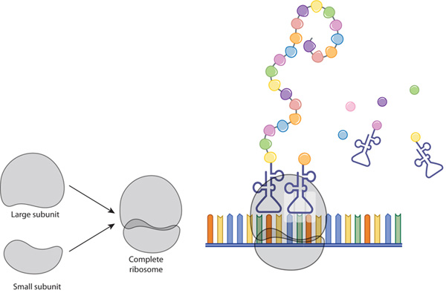

Figure 7:  translation

A ribosome is composed of two subunits: large and small. During translation, ribosomal subunits assemble together like a sandwich on the strand of mRNA, where they proceed to attract tRNA molecules tethered to amino acids (circles). A long chain of amino acids emerges as the ribosome decodes the mRNA sequence into a polypeptide, or a new protein.

Molecules of tRNA are responsible for matching amino acids with the appropriate codons in mRNA. Each tRNA molecule has two distinct ends, one of which binds to a specific amino acid, and the other which binds to the corresponding mRNA codon. During [translation](http://www.nature.com/scitable/topicpage/the-information-in-dna-determines-cellular-function-6523228), these tRNAs carry amino acids to the ribosome and join with their complementary codons. Then, the assembled amino acids are joined together as the ribosome, with its resident rRNAs, moves along the mRNA molecule in a ratchet-like motion. The resulting protein chains can be hundreds of amino acids in length, and synthesizing these molecules requires a huge amount of chemical energy (Figure 8).

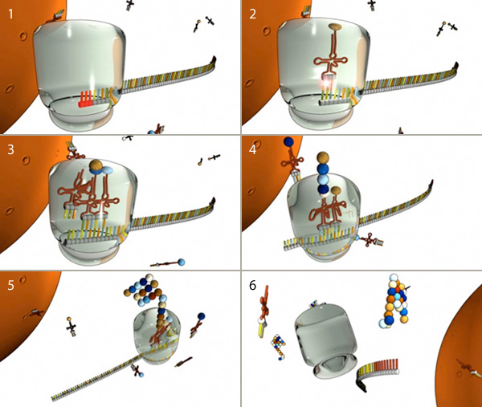

Figure 8: The major steps of translation

(1) Translation begins when a ribosome (gray) docks on a start codon (red) of an mRNA molecule in the cytoplasm. (2) Next, tRNA molecules attached to amino acids (spheres) dock at the corresponding triplet codon sequence on the mRNA molecule. (3, 4, and 5) This process repeats over and over, with multiple tRNAs docking and connecting successive amino acids into a growing chain that elongates out of the top of the ribosome. (6) When the ribosome encounters a stop codon, it falls off the mRNA molecule and releases the protein for use in the cell.

In prokaryotic cells, transcription (DNA to mRNA) and translation (mRNA to protein) are so closely linked that translation usually begins before transcription is complete. In eukaryotic cells, however, the two processes are separated in both space and time: mRNAs are synthesized in the nucleus, and proteins are later made in the cytoplasm

Translation, the second part of the central dogma of molecular biology, describes how the genetic code is used to make amino acid chains. In this lesson, explore the mechanics involved in polypeptidsynthesis. Learn the three major steps of translation as you watch tRNA, mRNA, and ribosomes go to work.

## The Three Steps of Translation

Translation is the second step in the central dogma that describes how the genetic code is converted into amino acids. We've talked about how the mRNA codes are recognized by tRNA and how the amino acids are linked together by peptide bonds. A chain of amino acids is also called a polypeptide. Polypeptides are assembled inside the ribosomes, which are tiny organelles on the rough ER of a cell.

Now that we're learning more about the mechanics of translation, we're going to have to start putting the pieces together. We already understand the role of the ribosome and the amino acids in the process of translation, but how does polypeptide assembly actually occur? There are three important steps to the process of translation.

There's a beginning step, called **initiation**, a middle step, called **elongation**, and a final step, called **termination**. These three words may sound familiar to you. The same terms are used in transcription to describe the steps involved in making the mRNA strand. But, here in translation, we're making a polypeptide strand. In either case, we're making a long molecule out of a chain of smaller subunits. So, whether we're referring to transcription or translation, the three terms accurately describe the mechanics of the process. Let's walk through each step, one at a time.

## Initiation

|  |
| --- |
| Description: mRNA Translation Initiation Step |
| In initiation, mRNA is attached to tRNA, which is attached to the specified amino acid. |

We'll start with **initiation**. During initiation, the mRNA, the tRNA, and the first amino acid all come together within the ribosome. The mRNA strand remains continuous, but the true initiation point is the start codon, AUG. Remember that the start codon is the set of three nucleotides that begins the coded sequence of a gene. Remember also that the start codon specifies the amino acid methionine. So, methionine is the name of the amino acid that is brought into the ribosome first.

And, how did methionine get itself to the ribosome? By attaching to the tRNA that contains the right anticodon. The anticodon for AUG is UAC. We know that because of the rules of [complementary base pairing](http://study.com/academy/lesson/complementary-base-pairing-definition-lesson-quiz.html). The tRNA with the anticodon UAC will automatically match to the codon AUG, bringing the methionine along for the ride. So, there you have it - mRNA is attached to tRNA, and tRNA is attached to methionine. That's initiation.

## Elongation

The next step makes up the bulk of translation. It's called **elongation**, and it's the addition of amino acids by the formation of peptide bonds. Elongation is just what it sounds like: a chain of amino acids grows longer and longer as more amino acids are added on. This will eventually create the polypeptide.

Now that we've begun with the start codon, the mRNA shifts a little through the ribosome so that the next codon is up for grabs. Let's say the next codon is UAU. So, now we need a tRNA that has the matching anticodon, AUA. Oh, look! Here's a tRNA with the right anticodon, and it's brought along a tyrosine. Tyrosine is the amino acid that is specified by the codon UAU. The tRNA attaches to the mRNA in the ribosome and lines up tyrosine right next to the waiting methionine. A peptide bond forms between the two amino acids.

Then, the first tRNA leaves everyone else behind and floats off to find more work to do. Poor methionine! Now it's just drifting around like a lonely kite in the wind! That tRNA left methionine hanging by only one anchor: its peptide bond with tyrosine. The tyrosine is still attached to its own tRNA, which, in turn, is clinging to the mRNA inside the ribosome. Already we can see the beginnings of a polypeptide elongating outward.

|  |
| --- |
| Description: mRNA Translation Elongation Step |
| Polypeptides form as amino acids are added during the elongation step. |

Should we walk through that process one more time? Let's keep everything just as we have it here and move on to add our third amino acid. mRNA shifts over again, and now the third codon is ready for a match. What's that codon? CAC. Here comes a tRNA with the matching anticodon, GUG. It's also brought us a histidine, since CAC codes for histidine. The tRNA's anticodon matches up with the mRNA's codon, putting the histidine in perfect position for making a peptide bond with tyrosine.

So, now we have methionine, tyrosine, and histidine all connected. We won't be needing tyrosine's tRNA anymore, so that tRNA detaches and floats away, just like the first one did in the beginning. Now we have an even longer kite; methionine and tyrosine are drifting around with only their peptide bonds to hold them down to the ribosome.

But, the histidine is still connected to its own tRNA, and it'll stay that way until it has the next amino acid to latch onto. You can see how this chain of amino acids would grow longer as each new codon is translated. The addition process and peptide bond formation continues over and over again until the chain is about one hundred amino acids long.