

**CPCS-403**

**Names: Mansour Ahmed Aldhahri, Musab Hassan Alsobhi**

**ID’s:** 2036538, 2035566

**Section:** CS1

**Date:** 2023/10/18

Table of Contents

Website 2

Project ideas 3

Functions 3

Recommended solution 3

Benefits 4

Storyboard 4

Sitemap 7

7

# Website

<https://21msb.github.io/TicketingPlatform/HTML/>

# Project ideas

Our website will focus on the ticketing industry. Therefore, we decided to build a user-

friendly website where customers can effortlessly browse upcoming events, purchase event

tickets, and even allow event organizers to easily connect with us for ticket distribution.

Moreover, Visitors to the website will be able to browse a wide variety of events, concerts,

sporting activities, and more. Overall, the website promises to provide a simple and effective

service for event attendees hoping to attend a variety of events and event organizers

searching for a dependable partner for ticket distribution.

## Functions

• Event Listings: A thorough listing of events, along with dates, times, and locations.

• Sales of Tickets: Customers may safely purchase event tickets using a variety of

payment methods.

• Collaboration with Event Organizers: A place set aside for event planners to get in

touch with us about their ticket distribution requirements.

• User profiles: Customized profiles for users and organizers of events.

• Search and filters: To assist customers in finding events based on preferences.

# Recommended solution

Our solution addresses the needs of event enthusiasts, ticket buyers, and event organizers,

offering a one-stop platform for all ticket-related operations. Our website makes the process

simple for customers who wish to purchase tickets and event organizers who want a trusted

partner for ticket distribution.

# Benefits

• Effortless Ticket Purchasing: Users will have a hassle-free transaction when

purchasing tickets for their selected events.

• Convenience for Event Organizers: Events benefit from a dependable partner to

ensure efficient ticket distribution.

• Diverse Event Selection: Access to several events and spots, giving options for a

diversity of interests.

• User Convenience: Efficiency in ticket buying with a user-friendly interface.

• Support Page: By adding a specific support page, users, including event organizers,

will always have access to help and information when they need it.

• Time and Cost Savings: Event organizers can concentrate on event planning and

execution since outsourcing ticket distribution saves them time and money.

• Community Engagement: Connecting buyers, sellers, and event organizers, creating a

thriving marketplace for event tickets.

# Storyboard

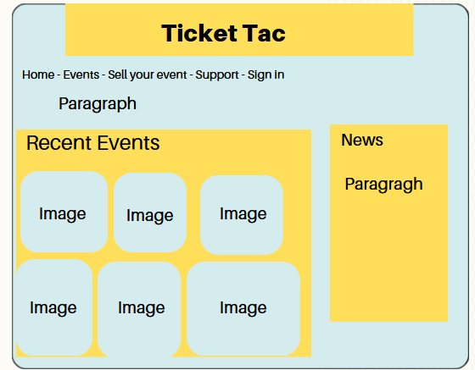

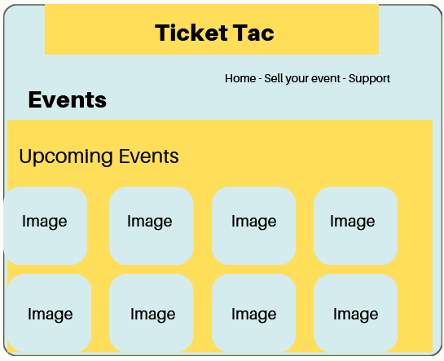

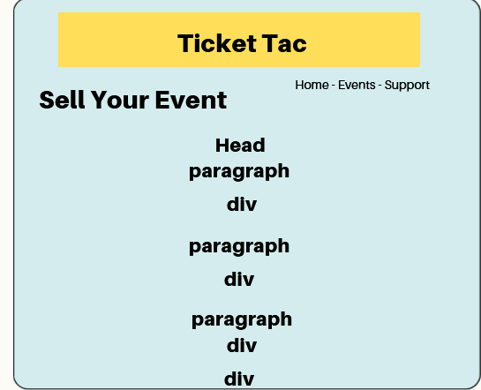

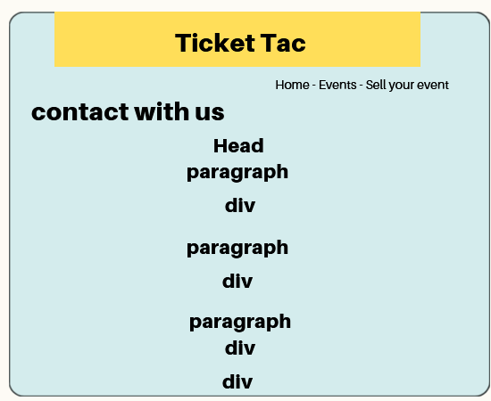

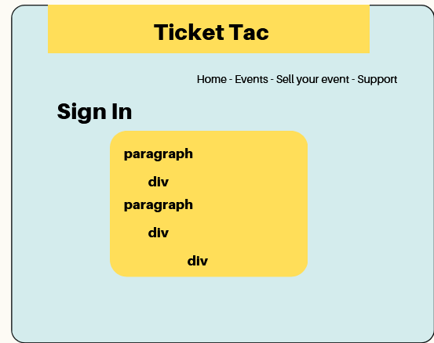

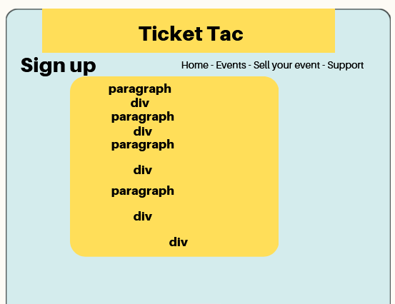

# Sitemap

