Tursynbay Mansur CS - 2428

Step-by-Step Guide to SSRF Exploit
Server-Side Request Forgery (SSRF) is a type of security vulnerability that occurs when an attacker can manipulate or forge requests from a vulnerable server to other internal or external resources. SSRF vulnerabilities typically arise when an application processes user-supplied input, such as URLs or file paths, without proper validation or sanitization.
The consequences of SSRF vulnerabilities can be severe, allowing attackers to:
- Access Internal Resources: Attackers can exploit SSRF vulnerabilities to access internal resources and services that are not intended to be directly accessible from the internet. This may include databases, internal APIs, backend systems, or sensitive files.
- Bypass Security Controls: SSRF can be used to bypass firewall restrictions or other security controls by forcing the vulnerable server to make requests to restricted internal or external resources on behalf of the attacker.
- Perform Port Scanning: Attackers can leverage SSRF to perform port scanning on internal network hosts to identify open ports and services, which can aid in further exploitation or lateral movement within the network.
- Execute Denial of Service (DoS) Attacks: SSRF vulnerabilities can be exploited to perform denial of service attacks by forcing the vulnerable server to make requests to resource-intensive or malicious endpoints, causing system overload or downtime.
Preventing SSRF vulnerabilities requires implementing robust input validation and sanitization mechanisms to ensure that user-supplied input is properly constrained and restricted. Additionally, server-side controls should be implemented to restrict the destinations that the server is allowed to access and to block requests to internal resources or sensitive endpoints.
Developers should also consider using whitelists instead of blacklists when defining allowable destinations for outgoing requests, as blacklists can be prone to evasion techniques and may miss new or unknown attack vectors. Regular security assessments and code reviews can help identify and mitigate SSRF vulnerabilities in applications before they can be exploited by attackers.
Below students can find an example of a task focused on SSRF vulnerability on the server with step by step explanation.

Step 1: Identifying the Target
In this task, we aim to exploit a Server-Side Request Forgery (SSRF) vulnerability on the server at utils.edu.stf (10.124.1.237). Figure 3.50 shows task on SSRF Critical event. The task description mentions accessing an internal service running on port 9732 (http://127.0.0.1:9732).
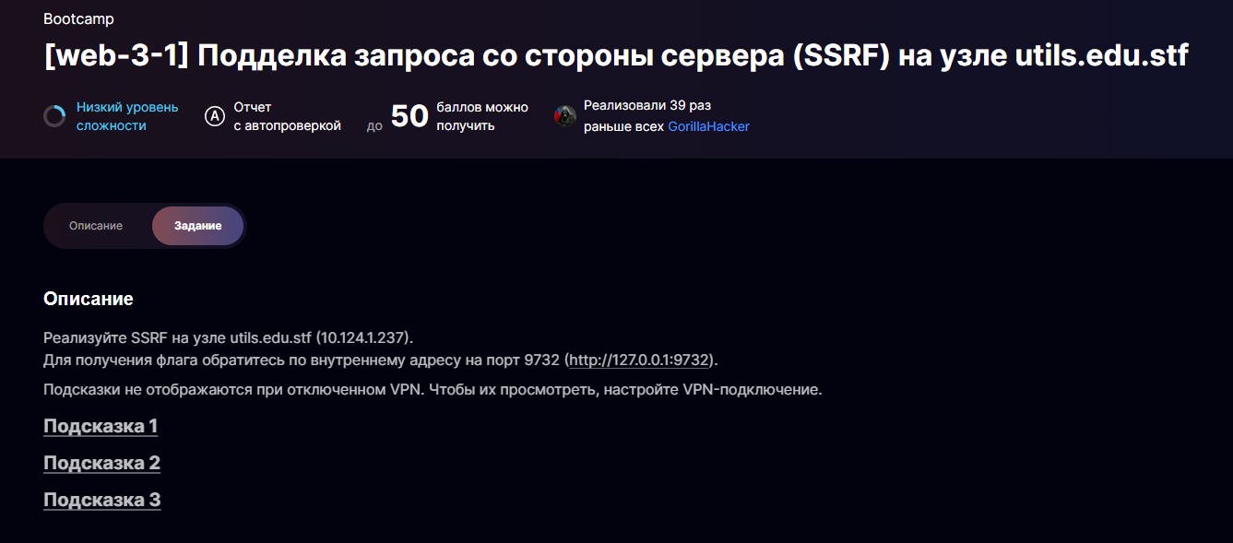
Fig. 3.50 SSRF Critical event

Step 2: Accessing the Web Service
We access the web service at http://10.124.1.237, which hosts a PDF converter application. Figure 3.51 presents Web service on 10.124.1.237. The PDF converter allows users to upload a file or specify a URL to convert.
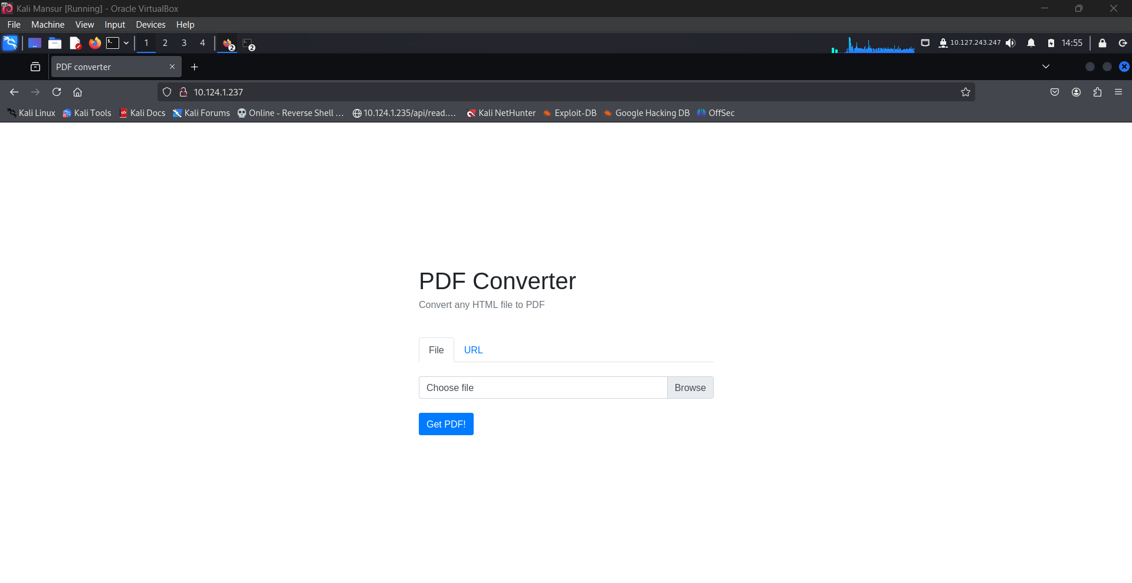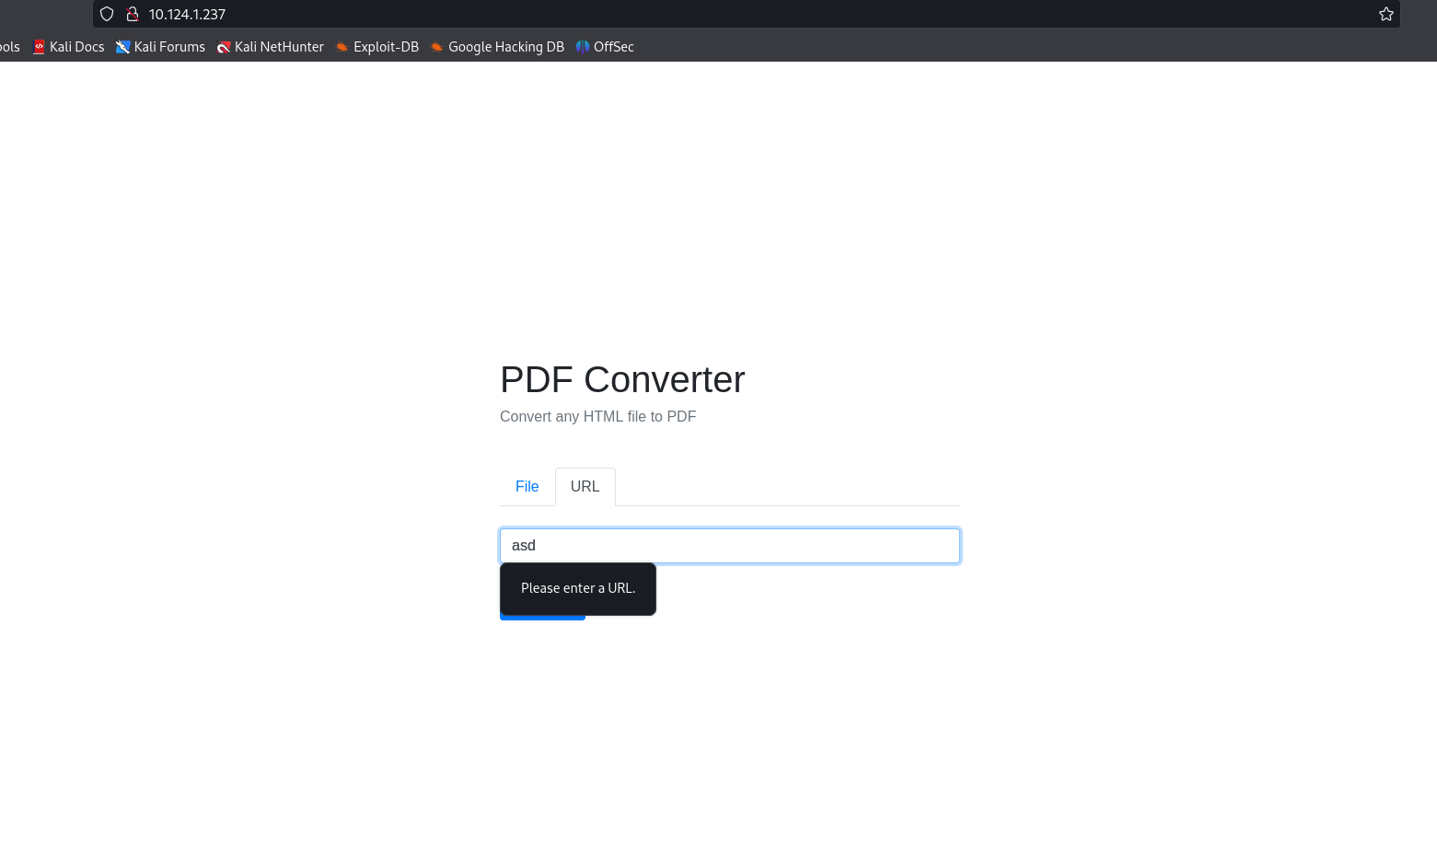
Fig. 3.51 Web service on 10.124.1.237

Step 3: Intercepting the POST Request
Using Burp Suite, we intercept the request sent when the URL is submitted. Figure 3.52 shows Intercepting the POST request on Burp Suite. The intercepted request shows the URL submission to the PDF converter. The URL field is modified to point to http://127.0.0.1:9732, aiming to exploit the SSRF vulnerability.

Step 4: Analyzing the Intercepted Request
The raw request intercepted by Burp Suite shows how the data is submitted to the server. Figure 3.52 demonstrates Intercepting the POST request on Burp Suite. The request data includes the URL pointing to the internal service. 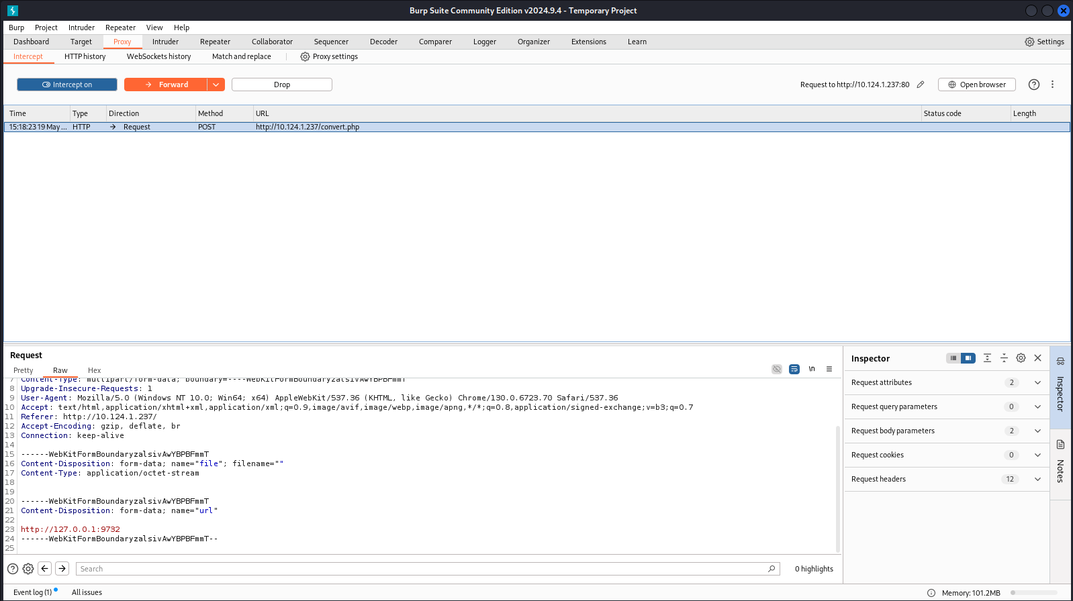
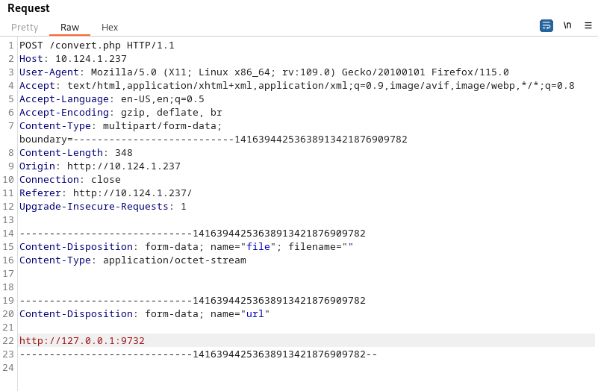
Fig. 3.52 Intercepting the POST request on burp suite

Step 5: Executing the Exploit
After modifying the request to target the internal service, we forward the request and observe the response. 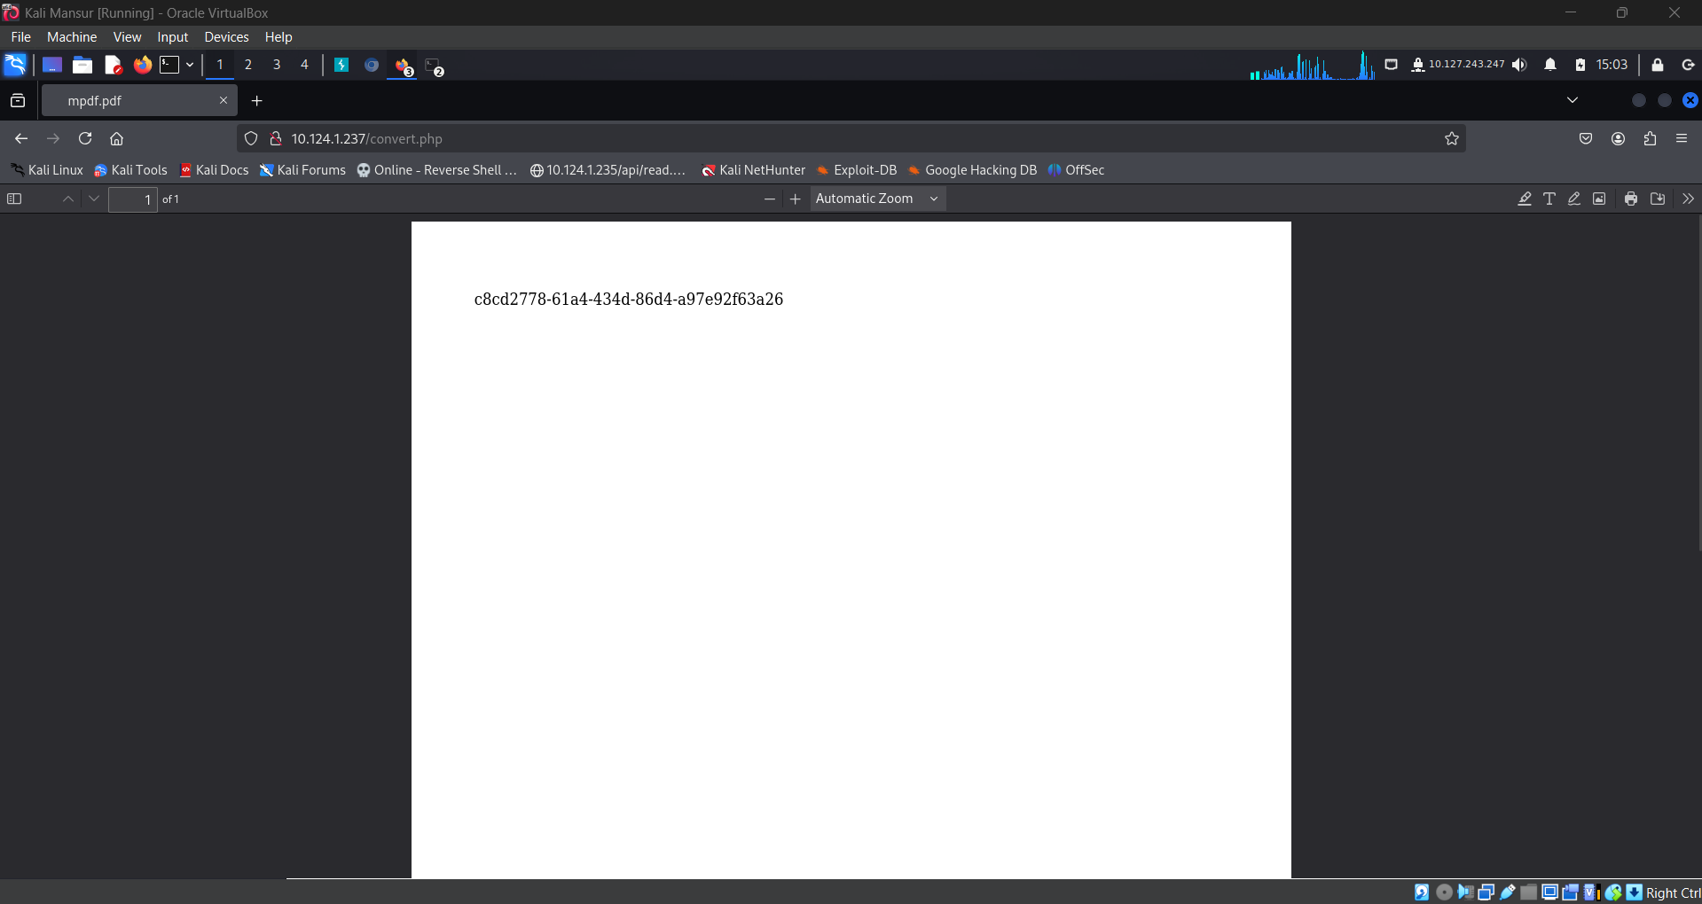
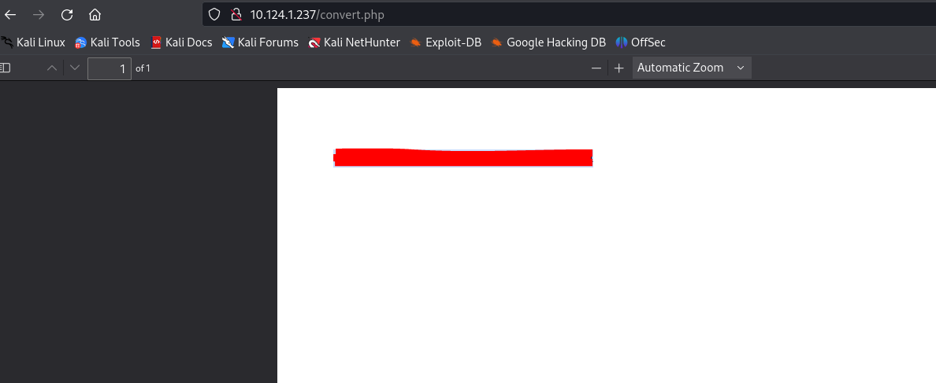
Fig. 3.53 Gaining flag via SSRF
Result (fig.3.53):
By successfully exploiting the SSRF vulnerability, we can access internal services that are not normally exposed to the public internet. This exploit can lead to sensitive information disclosure or further attacks on internal network services.

