Loan Approval Classification Dataset:
The Loan Approval Classification Dataset contains 45,000 records and 14 variables, designed to model and predict whether a loan application will be approved or rejected.The dataset includes both numerical variables (person’s age, income, employment length, loan amount, interest rate, credit score) and categorical variables are home ownership status, loan purpose, loan grade, credit default history. The target variable is loan_status, a binary indicator where 1 = approved and 0 = rejected.
The sample dataset is derived from the Loan Approval Classification dataset and contains 201 records with a mix of numerical and categorical variables related to loan applications. Unlike the full dataset, this sample includes 17 missing values distributed across five variables: person_age (4), person_gender (4), person_income (4), person_loan_status (3), and person_education (2). Our goal is to apply data preprocessing techniques, handling missing values and exploratory data analysis.
Code Description:
install.packages("dplyr")
library(dplyr)
library(ggplot2)
Installed and loaded the “dplyr” and “ggplot2” packages for data manipulation and visualization.
Code:
mydata<-read.csv("C:/R/Midterm_Dataset_Section(A).csv",header=TRUE,sep=",")
print(mydata)
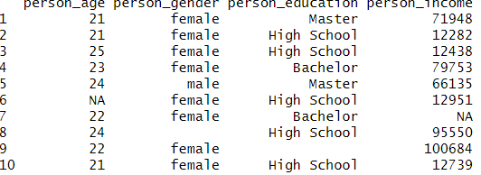
This code reads mydata.csv dataset into the R studio as mydata and prints all rows and columns.
Code:
colSums(is.na(mydata) | mydata == "" )
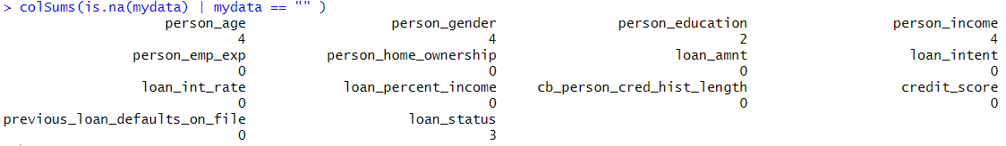
This code counts the number of missing values in each column for both NA and empty strings ("") as missing as missing value.
Code:
colSums(is.na(mydata) | mydata == "" )
summary(mydata)
missing_data <- data.frame(
variable = names(mydata),
missing_count = sapply(mydata, function(x) sum(is.na(x) | x == ""))
)
Counts missing values in each column, considering both NA and empty strings ("")
ggplot(missing_data, aes(x = reorder(variable, -missing_count), y = missing_count)) +
geom_bar(stat = "identity", fill = "steelblue") +
coord_flip() +labs(title = "Missing (NA or Empty String) Values per Variable", x = "Variables", y = "Number of Missing Values")
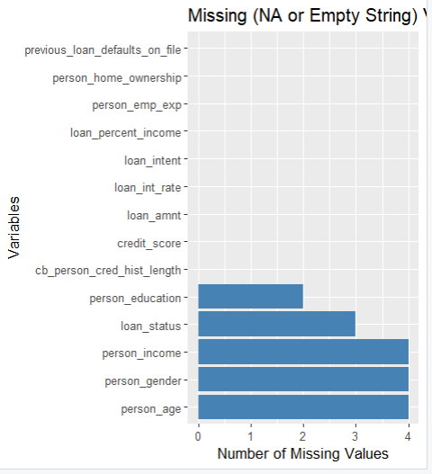
Visualize the number of missing values in a bar plot.

Code:
duplicated(mydata)
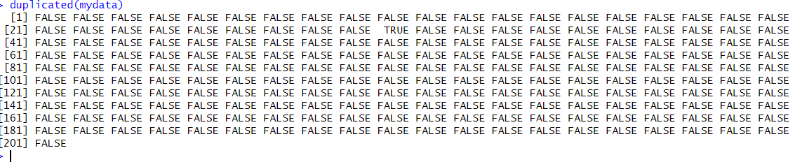
If there are any duplicate row it will show TRUE, else it will show FALSE
Code:
mean_age <- mean(mydata$person_age, na.rm = TRUE)
mean_age <-as.integer(round(mean_age))
mydata$person_age[is.na(mydata$person_age)] <- mean_age
- This code calculates mean value with mean() function. Then fills missing person_age values with the rounded mean age.

mode_gender <- names(sort(table(mydata$person_gender),decreasing = TRUE))[1]
mydata$person_gender[mydata$person_gender == ""] <- mode_gender
- This code calculates the most frequent gender (mode) and replaces all empty strings in the person_gender column with this mode.
mode_education <- names(sort(table(mydata$person_education),decreasing = TRUE))[1]
mydata$person_education[mydata$person_education == ""] <- mode_education
- This code finds the most frequent value (mode) in person_education and replaces all empty strings in that column with the mode.
mean_income <- mean(mydata$person_income, na.rm = TRUE)
mean_income <-as.integer(round(mean_income))
mydata$person_income[is.na(mydata$person_income)] <- mean_income
- This code computes the mean of person_income rounds it to the nearest integer, and replaces all missing person_income with this mean.
unique(mydata$loan_status)
mode_loan_status <- names(sort(table(mydata$loan_status),decreasing = TRUE))[1]
mydata$loan_status[is.na(mydata$loan_status)] <-mode_loan_status
- This code finds the mode in loan_status and replaces with the mode.
After handling missing value run,
colSums(is.na(mydata) | mydata == "" )
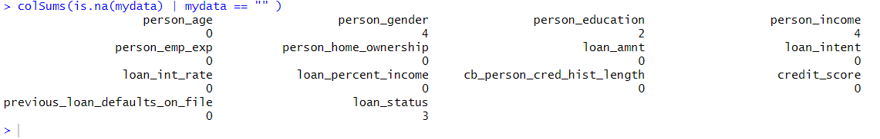
No missing value in our dataset.

Code: Outliers
boxplot(mydata$person_age)
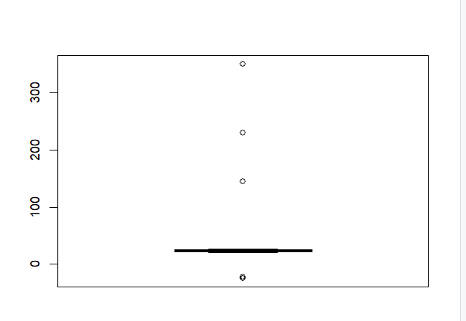
- 4 outleir in person_age
quantile(mydata$person_age)
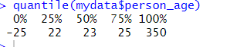
- Q1=22, Q3=25
x <- mydata$person_age
x
iqr <- IQR(x)
iqr
lower_bound_x <- 22 - 1.5 * iqr
upper_bound_x <- 25 + 1.5 * iqr
x[x < lower_bound_x | x > upper_bound_x] <- mean(x)
x <- as.integer(round(x))
mydata$person_age<- x
- This code calculates the IQR of person_age, determines outlier bounds, replaces values outside these bounds with the mean
boxplot(mydata$person_age)
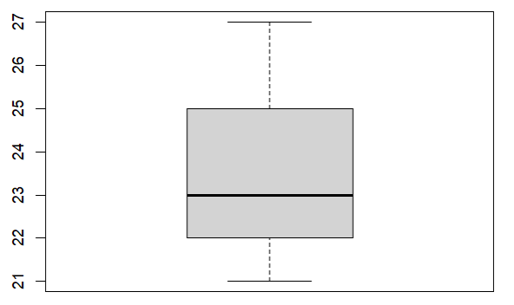
- Outliers removed
boxplot(mydata$person_emp_exp)
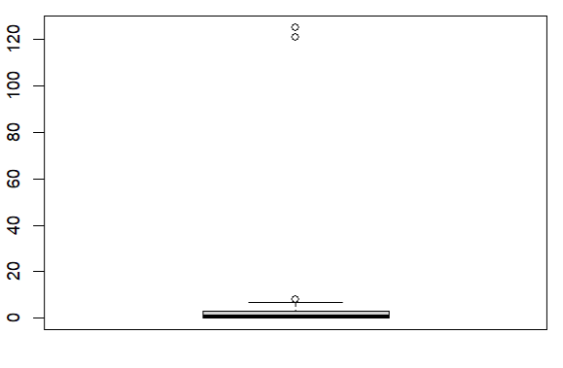
- person_emp_exp has three outlier
boxplot(mydata$person_emp_exp)
quantile(mydata$person_emp_exp)
exp <- mydata$person_emp_exp
exp
iqr_exp <- IQR(exp)
iqr_exp
lower_bound_exp <- 0 - 1.5 * iqr_exp
upper_bound_exp <- 3 + 1.5 * iqr_exp
exp[exp < lower_bound_exp | exp > upper_bound_exp] <- mean(exp)
exp <- as.integer(round(exp)
mydata$person_emp_exp<- exp
- This code calculates the IQR of person_emp_exp, determines outlier bounds, replaces values outside these bounds with the mean
boxplot(mydata$person_emp_exp)
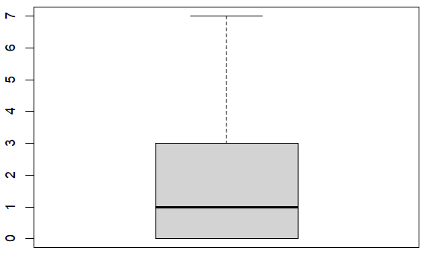
- Outliers removed

boxplot(mydata$person_income)
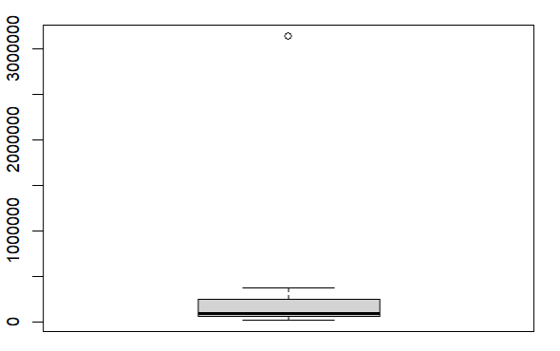
-> person_income has outlier
quantile(mydata$person_income)
i <- mydata$person_income
iqr_i <- IQR(i)
iqr_i
lower_bound_i <- 60747 - 1.5 * iqr_i
upper_bound_i <- 149875 + 1.5 * iqr_i
mean(i)
i[i < lower_bound_i | i > upper_bound_i] <- mean(i)
i <- as.integer(round(i))
mydata$person_income<-i
- This code calculates the IQR of person_income, determines outlier bounds, replaces values outside these bounds with the mean

boxplot($person_income)
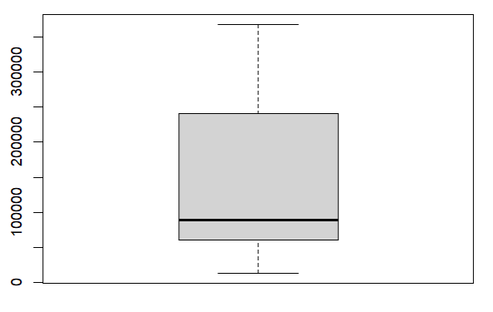
- Outlier removed

Code: Noisy Value
unique(mydata$person_gender)
- Here “malee” and “feemale” are noisy value
mydata <- mydata %>%
mutate(gender = case_when(
tolower(person_gender) %in% c("male", "malee") ~ "male",
tolower(person_gender) %in% c("female", "feemale") ~ "female"
))

mydata$person_gender<-mydata$gender
mydata$gender <- NULL
- This code creates a new Gender collum, convert and store misspelled entries into valid format. After that it replaced the values of person_gende with Gender collum. Then replaced the value of gender collum with Null and Gender collum will be removed.

unique(mydata$person_gender)
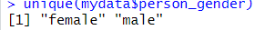-> Noisy value replaced

unique(mydata$person_home_ownership)
- RENTT , OOWN are noisy value
unique(mydata$person_home_ownership)
mydata <- mydata %>%
mutate(home = case_when(
toupper(person_home_ownership) %in% c("RENT", "RENTT") ~ "RENT",
toupper(person_home_ownership) %in% c("OWN", "OOWN") ~ "OWN",
toupper(person_home_ownership) %in% c("MORTGAGE") ~ "MORTGAGE",
toupper(person_home_ownership) %in% c("OTHER") ~ "OTHER" ))
mydata$person_home_ownership<-mydata$home
mydata$home <- NULL
- This code creates a new Homecollum, convert and store misspelled entries into valid format. After that it replaced the values ofperson_home_ownership with Home collum. Then replaced the value of Home collum with Null and Gender collum will be removed.

unique(mydata$person_home_ownership)
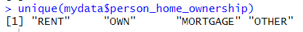 -> Noisy value removed

Categorical to Numeric:
mydata$person_gender <- factor(mydata$person_gender,
levels = c("female", "male"),labels = c(1,2))
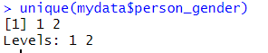

- Converted “female” , “male” to 0, 1.

unique(mydata$previous_loan_defaults_on_file)
mydata$previous_loan_defaults_on_file <- factor(mydata$previous_loan_defaults_on_file,
levels = c("No", "Yes"),labels = c(0,1))
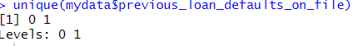
- Converted “No” , “Yes” to 0, 1.

Numeric to Categorical:
unique(mydata$loan_status)
mydata$loan_status <- factor(mydata$loan_status,
levels = c(0,1),labels = c("No","Yes"))
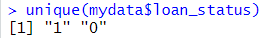
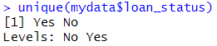 -> Converted 1,0 to “Yes”, “No”

Code: Min-Max Normalization
normalization <- function(n) {
(n - min(n, na.rm = TRUE)) / (max(n, na.rm = TRUE) - min(n, na.rm = TRUE))
}
mydata$person_income <- normalization(mydata$person_income)
- This code defines a min-max normalization function to scale numeric values between 0 and 1 and applies it to the person_income column.
Code: Filter data
filtered_data1 <- mydata %>%
filter(loan_amnt > 20000 | person_age < 20)
filtered_data1
str(filtered_data1) 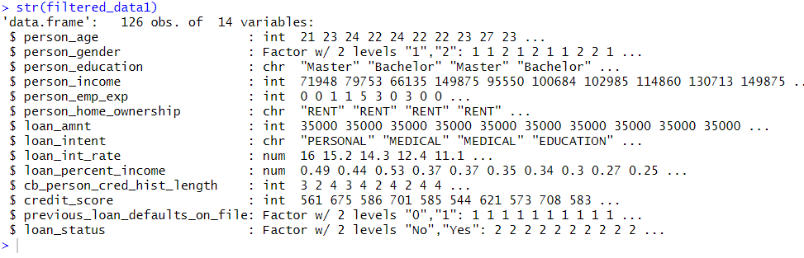
- This code filters the dataset to include rows where loan_amnt is greater than 20,000 or person_age is less than 20, then displays the filtered data and its structure.

filtered_data2 <- mydata %>%
filter(loan_status == "Yes" & person_age > 20)
filtered_data2
str(filtered_data2)
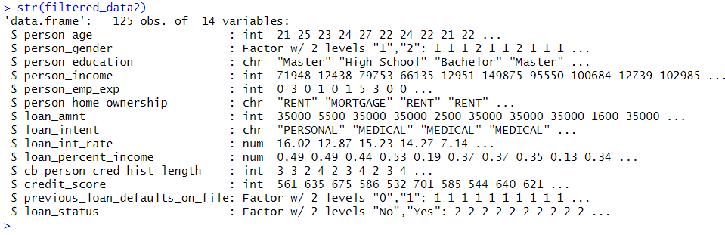
- This code selects rows where loan_status is "Yes" and person_age is greater than 20, then shows the filtered dataset and its structure.

Sampling: Oversampling method
table(mydata$person_gender)
balanced_data_over <- mydata %>%
group_by(person_gender) %>%
slice_sample(n = max(table(mydata$person_gender)), replace = TRUE) %>%
ungroup()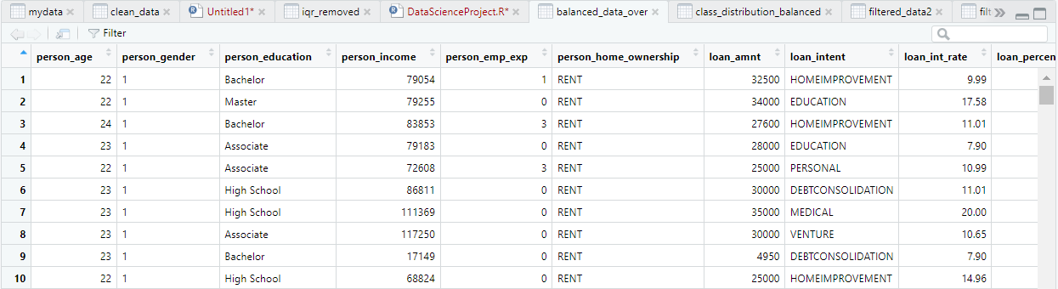
-> This code counts the number of records for each gender and then creates a balanced dataset by oversampling the minority gender to match the count of the majority gender.

table(balanced_data_over$person_gender)
class_distribution_balanced <- balanced_data_over %>%
count(person_gender) %>%
mutate(percentage = n / sum(n) * 100)
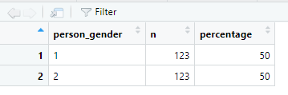
- This code shows the number of records for each gender in the balanced dataset and creates a table with both counts and their percentage of the total.

Test and Training dataset
set.seed(123)
train_data <- mydata %>%
sample_frac(0.8)
test_data <- mydata %>%
anti_join(train_data)
str(train_data)
str(test_data)
-> This code splits the dataset into a training set (80% of the data) and a test set (remaining 20%), then displays the structure of the training set.

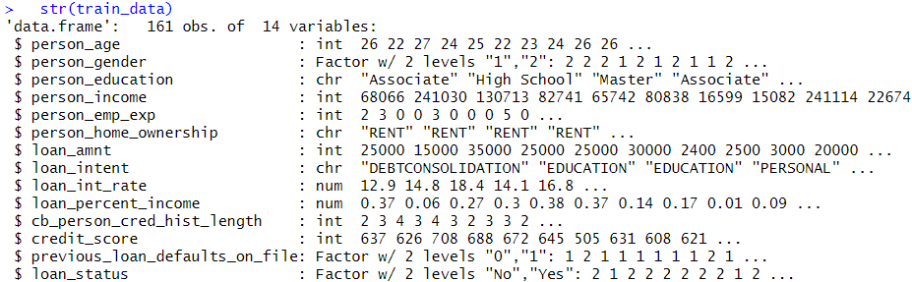
- Tain data total 161 obs
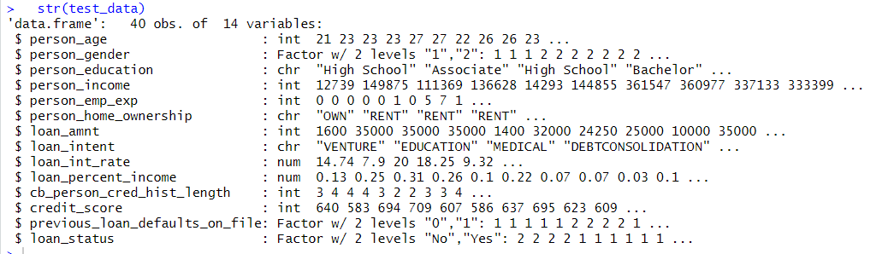
- Test data total 40 obs

Descriptive Statistics
summarize_age_income<- mydata %>%
group_by(loan_status) %>%
summarise(
mean_age = mean(person_age, na.rm = TRUE),
median_age = median(person_age, na.rm = TRUE),
sd_age = sd(person_age, na.rm = TRUE),
min_age = min(person_age, na.rm = TRUE),
max_age = max(person_age, na.rm = TRUE),

mean_income = mean(person_income, na.rm = TRUE),
median_income = median(person_income, na.rm = TRUE),
sd_income = sd(person_income, na.rm = TRUE),
min_income = min(person_income, na.rm = TRUE),
max_income = max(person_income, na.rm = TRUE)
)
summarize_age_income
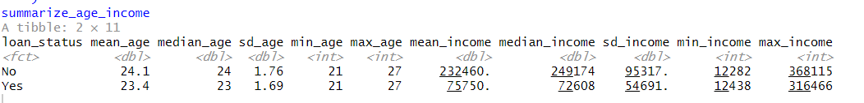

Average credit_score between customers with loan_status 1 and with loan_status 0
avg_credit <- mydata %>%
group_by(loan_status) %>%
summarise(
mean_credit = mean(credit_score, na.rm = TRUE),
median_credit = median(credit_score, na.rm = TRUE),
sd_credit = sd(credit_score, na.rm = TRUE),
count = n()
)
avg_credit
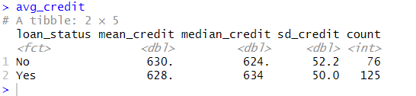
Spread in person_emp_exp for customers with different levels of person_education
emp_exp_stats <- mydata %>%
group_by(person_education) %>%
summarise(
mean_exp = mean(person_emp_exp, na.rm = TRUE),
median_exp = median(person_emp_exp, na.rm = TRUE),
sd_exp = sd(person_emp_exp, na.rm = TRUE),
min_exp = min(person_emp_exp, na.rm = TRUE),
max_exp = max(person_emp_exp, na.rm = TRUE),
IQR_exp = IQR(person_emp_exp, na.rm = TRUE),
n = n()
)
emp_exp_stats
unique(mydata$person_education)
