

Project report: Angular Project
Mansura Khajra
Student Id: S00265100

- Initial design proposal
This was the original idea for the project I submitted at the beginning. Some aspects if the project changed during the development which I explained later in this report
- Project description

- The idea behind my web application is to create a perfume recommendation platform/page where users can discover, rate, and share their favourite perfumes. Users can browse trending perfumes, also can see who’s favourite perfume is which and they can learn about many perfumes search for specific scents, and view detailed information such as fragrance notes, brand, and user reviews. The application will allow users to upload their own favourite perfumes, including images and descriptions, type of scent, creating a community-driven experience.
- Main features View trending perfumes
- Search perfumes by name or brand
- Add favourite perfumes (with image + description)
- Rate perfumes (1–5 stars)
- View detailed perfume pages
- Filter perfumes (by scent type: floral, woody, fresh)
- Navigation bar for easy access
- Why it is useful / interesting
This application is useful because choosing perfumes can be difficult without recommendations. It allows users to discover new scents based on popularity and reviews. It is also fun and interactive for perfume lover like myself who are look for recommendation, as users can share their personal favourites and see what others like. The rating and trending features make it engage and help users make better decisions when buying perfumes based on people favourites and trending.

- User Interface (UI) design
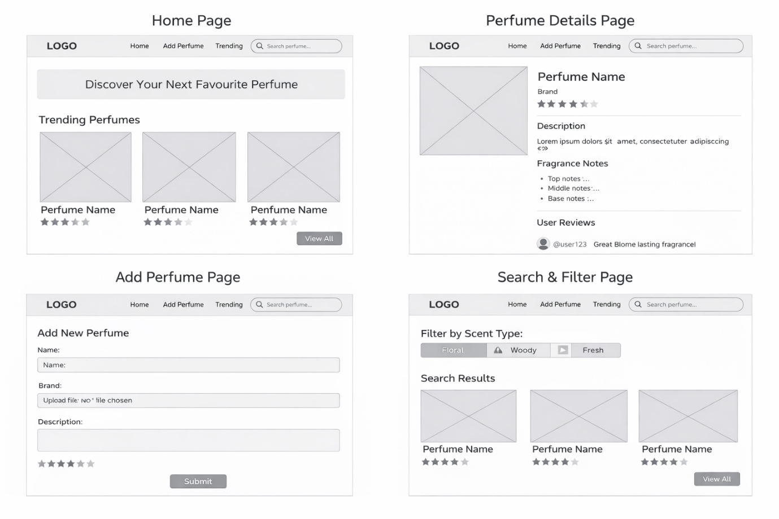
- API
API Overview
I will use api to retrieve perfume data including name, brand, image, and description.
Endpoints
Example:
GET /perfumes
GET /perfumes/{id}
GET /perfumes?search=keyword
Postman Testing
- Tested API using GET requests
- Verified data returns JSON
- Checked search functionality

Search / Filtering
- Use API search (if available)
- Or filter locally by: brand /scent type /rating

Data Shape (IMPORTANT)
List view:
- id
- name
- brand
- image
-scent type
- rating
Detail view:
- name
- brand
- description
-scent type
- notes (top/middle/base)
- image
- rating

MongoDB Storage
You will store:
- name
- brand
- description
- image UR
-scent type
- user rating
- user reviews

- Component Diagram :
App Component

Navbar Component

Router Outlet

Home Component

Perfume Service
Perfume-list Component

Sends HTTP requests to Express API (Ec2)
Add perfume Component

Perfume Details Component

About Component

This application is structured using angular components, the app is component is the root component and contains the navbar and router outlet . The router outlet outlets loads different components such as home, perfume list , add perfume , perfume details and about based on the route and the perfume service is used by many components to send http request to the express backed Api hosted by EC2.

- Architecture Diagram :
User (Browser)
MongoDB Database (Stores perfumes and reviews)
PerfumeService.ts
HTTP Requests
Express API Server
Hosted on AWS EC2
Angular Frontend hosted on AWS S3

The application is followed by a client server acritecture. The user interacts with the angular frontend which is hosted on AWS S3. The front end uses PerfumeSerivce to send HTTP requests to the Express backend API hosted on AWS EC2. The backend then processes the request to communicate with mongo DB where perfume and reviews are stored and if its edited its stored again the edited version.

- Differences from proposal
The final application is a bit different Initially I thought of adding a search and filtering system but then I thought its not a perfume buying or selling website , this website is about recommendation for perfume lovers like a blog where people can see and review perfumes and learn about them and take recommendation if they want to buy a nice perfume according to their taste.

