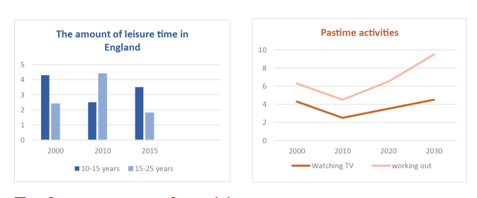

The bar chart demonstrates the quantity of free time various age groups in England had, and the line graph shows several species of pastime activities with a projection for the future.

According to the bar chart in 10 to 15, English children’s leisure time was than more to 4 hours, this indicate was almost 2 times less in 2010. Indicate of children under 15 years of age was plunged. But in 15 to 25 years old people' leisure time was increased in England in 2010. In 2015, in 10 to 15, Children in England leisure time was again increased, however teenagers and adults’ leisure time was almost 2 times decreased.

The line graph shows 2 types of pastime activities which in from 2000 to 2030. Absolutely the most pastime activity was working out in this time. Approximately this indicate was increased to 10 hours. Second type of pastime activity was watching TV. In 2010, number of young people’s hours was decreased that their spent to pastime activities.

In general, information of leisure time and types of pastime activities was compared.

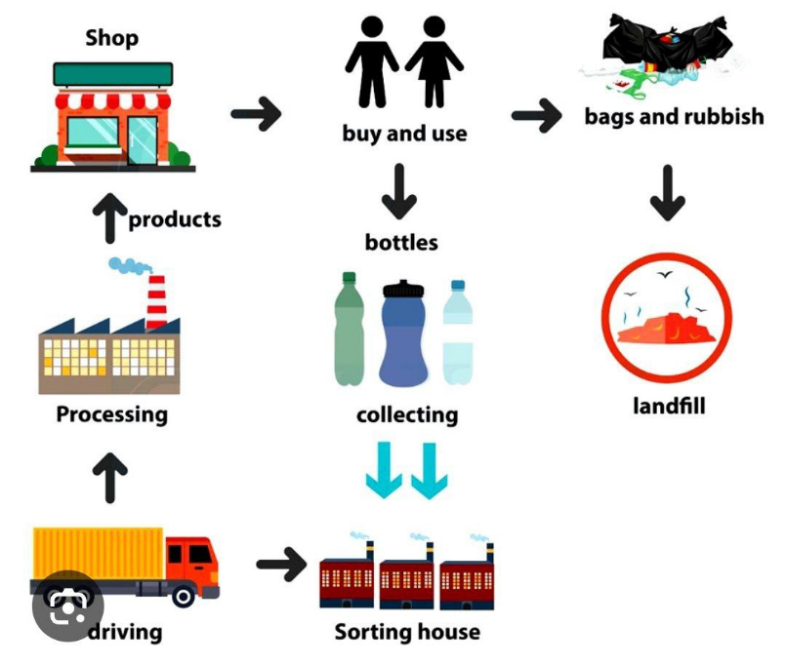

The diagram demonstrates how plastic products is made and several stages which in process.  
 In general, a few steps, different conditionals and some automated machines are involved in bottles production, starting with buying and ending with transporting prepared bottles to the shop or landfilling.

First of all, bottles are bought and used by consumers. Following this step, used bottles are collected and sent to the sorting house. According to attributes of Plastic products are sorted in sorting house and loaded to lorry. At the same time lorry is delivered to the factory. New products are created in factory as well as spread to shops.

If some plastic products are non-recyclable and unfit, they are landfilled. These are bags and rubbish.

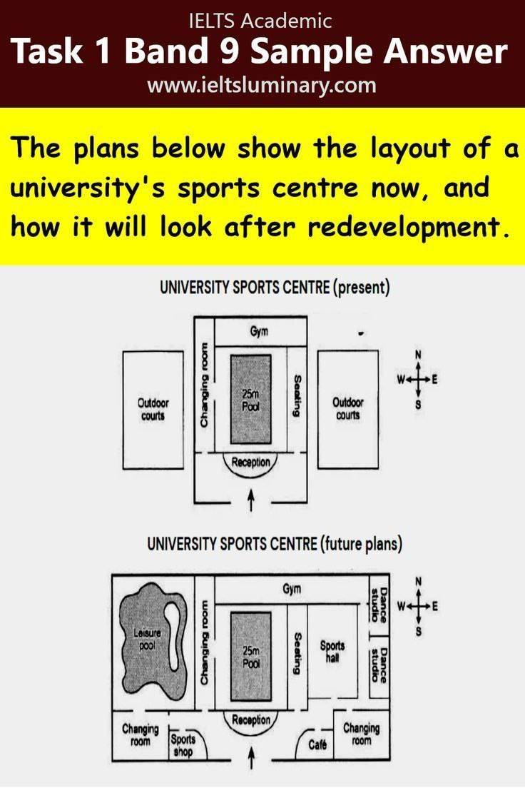

The map demonstrates the plans of a university’s sport center at present, and how its structure after reconstructing.  
 According to plans of the university, its square will be expanded, in additional a leisure pool, two changing rooms, two dance studios, a sports shop, a café and sports hall will be constructed.

At present, 25m Pool is situated in the middle of the university sports center, the gym to the north of the 25m Pool is located. The changing room is situated in the western region, a seating is constructed in the East. There are outdoor courts in the farthest east and west side.

After redevelopment, a changing room in the southwest as well as a changing room of the university sports center is constructed. There are sports center and a café in the south. In east side, sports hall and two dance studios are situated instead of outdoor courts. Leisure pool is organized in the west.

**Condolence letter**

* **Condolence -- Hamdardlik**
* **Offer condolence -- hamdardlik bildiring**
* **Pass away -- vafot etmoq**
* **Console -- yupatmoq**
* **Loss -- yo’qotish**
* **Grieve -- qayg’uda**
* **Sadden -- xafa qilmoq**
* **Sympathy -- hamdardlik**
* **Sorrow -- g’am alam**
* **Reminisce -- o’tmishni yaxshi xotiralarini eslash**

**Hamdardlik bildirish uchun iboralar**

* **I am writing to express my sorrow after the death of your sister**
* **I am so sorry to hear that Uncle Brad has passed away**
* **I was deeply saddened to hear about Tom’s passing**
* **I am incredibly sorry to hear that Scott has passed**
* **I am reaching out let you know how sorry I am about Joe**
* **I am grieved to hear the sad news about the death of your mother.**

**Letter.**

**Hello my dear neighbor. I am grieved to hear the sad news about the fire and of your house. You should not be hopeless, because, you have many close people and we help you to construct a new house. We always respect you. At present, building a new house isn’t difficult. The most important thing for people is appreciate each other in life. I have known you for 10 years. At the same time your house is very valuable for you, because that house was built by your parents. You should believe to my sentences and you overcome this loss. This life is a cruel for everyone. Therefore there are many problems in everybody’s life. This is fact. The life isn’t easy for anybody. You are the best neighbor for me. I am trying to help you find a solution to your problem**

**Again, I am so sorry for your loss.**



**Your neighbor is Mansurbek.**

**Task1**

The pie charts demonstrate information on different ages of the populations Yemen and Italy in 200 and forecasts for 2050. Where the share of the population of different ages is given in percentages. Main changes and information are compared on charts.

In Yemen, more than half of population were children in 2020. 46,3 percent of the total population were people aged 15 to 59 years. At the same time, older than 60 years people’ percentage was 3,6. According to prognosis 15 to 59 years old induviduals

Task2  
People’s relationships  
 **Some people think that in the modern world we are more dependent on each other, while others think that people have become more independent.  
  
Discuss both views and give your opinion.** According to opinions of people, in the modern world we are dependent on each other, while others think that people have become more independent. Many lifestyles of people depend on each other and every sphere should develop at same time. In my opinion, people is completely dependent on each other. In this essay I will write my opinion with supposes and examples about this topic.  
 On the one hand, role of every country is very important in the world. Some resources are not available in many countries, but they can buy these resources from another country. For instance, Uzbekistan buy products of coffee and chemical products for use in daily life. Future of countries, how able to success and again many factors depend on each other respect.  
 On the other hand, we can comprehend this topic among people’s family members in social life. In my country even when children grow up, they rely on their parents. Our people save relationship and respect among their family. I mean extended family. Average number of members a family is 6 in my country. At most situations young people earn money, feed their family but always request their parents when purchase new things. In my view, this situation is a type of depend.  
 We continue opinions, suppose one enterprise. Many factory workers work in that factory, and it has many customers. In this situation, every worker depend factory, many customers believe factory, and at the same time the factory depend government. So, we can see and say that nobody is absolutely independent in the world.

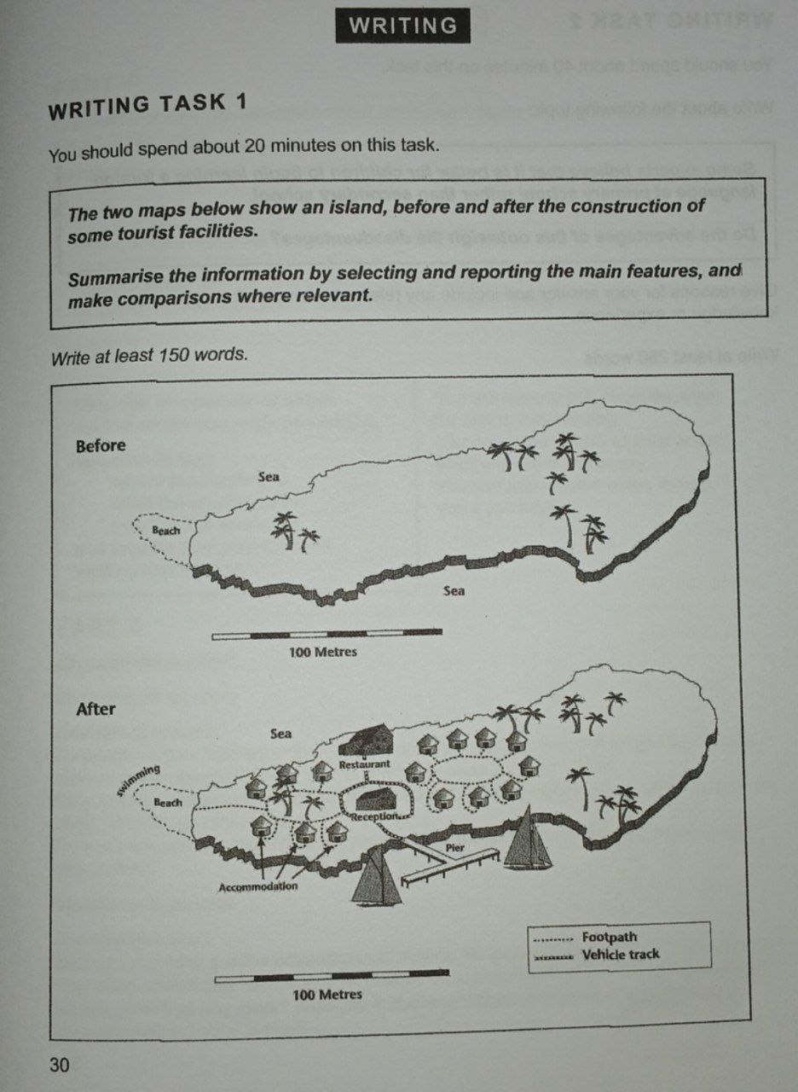

The two maps demonstrate an island, before and after changes for tourists in the island.

This island was radically changed. Before it was natural environment, but after the construction, it has many accommodations, a restaurant, a reception place and a beach for swimming. After construction, there is a pier for ships and a vehicle track on the island.

Before construction, only natural landscapes existed on the island. There were trees and a beach in the island.

The next map shows various changes. Accommodations have been constructed in the center of the island. Footpath system is connected all the accommodations. Restaurant, reception place and pier are connected with vehicle track. The location of the trees was not changed. The beach is adapted for swimming. In the right part of the map, number of accommodations are more than left. Beach and reception place are connected with footpath. The right part of the island was not changed.

In generally, the island was changed by people for tourists.

**New topic  
Considering a high income is the most critical factor when choosing a career.  
To what extend do you agree with this opinion.  
  
  
  
 High salary is the most critical factor when choosing a career. I completely agree to this idea, high salary is important for workers.**

**Firstly, every person wants to earn a lot of money as well as people try choose the most high salary job. Day by day, new types of job are increasing. This situation is very good for workers. Nowadays high-tech technologies are developed, therefore modern jobs have high salaries, such as a programming. Money is very necessary item. No one is wants to work for poor salary. I know a person who always has tried to work at comfortable and rich company. Finally, he found his job. At present he is happy and rich at the same time his level is improving.**

**Secondly, rich people’ lifestyle is easy. They have more leisure time than another. Besides, they can travel with their family, buying more interesting things. The most factor is rich people live longer than poor people.**

**On the other hand, if gave a chance to applicants for job which two choice for job. These are lovely job and another high salary job. At that situation some people choose lovely job. Because lovely job is useful for physical condition. Their lifestyle is simple, but calm and happy who has lovely job.**

**In conclusion, good and bad points are considered of this topic, high salary is important factor when choosing a career.**