‘Hunt The Wumpus’
Rules:

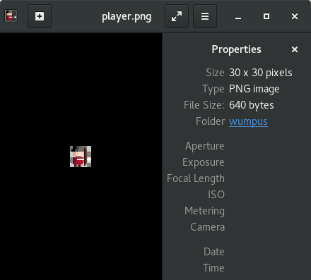
Player:
⬆
Controls: ⬅ ⬇ ➡
Shooting: ‘W’ - up
‘A’ - left
‘D’ - right
‘S’ - down
Hint: ‘H’
Selection: SPACE BAR
Goal: Catch the treasure,
find an exit.
Wumpus and Pitfall kill the player.
Wumpus is smelled and can be shoot.
It moves away if a shoot is missed.
Pitfall is felt with breeze.

To play the game:
1) javac src/*.java outside src folder
2) java src/Game

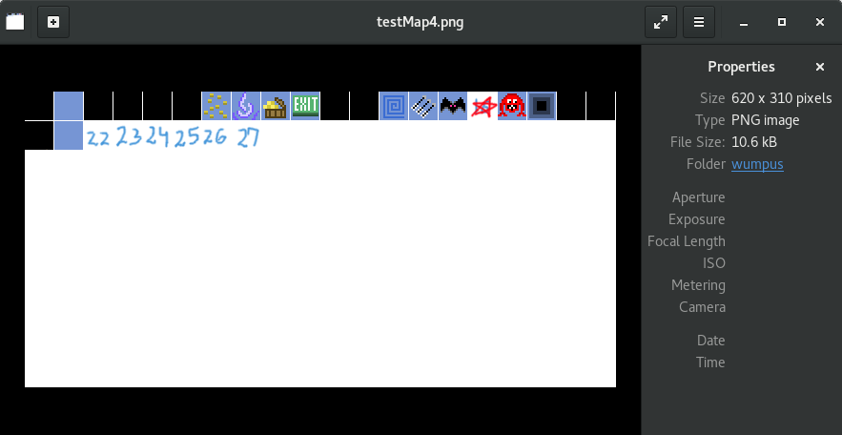
Wumpus:

Smell:

Pitfall:

Breeze:
Bat:

Treasure:

Glitteringness:

Arrows:

Exit:

Unexplored tile:

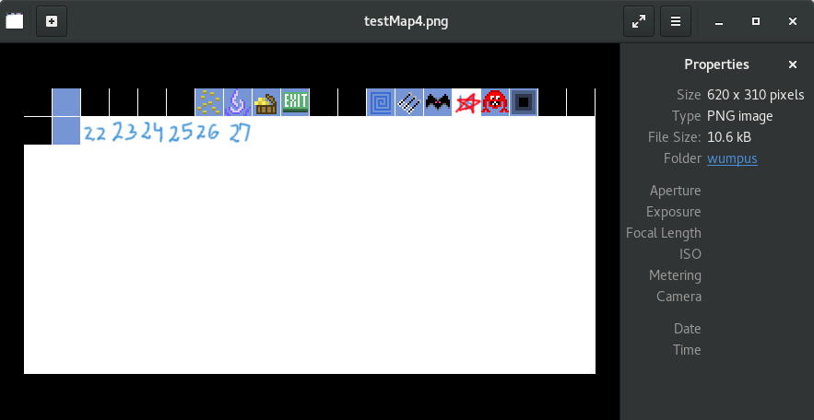
Explored empty tile:

