Email Spam Classifier:
Downloaded the dataset from Kaggle named as spam_ham_dataset
Step 1: Data Cleaning:
1]Checking Null values:
{As there no null values in our dataset and it is a crucial step to remove null values because Models like CountVectorizer/TfidfVectorizer cannot process NULL values
If we had null values we will be removing it by using three steps
1)Remove rows with null text (df = df.dropna(subset=['message'])
2)Replace null with empty string(df['message'] = df['message'].fillna("")
3)Replace null with a placeholder token(df['message'] = df['message'].fillna("no content"))}
2]Dropping unnecessary columns:
(df=df.drop(columns=['Unnamed: 0'])
3]Renaming column name for better understanding
4]Check for duplicated values:
if found duplicate values drop the row

Step 2:Exploratory Data Analysis:
1]Counting Spam and ham messages and also plotting pie chart for it
2]Importing nltk library and download punkt(pre trained tokenizer) from nltk
3]Counting length of each message and sort ascending=False
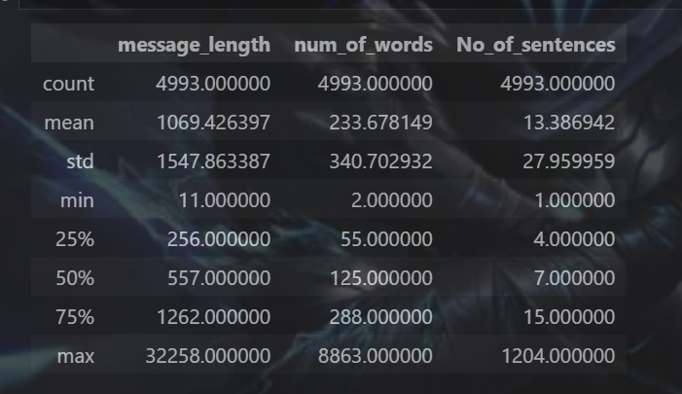
It is calculating number of rows in that particular column
4]Splitting message into words the calculate num of words
5]Splitting into sentences and calculate the no of sentences
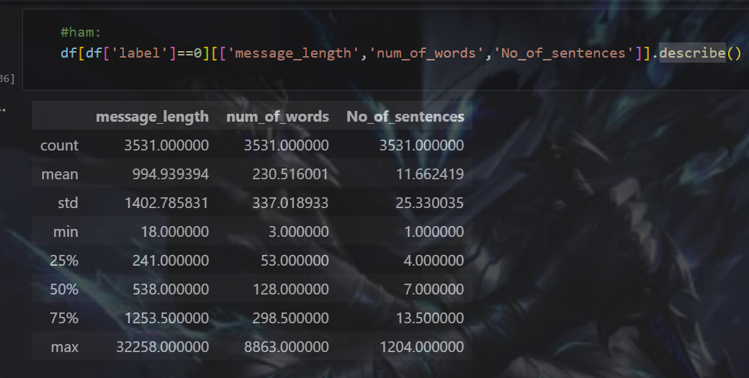
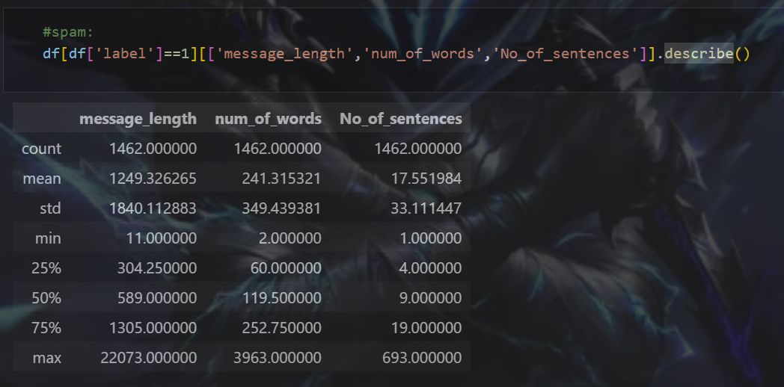
Also we can plot histogram for all the comparisons

Step 3: Data Preprocessing:
- Lower case
- Tokenization
- Removing special characters
- Removing stop words and punctuation
- stemming

Comparing different ml models to check their accuracy and precision with our dataset
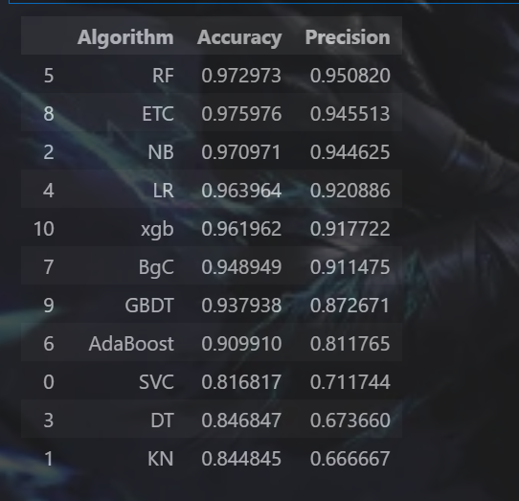
For improving accuracy and precision I have passed max_features = 3000 results remain same
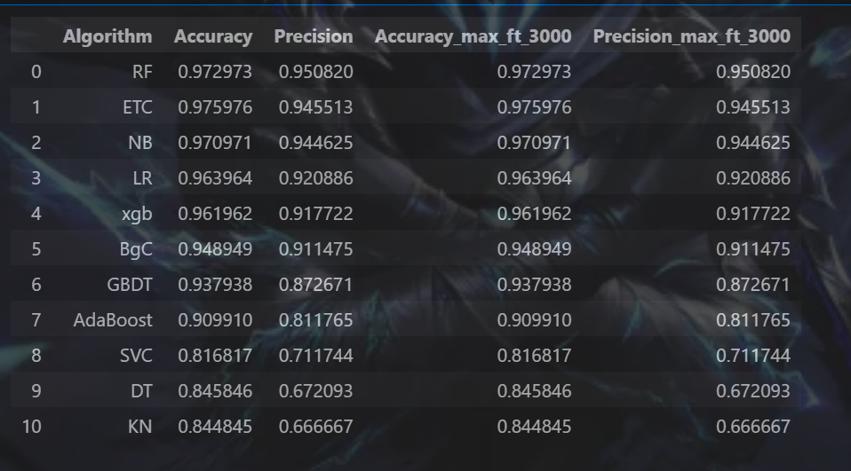
and also did voting classifier but not much improvement so I will not go with voting classifier
then tried stacking but yet no improvements
Every Python file should import its own libraries.

My model works correct for following mails:
✅ HAM (Not Spam) – should predict "ham"
1️⃣
Subject: Meeting Reminder
“Hey team, just a reminder that our project meeting is scheduled for 3 PM tomorrow. Please bring your progress updates.”
2️⃣
Subject: Invoice Attached
“Dear John,
Your invoice for the month of October is attached. Let me know if you have any questions.
Regards, Finance Team”
3️⃣
Subject: Schedule Update
“Hi, please note that your dentist appointment is confirmed for Monday at 11 AM.”
4️⃣
Subject: Family Dinner
“Hey, we’re planning a family dinner this Sunday. Let me know if you can join!”
5️⃣
Subject: Delivery Notification
“Your package has been shipped and is expected to arrive on Wednesday. Track your order through our official website.”
🚨 SPAM Emails – should predict "spam"
6️⃣
Subject: Congratulations! You Won $5,000
“You have been selected for a cash prize of $5000! Click the link to claim your reward immediately!”
7️⃣
Subject: Your Account Will Be Closed
“Your bank account will be suspended in 24 hours. Verify your identity by clicking the link below.”
8️⃣
Subject: Urgent: Update Required
“Your device has been infected with 3 viruses. Install the antivirus now to protect your data!”
9️⃣
Subject: Limited Time Offer
“Buy 1 get 3 free!!! Visit our website now to grab the unbelievable offer before it ends!”
🔟
Subject: Earn Money Fast
“Work from home and earn $5000 per week with zero experience. Sign up now!”
To host the web:
streamlit run "c:/Email Spam Classifier/app.py"

