Given an array of integers nums and an integer target, return indices of the two numbers such that they add up to *target*.

You may assume that each input would have **exactly one solution**, and you may not use the same element twice.

You can return the answer in any order.

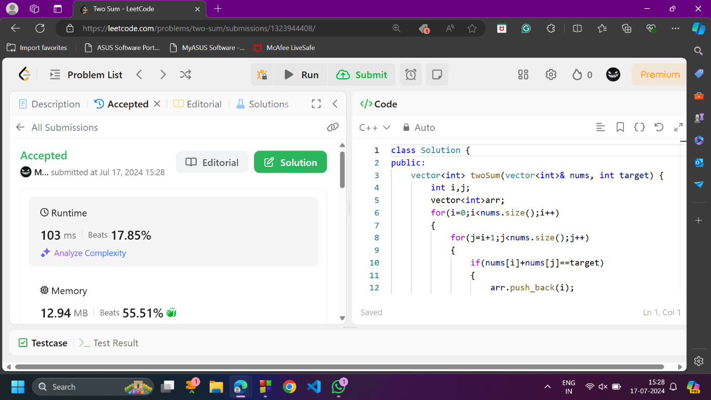

Given a string s containing just the characters '(', ')', '{', '}', '[' and ']', determine if the input string is valid.

An input string is valid if:

1. Open brackets must be closed by the same type of brackets.
2. Open brackets must be closed in the correct order.

