Title: Foundations of Machine Learning
Sections:
- Introduction to Machine Learning (definitions, types, examples)
Machine Learning (ML) is a field of AI where machines learn from data to make decisions.In ML, instead of writing rules for every situation, we feed data to a model, and the model learns patterns from that data to make decisions or predictions in the future.
For example:
- A spam filter learns to identify spam emails by studying examples of spam and non-spam messages.
- A recommendation system like Netflix learns your movie preferences from your watch history.

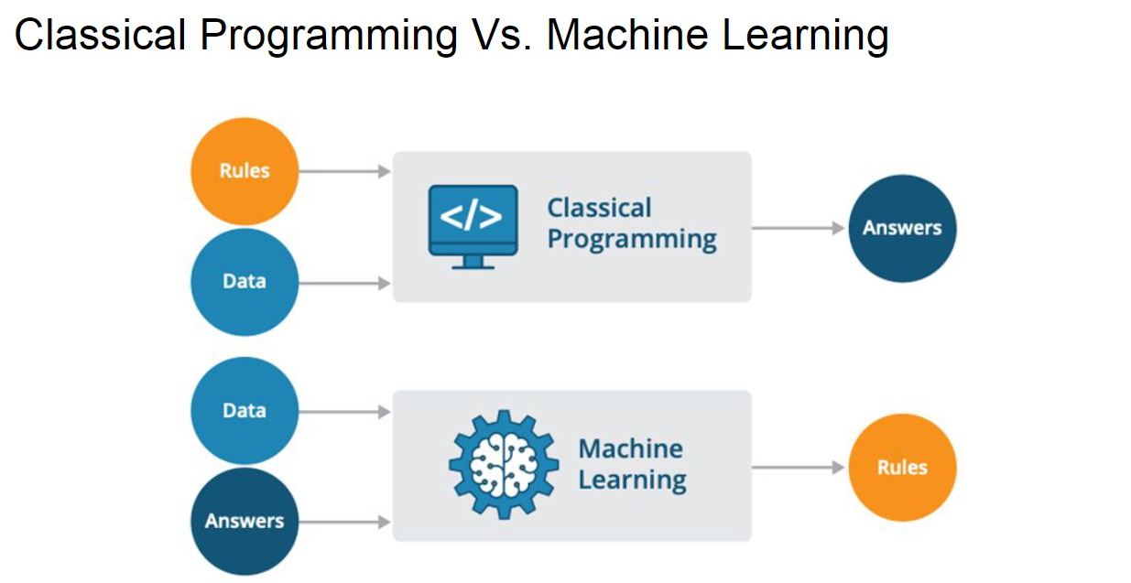
Types of ML:

Supervised Learning
- Definition: The model learns from labeled data (data with correct answers).
- Goal: Learn to predict the label for new data.
- Common Problems:
  - Classification: the goal is to predict the categorical label (class) of a given input based on training data.(e.g., spam or not spam, cat or dog).
  - Regression: goal is to predict a continuous output variable based on one or more input variables.(e.g., house prices, stock price analysis).
- Unsupervised Learning
- Definition: The model learns patterns and structures without labeled outputs.
- Goal:Find hidden patterns in data.
- Common Problems:
  - Clustering: Grouping similar data points (e.g., customer segmentation).
  - Dimensionality Reduction: Reducing data features while keeping essential information (e.g., PCA).
3. Reinforcement Learning (RL)
- Definition: The model learns by trial and error through interaction with an environment.
- Goal: Maximize cumulative reward.
- Key Components:
  - Agent: Learner/decision-maker.
  - Environment: The world the agent interacts with.Actions: Choices the agent can make.
  - Reward: Feedback after actions.
- Examples:
  - A robot learning to walk.
  - An AI playing games like chess.
- Linear Algebra for ML

1. What is a Vector?
- Physics Perspective: Vectors are arrows defined by length and direction. They can be moved around in space.
- Computer Science Perspective: Vectors are ordered lists of numbers (e.g., house prices represented by square footage and price).
- Mathematician's Perspective: A vector is anything where addition and scalar multiplication are defined.
2. Geometric View
- In 2D, coordinates are (x, y).
- In 3D, coordinates are (x, y, z).

3. Vector Operations
Vector Addition:
- The sum is a vector from the tail of the first to the tip of the second.
- (x₁, y₁) + (x₂, y₂) = (x₁+x₂, y₁+y₂)
Scalar Multiplication:
- Multiplying a vector by a scalar (a number) changes its length (stretches or shrinks).
- Multiplying by a negative scalar reverses the direction.
- c × (x, y) = (cx, cy)

4. Linear Combinations
- A vector described by coordinates is the sum of two scaled vectors.
- Adding together two scaled vectors is a linear combination.
5. Span
- The "span" is the full collection of all vectors you can create by combining vectors.
- The span of most pairs of 2D vectors is all vectors in 2D space.
- If vectors line up, their span is a line.

6. Linear Dependence and Independence
- Linearly Dependent: If one vector can be expressed as a linear combination of others, it's redundant meaning Some vectors are "repeats" — one is a scaled version of another. Eg (2, 4) is a scaled version of (1, 2).
- Linearly Independent: Each vector adds a new dimension to the span meaning All vectors point in different directions. No repeats!. Eg (1, 0) and (0, 1) — like x and y axes..

7. Introduction to Linear Transformations
- A transformation is a function that takes an input and produces an output (e.g., a vector to another vector).

8. Matrices and Linear Transformations
- A 2x2 matrix can represent a linear transformation.
- The columns of the matrix are the transformed i-hat and j-hat vectors.
- General case: For a matrix [[A, B], [C, D]] applied to a vector [x, y], the result is [Ax + By, Cx + Dy].
- Examples of Linear Transformations
- Rotation: A 90-degree counterclockwise rotation transforms i-hat to (0, 1) and j-hat to (-1, 0), resulting in the matrix [[0, -1], [1, 0]].
- Shear: i-hat remains fixed (1, 0), and j-hat moves to (1, 1), resulting in the matrix [[1, 1], [0, 1]].

Composition of Transformations
- Applying one transformation after another is called composition.
- The overall effect is another linear transformation, which can be represented by a new matrix.

Example 1: Rotation then Shear
- If you rotate and then shear, the combined matrix is found by following where i-hat and j-hat land after both transformations.
- i-hat goes to (1,1) and j-hat goes to (-1,0), so these become the columns of the new matrix.
9. Determinant
Determinant tells you how much a linear transformation stretches or squishes space (scales space).
- In 2D:
  - Positive determinant → area stretches, orientation stays the same.
  - Negative determinant → area stretches, but orientation flips (like flipping a page over).
  - Zero determinant → space collapses into a line or point (loses a dimension).
- In 3D:
  - Determinant tells how volume changes.
  - A zero determinant means everything gets flattened (no volume left).

10.Linear Systems of Equations
- Linear algebra is crucial for solving systems of equations.
- A linear system involves variables and equations, often organized with variables on the left and constants on the right.
- This can be represented as a matrix-vector equation (Ax = V), where A is the coefficient matrix, x is the variable vector, and V is the constant vector.
  - Inverse Matrices
- The inverse transformation, A⁻¹, satisfies A⁻¹A = I (identity matrix).
- Geometrically, this means "undoing" the transformation.
- Solving for x involves multiplying the inverse matrix by V (x = A⁻¹V).

Zero Determinant
- When the determinant is zero, there is no inverse.
- The transformation squishes space into a lower dimension (line, point).
- Solutions may still exist, but it depends on whether V lies within the transformed space.

Rank
- Rank is the dimension of the output of a transformation.Tells how many independent directions the matrix covers
- Rank 1: output is a line.
- Rank 2: output is a plane.
- Rank 3: output is 3D space.
- The column space is the set of all possible outputs (span of the columns of the matrix).

Null Space
- The null space (or kernel) is the set of vectors that map to the origin.
- For non-full rank matrices, many vectors can map to zero.
- In terms of equations, when V is the zero vector, the null space gives all possible solutions

11.Dot Product Introduction
- The dot product is introduced early in linear algebra.
- It is a numerical operation: multiply corresponding coordinates and sum them.
- Example: (1, 2) · (3, 4) = 1*3 + 2*4.
- The dot product has a geometric interpretation.

Geometric Interpretation
- Project vector w onto the line through v.
- The dot product v · w is the product of the length of the projection of w onto v and the length of v.
- If the projection of w is in the same direction as v, the dot product is positive.
- If they are perpendicular, the dot product is zero.
- If they point in opposite directions, the dot product is negative.
- The order of vectors does not matter in the dot product.
- You can project v onto w and get the same result

Duality Explained
- A linear transformation from 2D space to the number line is described by a 1x2 matrix.
- This is related to a 2D vector via the dot product.
- Duality: A vector is a linear transformation, and a linear transformation is a vector
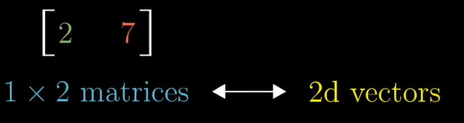

12. Cross Product
- The 3D cross product, denoted as v cross w, is computed using a matrix with i-hat, j-hat, and k-hat in the first column and the coordinates of v and w in the second and third columns, respectively.
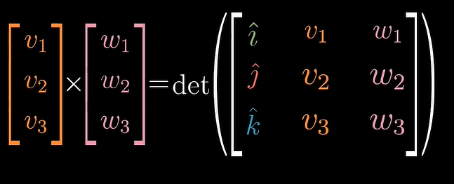
- The determinant of this matrix is computed.
- The resulting vector has a length equal to the area of the parallelogram defined by v and w.
- The resulting vector is perpendicular to both v and w and follows the right-hand rule.
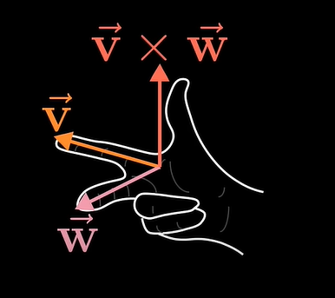

13.Understanding Eigenvectors
- Consider a linear transformation in two dimensions.
- Most vectors change direction during transformation.
- Eigenvectors are special vectors that remain on their span (the line passing through their origin and tip) during a transformation.
- The effect of the matrix on an eigenvector is to stretch or squish it.

Defining Eigenvalues
- Eigenvectors have an associated eigenvalue (the factor by which it's stretched or squished).
- Example: An eigenvector with eigenvalue -1/2 gets flipped and squished by 1/2.
- Eigenvectors stay on their span.

Applications of Eigenvectors
- In 3D rotations, an eigenvector represents the axis of rotation.
- The corresponding eigenvalue for rotation is 1.
- Eigenvectors and eigenvalues offer a better way to understand linear transformations.

Computation of Eigenvectors and Eigenvalues
- A matrix (A) times an eigenvector (v) equals the eigenvalue (lambda) times the eigenvector (v) (A * v = lambda * v).
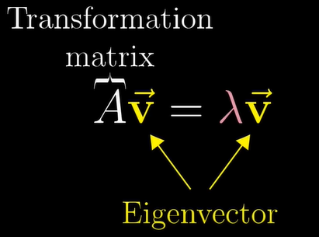
- Finding eigenvectors and eigenvalues involves finding v and lambda that satisfy the equation.
- Rewrite the right-hand side as matrix-vector multiplication using a matrix with lambda on the diagonal (lambda * I).
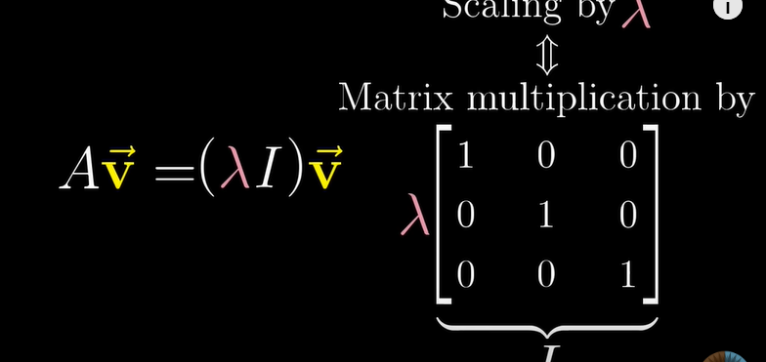
- A - lambda * I times v = 0.
- For a non-zero eigenvector, the determinant of the matrix must be zero.
- Find the value of lambda that makes the determinant zero.
- Probability Distributions in ML

Random Variables
- Definition: A random variable is a variable whose value is determined by the outcome of a random event. It can be:
  - Discrete: Takes on countable values (e.g., number of heads in coin tosses).
  - Continuous: Takes on any value within a range (e.g., height of individuals).
- Probability Distributions
- Purpose: Describes how probabilities are distributed over the values of the random variable.
- Types:
  - Probability Mass Function (PMF): For discrete random variables.
  - Probability Density Function (PDF): For continuous random variables.
  - Cumulative Distribution Function (CDF): For both discrete and continuous variables.

Probability Mass Function (PMF)

Definition: A function that gives the probability that a discrete random variable is exactly equal to some value.
- Properties:
  - The probability for each outcome is between 0 and 1.
  - The sum of probabilities for all possible outcomes equals 1.
- Visualization: Represented as a bar graph where each bar corresponds to a possible value of the random variable and its height represents the probability.
- Example: Rolling a fair six-sided die:
  - Possible outcomes: 1, 2, 3, 4, 5, 6
  - PMF: Each outcome has a probability of 1/6.

Probability Density Function (PDF)
- Definition: A function that describes the likelihood of a continuous random variable to take on a particular value.
- Key Points:
  - The probability of the variable taking an exact value is zero; instead, we consider the probability over an interval.
  - The area under the curve of the PDF over an interval represents the probability of the variable falling within that interval.
  - The total area under the entire curve equals 1.
- Visualization: A smooth curve where the area under the curve between two points represents the probability of the variable falling within that range.
- 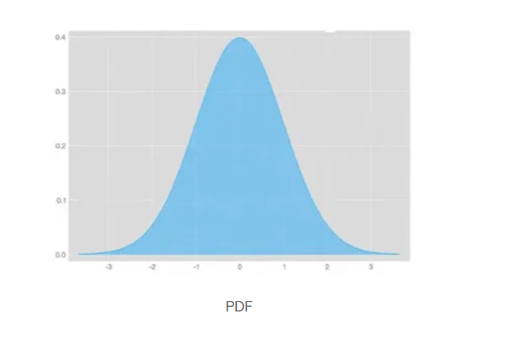
- Example: Heights of individuals in a population can be modeled using a normal distribution, which has a bell-shaped PDF.

Cumulative Distribution Function (CDF)
- Definition: A function that gives the probability that a random variable is less than or equal to a certain value 𝐹(𝑥)=𝑃(𝑋<=𝑥).
- Properties:
  - For discrete variables: The CDF is a step function.
  - For continuous variables: The CDF is a continuous, non-decreasing function.
  - The CDF starts at 0 and approaches 1 as the variable increases.
- Relationship with PMF and PDF:
  - For discrete variables: CDF is the sum of the PMF up to a certain value.
  - For continuous variables: CDF is the integral of the PDF up to a certain value.
  - 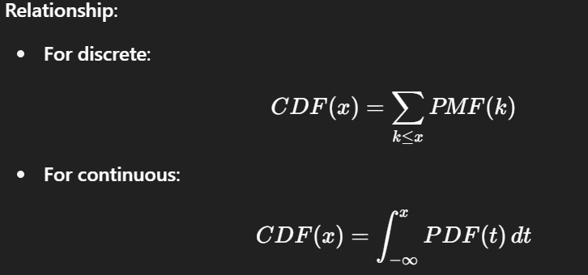

Why Probability Density and Not Just Probability?
- For continuous random variables, assigning a non-zero probability to a single, exact value is impossible because there are infinite possible values.
- Instead, we use probability density:
  - It describes how densely packed the probabilities are over a range of values.
  - The area under the PDF curve between two points gives the probability of the variable falling within that range.
- Normal Distribution
Probability Density Function (PDF)
- The probability density function, denoted as f(x), is given by
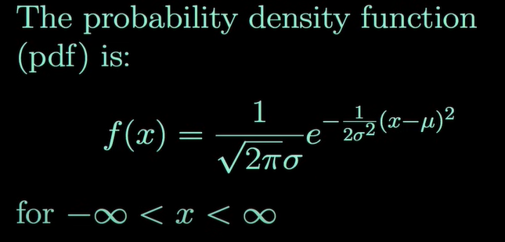.
- The random variable X in a normal distribution can take on any finite value.
Parameters of the Normal Distribution
- Mean (μ): The mean of the distribution, which can take on any finite value. It is located at the center of the distribution.
- Standard Deviation (σ): A positive value that determines the spread of the distribution.
- Variance (σ²): The square of the standard deviation.

Standard Normal Distribution
- The standard normal distribution has a mean of 0 and a variance of 1.
- Random variables with the standard normal distribution are often denoted as Z.
- Z ~ N(0, 1).
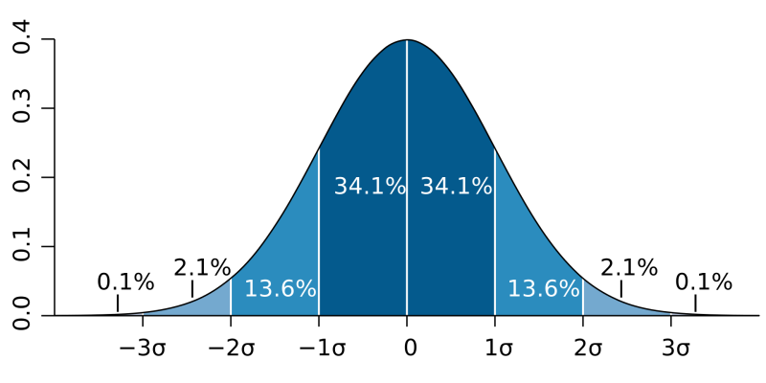
- Approximately 68% of the area under the normal distribution lies within one standard deviation of the mean (μ ± σ).
- About 95% of the area lies within two standard deviations of the mean (μ ± 2σ).
- Roughly 99.7% of the area is within three standard deviations of the mean (μ ± 3σ).
- A larger standard deviation results in a wider distribution with lower peak.

Notation
- If X is a random variable that follows a normal distribution with mean μ and variance σ², it's written as X ~ N(μ, σ²).

Calculating Probabilities
- Probabilities in the normal distribution are calculated by finding the area under the curve.
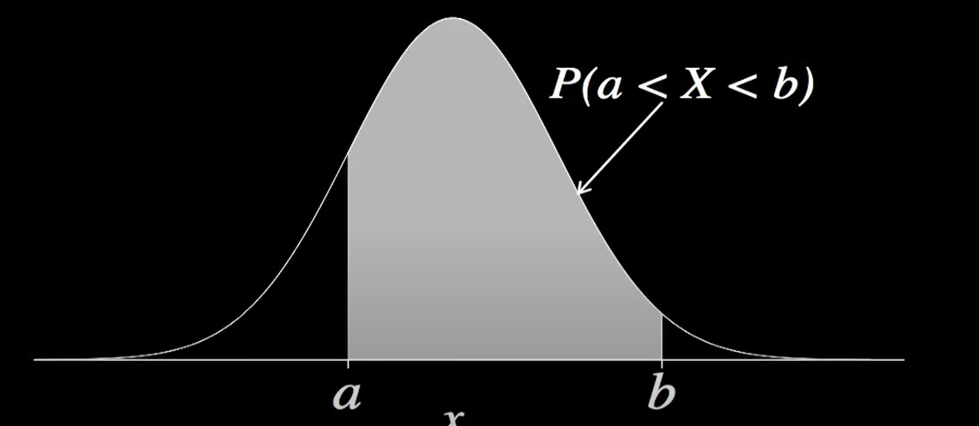
- Due to the lack of a closed-form solution, numerical integration, software, or standard normal tables are used to find probabilities and percentiles.

- Central Limit Theorem
The central limit theorem (CLT), is a core concept in probability. Explains why the normal distribution is common;, also known as the bell curve or Gaussian distribution.The sum of independent random variables tends toward a normal distribution

The Galton Board
The Galton board is used to illustrate the CLT. The board demonstrates how, even with random events, the relative proportions of outcomes can be predicted. The ball's path is a series of random choices, and the final position approximates a normal distribution.


General idea of Central limit Theorem
The central limit theorem states that when plotting a sample distribution of means the means of the sample will be equal to the population mean and the sample distribution with variance equal to standard error.

The mean of the sum of variables is the sum of the means of the individual variables.
- The variance of the sum of independent variables is the sum of their variances.
- The standard deviation of the sum is the square root of the sum of variances.
Assumptions of the CLT
The three assumptions of the CLT are:
- Independence: Variables are independent.
- Identical Distribution: Variables are drawn from the same distribution.
- Finite Variance: The variance of the variables is finite

