Transformer

A High-Level Look
Let’s begin by looking at the model as a single black box. In a machine translation application, it would take a sentence in one language, and output its translation in another.
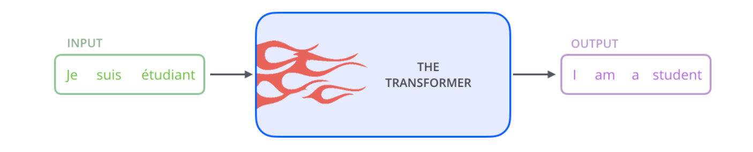
fg

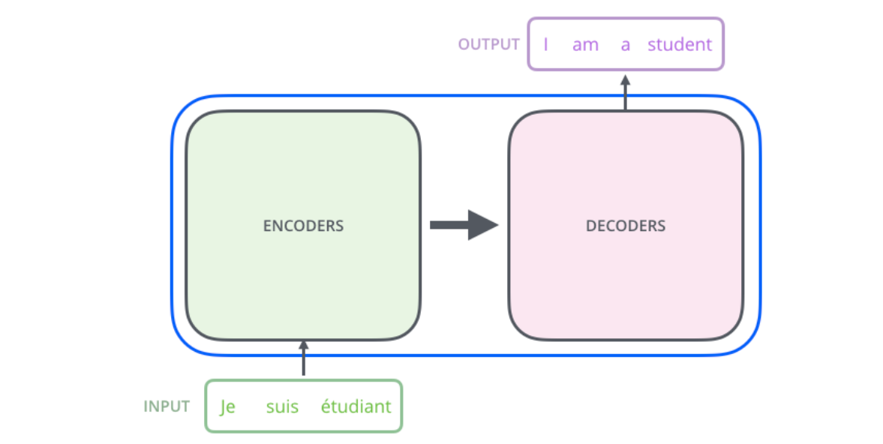

The encoding component is a stack of encoders (the paper stacks six of them on top of each other – there’s nothing magical about the number six, one can definitely experiment with other arrangements). The decoding component is a stack of decoders of the same number.
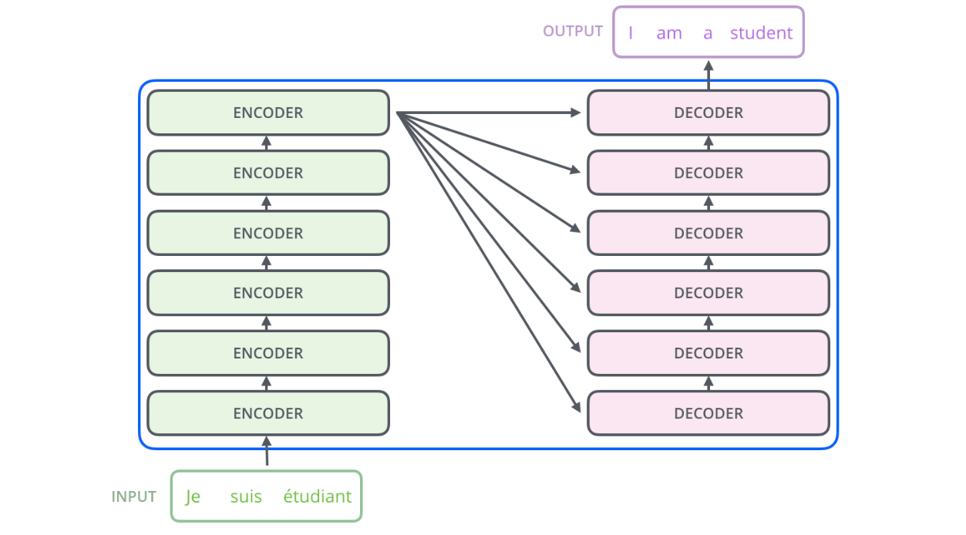

The encoders are all identical in structure (yet they do not share weights). Each one is broken down into two sub-layers:
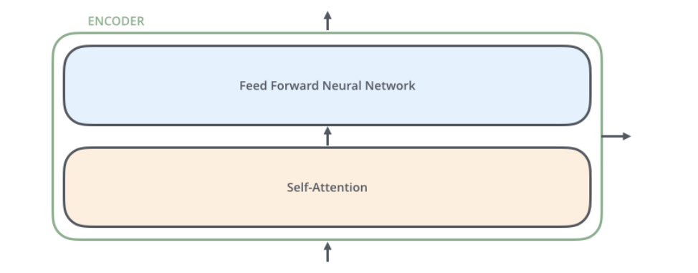
The encoder’s inputs first flow through a self-attention layer – a layer that helps the encoder look at other words in the input sentence as it encodes a specific word.
The outputs of the self-attention layer are fed to a feed-forward neural network. The exact same feed-forward network is independently applied to each position.
The decoder has both those layers, but between them is an attention layer that helps the decoder focus on relevant parts of the input sentence (similar what attention does in seq2seq models.

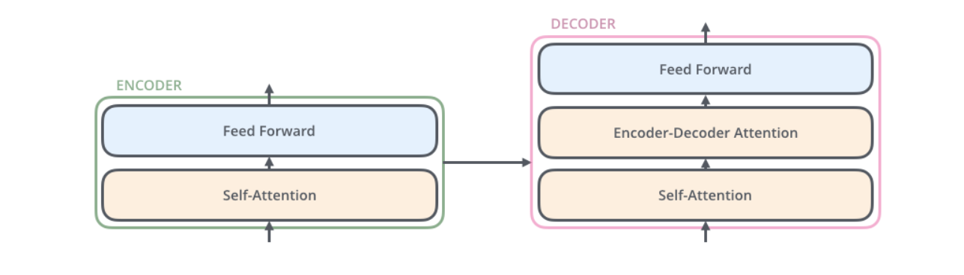

Bringing The Tensors Into The Picture
Now that we’ve seen the major components of the model, let’s start to look at the various vectors/tensors and how they flow between these components to turn the input of a trained model into an output.
As is the case in NLP applications in general, we begin by turning each input word into a vector using an embedding algorithm.
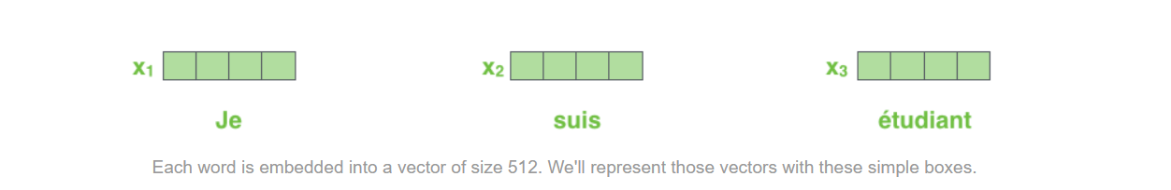

Self-Attention at a High Level
Say the following sentence is an input sentence we want to translate:
”The animal didn't cross the street because it was too tired”
What does “it” in this sentence refer to? Is it referring to the street or to the animal? It’s a simple question to a human, but not as simple to an algorithm.
When the model is processing the word “it”, self-attention allows it to associate “it” with “animal”.
As the model processes each word (each position in the input sequence), self attention allows it to look at other positions in the input sequence for clues that can help lead to a better encoding for this word.
If you’re familiar with RNNs, think of how maintaining a hidden state allows an RNN to incorporate its representation of previous words/vectors it has processed with the current one it’s processing. Self-attention is the method the Transformer uses to bake the “understanding” of other relevant words into the one we’re currently processing.
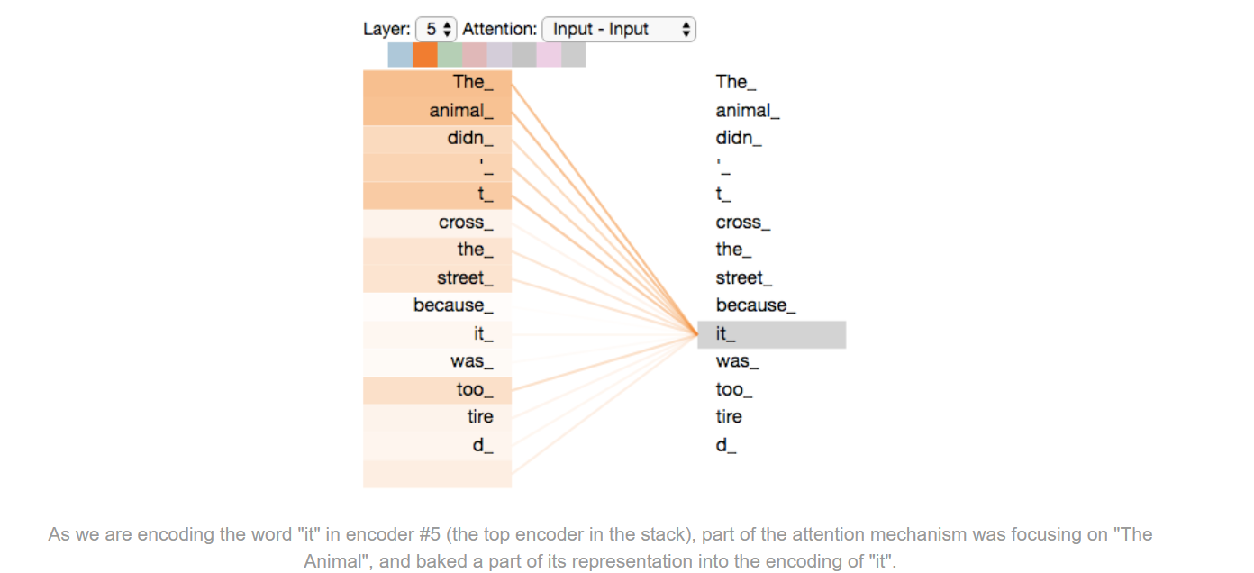

Self-Attention in Detail
Let’s first look at how to calculate self-attention using vectors, then proceed to look at how it’s actually implemented – using matrices.
The first step in calculating self-attention is to create three vectors from each of the encoder’s input vectors (in this case, the embedding of each word). So for each word, we create a Query vector, a Key vector, and a Value vector. These vectors are created by multiplying the embedding by three matrices that we trained during the training process.
Notice that these new vectors are smaller in dimension than the embedding vector. Their dimensionality is 64, while the embedding and encoder input/output vectors have dimensionality of 512. They don’t HAVE to be smaller, this is an architecture choice to make the computation of multiheaded attention (mostly) constant.

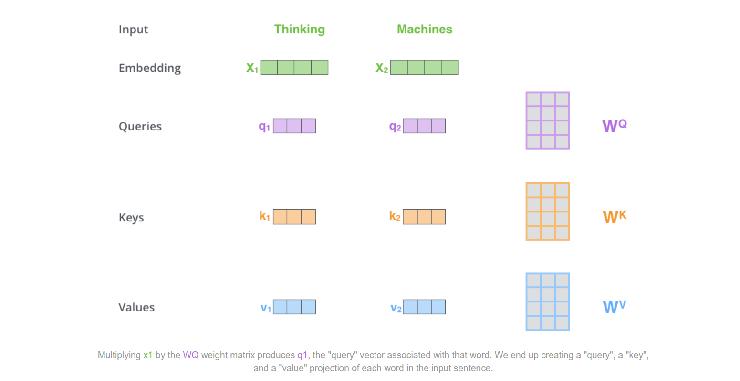
What are the “query”, “key”, and “value” vectors?
They’re abstractions that are useful for calculating and thinking about attention. Once you proceed with reading how attention is calculated below, you’ll know pretty much all you need to know about the role each of these vectors plays.
The second step in calculating self-attention is to calculate a score. Say we’re calculating the self-attention for the first word in this example, “Thinking”. We need to score each word of the input sentence against this word. The score determines how much focus to place on other parts of the input sentence as we encode a word at a certain position.
The score is calculated by taking the dot product of the query vector with the key vector of the respective word we’re scoring. So if we’re processing the self-attention for the word in position #1, the first score would be the dot product of q1 and k1. The second score would be the dot product of q1 and k2.
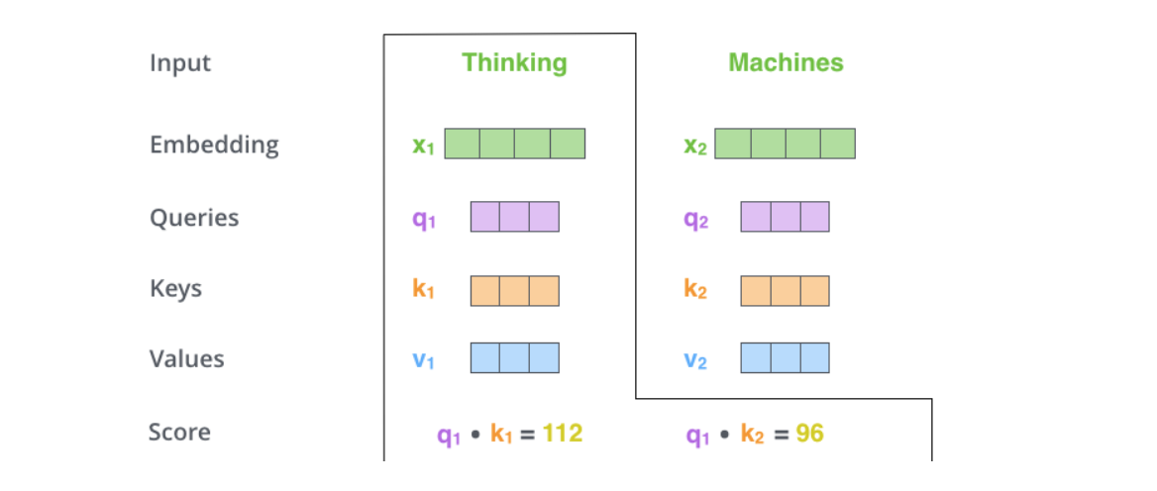

The third and fourth steps are to divide the scores by 8 (the square root of the dimension of the key vectors used in the paper – 64. This leads to having more stable gradients. There could be other possible values here, but this is the default), then pass the result through a softmax operation. Softmax normalizes the scores so they’re all positive and add up to 1.
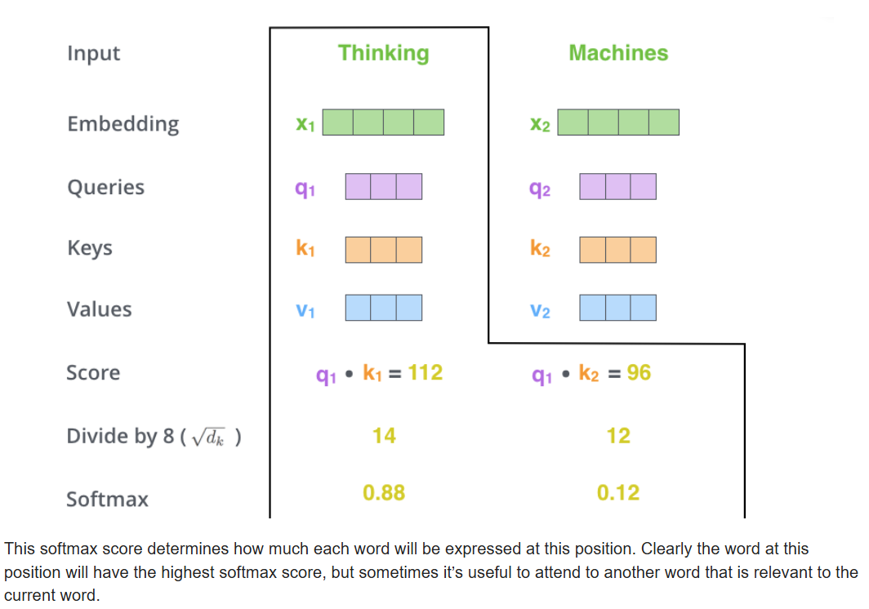
The fifth step is to multiply each value vector by the softmax score (in preparation to sum them up). The intuition here is to keep intact the values of the word(s) we want to focus on, and drown-out irrelevant words (by multiplying them by tiny numbers like 0.001, for example).
The sixth step is to sum up the weighted value vectors. This produces the output of the self-attention layer at this position (for the first word).
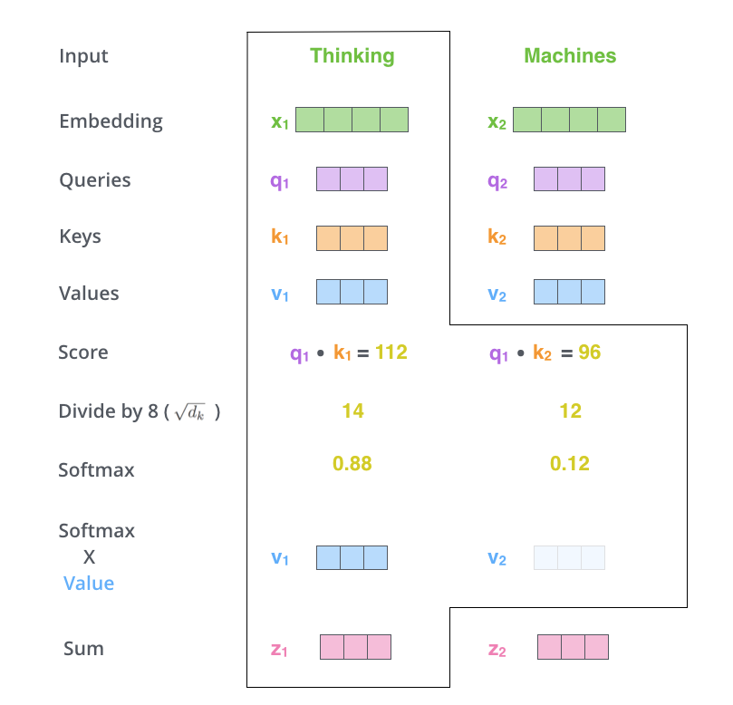
That concludes the self-attention calculation. The resulting vector is one we can send along to the feed-forward neural network. In the actual implementation, however, this calculation is done in matrix form for faster processing. So let’s look at that now that we’ve seen the intuition of the calculation on the word level.

Matrix Calculation of Self-Attention
The first step is to calculate the Query, Key, and Value matrices. We do that by packing our embeddings into a matrix X, and multiplying it by the weight matrices we’ve trained (WQ, WK, WV).

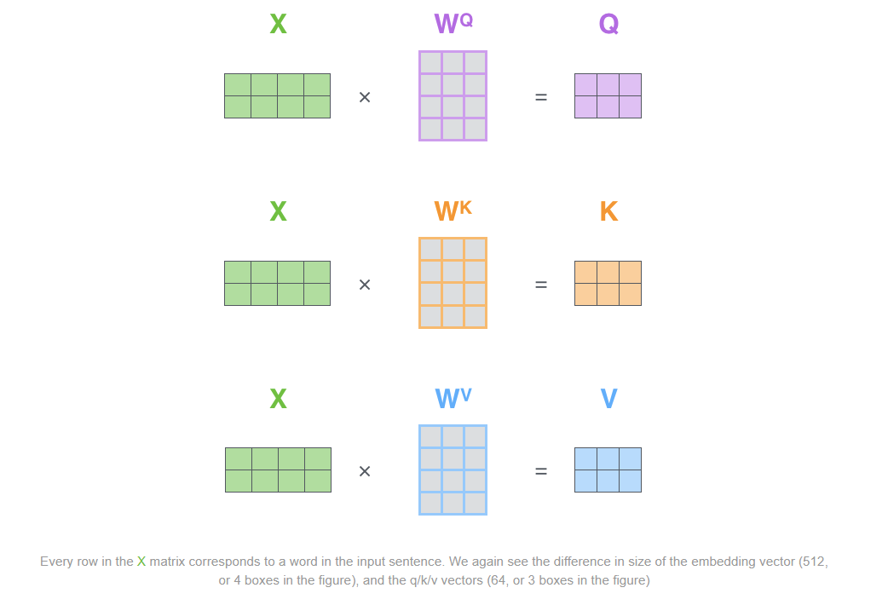
Finally, since we’re dealing with matrices, we can condense steps two through six in one formula to calculate the outputs of the self-attention layer.
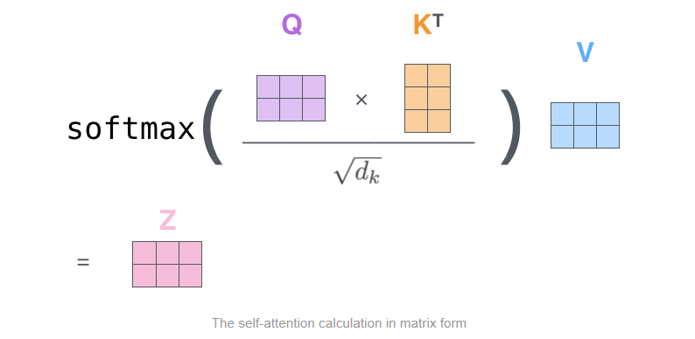

The Beast With Many Heads
The paper further refined the self-attention layer by adding a mechanism called “multi-headed” attention. This improves the performance of the attention layer in two ways:
- It expands the model’s ability to focus on different positions. Yes, in the example above, z1 contains a little bit of every other encoding, but it could be dominated by the actual word itself. If we’re translating a sentence like “The animal didn’t cross the street because it was too tired”, it would be useful to know which word “it” refers to.
- It gives the attention layer multiple “representation subspaces”. As we’ll see next, with multi-headed attention we have not only one, but multiple sets of Query/Key/Value weight matrices (the Transformer uses eight attention heads, so we end up with eight sets for each encoder/decoder). Each of these sets is randomly initialized. Then, after training, each set is used to project the input embeddings (or vectors from lower encoders/decoders) into a different representation subspace.

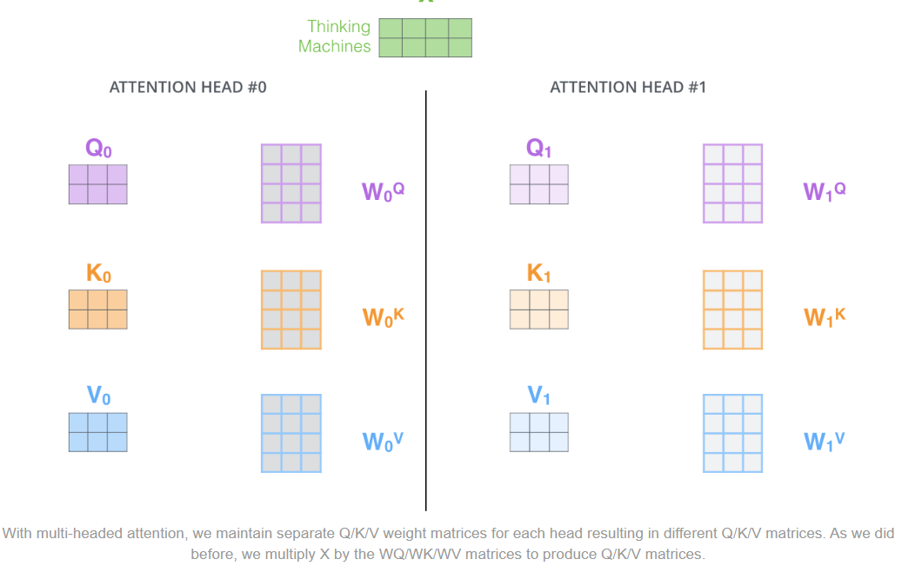
If we do the same self-attention calculation we outlined above, just eight different times with different weight matrices, we end up with eight different Z matrices
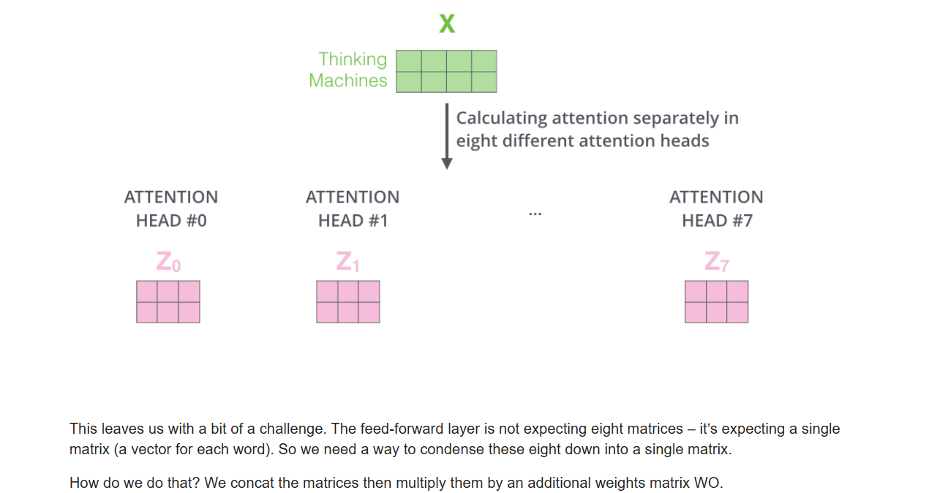

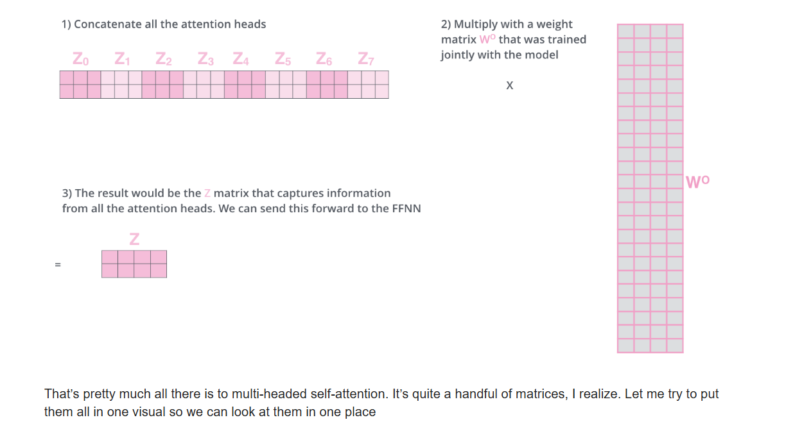
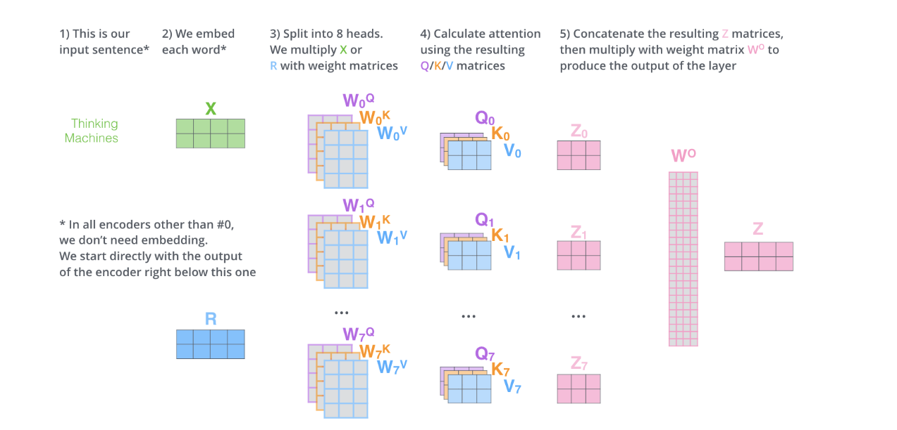

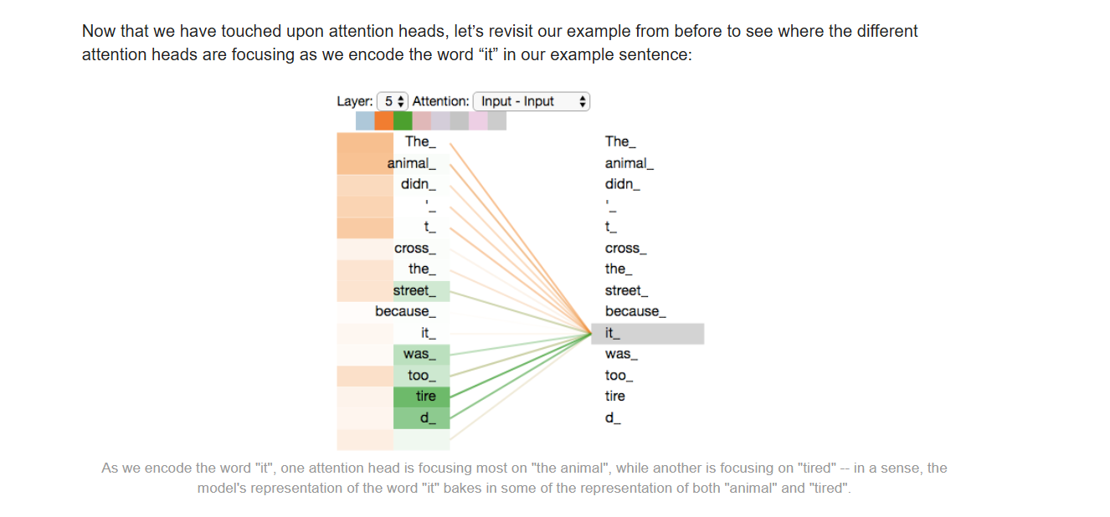

Representing The Order of The Sequence Using Positional Encoding
One thing that’s missing from the model as we have described it so far is a way to account for the order of the words in the input sequence.
To address this, the transformer adds a vector to each input embedding. These vectors follow a specific pattern that the model learns, which helps it determine the position of each word, or the distance between different words in the sequence. The intuition here is that adding these values to the embeddings provides meaningful distances between the embedding vectors once they’re projected into Q/K/V vectors and during dot-product attention.

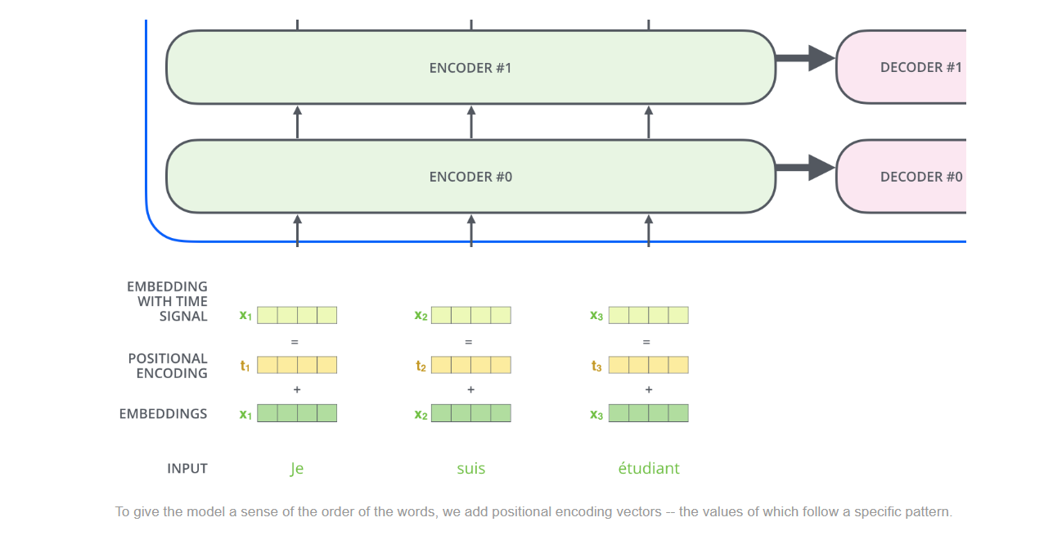
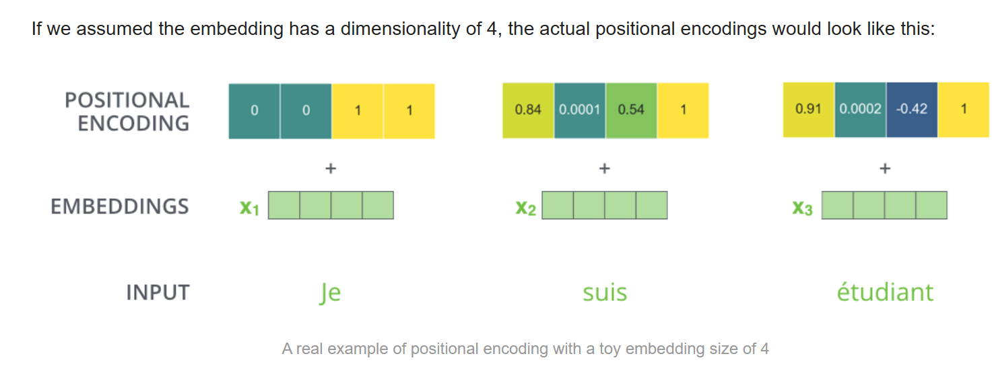

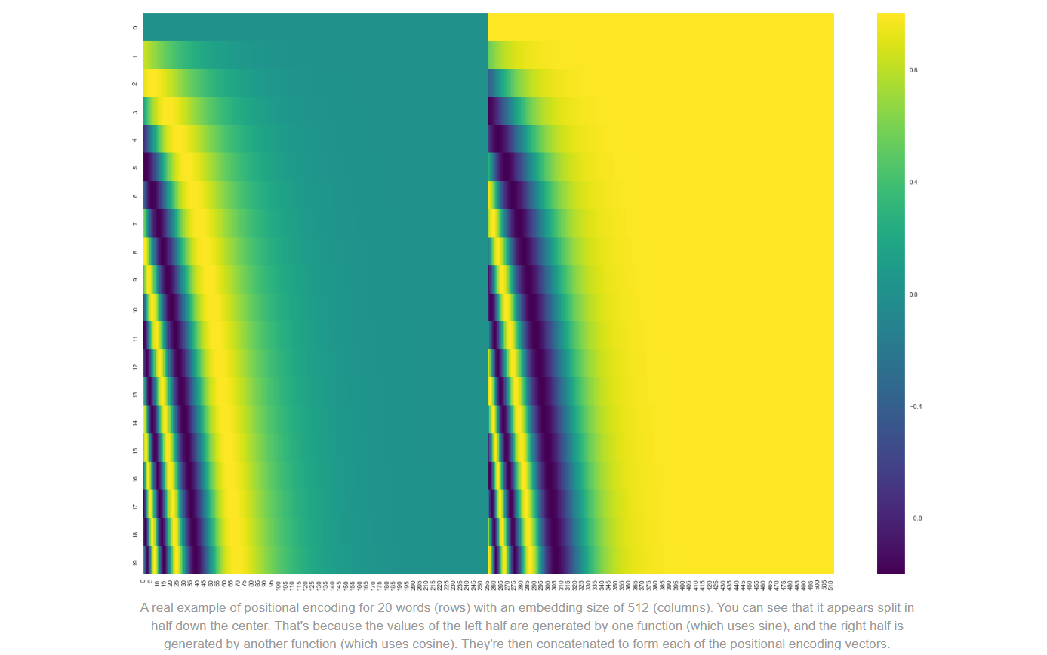
The formula for positional encoding is described in the paper (section 3.5). You can see the code for generating positional encodings in get_timing_signal_1d(). This is not the only possible method for positional encoding. It, however, gives the advantage of being able to scale to unseen lengths of sequences (e.g. if our trained model is asked to translate a sentence longer than any of those in our training set).
July 2020 Update: The positional encoding shown above is from the Tensor2Tensor implementation of the Transformer. The method shown in the paper is slightly different in that it doesn’t directly concatenate, but interweaves the two signals. The following figure shows what that looks like. Here’s the code to generate it:

The Residuals
One detail in the architecture of the encoder that we need to mention before moving on, is that each sub-layer (self-attention, ffnn) in each encoder has a residual connection around it, and is followed by a layer-normalization step.

Layer Normalization
Jimmy Lei Ba, Jamie Ryan Kiros, Geoffrey E. Hinton
Training state-of-the-art, deep neural networks is computationally expensive. One way to reduce the training time is to normalize the activities of the neurons. A recently introduced technique called batch normalization uses the distribution of the summed input to a neuron over a mini-batch of training cases to compute a mean and variance which are then used to normalize the summed input to that neuron on each training case. This significantly reduces the training time in feed-forward neural networks. However, the effect of batch normalization is dependent on the mini-batch size and it is not obvious how to apply it to recurrent neural networks. In this paper, we transpose batch normalization into layer normalization by computing the mean and variance used for normalization from all of the summed inputs to the neurons in a layer on a single training case. Like batch normalization, we also give each neuron its own adaptive bias and gain which are applied after the normalization but before the non-linearity. Unlike batch normalization, layer normalization performs exactly the same computation at training and test times. It is also straightforward to apply to recurrent neural networks by computing the normalization statistics separately at each time step. Layer normalization is very effective at stabilizing the hidden state dynamics in recurrent networks. Empirically, we show that layer normalization can substantially reduce the training time compared with previously published techniques.
Subjects: | Machine Learning (stat.ML); Machine Learning (cs.LG)
Cite as: | arXiv:1607.06450 [stat.ML]
 | (or arXiv:1607.06450v1 [stat.ML] for this version)
https://doi.org/10.48550/arXiv.1607.06450
Focus to learn more

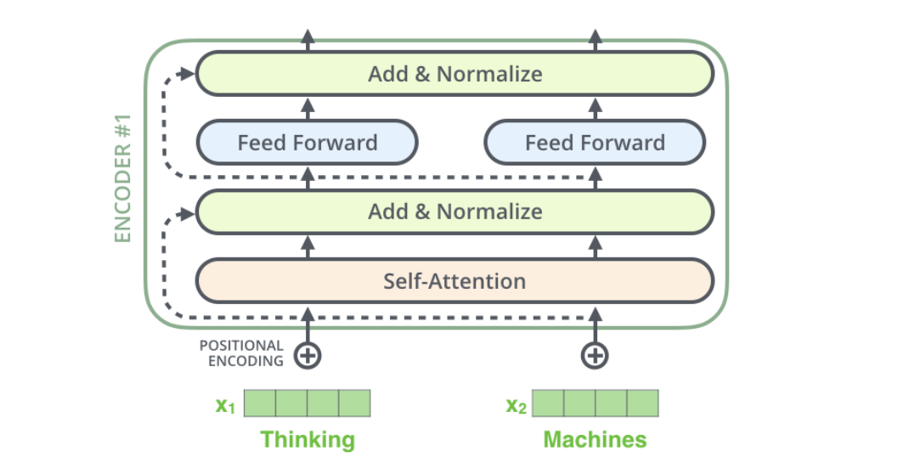
f we’re to visualize the vectors and the layer-norm operation associated with self attention, it would look like this:
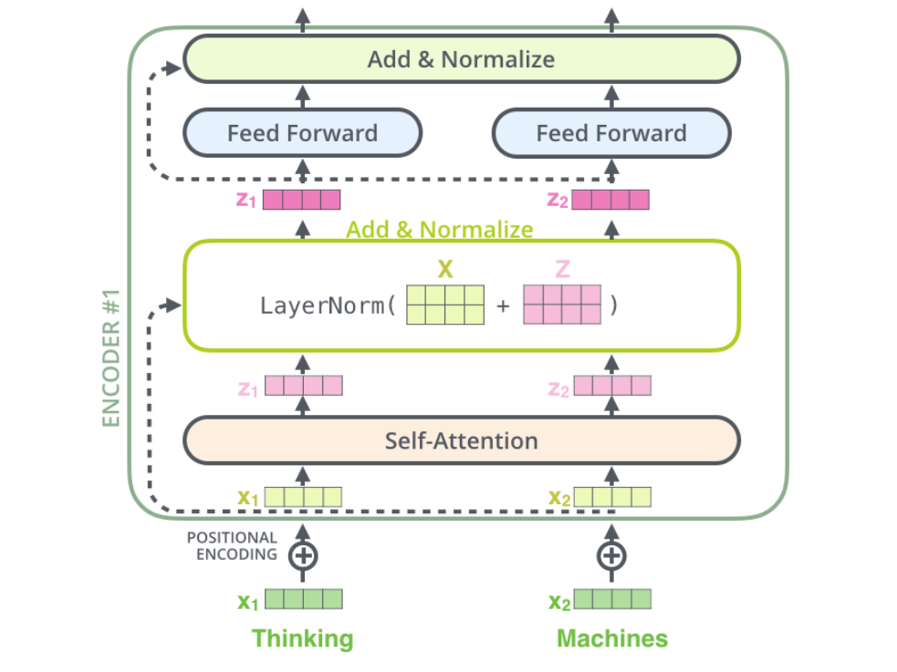
This goes for the sub-layers of the decoder as well. If we’re to think of a Transformer of 2 stacked encoders and decoders, it would look something like this:
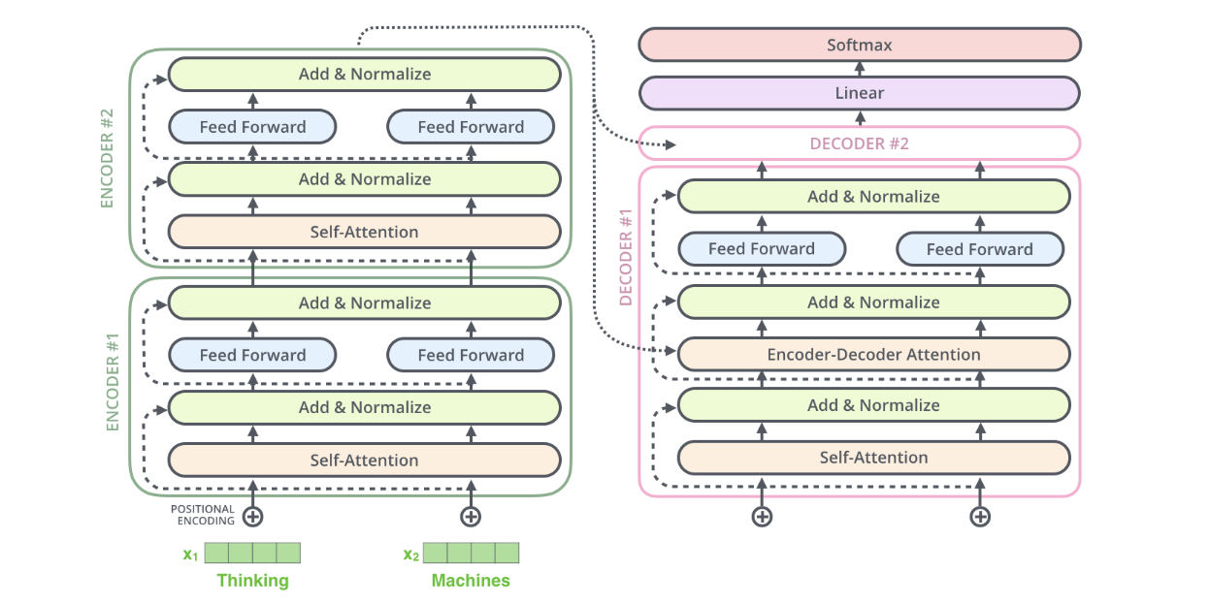

The Decoder Side
The encoder start by processing the input sequence. The output of the top encoder is then transformed into a set of attention vectors K and V. These are to be used by each decoder in its “encoder-decoder attention” layer which helps the decoder focus on appropriate places in the input sequence:
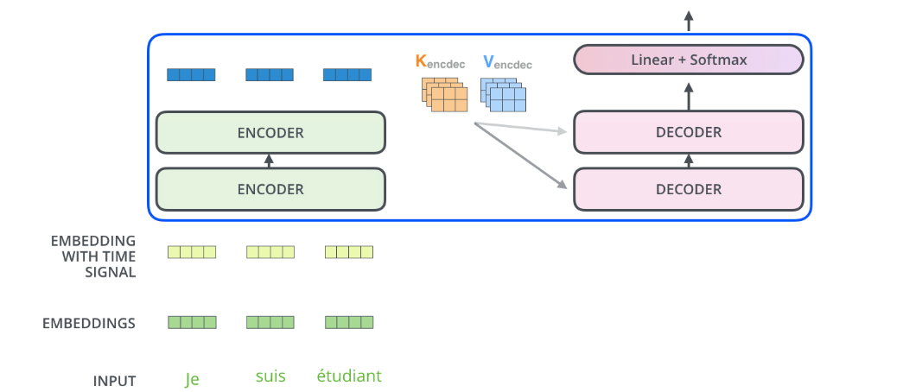

Each step in the decoding phase outputs an element from the output sequence (the English translation sentence in this case).

The following steps repeat the process until a special symbol is reached indicating the transformer decoder has completed its output. The output of each step is fed to the bottom decoder in the next time step, and the decoders bubble up their decoding results just like the encoders did. And just like we did with the encoder inputs, we embed and add positional encoding to those decoder inputs to indicate the position of each word.

The self attention layers in the decoder operate in a slightly different way than the one in the encoder:
In the decoder, the self-attention layer is only allowed to attend to earlier positions in the output sequence. This is done by masking future positions (setting them to -inf) before the softmax step in the self-attention calculation.
The “Encoder-Decoder Attention” layer works just like multiheaded self-attention, except it creates its Queries matrix from the layer below it, and takes the Keys and Values matrix from the output of the encoder stack.

The Final Linear and Softmax Layer
The decoder stack outputs a vector of floats. How do we turn that into a word? That’s the job of the final Linear layer which is followed by a Softmax Layer.
The Linear layer is a simple fully connected neural network that projects the vector produced by the stack of decoders, into a much, much larger vector called a logits vector.
Let’s assume that our model knows 10,000 unique English words (our model’s “output vocabulary”) that it’s learned from its training dataset. This would make the logits vector 10,000 cells wide – each cell corresponding to the score of a unique word. That is how we interpret the output of the model followed by the Linear layer.
The softmax layer then turns those scores into probabilities (all positive, all add up to 1.0). The cell with the highest probability is chosen, and the word associated with it is produced as the output for this time step.
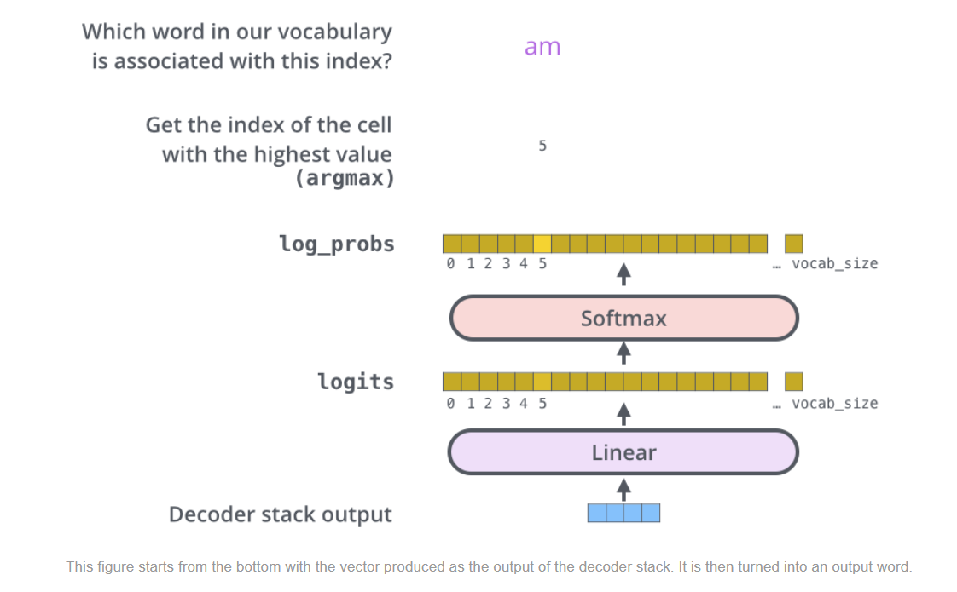

Recap Of Training
Now that we’ve covered the entire forward-pass process through a trained Transformer, it would be useful to glance at the intuition of training the model.
During training, an untrained model would go through the exact same forward pass. But since we are training it on a labeled training dataset, we can compare its output with the actual correct output.
To visualize this, let’s assume our output vocabulary only contains six words(“a”, “am”, “i”, “thanks”, “student”, and “<eos>” (short for ‘end of sentence’)).
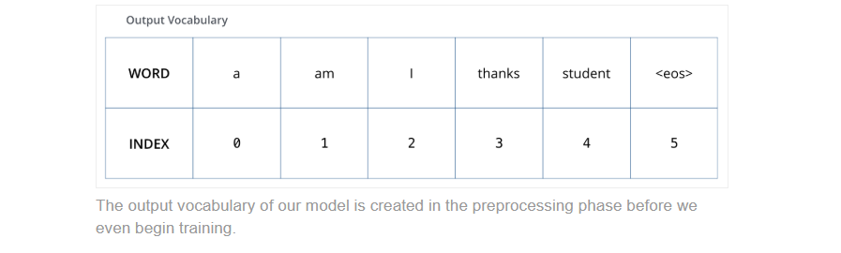
Once we define our output vocabulary, we can use a vector of the same width to indicate each word in our vocabulary. This also known as one-hot encoding. So for example, we can indicate the word “am” using the following vector:
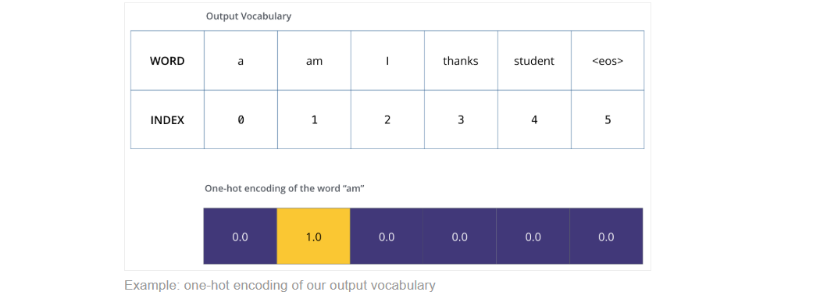
Following this recap, let’s discuss the model’s loss function – the metric we are optimizing during the training phase to lead up to a trained and hopefully amazingly accurate model.

The Loss Function
Say we are training our model. Say it’s our first step in the training phase, and we’re training it on a simple example – translating “merci” into “thanks”.
What this means, is that we want the output to be a probability distribution indicating the word “thanks”. But since this model is not yet trained, that’s unlikely to happen just yet.
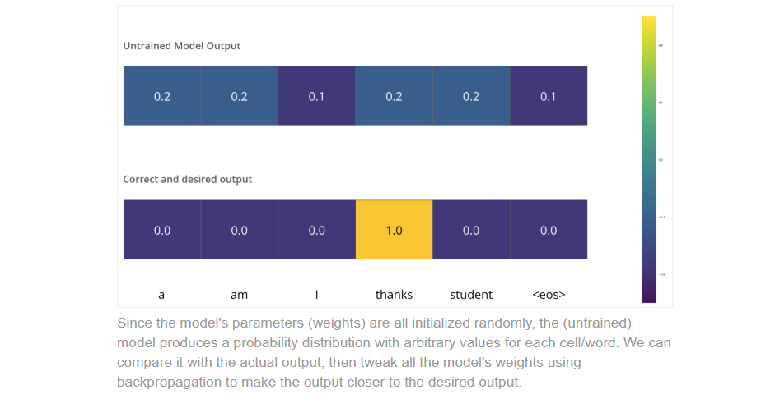

How do you compare two probability distributions? We simply subtract one from the other. For more details, look at cross-entropy and Kullback–Leibler divergence.
But note that this is an oversimplified example. More realistically, we’ll use a sentence longer than one word. For example – input: “je suis étudiant” and expected output: “i am a student”. What this really means, is that we want our model to successively output probability distributions where:
- Each probability distribution is represented by a vector of width vocab_size (6 in our toy example, but more realistically a number like 30,000 or 50,000)
- The first probability distribution has the highest probability at the cell associated with the word “i”
- The second probability distribution has the highest probability at the cell associated with the word “am”
- And so on, until the fifth output distribution indicates ‘<end of sentence>’ symbol, which also has a cell associated with it from the 10,000 element vocabulary.

