Game Design Document

Fill up the Following document

1. Write the title of your project.

Ninja Fruit

1. What is the goal of the game?

Cutting of fruit

1. Write a brief story of your game?

A knife a mouse controller will cut the fruit that will spawn on the screen.

1. Which are the playing characters of this game?

* Playing characters are the ones which respond to the user based on the input from the user
* Cars, monkeys, dinos, wizards etc, are the playing characters in the game.

|  |  |  |
| --- | --- | --- |
| Number | Character Name | What can this character do? |
| 1 | knife | They will cut the fruit |
| 2 | - | - |
| 3 | - | - |
| 4 | - | - |
| 5 | - | - |
| 6 | - | - |
| 7 | - | - |
| 8 | - | - |

1. Which are the Non Playing Characters of this game?

* Non Playing characters are the ones which don't have an action or a behaviour when the user interacts with the game.
* Hurdles, stones, bananas, coins, etc are non playing characters in the game.

|  |  |  |
| --- | --- | --- |
| Number | Character Name | What can this character do? |
| 1 | Fruits | They will spawn from any of the direction. |
| 2 | - | - |
| 3 | - | - |
| 4 | - | - |
| 5 | - | - |
| 6 | - | - |
| 7 | - | - |
| 8 | - | - |

Draw your imagination of this game. What does this game look like?

* Draw the game either on your computer or on paper,
* Add images of scenes of the game to show each of the playing and non-playing characters at least once.

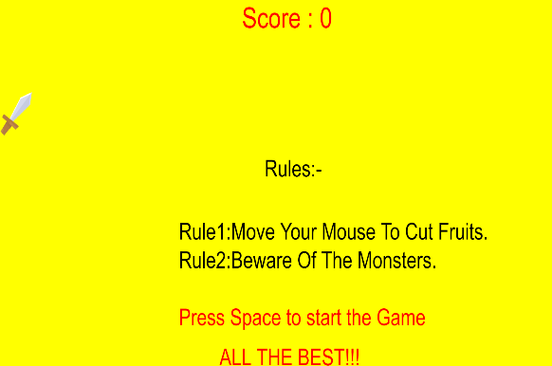

How do you plan to make your game engaging?

On Visual Studio