**Manthan Chauhan**

**(1900290149058)**

**QUESTION:- 2D Rotation of an object**

#include<stdio.h>

#include<graphics.h>

#include<math.h>

#include<conio.h>

main()

{

int gd=0,gm,x1,y1,x2,y2,x3,y3;

double s,c, angle;

initgraph(&gd, &gm, "C:\\TURBOC3\\BGI");

setcolor(RED);

printf("Enter coordinates of triangle: ");

scanf("%d%d%d%d%d%d",&x1,&y1,&x2,&y2, &x3, &y3);

setbkcolor(WHITE);

cleardevice();

line(x1,y1,x2,y2);

line(x2,y2, x3,y3);

line(x3, y3, x1, y1);

getch();

setbkcolor(BLACK);

printf("Enter rotation angle: ");

scanf("%lf", &angle);

setbkcolor(WHITE);

c = cos(angle *M_PI/180);

s = sin(angle *M_PI/180);

x1 = floor(x1 * c + y1 * s);

y1 = floor(-x1 * s + y1 * c);

x2 = floor(x2 * c + y2 * s);

y2 = floor(-x2 * s + y2 * c);

x3 = floor(x3 * c + y3 * s);

y3 = floor(-x3 * s + y3 * c);

cleardevice();

line(x1, y1 ,x2, y2);

line(x2,y2, x3,y3);

line(x3, y3, x1, y1);

getch();

closegraph();

return 0;

getch();

}

**OUTPUT:-**

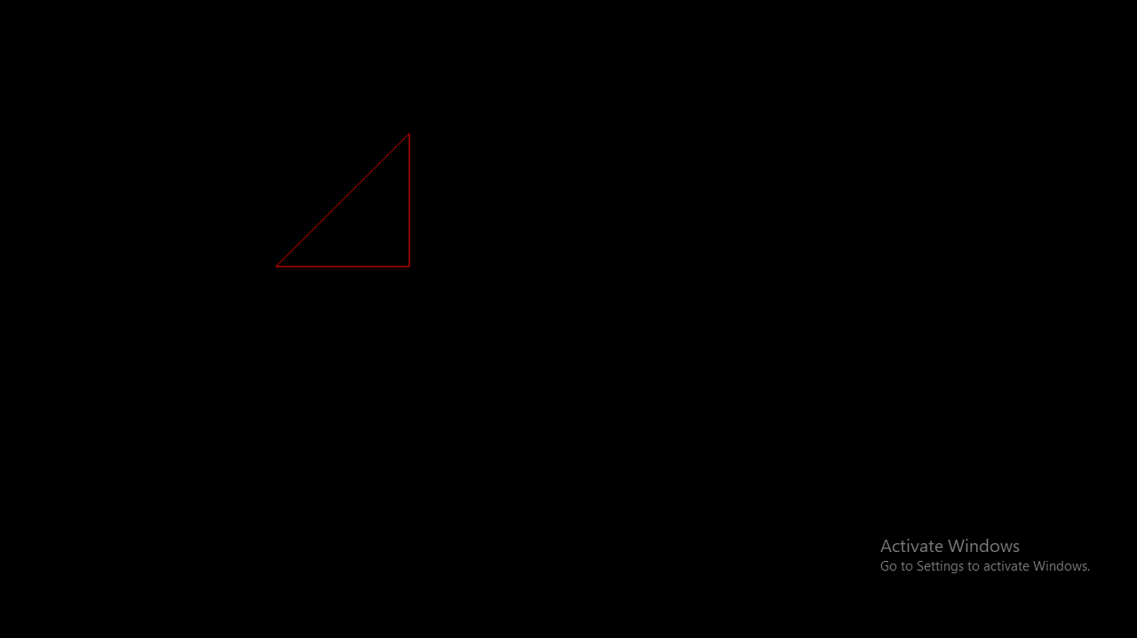

After rotation:

