Q1. Find the roots of a quadratic equation

1. We take user input a, b, and c for the equation $ax^{2}+bx+c$.
2. We calculate $D=b^{2}-4ac$ to check if the roots will be real, equal or imaginary.
3. If D = 0, then the roots are equal. We calculate $-\frac{b+\sqrt{D}}{4a}$ and return the same value for both the roots because it has equal root.
4. If D>0, then the roots are real. We calculate $-\frac{b+\sqrt{D}}{4a}$ and $-\frac{b-\sqrt{D}}{4a}$ as it will have 2 real distinct roots and return it.
5. If D<0, then the roots are imaginary. We calculate $-\frac{b+\sqrt{D}}{4a}$ and $-\frac{b-\sqrt{D}}{4a}$ for the 2 distinct imaginary roots and return it.

Q2. Find average of 3 numbers

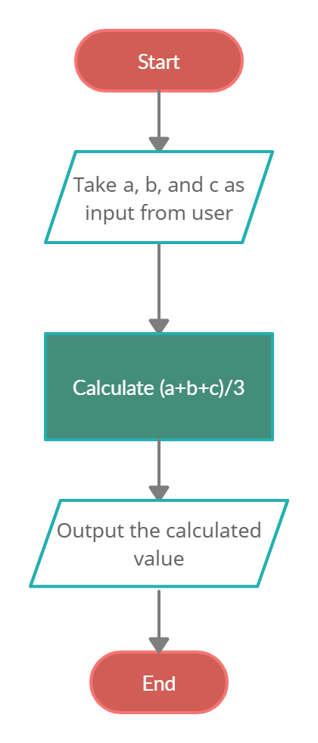

Q3. Find whether given triangle is isosceles or not

1. Take the 3 sides of triangle as input from user.
2. Check if any 2 sides are equal or not. If 2 equal sides found then check it with the 3rd side. It should be unequal to the 3rd side.
3. If 2 equal sides aren’t found then return false
4. If all sides are equal then return false
5. If 2 sides are equal and unequal to 3rd side then return true

Q4. Find sum of digits

