CREATE DATABASE NorthwindDatabase;

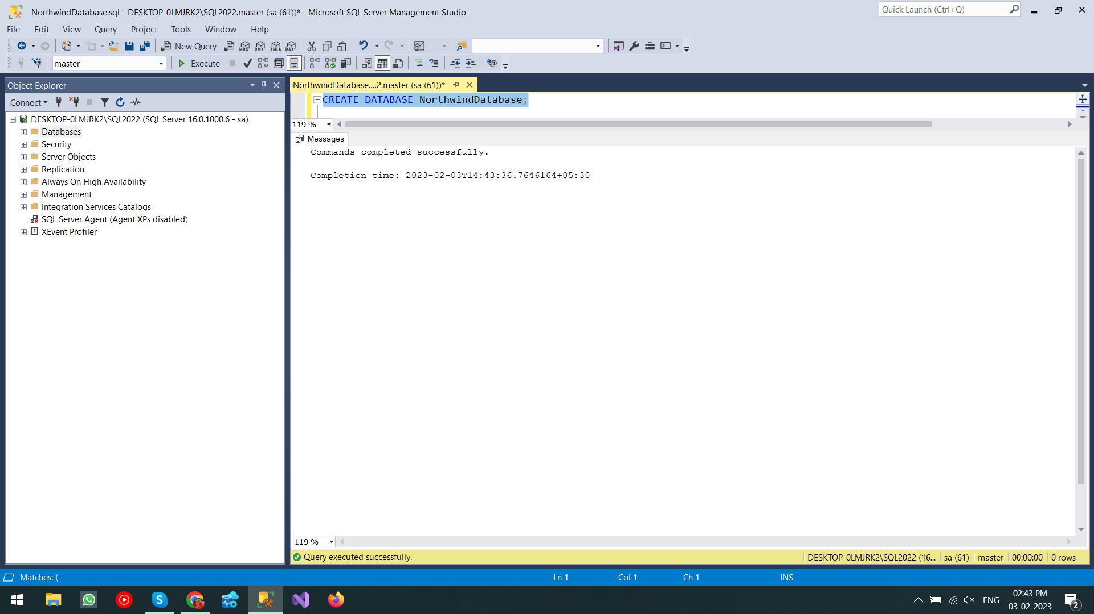

USE NorthwindDatabase;

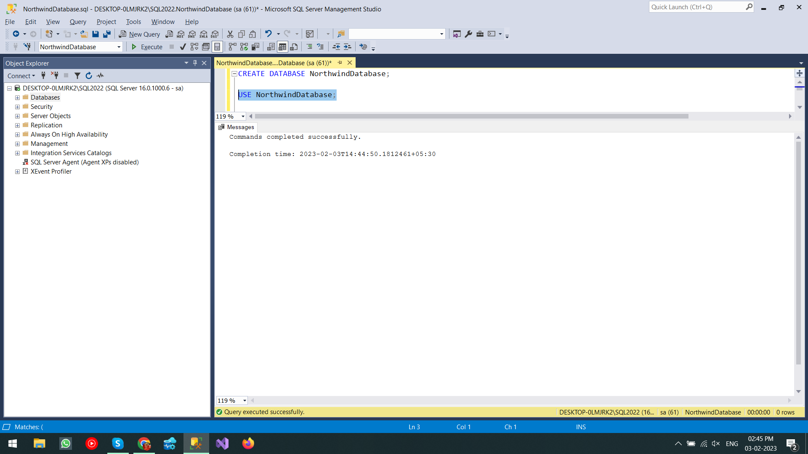

IF OBJECT_ID(N'products', N'U') IS NULL

CREATE TABLE products(

productId varchar(5) primary key,

productName varchar(50),

supplierId varchar(5),

categoryId varchar(5),

quantityPerUnit int,

unitPrice int,

unitsInStock int,

unitsOnOrder int,

reorderLevel int,

discontinued bit

);

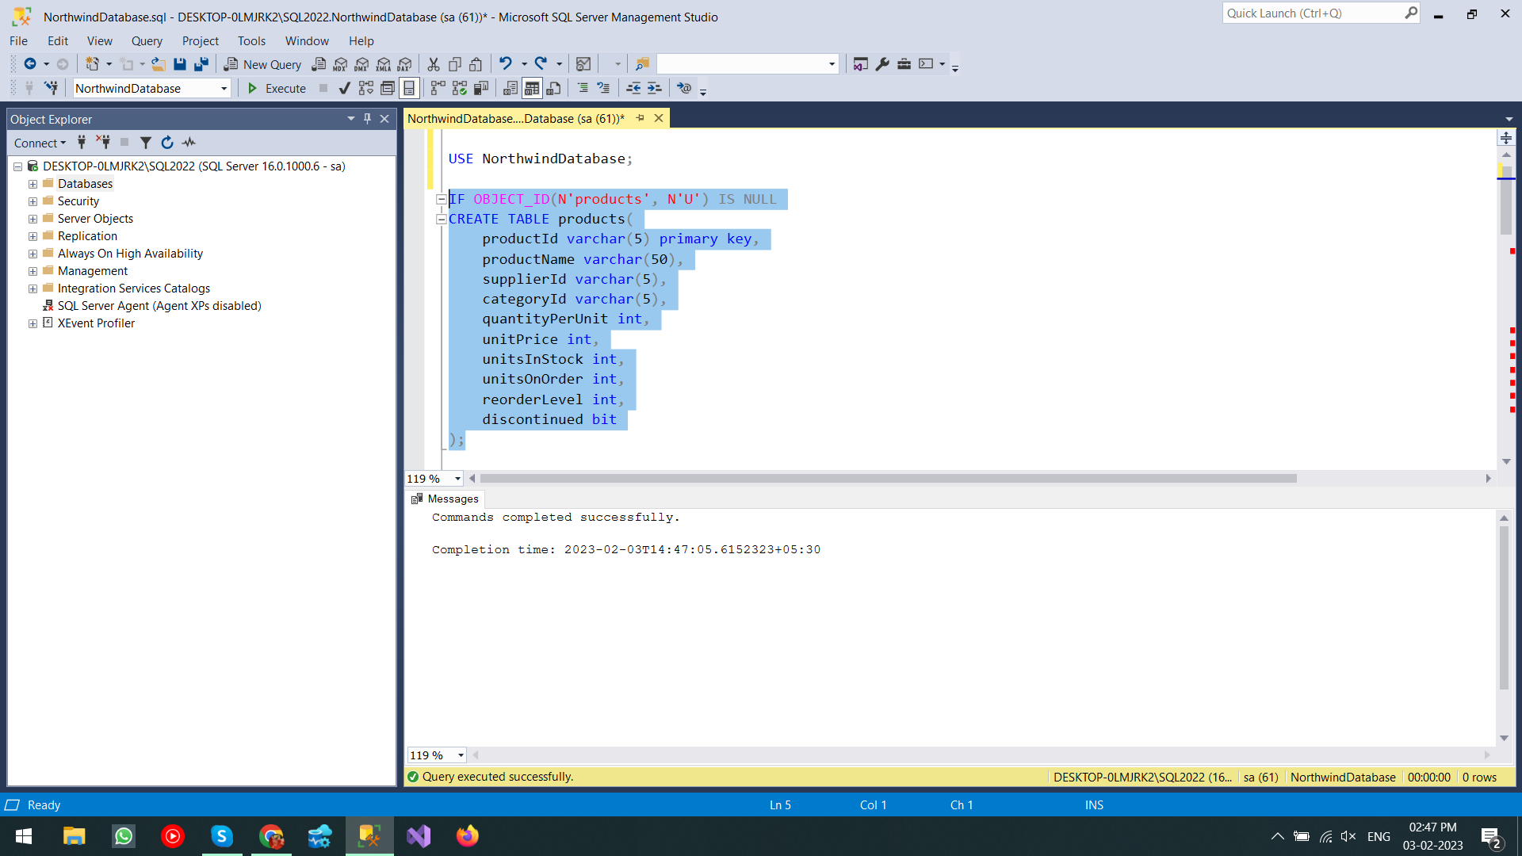

INSERT INTO products VALUES

('P001','oreo','S001','C001',5,10,50,10,1,0),

('P002','bourbon','S002','C001',6,10,30,5,2,1),

('P003','hide n seek','S003','C001',10,25,30,55,1,0),

('P004','parle-g','S004','C001',10,25,30,15,1,0),

('P005','coke','S005','C005',1,15,30,10,1,1),

('P014','diet coke','S003','C005',1,12,60,20,1,0),

('P006','maggie noodles','S005','C006',1,12,30,10,1,0),

('P007','cuppy noodles','S002','C006',1,20,60,25,1,0),

('P008','chinese noodles','S005','C006',1,15,10,0,1,1),

('P009','haka noodles','S004','C006',1,10,45,20,1,0),

('P010','wow noodles','S002','C006',1,50,60,20,1,0),

('P011','spicy noodles','S001','C006',1,250,60,20,1,0),

('P012','chings noodles','S003','C006',1,12,60,20,1,1),

('P013','soupy noodles','S002','C006',1,12,60,20,1,1);

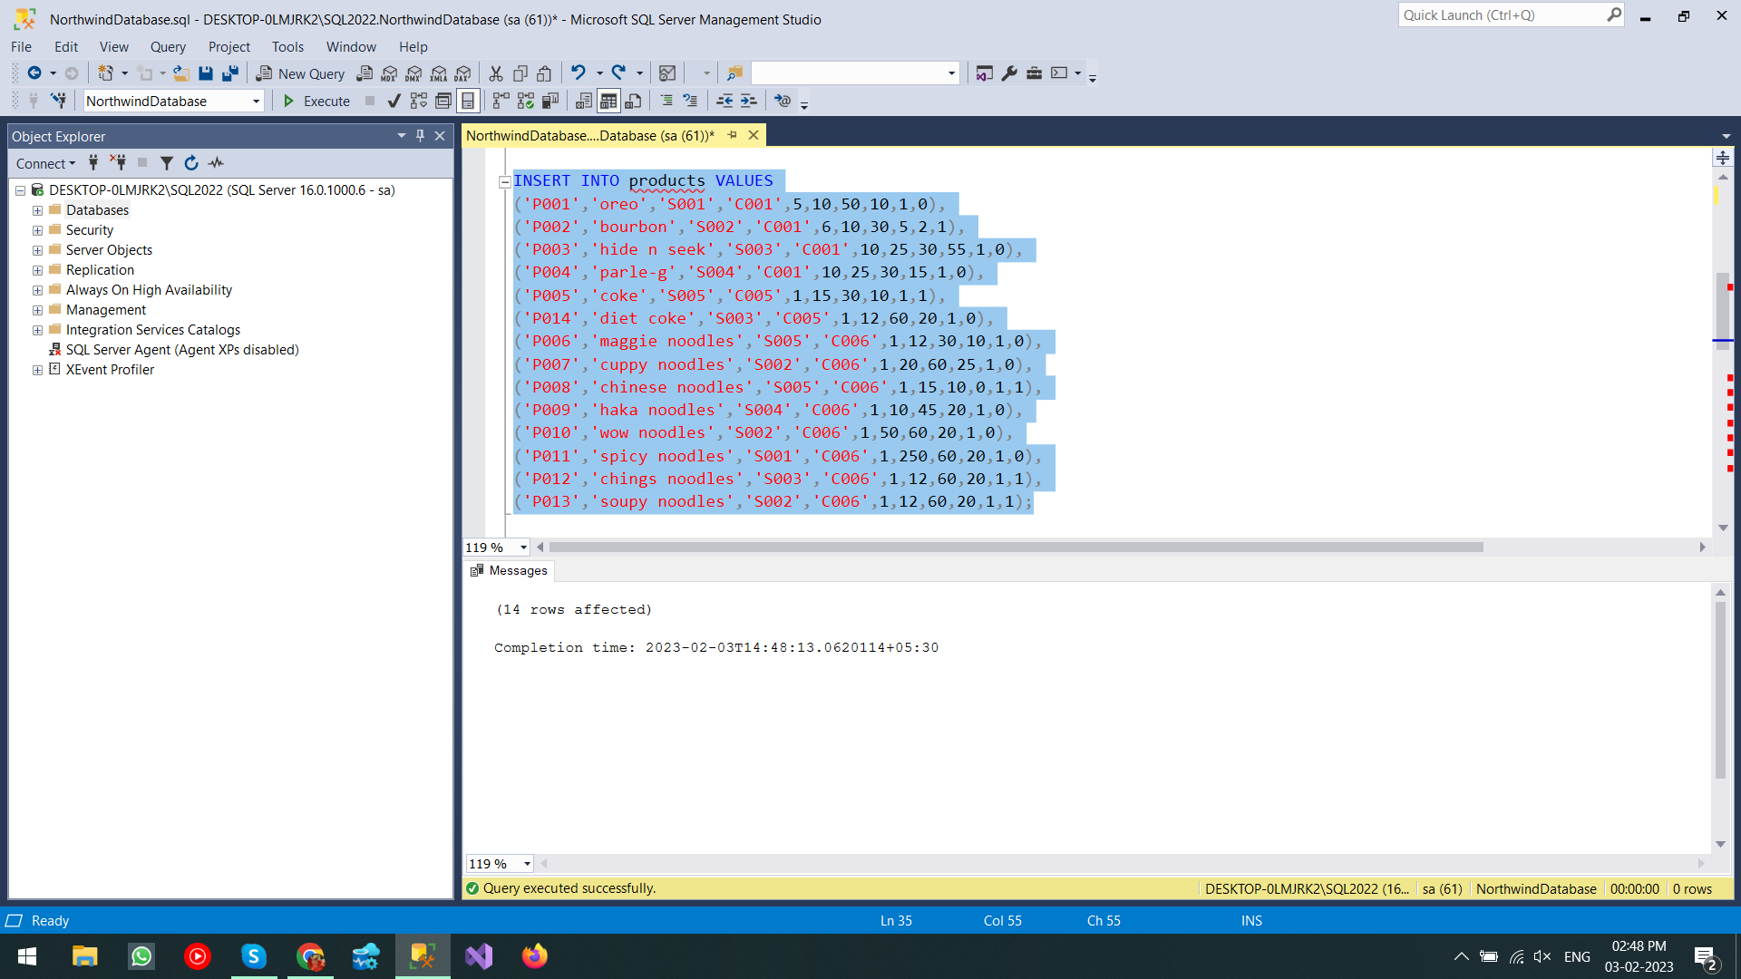

-- 1. Write a query to get a Product list (id, name, unit price) where current products cost less than $20.

SELECT productId,productName,unitPrice from products WHERE unitPrice < 20;

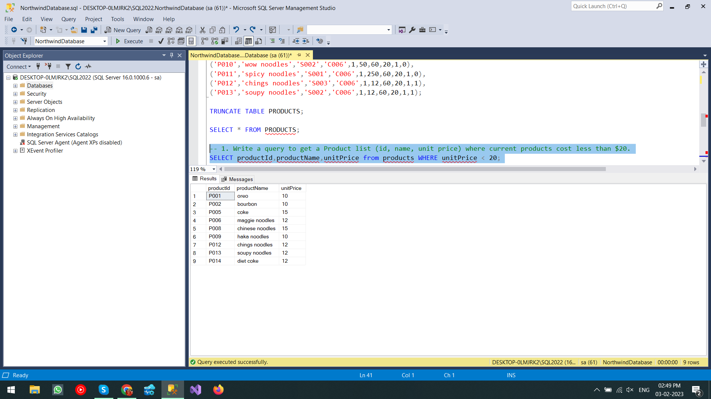

-- 2. Write a query to get Product list (id, name, unit price) where products cost between $15 and $25

SELECT productId,productName,unitPrice from products WHERE unitPrice BETWEEN 15 AND 25;

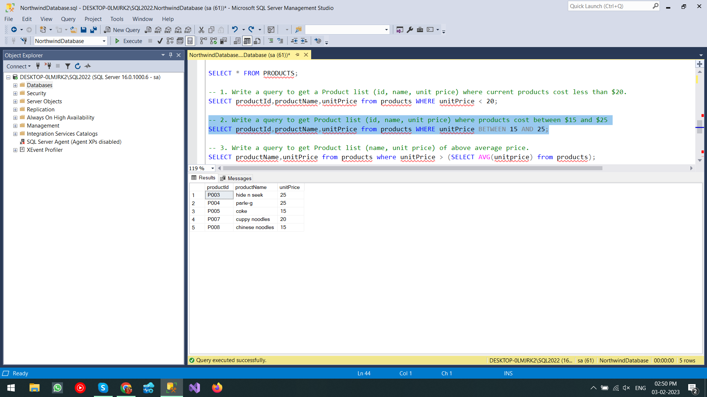

-- 3. Write a query to get Product list (name, unit price) of above average price.

SELECT productName,unitPrice from products where unitPrice > (SELECT AVG(unitprice) from products);

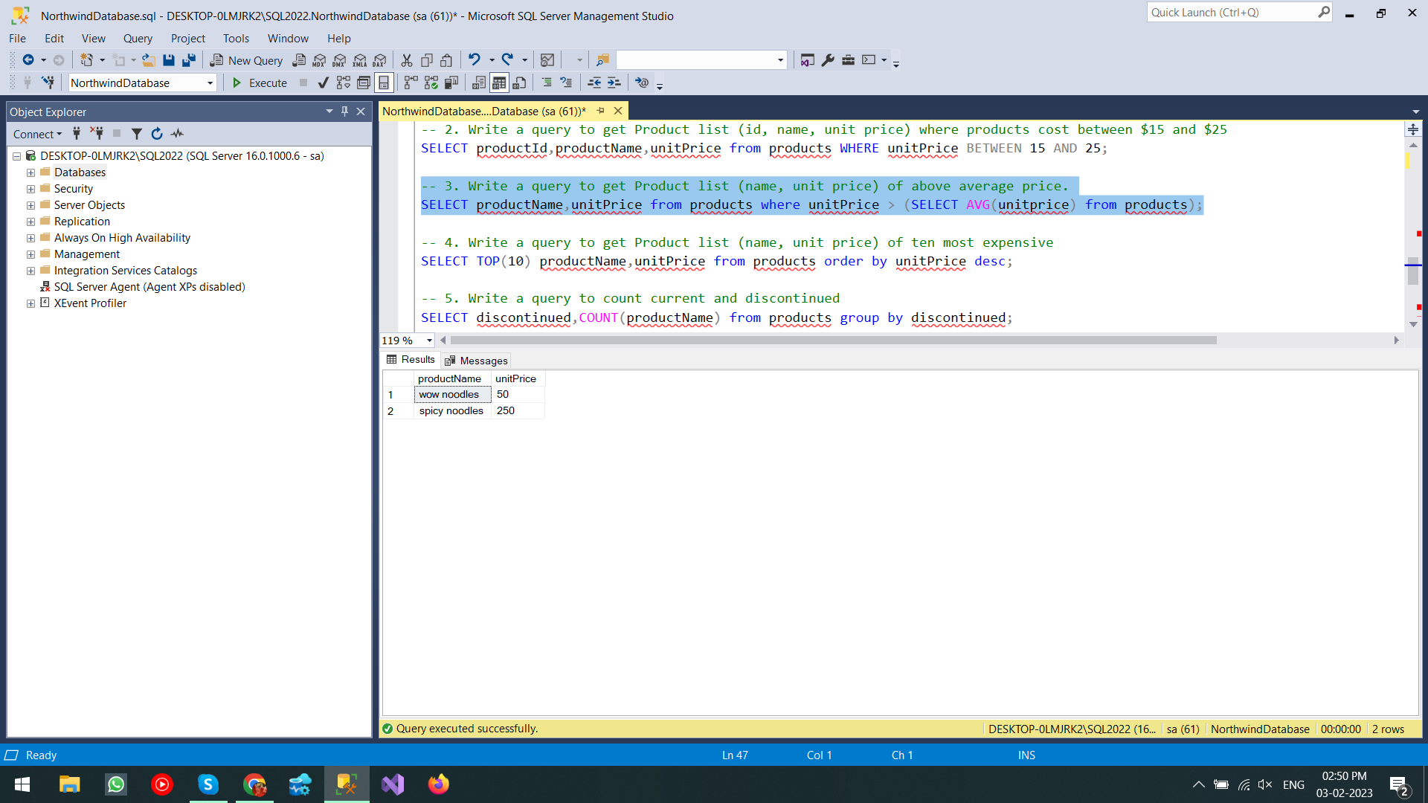

-- 4. Write a query to get Product list (name, unit price) of ten most expensive

SELECT TOP(10) productName,unitPrice from products order by unitPrice desc;

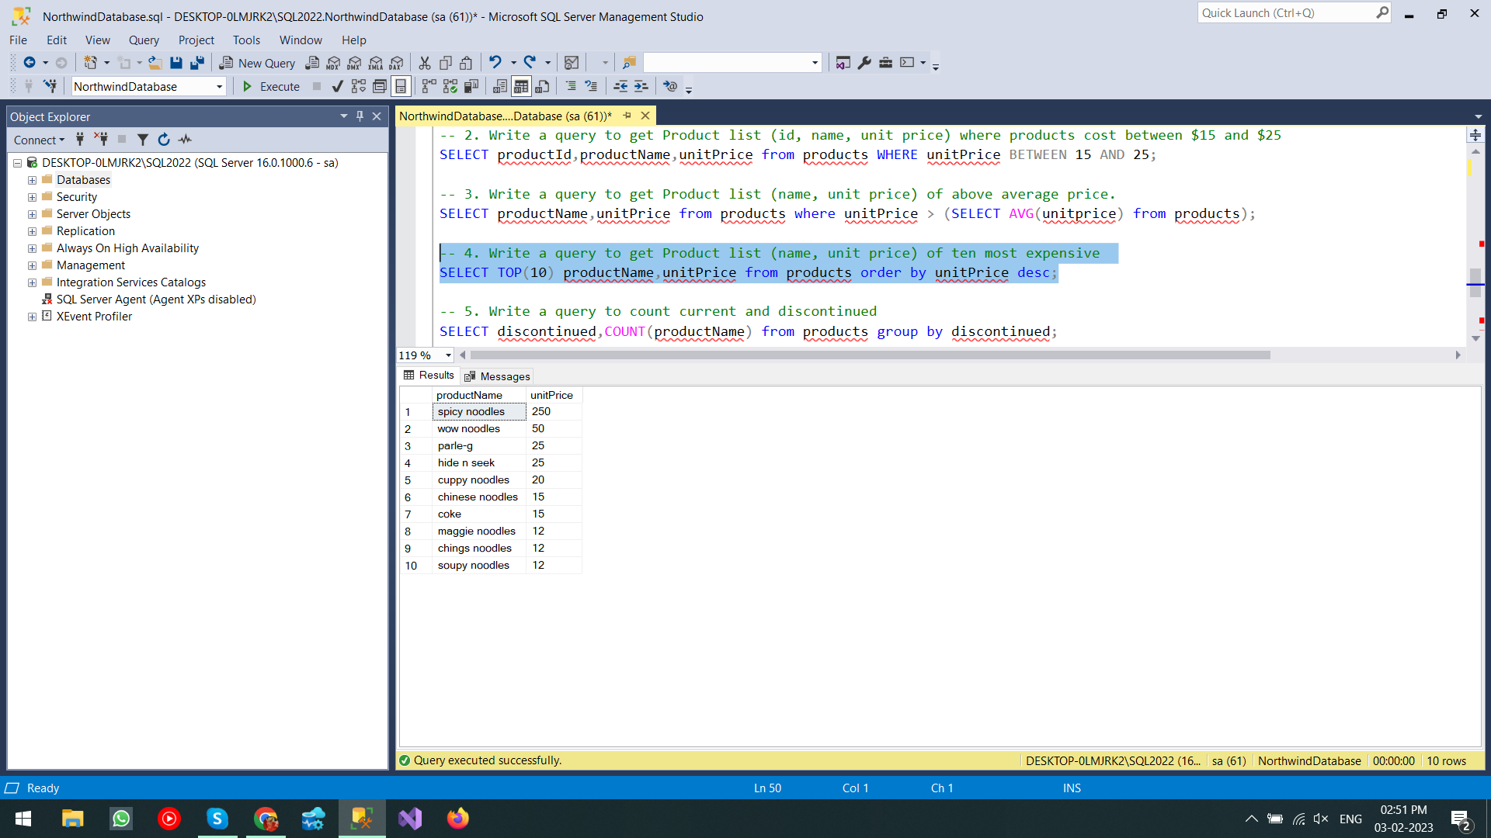

-- 5. Write a query to count current and discontinued

SELECT discontinued,COUNT(productName) from products group by discontinued;

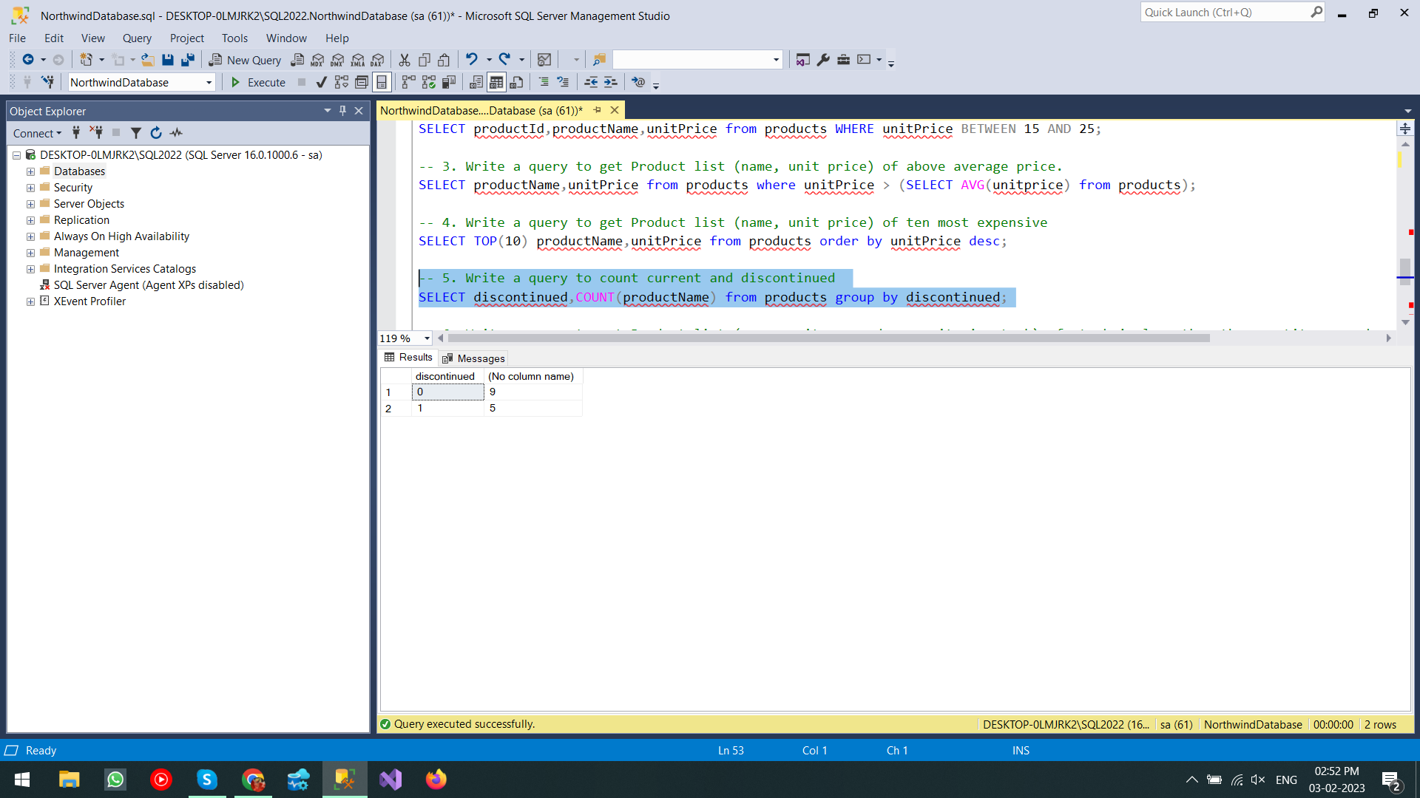

-- 6. Write a query to get Product list (name, units on order , units in stock) of stock is less than the quantity on order

SELECT productName,unitsOnOrder,unitsInStock from products where unitsInStock < unitsOnOrder;

