CREATE DATABASE Assignment3;

USE Assignment3;

CREATE TABLE department(

dept_id INT PRIMARY KEY IDENTITY(1,1),

dept_name nvarchar(20)

);

CREATE TABLE employee (

emp_id INT PRIMARY KEY IDENTITY(1,1),

dept_id INT ,

mngr_id INT ,

emp_name NVARCHAR(20),

salary INT,

FOREIGN KEY (dept_id) REFERENCES department(dept_id)

);

INSERT INTO department (dept_name) values ('SALES'),('MANAGEMENT'),('IT'),('NETWORK');

INSERT INTO employee (dept_id,mngr_id,emp_name,salary) values

(1,5,'Bhargav Trivedi',20000),

(1,4,'Umang Gohel',40000),

(3,2,'Paras Gediya',50000),

(3,1,'Hardik Mer',35000),

(4,1,'Sagar Mer',35000),

(4,1,'Bhumika Shah',70000),

(2,1,'Eric Shah',32000);

--1. write a SQL query to find Employees who have the biggest salary in their Department

SELECT e.emp_name,e.salary,d.dept_name

FROM employee as e

INNER JOIN department as d

ON e.dept_id=d.dept_id

WHERE (e.dept_id) in (

SELECT d.dept_id

FROM Department as d

INNER JOIN employee e

ON d.dept_id=e.dept_id

GROUP BY d.dept_id

)

AND(e.salary) in (

SELECT MAX(e.salary)

FROM Department as d

INNER JOIN employee e

ON d.dept_id=e.dept_id

GROUP BY d.dept_id

);

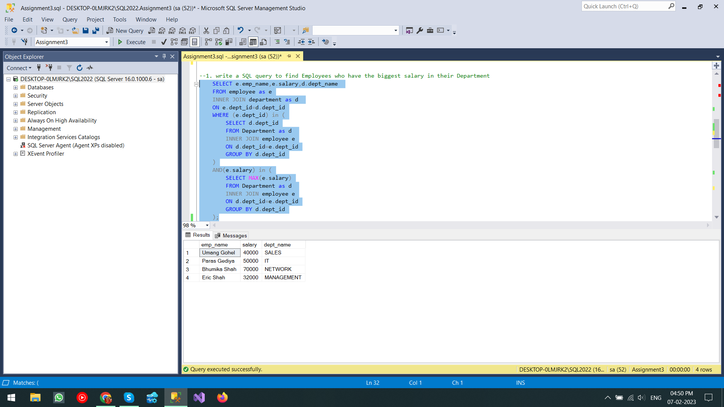

--2. write a SQL query to find Departments that have less than 3 people in it

SELECT d.dept_name,COUNT(e.emp_id) from department as d

INNER JOIN employee as e

ON d.dept_id=e.dept_id

GROUP BY d.dept_name

HAVING COUNT(e.emp_id)<3

;

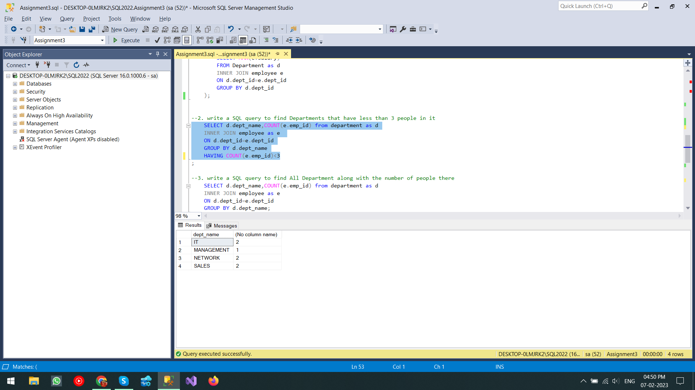

--3. write a SQL query to find All Department along with the number of people there

SELECT d.dept_name,COUNT(e.emp_id) from department as d

INNER JOIN employee as e

ON d.dept_id=e.dept_id

GROUP BY d.dept_name;

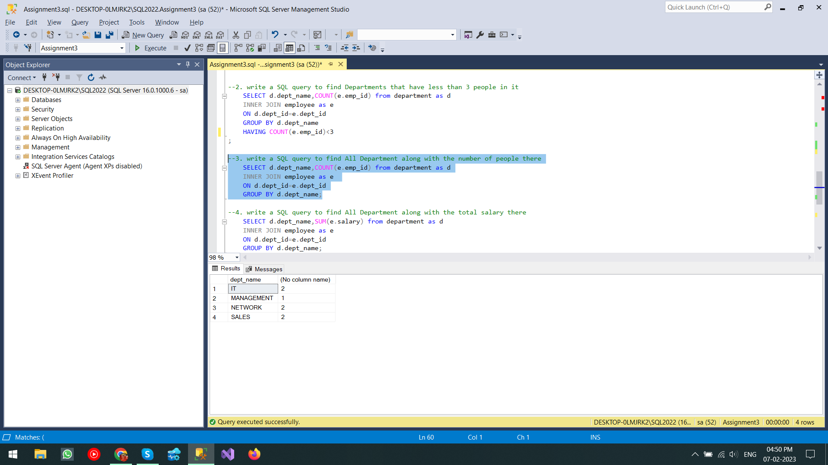

--4. write a SQL query to find All Department along with the total salary there

SELECT d.dept_name,SUM(e.salary) from department as d

INNER JOIN employee as e

ON d.dept_id=e.dept_id

GROUP BY d.dept_name;

