The two instances of AWS services are EC2(virtual machine) and S3(Storage) to add Jar and War file.

How to create EC2 instance🡪

* EC2 dashboard ----🡪Go to launch instance.
* Choose Amazon Machine Image(amazon linux 2 AMI (HVM)
* Create new key pair, just say “Manthan_Example.pem”. a .pem file is generated. It is used to connect your aws to your PC.
* You can change number of instances, size of storage and other things as per your demand.

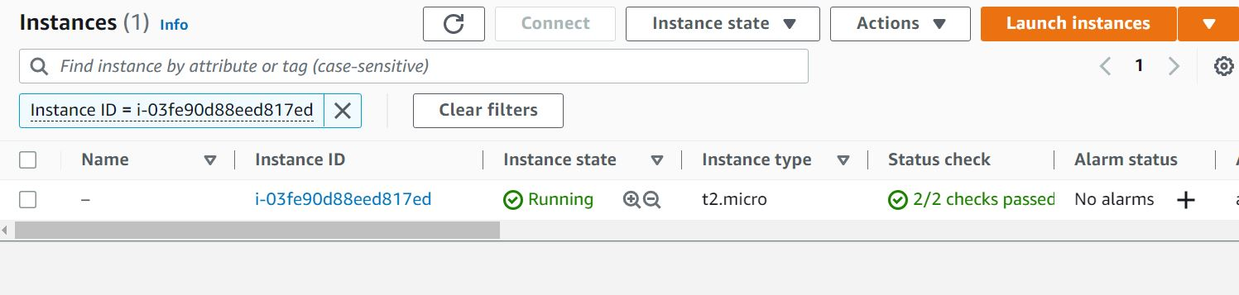

* On clicking on connect you will get all the information, host-name, user name , keypair file and other required information.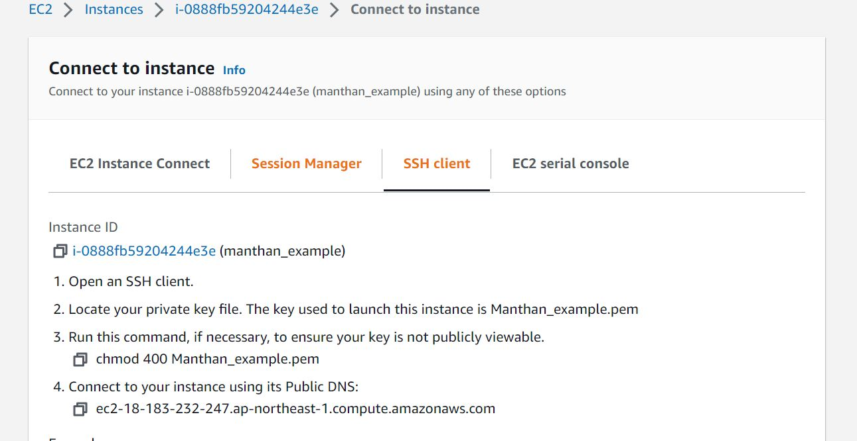

How to deploy your Spring Boot Application in new EC2 instance?

Firstly go to spring boot application,update pom.xml after</plugins>…..<finalName>spring-boot-file-upload</finalName>

Open terminal--🡪mvn clean and install….open Putty App.

Convert .pem file to api key(windows compatabilty).

In putty tool it will ask for the host name which is

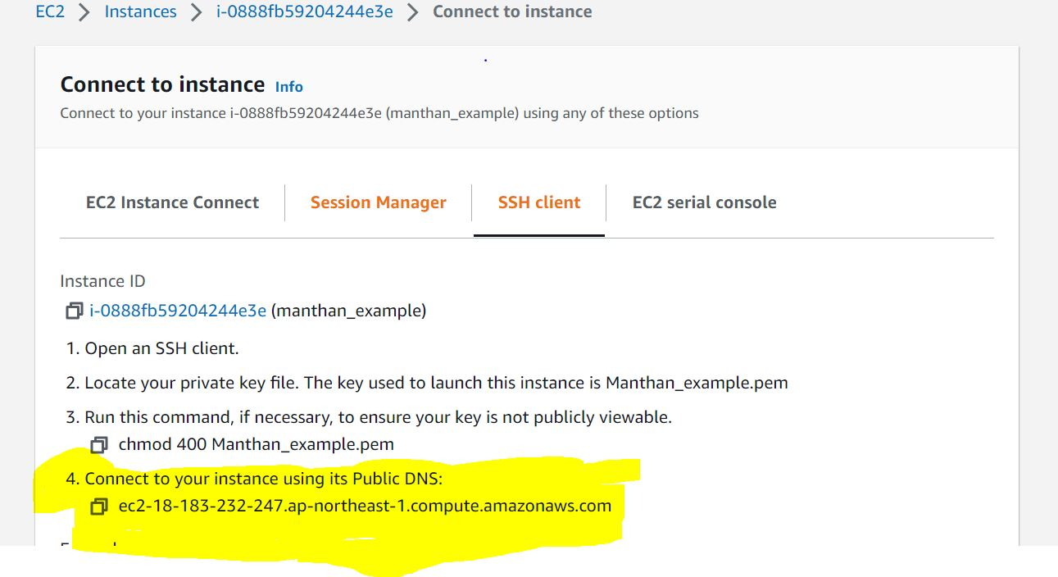

Go to data under—connection, name username --- ec2-user

Then go to SSH, select Auth …then browse, select api key..then connect