## Kafka-Real-World-Project🡪

* we need to make this project as Multimodule maven Project
* for that we need to add “<packaging>pom</packaging>” after <parent></parent>
* after that we create submodule with in the project named as “kafka-producer-wikimedia”.
* Create kafka-Topic-config and write Configurations.
* 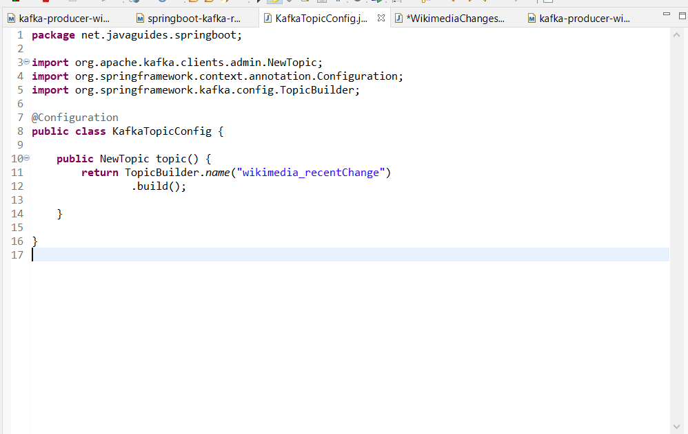
* Create WikimediaChangesProducer class in submodule.
* //to read real time stream data from wikimedia,we use eventsource so will add dependency to submodule.

<dependency>

<groupId>com.launchdarkly</groupId>

<artifactId>okhttp-eventsource</artifactId>

<version>2.5.0</version>

* </dependency>