KAFKA- is a distributed message streaming platform that uses publish and subscribe mechanism to stream the records.

Records are copied in the multiple systems. if one System crashes out, we can access it through other systems. More space is used.

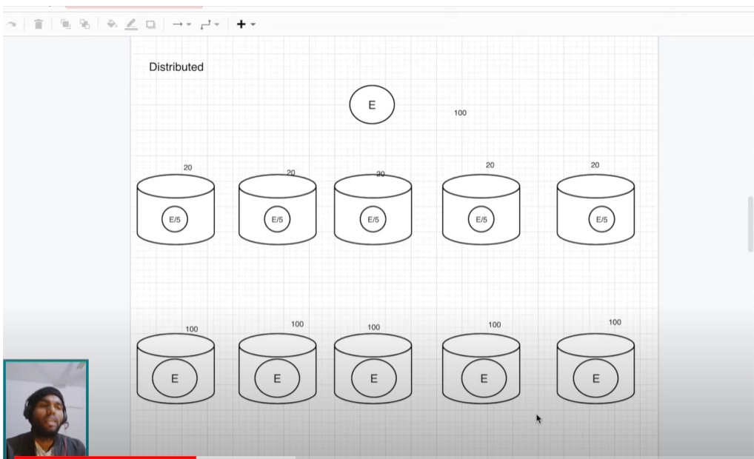

There are multiple services and it became really difficult to manage the connection between the system. Hence we need a service to maintain messaging systems.Hence the Kafka entered the picture.

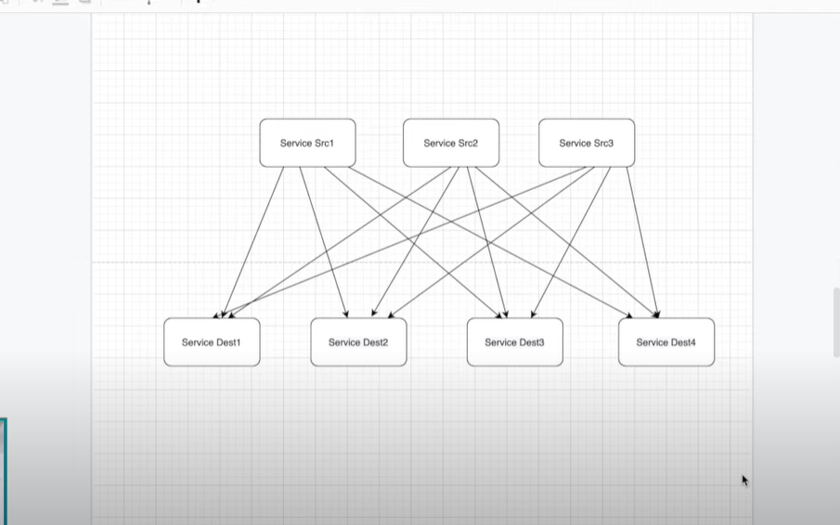

Service will give data to messaging System and consumer data will fetch the services from the messaging system.it reduces number of connections.

As soon as data comes in messaging system, the notification is pushed to the receiving applications to take off the data.

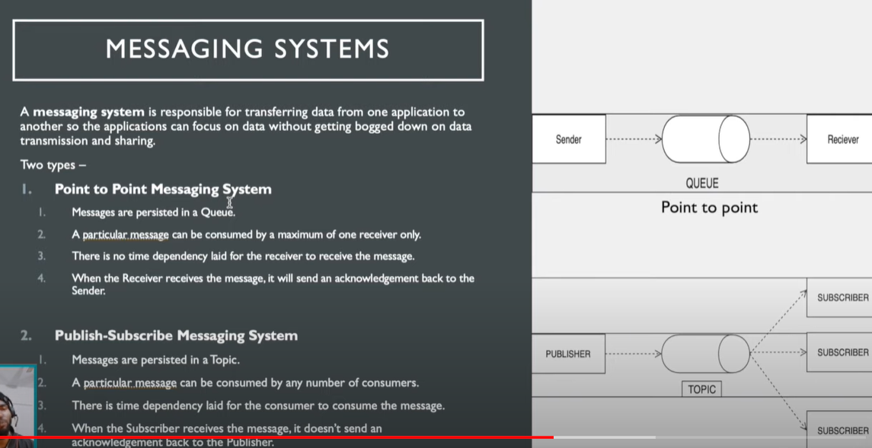

Multiple subscribers can consume a single message.

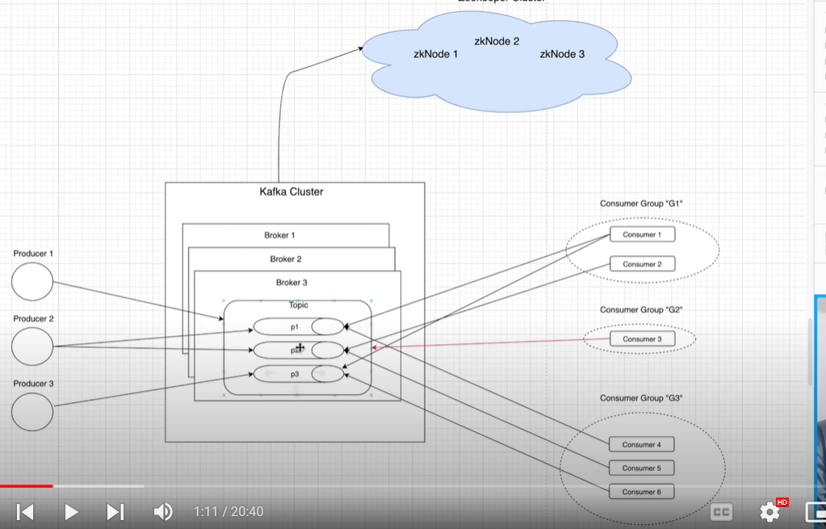

Each consumer is associated with some consumer group. The services that are having information, store the similar type of data as per same topic, which is consumed by the group of similar type of consumers. In an cluster we cannot create the two topics with same name.

Topics are split into partitions

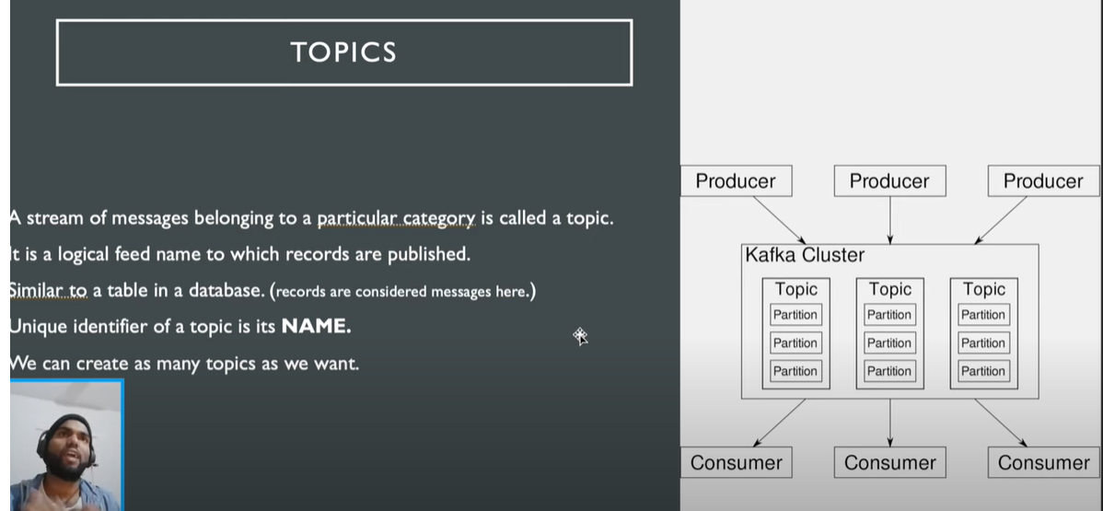

## PARTITION

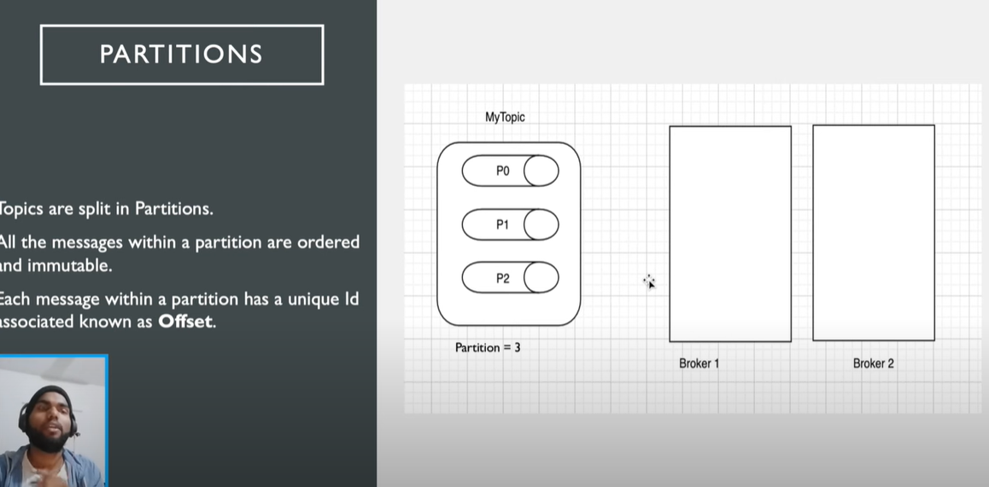

# Replica and Replication->

Replica are backups of partition.

Replicas never read or write partition.

Used to prevent Data Loss.

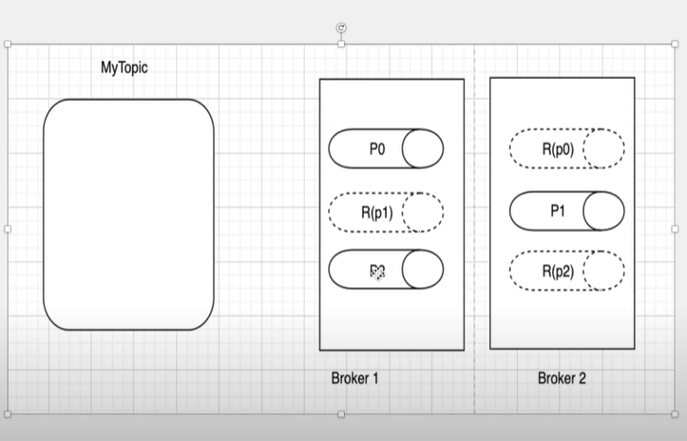

If one or more broker is down our complete data is not lost.i.e if there are multiple brokers our data is still available to be consumed for multiple replications.Producer will produce message under .Replica’s nor they consume message under Replica’s.Producers and Consumers basically read and write data.

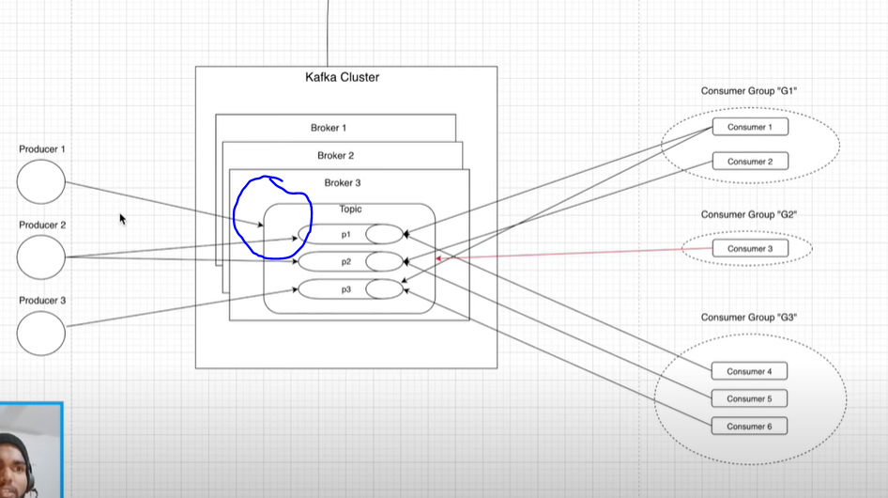

Producer can produce message for the topic i.e, it can be moved to all the partitions at once. Producer can also send messages separately to different partitions.

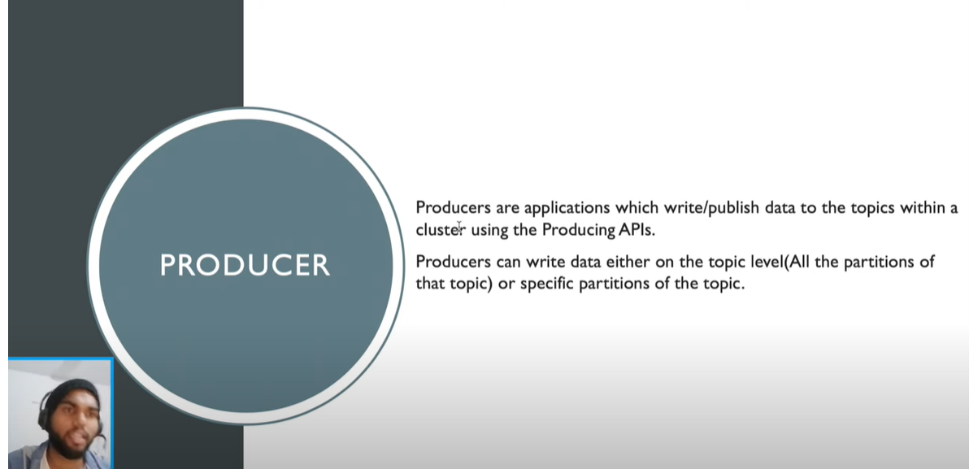

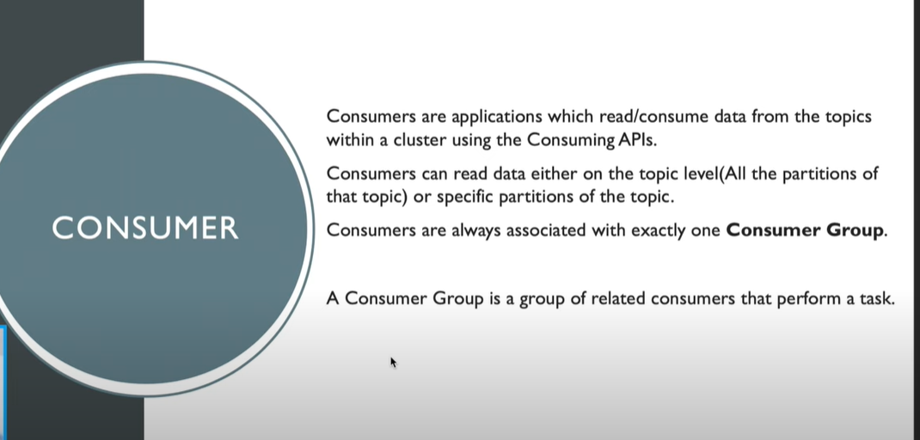

Brokers are the software processes that manage the topics and messages present in the topics.

Kafka Cluster->comprises of multiple brokers who can perform the maintainance and management tasks.

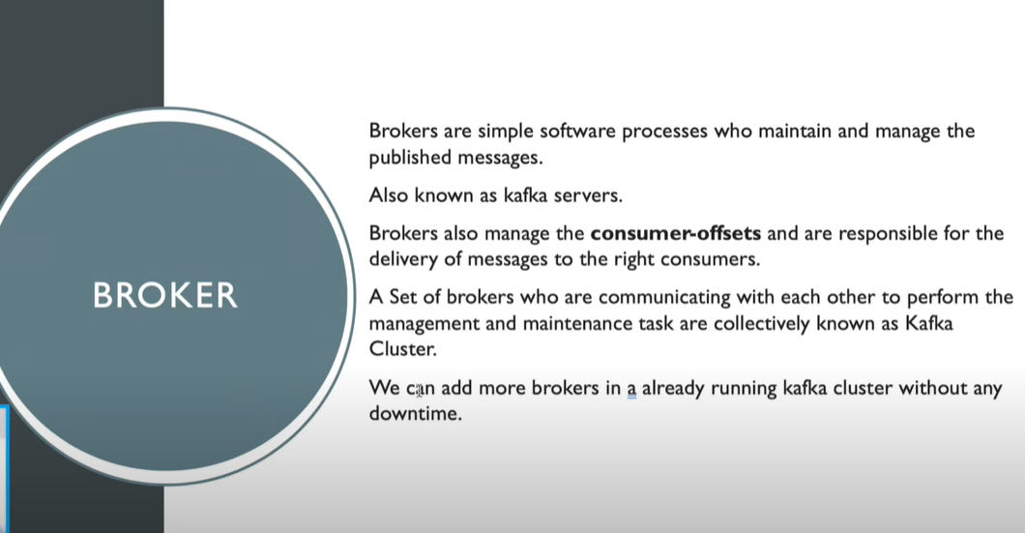

## ZOOKEEPER->

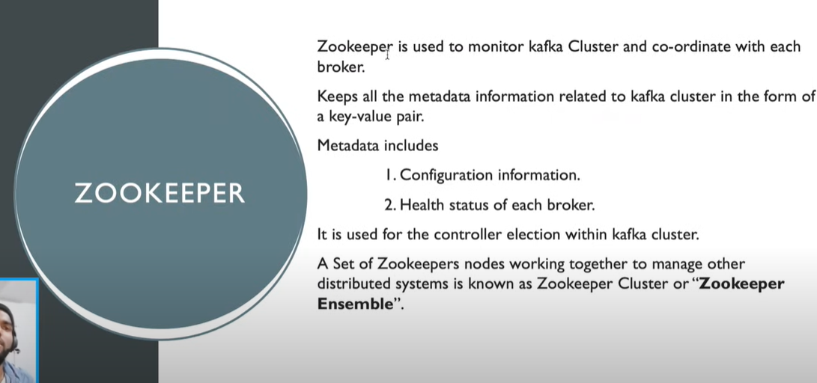

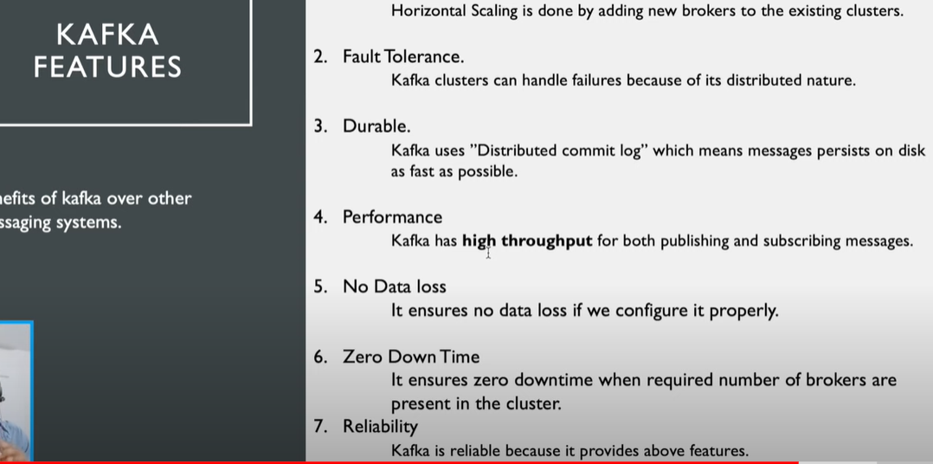

Kafka Installation& Setup

TO EXTRACT FILES->

#### C:\Users\Hp\Downloads>tar -xf apache-zookeeper-3.5.7-bin.tar.gz

1)Download Kafka

2)Zookeeper is a service used to manage the state of Brokers in Kafka Cluster,it manages the configuration of topic as well as state of Producers and Consumers

3)Before starting broker, we need to start the Zookeeper to manage the state of brokes.

**4)https://www.youtube.com/watch?v=BwYFuhVhshI** follow this make required changes

Commands:-

Topic-is a table in a relational db, data can be over flexible schema, but it stores the data in a Json format.

Go to C:\Kafka folder then just run below commands.

Start Zookeeper in kafka

.\bin\windows\zookeeper-server-start.bat .\config\zookeeper.properties

Start Kafka Server

.\bin\windows\kafka-server-start.bat .\config\server.properties

Create Topic in Kafka

.\bin\windows\kafka-topics.bat --create --topic topic-example --bootstrap-server localhost:9092

Create Producer for event

.\bin\windows\kafka-console-producer.bat --topic topic-example --bootstrap-server localhost:9092

Enter data

Create Consumer Event

.\bin\windows\kafka-console-consumer.bat --topic topic-example --from-beginning --bootstrap-server localhost:9092

Fetch all Data in topic-

.\bin\windows\kafka-console-consumer.bat --topic javaguides --from-beginning --bootstrap-server localhost:9092

Create Topic Using KafkaConfig

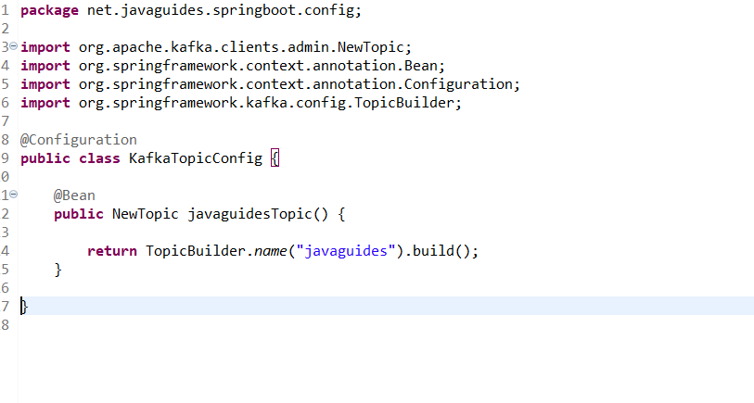Now you can create Kafka Producer to push data into topic

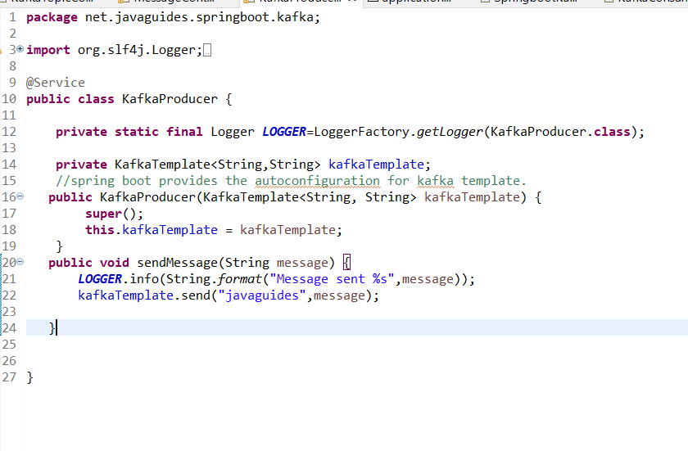

Now you can create Kafka Consumer to consume data from topic

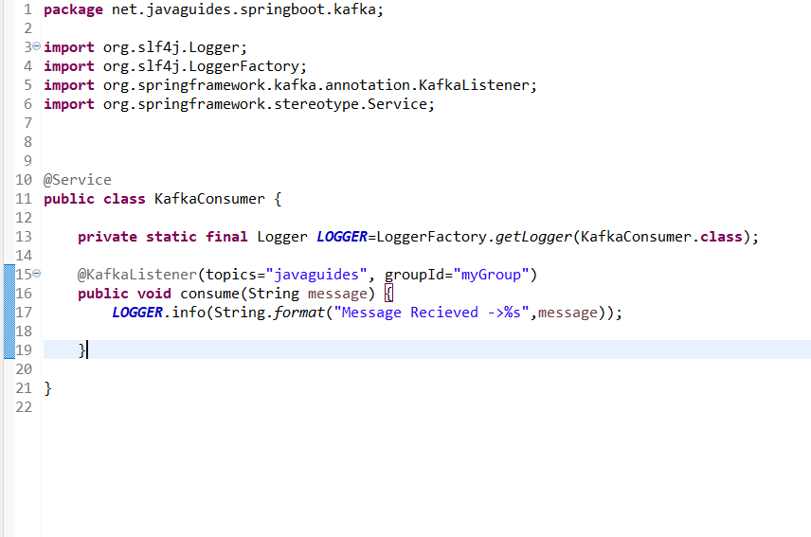

Configure Kafka Producer and Consumer for Json Message

in yml file add

1)spring.kafka.consumer.value-deserializer:org.springframework.kafka.support.serializer.JsonDeserializer

2)spring.kafka.producer.value-serializer:org.springframework.kafka.support.serializer.JsonSerializer

create Pojo classes for serialize and deserialize(user)

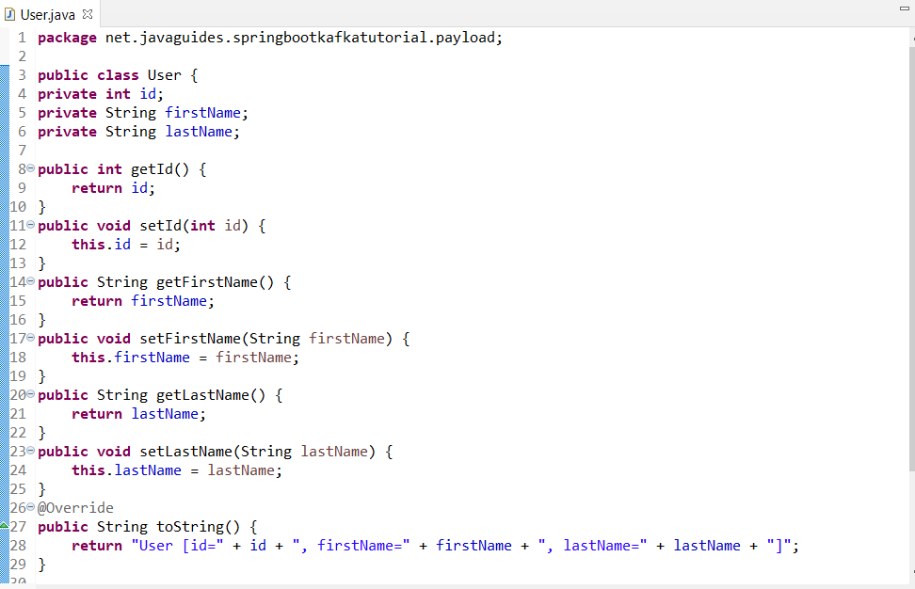

Create Json Kafka Producer to Produce messages in Json format.

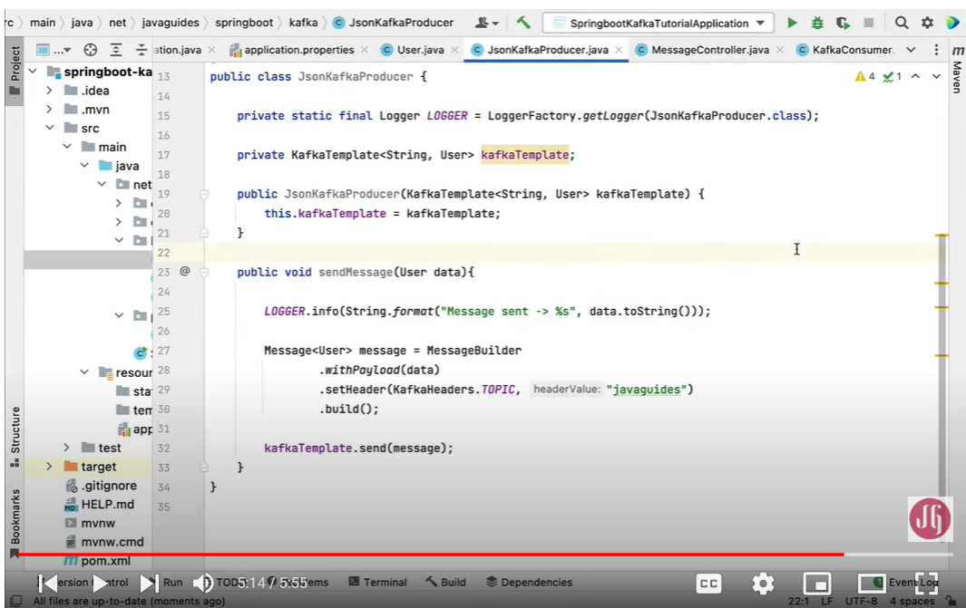

CONFIGURE JsonMessageController->

1)Create Class User-

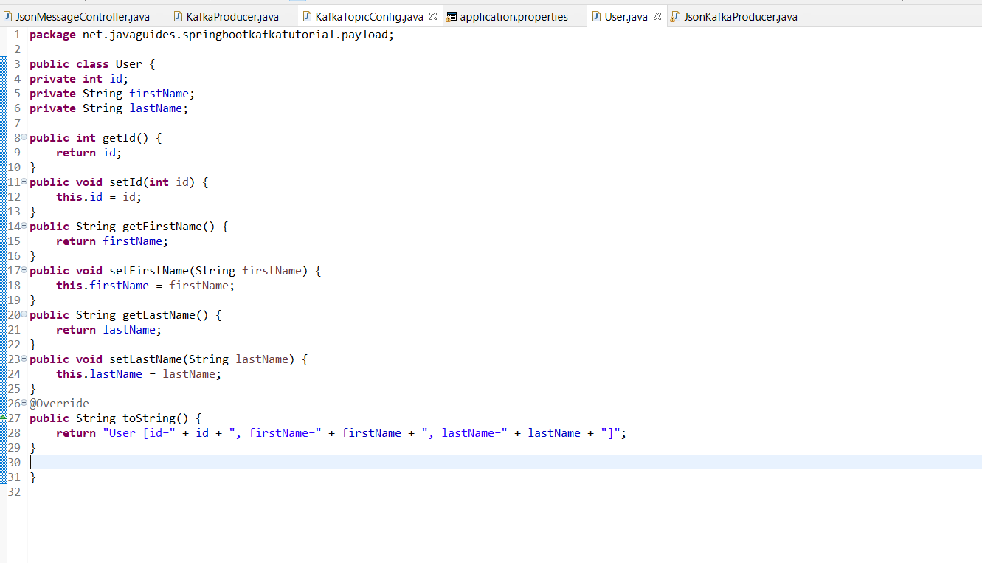

2)Create JsonKafkaProducer🡪

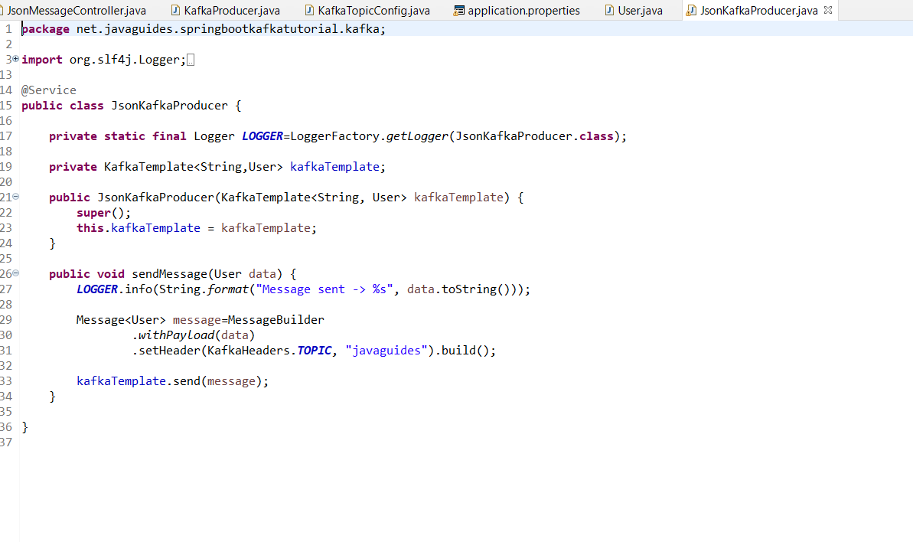3)Create JsonMessageController-

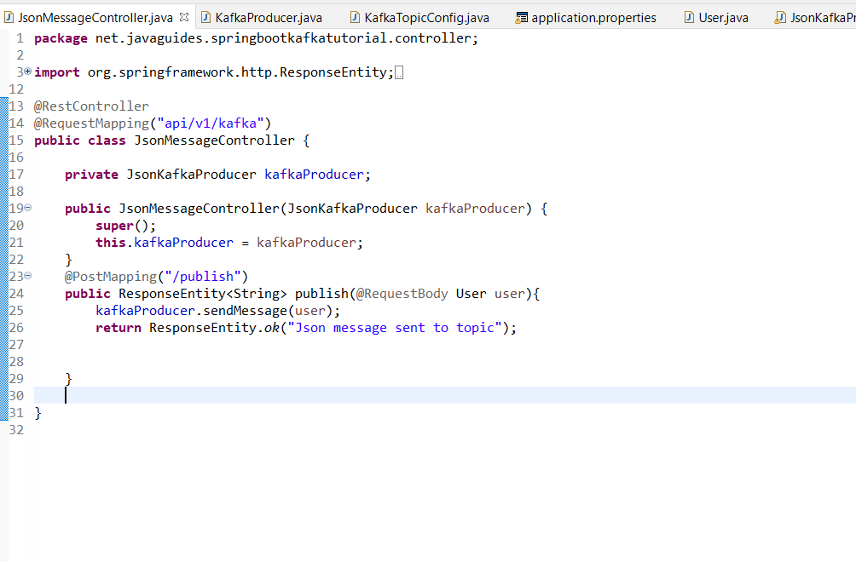

KafkaTopic Config Configuration.

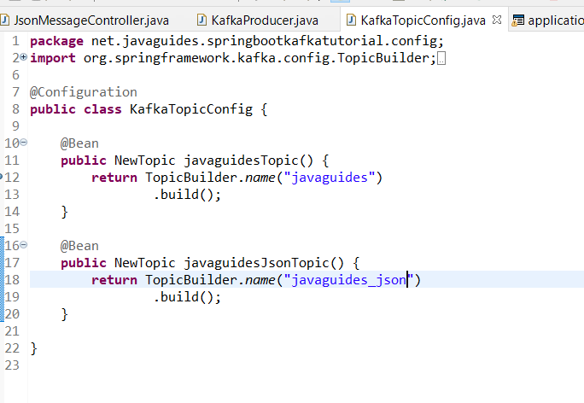

Json Kafka Consumer:-

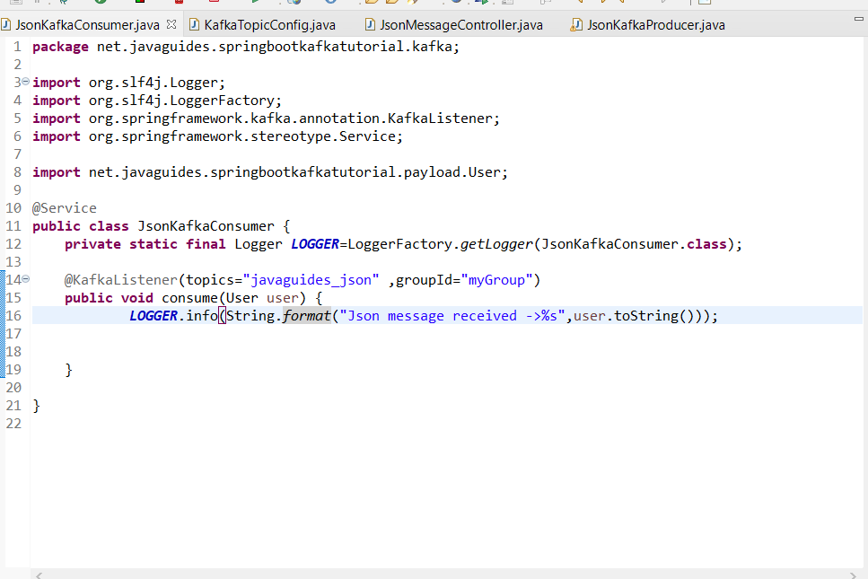

Work of consumer is to consume data in json format and print the logs to the desired location

Get running code here🡪

<https://github.com/Manthan2021/kafka-project.git>