Task-1: Create a GIT repository named as your enrollment number. Create 2 folder in

your repository named as Assignment_1 and Assignment_2.

Prepare a word file which contains each step of this task.

Upload your assignments in the respective folder. Share your git repository link in a

google form asked to you at the time of submission.

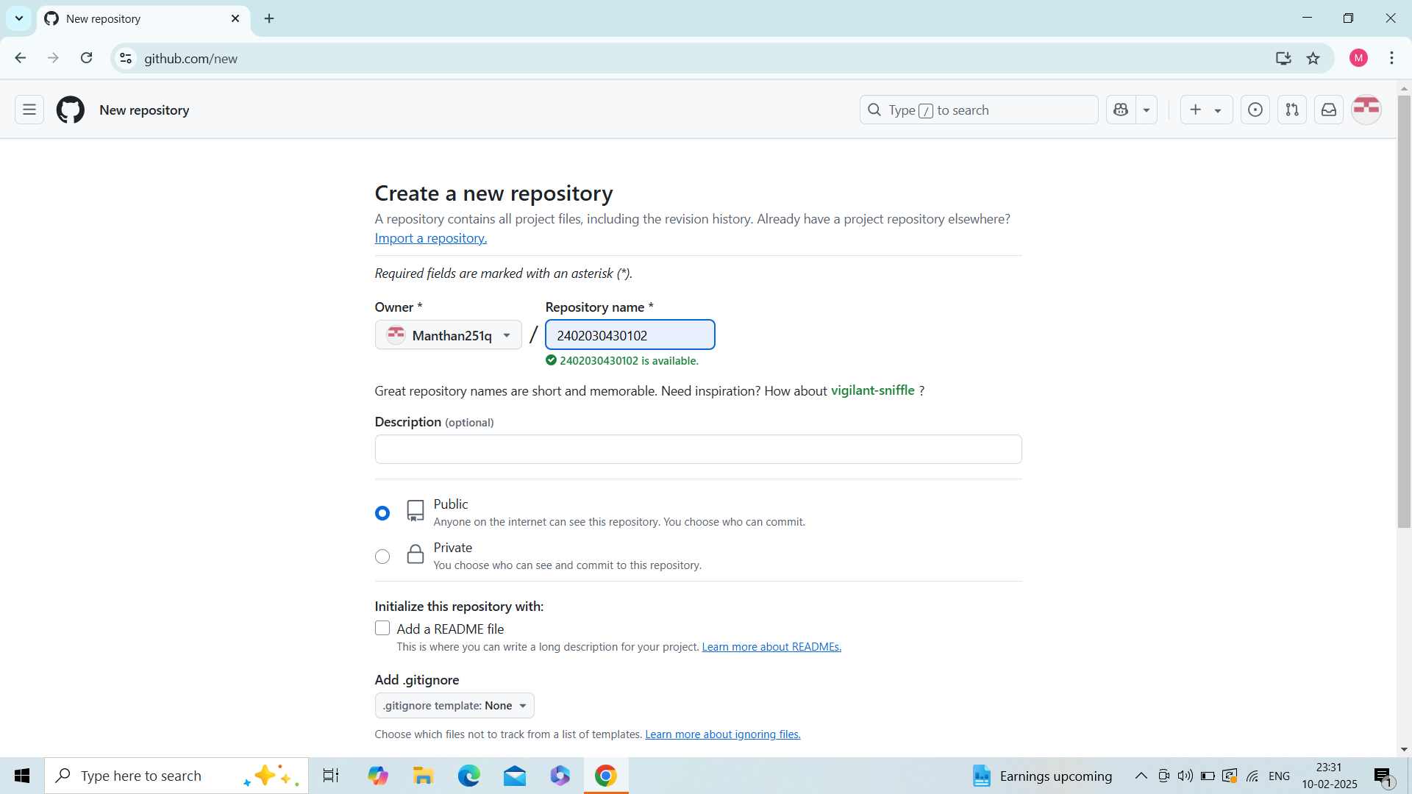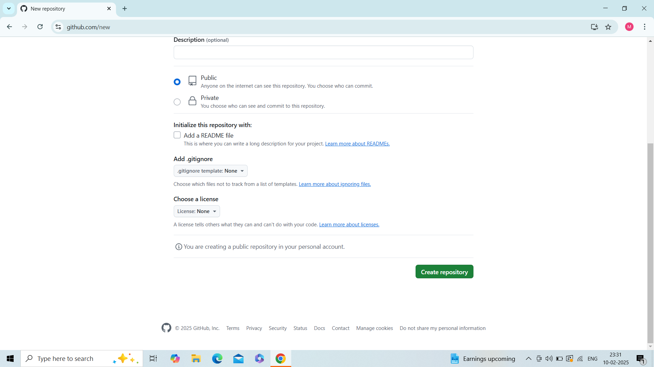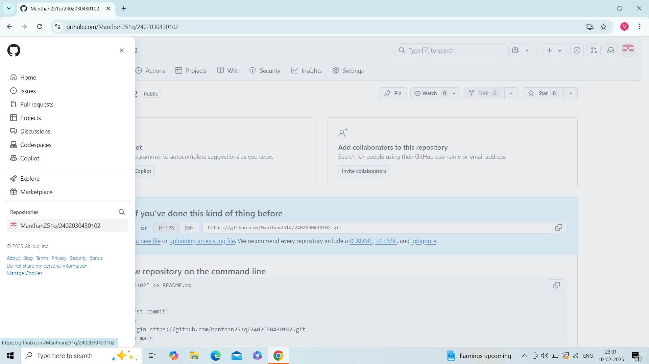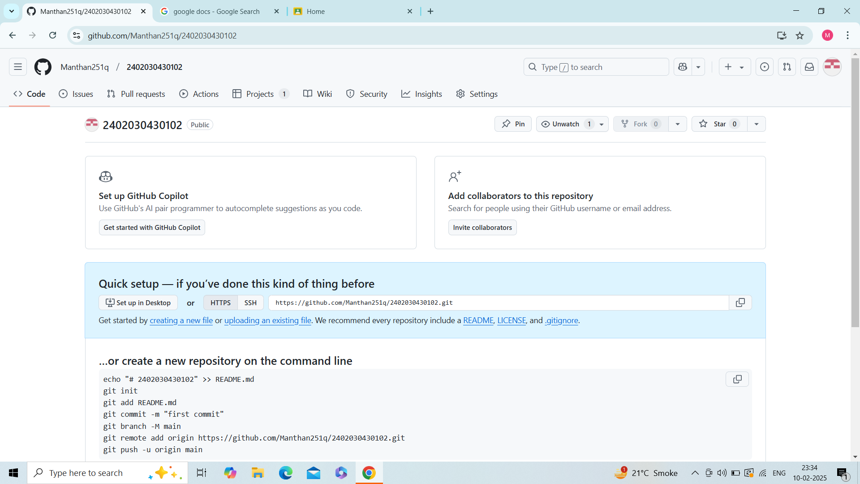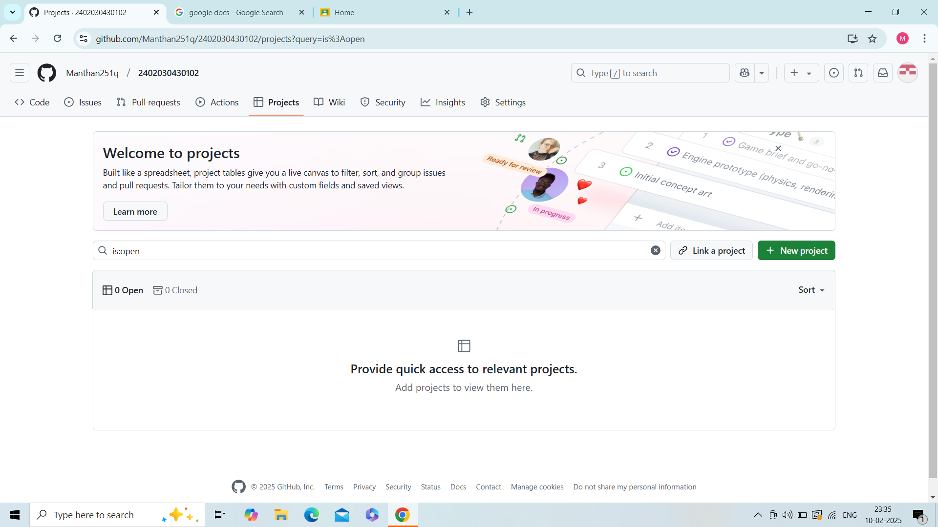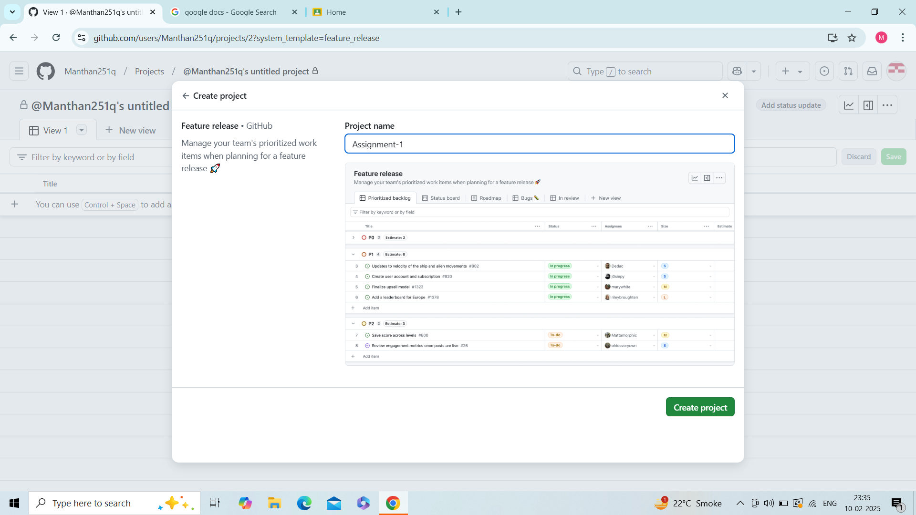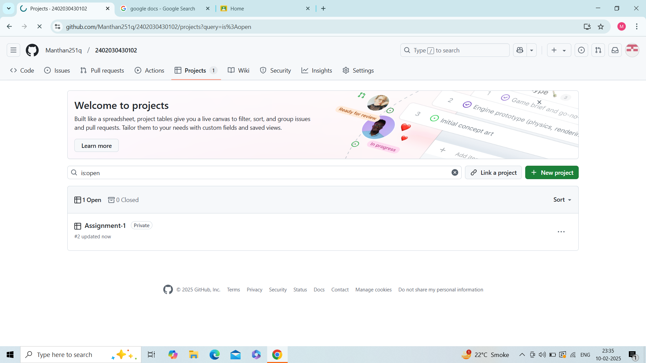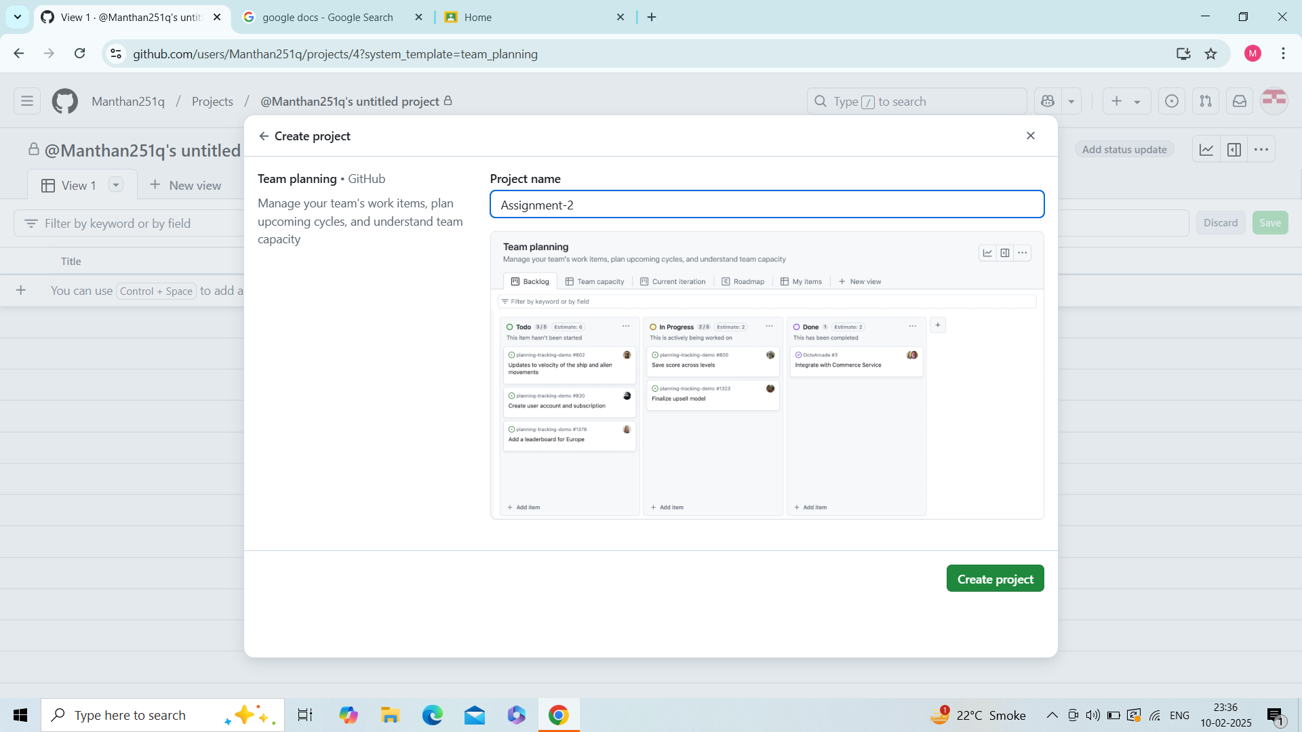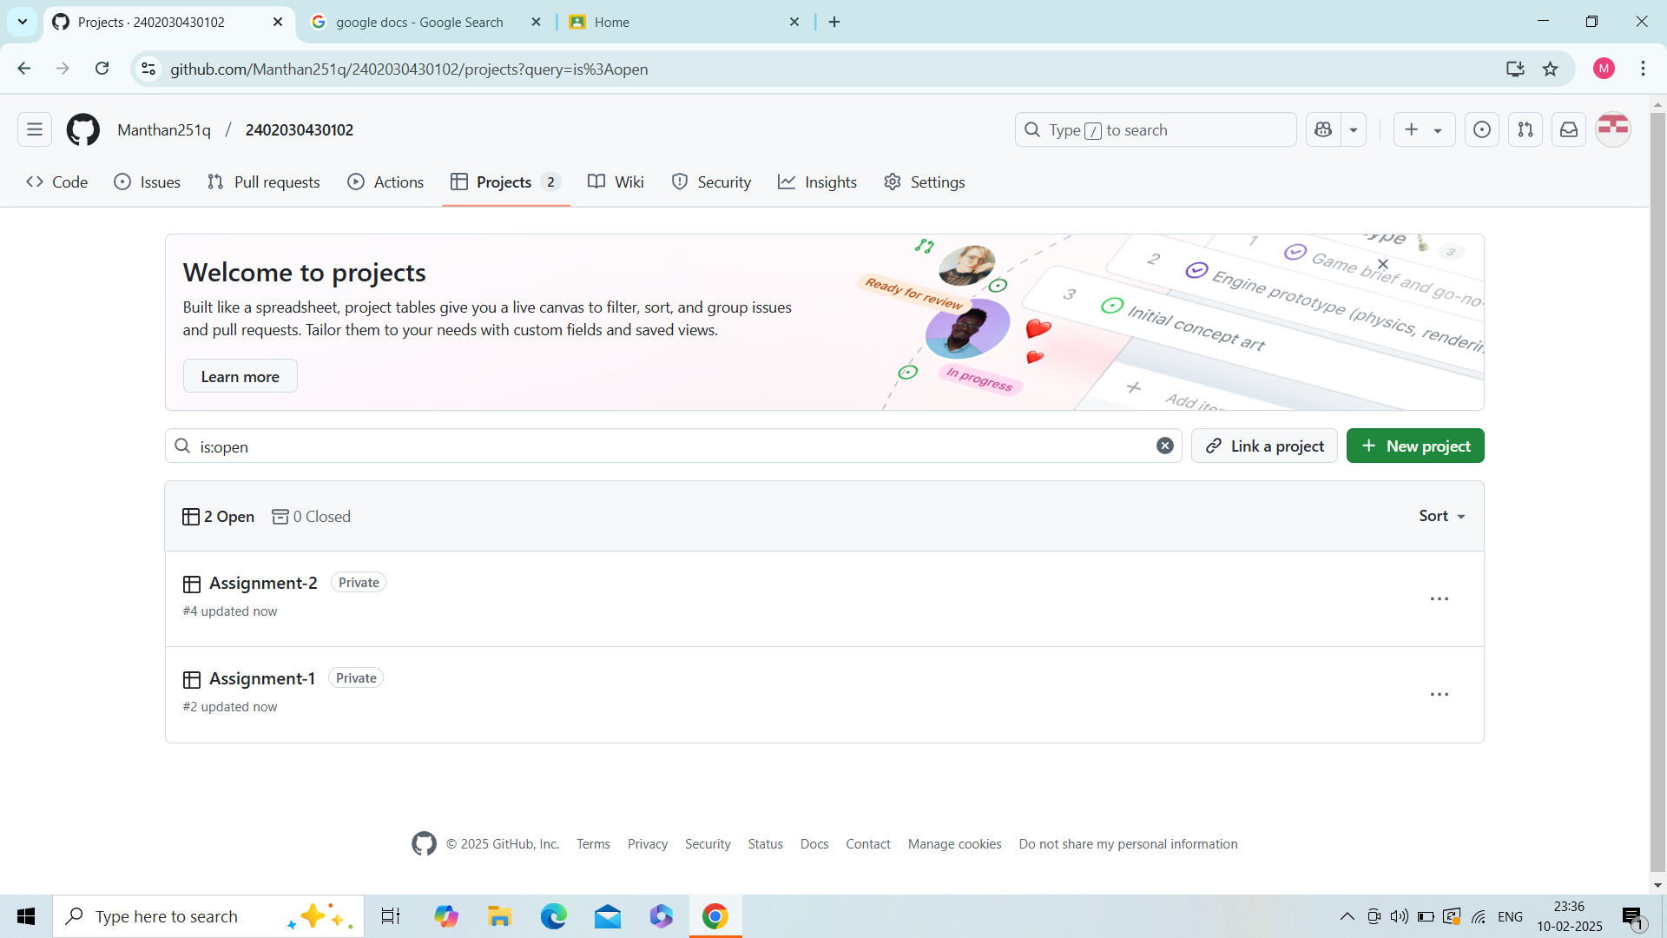

Guided By -   
Mr. Jay Kumar Gandharva

Prepared By -

Manthan Davra

2402030430102  
4CE_C_061