**Assignment 7**

Create a script named hello_world and write a single line in it.



Now, call it with bash.



Create multiline bash script.

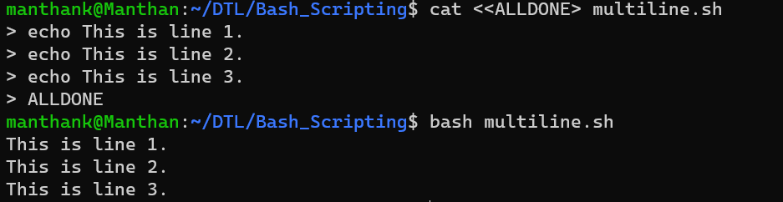

Creating an empty file with current timestamp.



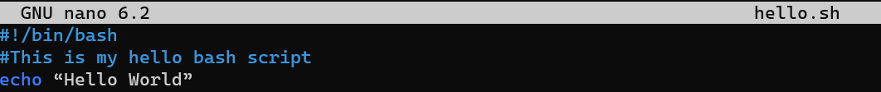

Add execute permissions to the file.

Execute the script file.

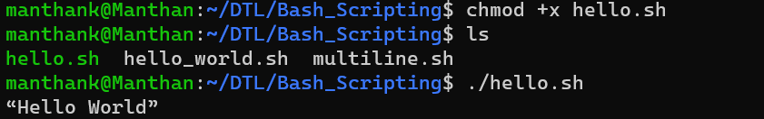

**Debugging**

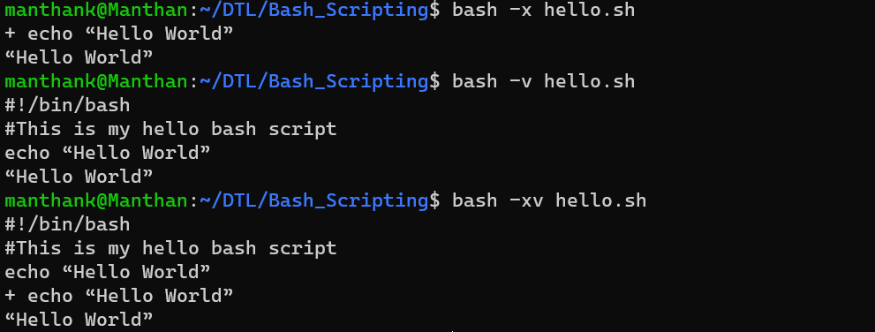

**Special Parameters**

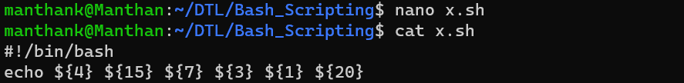

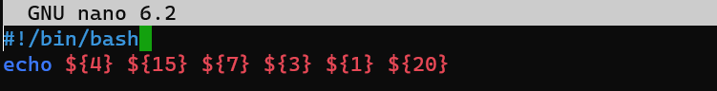



All parameters

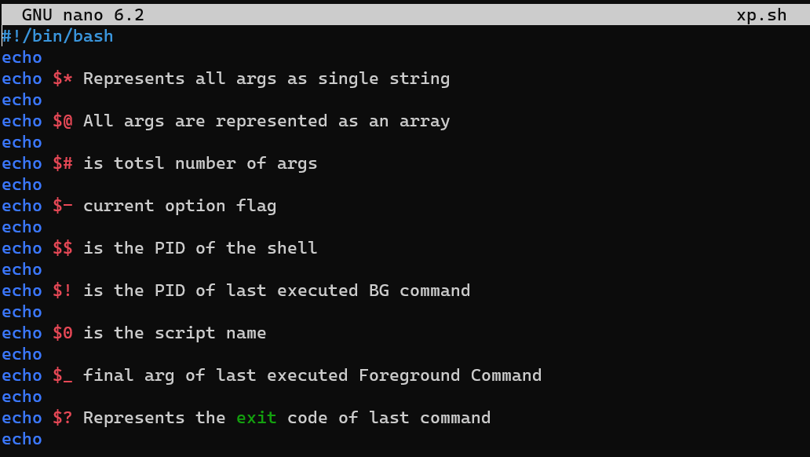

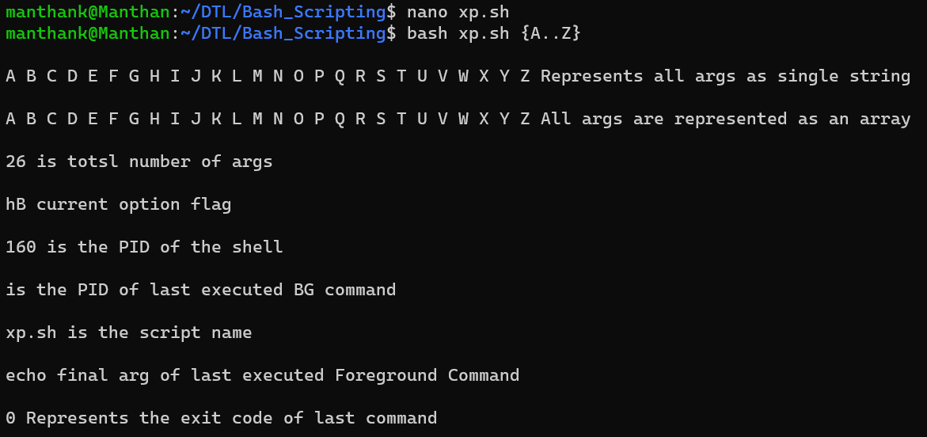

**Shell Expansion**

1. Brace Expansion

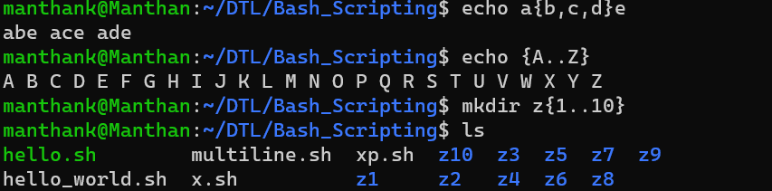

1. Parameter Expansion

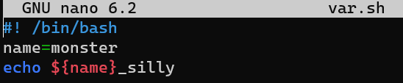

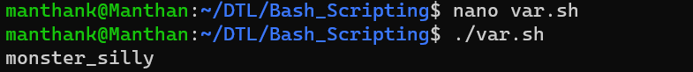

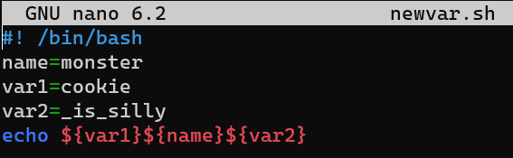

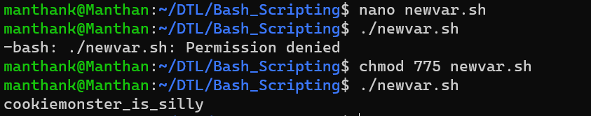

1. Arithmetic Expansion

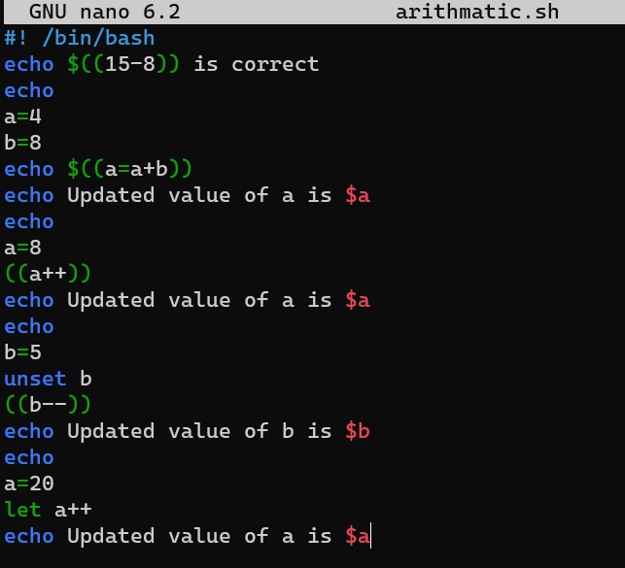

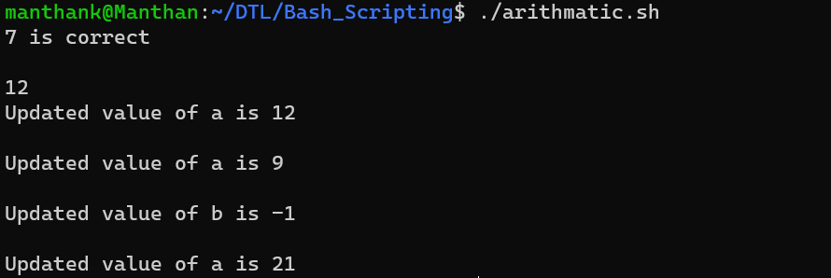

1. Command Expansion

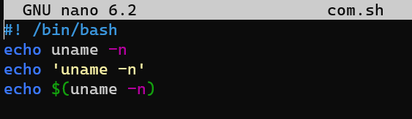

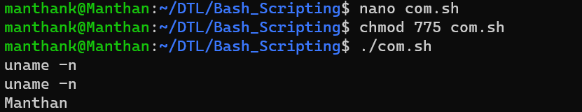

**Variables**

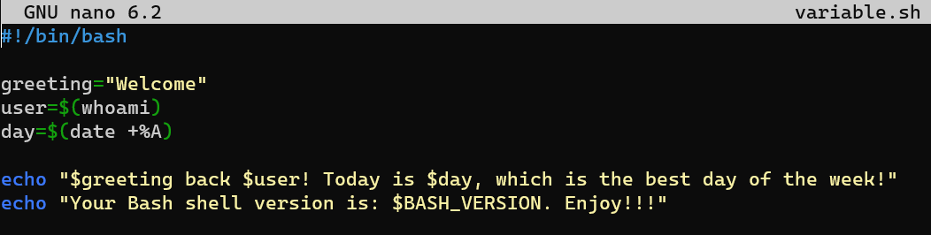

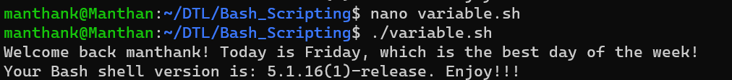

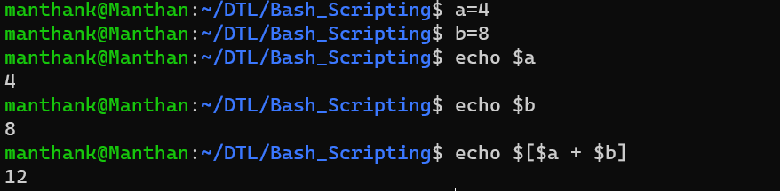

Backup:

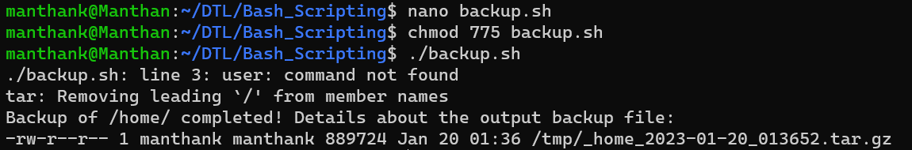

Environment

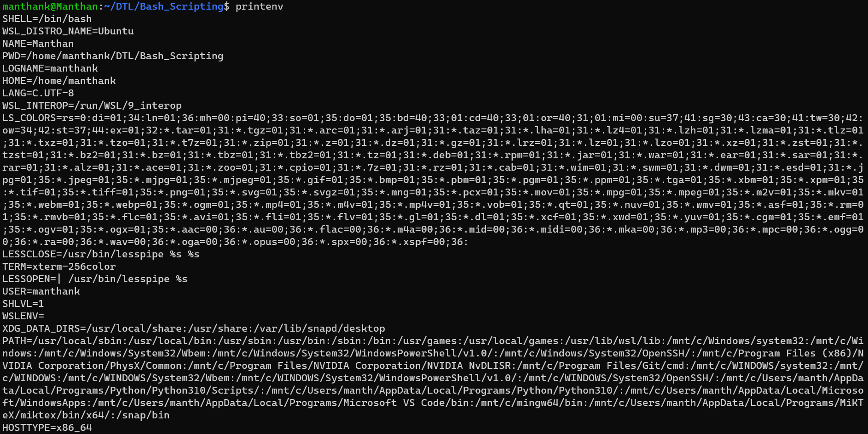

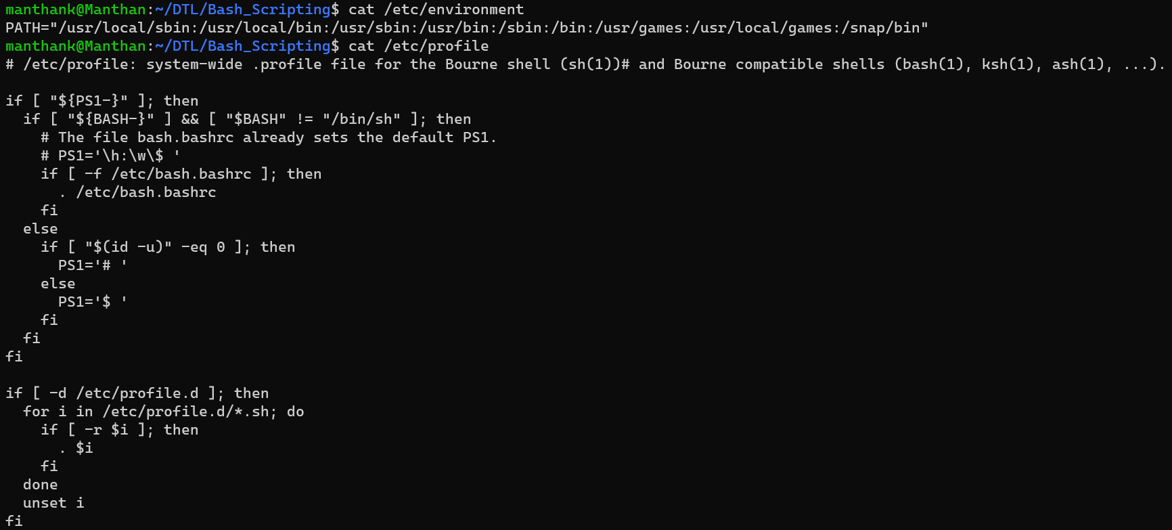

**Input, Output and Error Redirection**

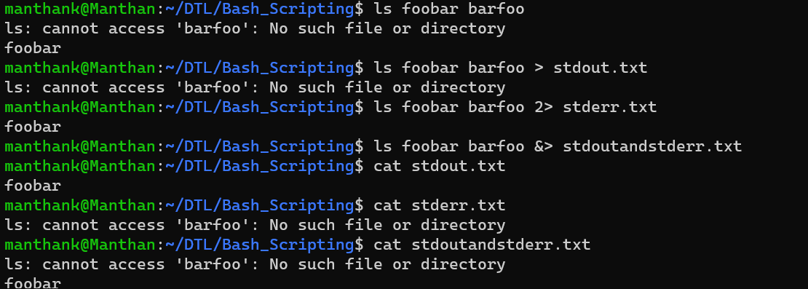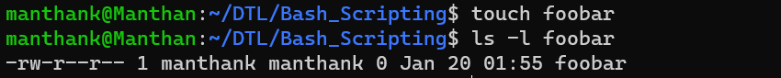

**Function**





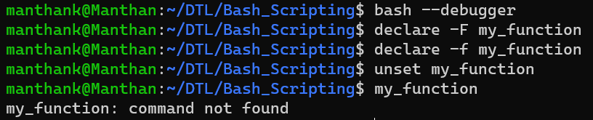

**Numeric and String Comparison**

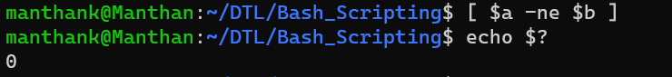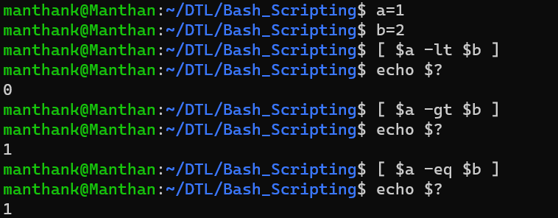



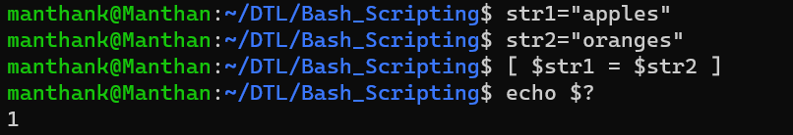

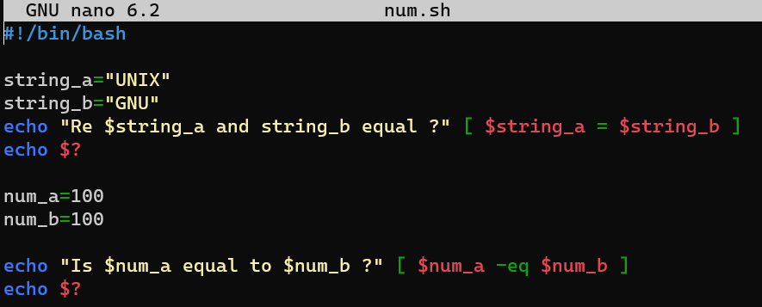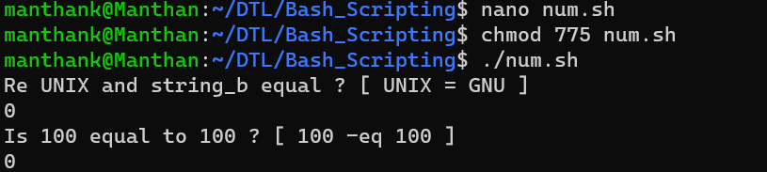

**Conditional Statement**

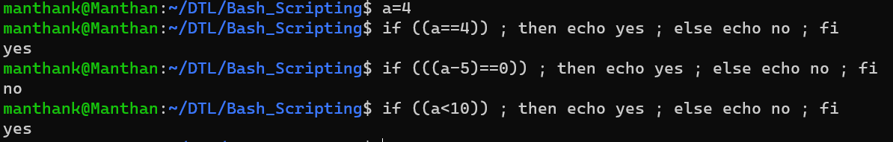 

**Arithmetic Operations**

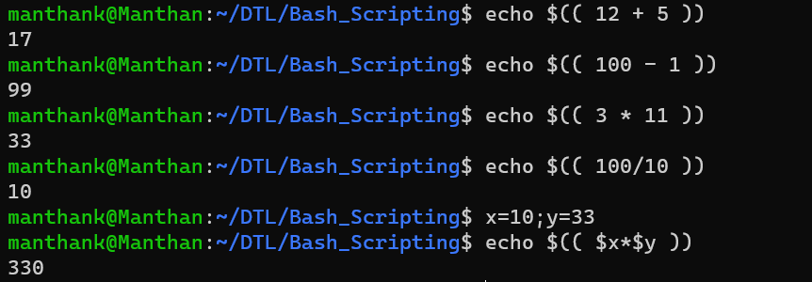

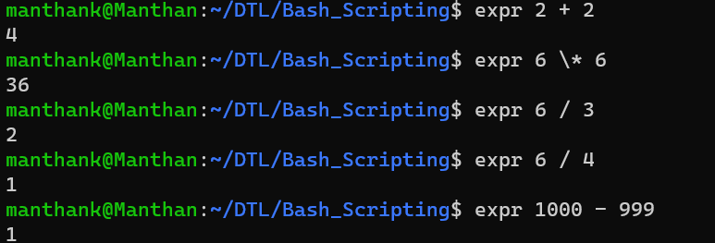

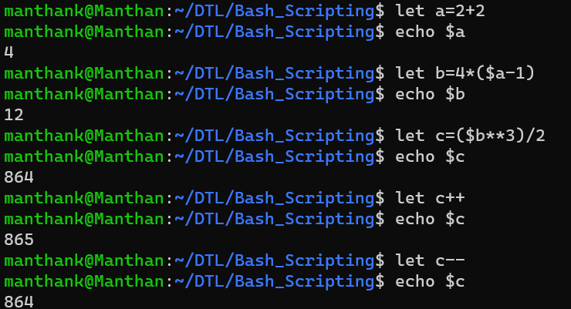

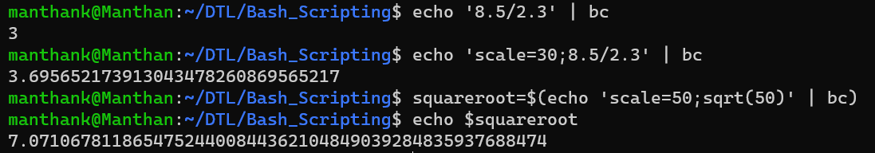

Name: Manthan Kshetrapal

MIS: 112103086

Div 2 S1