Experiment3

Q1.Write Shell script to find Area, circumference and volume of the sphere

#!/bin/bash

read -p "Enter Radius: " radius

pi=3.14

area=$(echo "scale=2; $pi * $radius * $radius" | bc)

circumference=$(echo "scale=2; 2 * $pi * $radius" | bc)

volume=$(echo "scale=2; (4/3) * $pi * ($radius * $radius * $radius)" | bc)

echo "Area of the sphere: $area"

echo "Circumference of the sphere: $circumference"

echo "Volume of the sphere: $volume"

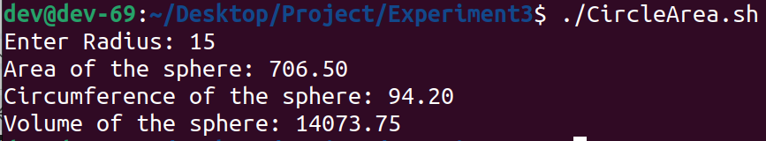

Q2.Write shell script to find Simple interest

#!/bin/bash

read -p "Enter Principal Amount: " principal

read -p "Enter Rate: " rate

read -p "Enter Time Period: " duration

simple_interest=$(echo "scale=2; ($principal * $rate * $duration)/100" | bc)

echo "Simple Interest for given data is : $simple_interest"

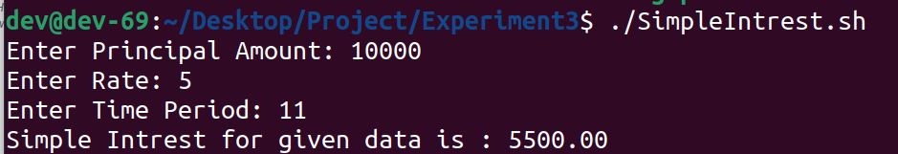

Q3.Write code to demonstrate File Operators, Read file and directory name from user

#!/bin/bash

read -p "Enter a file or directory name: " file_or_directory

if [ -e "$file_or_directory" ]; then

echo "File or directory '$file_or_directory' exists."

if [ -f "$file_or_directory" ]; then

echo "'$file_or_directory' is a regular file."

if [ -s "$file_or_directory" ]; then

echo "'$file_or_directory' is not empty."

else

echo "'$file_or_directory' is empty."

fi

if [ -x "$file_or_directory" ]; then

echo "You have execute permission on '$file_or_directory'."

else

echo "You do not have execute permission on '$file_or_directory'."

fi

fi

if [ -d "$file_or_directory" ]; then

echo "'$file_or_directory' is a directory."

if [ -x "$file_or_directory" ]; then

echo "You have execute permission on '$file_or_directory'."

else

echo "You do not have execute permission on '$file_or_directory'."

fi

fi

if [ -r "$file_or_directory" ]; then

echo "You have read permission on '$file_or_directory'."

else

echo "You do not have read permission on '$file_or_directory'."

fi

if [ -w "$file_or_directory" ]; then

echo "You have write permission on '$file_or_directory'."

else

echo "You do not have write permission on '$file_or_directory'."

fi

else

echo "File or directory '$file_or_directory' does not exist."

fi

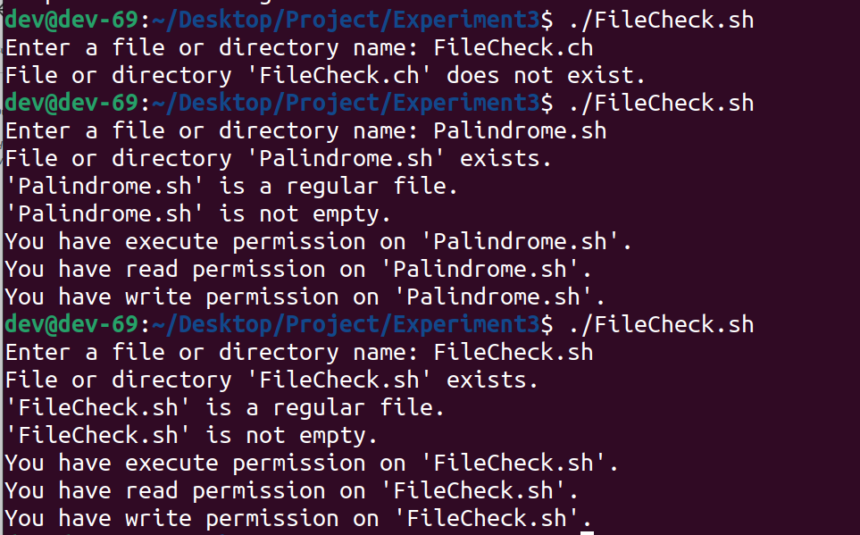

Q4.Write shell script to Swap two numbers without using 3rd variable

#!/bin/bash

read -p "Enter the first number: " num1

read -p "Enter the second number: " num2

echo "Before swapping: num1=$num1, num2=$num2"

num1=$((num1 + num2))

num2=$((num1 - num2))

num1=$((num1 - num2))

echo "After swapping: num1=$num1, num2=$num2"

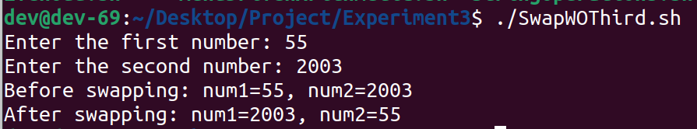

Q5.Write script for Menu Driven program to perform different arithmetic operation(Case)

#!/bin/bash

while true; do

echo "Menu:"

echo "1. Addition"

echo "2. Subtraction"

echo "3. Multiplication"

echo "4. Division"

echo "5. Exit"

read -p "Enter your choice (1-5): " choice

case $choice in

1)

read -p "Enter first number: " num1

read -p "Enter second number: " num2

result=$((num1 + num2))

echo "Result: $result"

;;

2)

read -p "Enter first number: " num1

read -p "Enter second number: " num2

result=$((num1 - num2))

echo "Result: $result"

;;

3)

read -p "Enter first number: " num1

read -p "Enter second number: " num2

result=$((num1 * num2))

echo "Result: $result"

;;

4)

read -p "Enter dividend: " num1

read -p "Enter divisor: " num2

result=$((num1 / num2))

echo "Result: $result"

;;

5)

# Exit

echo "Exit."

exit 0

;;

*)

# Invalid choice

echo "Invalid choice. Please enter a number between 1 and 5."

;;

esac

done

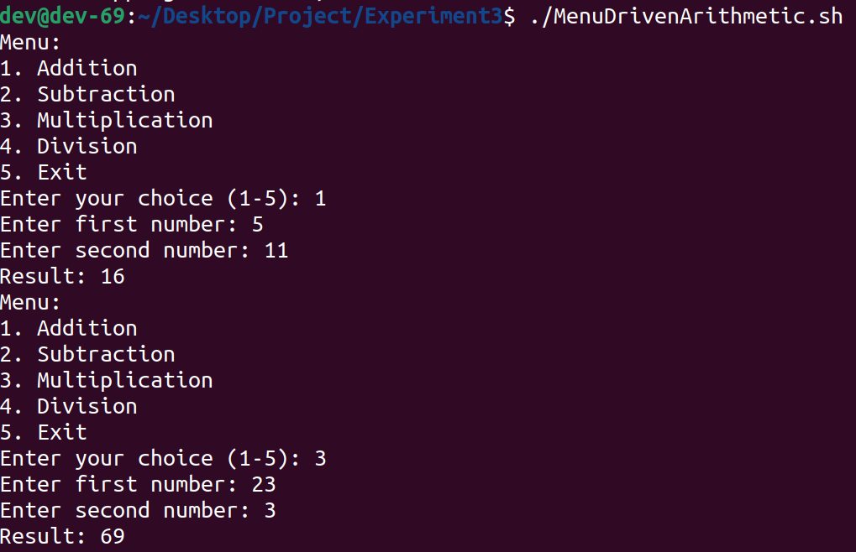

Q6.Write script to find maximum of three numbers(if-elif-else-fi)

#!/bin/bash

read -p "Enter the first number: " num1

read -p "Enter the second number: " num2

read -p "Enter the third number: " num3

if [ $num1 -gt $num2 ] && [ $num1 -gt $num3 ]; then

echo "$num1 is the maximum number."

elif [ $num2 -gt $num1 ] && [ $num2 -gt $num3 ]; then

echo "$num2 is the maximum number."

else

echo "$num3 is the maximum number."

fi

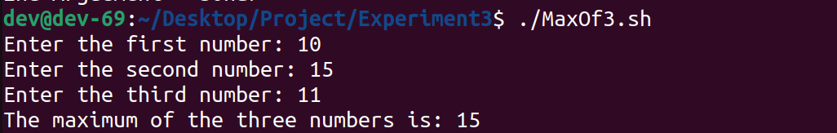

Q7.Write script to demonstrate all command line argument

#!/bin/bash

echo "Total Arguments: $#"

echo "1st Argument = $1"

echo "2nd Argument = $2"

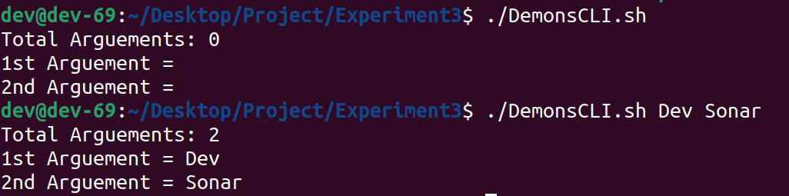

Q8.Given sides of Triangle and decide whether the triangle is isosceles, equilateral, scalene, obtuse, acute, and right Write script for the same.

#!/bin/bash

read -p "Enter the length of side 1: " side1

read -p "Enter the length of side 2: " side2

read -p "Enter the length of side 3: " side3

if [ "$side1" -eq "$side2" -a "$side2" -eq "$side3" ]; then

echo "Equilateral Triangle"

elif [ "$side1" -eq "$side2" -o "$side2" -eq "$side3" -o "$side1" -eq "$side3" ]; then

echo "Isosceles Triangle"

else

echo "Scalene Triangle"

fi

if [ "$side1" -gt "$side2" ]; then

temp=$side1

side1=$side2

side2=$temp

fi

if [ "$side2" -gt "$side3" ]; then

temp=$side2

side2=$side3

side3=$temp

fi

if [ "$side1" -gt "$side2" ]; then

temp=$side1

side1=$side2

side2=$temp

fi

a=$side1*$side1

b=$side2*$side2

c=$side3*$side3

if [ "$((a+b))" -eq "$((c))" ]; then

echo "Right-angled Triangle"

elif [ "$((a+b))" -lt "$((c))" ]; then

echo "Acute-angled Triangle"

else

echo "Obtuse-angled Triangle"

fi

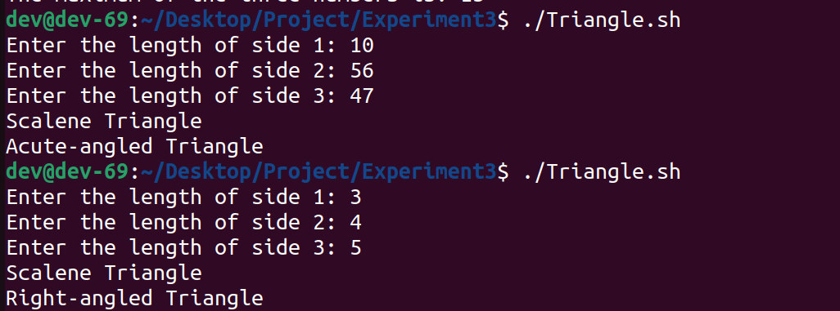

Q9.Write script to Find whether entered number is even or odd

#!/bin/bash

read -p "Enter a number: " number

if [ "$((number % 2))" -eq 0 ]; then

echo "Even"

else

echo "Odd"

fi

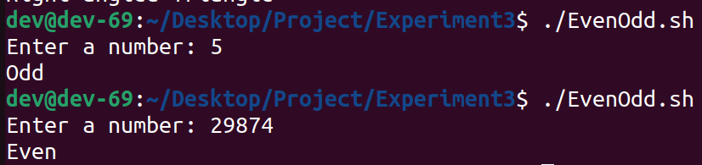

Q10.Write script to perform following String Operation

● Find Length of String

● Find and Replace String

● To Concatenate String

● Reversing the string

#!/bin/bash

read -p "Enter string for length: " input_string

i=${#input_string}

echo "Length: $i"

read -p "Enter a string: " input_string

read -p "Enter string to find: " input2_string

read -p "Enter to replace: " input3_string

op_string="${input_string//$input2_string/$input3_string}"

echo $op_string

read -p "Enter String1: " input_string

read -p "Enter String2: " input1_string

op_string="$input_string$input1_string"

echo "Concatenated String: $op_string"

read -p "Enter string to reverse: " input_string

op_string=$(echo "$input_string" | rev)

echo "The reversed string is: $op_string"

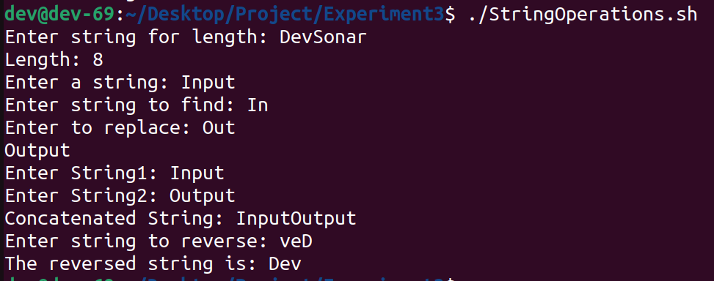

Q11.Write to check whether entered string is palindrome or not

#!/bin/bash

read -p "Enter a string: " str

s="$str"

if [ "$(echo "$s" | rev)" == "$str" ]

then

echo "The string is a palindrome."

else

echo "The string is not a palindrome."

fi

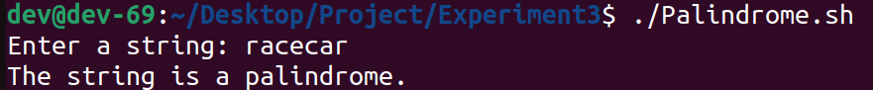

Q12.Write shell script to display menu for Celsius to Fahrenheit and Fahrenheit to Celsius, Read the temperature accordingly and convert.

#!/bin/bash

while true; do

echo "Menu:"

echo "1. Convert Celsius to Fahrenheit"

echo "2. Convert Fahrenheit to Celsius"

echo "3. Exit"

read -p "Enter your choice (1/2/3): " choice

case $choice in

1)

read -p "Enter temperature in Celsius: " celsius

fahrenheit=$(echo "scale=2; $celsius * 9/5 + 32" | bc)

echo "$celsius degrees Celsius is equal to $fahrenheit degrees Fahrenheit."

;;

2)

read -p "Enter temperature in Fahrenheit: " fahrenheit

celsius=$(echo "scale=2; ($fahrenheit - 32) * 5/9" | bc)

echo "$fahrenheit degrees Fahrenheit is equal to $celsius degrees Celsius."

;;

3)

echo "Exit"

exit 0

;;

*)

echo "Invalid choice. Please enter 1, 2, or 3."

;;

esac

done

