Experiment 4

Q1.Write shell script to find reverse of 5 digit number using while loop

#!/bin/bash

read -p "Enter a 5-digit number: " number

if [ ${#number} -ne 5 ]; then

echo "Please enter a valid 5-digit number."

exit 1

fi

rev=0

while [ $number -gt 0 ]; do

digit=$((number % 10))

rev=$((rev * 10 + digit))

number=$((number / 10))

done

echo "Reversed Number = $rev"

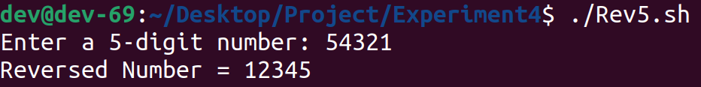

Q2.Write shell script to find factorial of number using while Loop

#!/bin/bash

read -p "Enter number: " n

ans=1

while [ $n -ge 1 ]; do

ans=$((ans * n))

n=$((n - 1))

done

echo "$ans"

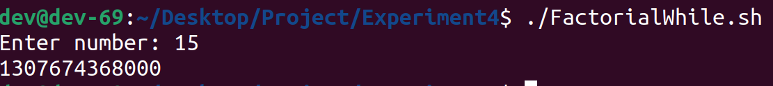

Q3.Write shell script to generate Fibo series till the limit entered by user(for and while)

for:

#!/bin/bash

read -p "Enter the number of terms for Fibonacci series: " n

if [ $n -lt 1 ]; then

echo "Please enter a valid positive number."

exit 1

fi

a=0

b=1

echo "Fibonacci series up to $n terms:"

for ((i = 0; i < n; i++)); do

echo -n "$a "

next=$((a + b))

a=$b

b=$next

done

echo

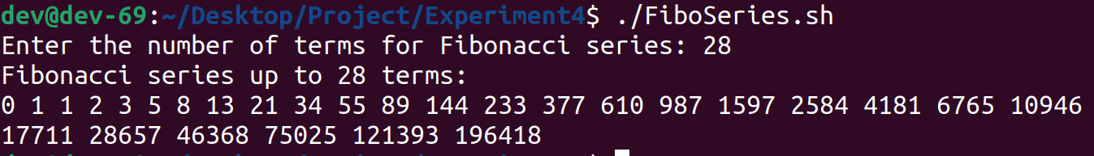

while:

#!/bin/bash

read -p "Enter the number of terms for Fibonacci series: " n

if [ $n -lt 1 ]; then

echo "Please enter a valid positive number."

exit 1

fi

a=0

b=1

i=0

echo "Fibonacci series up to $n terms:"

while ((i < n)); do

echo -n "$a "

next=$((a + b))

a=$b

b=$next

i=$i+1

done

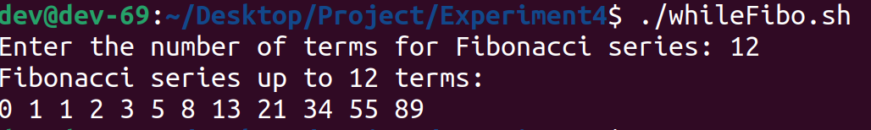

Q4.Write shell script to generate prime number between limit specified by user using for loop

#!/bin/bash

read -p "Enter the lower bound of the range: " lower

read -p "Enter the upper bound of the range: " upper

for ((num = lower; num <= upper; num++)); do

is_prime=true

for ((i = 2; i*i <= num; i++)); do

if [ $((num % i)) -eq 0 ]; then

is_prime=false

break

fi

done

if [ "$is_prime" = true ]; then

echo -n "$num "

fi

done

echo

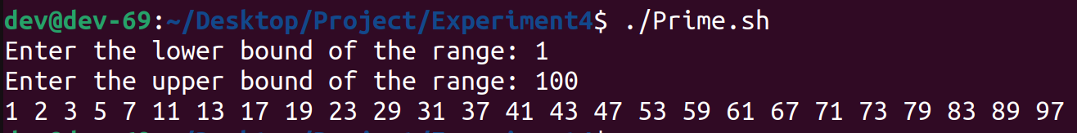

Q5.Write shell script to generate table of the number specified by the user using for in Loop

#!/bin/bash

read -p "Enter the number:" n

for((i=1;i<=10;i++))

do

result=$((n*i))

echo $result

done

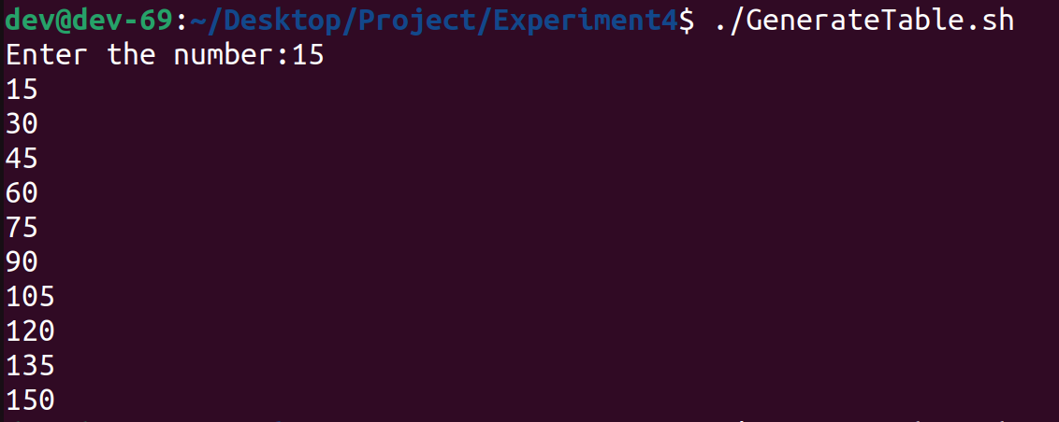

Q6.Write shell script to generate even number between limit specified by user

#!/bin/bash

read -p "Enter the lower bound of the range: " lower

read -p "Enter the upper bound of the range: " upper

for ((num = lower; num <= upper; num++));

do

if [ $((num % 2)) -eq 0 ]

then

echo -n "$num "

fi

done

echo

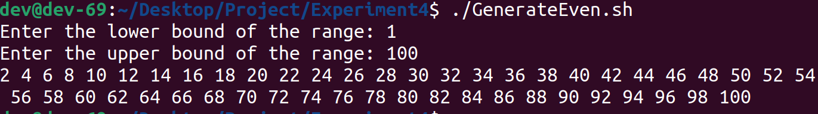

Q7.Write shell script to Generate sum of N numbers. Read N from user and until loop

#!/bin/bash

read -p "Enter the limit: " n

sum=0

i=1

until [ $i -gt $n ]; do

sum=$((sum + i))

((i++))

done

echo "The sum is $sum"

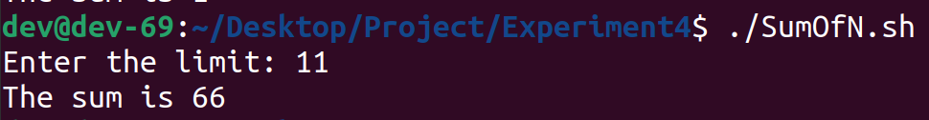

Q8.Write shell script to display 4x4 matrix and read data from user from keyboard. Use for Loop

#!/bin/bash

echo "Enter elements for a 4x4 matrix:"

for ((row=0; row<4; row++)); do

for ((col=0; col<4; col++)); do

echo "Enter element for [$((row+1))][$((col+1))]: "

read matrix["$row,$col"]

done

done

# Display the entered matrix

echo -e "\nEntered Matrix:"

for ((row=0; row<4; row++)); do

for ((col=0; col<4; col++)); do

echo -n "${matrix[$row,$col]} "

done

echo

done

