**PCET’s**

***Pimpri Chinchwad College of Engineering,***

**Nigdi, Pune-44**

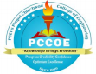

**Department of Electronics & Telecommunication**

**MINI PROJECT LOG/WORK BOOK Year 2020 - 2021**

Project Title: **CHEERBOXITE**

Area of Project: Embedded systems

**Name of the Faculty Guide : Prakash Sontakke**

Group Id. C1-05

Name of the student

**1) Sakshee Kolhe T150333109**

**2) PILLAI BHAGYA VENU T150333170**

**3) Manthan Choudhury T150333134**

.

**INDEX**

|  |  |  |
| --- | --- | --- |
| **Sr.**  **No.** | **Contents** | **Page No.** |
| **1** | **Project Group Information** | **3** |
| **2** | **Course Objectives, Course Outcome, Programme Outcome and Mapping** | **4-6** |
| **3** | **Undertaking by the students** | **7** |
| **4** | **Abstract** | **12** |
| **5** | **Monthly Planning sheet (December to March)** | **15-18** |

P.C.C.O.E. E & TC Mini Project workbook

|  |  |  |
| --- | --- | --- |
|  | **Pimpri Chinchwad Education Trust’s**  **Pimpri Chinchwad College of Engineering** |  |

|  |
| --- |
| **Project Group Formation** |

**Group No.**

|  |  |  |  |  |  |
| --- | --- | --- | --- | --- | --- |
| **Sr.**  **No** | **Name of the Student** | **Roll**  **No.** | **Exam No** | **Mobile No** | **Email ID** |
| 1. | Sakshee Kolhe | TEETC317 | T150333109 | 78754 01970 | 78754 01970  saksheekolhe0105@gmail.com |
| 2. | Bhagya Venu Pillai | TEETC338 | T150333170 | 8275300250 | srikutti.pillai@gmail.com |
| 3. | Manthan choudhury | TEETC321 | T150333134 | 8729068963 | manthansniper007@gmai.com |

2020-21

P.C.C.O.E. E & TC Mini Project workbook

|  |  |  |
| --- | --- | --- |
|  | **Pimpri Chinchwad Education Trust’s**  **Pimpri Chinchwad College of Engineering** |  |

|  |
| --- |
| **Course Objectives, Course Outcomes, Programme Outcomes and Mapping** |

**Course Objectives**:

∙ To understand the Product Development Process including budgeting through Mini Project.

∙ To plan for various activities of the project and distribute the work amongst team members.

∙ To inculcate electronic hardware implementation skills by -

∙ Learning PCB artwork design using an appropriate EDA tool.

∙ Imbibing good soldering and effective trouble-shooting practices.

∙ Following correct grounding and shielding practices.

∙ To develop student‘s abilities to transmit technical information clearly and test the same by delivery of Seminar based on the Mini Project.

∙ To understand the importance of document design by compiling Technical Report on the Mini Project work carried out.

**Course Outcome :**

On completion of the course, student will be able to

On completion of the course, student will be able to

CO1. Administer and implement a mini project through a group of students.

CO2. Correlate the ‘Product Development Cycle’ through mini project.

CO3. Plan and analyze the budget requirement of the project.

CO4. Develop electronic hardware implementation skills by

a. Learning PCB artwork design using an appropriate EDA tool.

b. Imbibing good soldering and effective trouble-shooting practices.

c. Following correct grounding and shielding practices.

d. Knowing the significance aesthetics & ergonomics while designing electronic product. CO5.Prepare and deliver technical seminar based on the mini project work carried out. CO6.Validate the importance the document design by compiling technical report on mini project work carried out

2020-21

P.C.C.O.E. E & TC Mini Project workbook

**Program Outcomes:**

**Engineering Graduates will be able to:**

**1. Engineering knowledge:** Apply the knowledge of mathematics, science, engineering fundamentals, and an engineering specialization to the solution of complex engineering problems.

**2. Problem analysis:** Identify, formulate, review research literature, and analyze complex engineering problems reaching substantiated conclusions using first principles of mathematics, natural sciences, and engineering sciences.

**3. Design/development of solutions:** Design solutions for complex engineering problems and design system components or processes that meet the specified needs with appropriate consideration for the public health and safety, and the cultural, societal, and environmental considerations.

**4. Conduct investigations of complex problems:** Use research-based knowledge and research methods including design of experiments, analysis and interpretation of data, and synthesis of the information to provide valid conclusions.

**5. Modern tool usage:** Create, select, and apply appropriate techniques, resources, and modern engineering and IT tools including prediction and modeling to complex engineering activities with an understanding of the limitations.

**6. The engineer and society:** Apply reasoning informed by the contextual knowledge to assess societal, health, safety, legal and cultural issues and the consequent responsibilities relevant to the professional engineering practice.

**7. Environment and sustainability:** Understand the impact of the professional engineering solutions in societal and environmental contexts, and demonstrate the knowledge of, and need for sustainable development.

**8. Ethics:** Apply ethical principles and commit to professional ethics and responsibilities and norms of the engineering practice.

**9. Individual and team work:** Function effectively as an individual, and as a member or leader in diverse teams, and in multidisciplinary settings.

**10. Communication:** Communicate effectively on complex engineering activities with the engineering community and with society at large, such as, being able to comprehend and write effective reports and design documentation, make effective presentations, and give and receive clear instructions.

**11. Project management and finance:** Demonstrate knowledge and understanding of the engineering and management principles and apply these to one’s own work, as a member and leader in a team, to manage projects and in multidisciplinary environments.

2020-21

P.C.C.O.E. E & TC Mini Project workbook

**12. Life-long learning**: Recognize the need for, and have the preparation and ability to engage in independent and life-long learning in the broadest context of technological change.

**Mapping of CO with PO**

|  |  |  |  |  |  |  |  |  |  |  |  |  |
| --- | --- | --- | --- | --- | --- | --- | --- | --- | --- | --- | --- | --- |
| CO | PO1 | PO2 | PO3 | PO4 | PO5 | PO6 | PO7 | PO8 | PO9 | PO10 | PO11 | PO12 |
| CO1 | 1 | - | 3 | 3 | - | 2 | - | 2 | 3 | 3 | 1 | 3 |
| CO2 | 2 | 3 | 3 | 2 | 2 | 1 | 1 | - | 1 | 1 | 3 | 3 |
| CO3 | 3 | - | - | 2 | - | 2 | - | - | 1 | - | 3 | 3 |
| CO4 | 3 | 2 | 3 | 3 | 2 | 1 | 2 | - | - | - | - | 2 |
| CO5 | 2 | 2 | - | 3 | 1 | 2 | - | 1 | 3 | 3 | 1 | 3 |
| CO6 | 1 | 2 | 3 | 2 | 1 | 1 | 1 | 1 | 2 | 3 | 1 | 3 |

P.C.C.O.E. E & TC Mini Project workbook 2020-21

**UNDERTAKING BY THE STUDENT**

We, the students of T.E (E&TC) hereby assure that we will follow all the rules and regulations related to the project activity for the academic year 2020-2021. The project entitled - **CHEERBOXITE**

Will be fully designed/ developed by us and no part of the project will be readymade purchased from outside parties. If it is observed that certain malpractices are done by our group then we will be responsible for further consequences.

Name of the student Signature

1. Sakshee Kolhe

1. PILLAI BHAGYA VENU
2. Manthan Choudhury

2020-21

P.C.C.O.E. E & TC Mini Project workbook

**1. Objectives of the Project:**

**2. SPECIFICATIONS:**

**2.1Microcontroller: ATmega328**

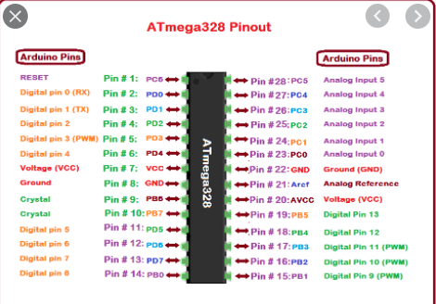

**Fig.2.1Mega328P board**

**Features:**

* Operating Voltage (logic level): 5 V
* Input Voltage (Recommended): 7-12 V
* Input Voltage (limits): 6-20 V
* Digital I/O Pins: 14 (of which 6 provide PWM Output)
* Analog Input Pins: 8
* DC Current per I/O Pin: 40 mA
* Flash Memory:16/32 KB (ATmega328) of which 2 KB used by bootloader
* SRAM: 1/2 KB (ATmega328)

**2.2.DC motor:**

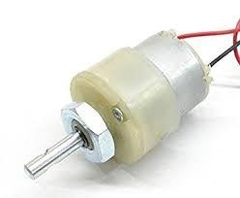

**Fig.2.2 DC motor**

**Specifications:**

* Torque: 2Kg-cm Rotational speed (No load): 10 rpm
* Operating voltage: 12V
* Current: 0.20A (no load), 1.25A (max)

**2.3 Servo Motor:**

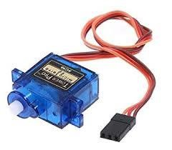

**Fig.2.3 Servo motor**

**Specifications:**

* Model no:SG90
* Operating voltage:4.8-7.2 volts
* Speed:0.17-0.14 seconds
* Torque:9.4-11 kg/cm
* Dimensions:41x20x43

**3.4 Motor driver (L293D):**

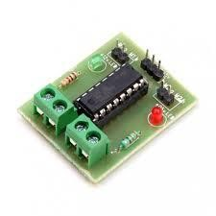

**Fig.2.4 Motor driver(L293D)**

**Specifications:**

* Supply voltage: 12V
* Peak Output Current: - 600mA
* VCC: 5V

**2.5 VMA309 MICROPHONE SOUND SENSOR MODULE:**

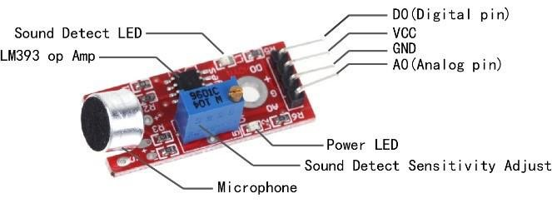

**Fig.2.5 VMA309 Microphone Sound Sensor Module**

**Specifications:**

* Voltage: 3.3-5V
* 2 indicator LEDs:1 power indicator + 1 comparator output indicator
* Frequency response:50 Hz - 20 KHz
* Impedance :2.2 kΩ
* Sensitivity :48-66 dB
* Operating temperature: -40 °C to +85 °C
* Dimensions :44 x 15 x 10 mm
* Weight: 4 g

**Abstract**

Dance as a form of performing arts includes a wide range of social behaviors, is an important means of communication , is a useful tool for psychological and physical therapy [, and is a natural means of emotional expression . Dance interweaves with other aspects of human life, such as communication and learning, belief systems, social relations and political dynamics, loving and fighting, and urbanization and change.

Robotic dance has attracted interest in the field of social robotics, and dancing robots can perform many kinds of robotic dances. In general, robotic dance has many social effects in society: 1) It is a kind of interactive social behavior, in particular human–robot interaction and animal activity , 2) it is a way to express the emotions or intentions of robots through nonverbal communication , 3) it is a treatment and therapy for a wide range of illnesses, including autism , developmental disorders , and attention deficit and cognitive disabilities , 4) it is a tool to enrich the need of growing spiritual cultures of society.

Dancing robots involve the exploration of the physical hardware structures, kinematics, dynamics, and the automation of a robot so it can dance. On the other hand, robotic dance is an expressive form of the art of dance performed by robots and is focused on how to make a robot dance as a human does, and how a robot creates and performs beautiful dance.

**Required hardware and software:**

**1.** Proteus 8

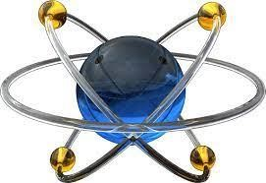

**Fig 3.6 Proteus Software logo**

Proteus is a simulation and design software tool developed by Lab center Electronics for Electrical and Electronic circuit design.

About Proteus, It is a software suite containing schematic, simulation as well as PCB designing. ISIS is the software used to draw schematics and simulate the circuits in real time. The simulation allows human access during run time, thus providing real time simulation. ARES is used for PCB designing. It has the feature of viewing output in 3D view of the designed PCB along with components. ISIS has wide range of components in its library. It has sources, signal generators, measurement and analysis tools like oscilloscope, voltmeter, ammeter etc. probes for real time monitoring of the parameters of the circuit, switches, displays, loads like motors and lamps, discrete components like resistors, capacitors, inductors, transformers, digital and analog Integrated circuits, semi-conductor switches, relays, microcontrollers, processors, sensors etc.

**2.Arudino IDE**

Ever since computers first entered the world, programming has always been seen as a rather esoteric process. With all its codes and symbols, programming has never been very beginner friendly. It usually takes years and years of studying to get even the most basic concepts down and it’s especially difficult to apply these codes to real work devices. Nowadays, however, knowing how to code and program is a very useful skill to have. Arudino IDE is a coding software that makes the programming world more accessible to beginners with its simple interface and community-driven system.

**Prominent Reference Books/ Papers:**

2020-21

P.C.C.O.E. E & TC Mini Project workbook

**Monthly Planning Sheet**

|  |  |  |  |  |
| --- | --- | --- | --- | --- |
| **Day**  **and**  **Date** | **Task** | **Discussion/Description** | **Action Point** | **Signature**  **of Int/**  **Guide** |
| Week1 | Formation of groups | We planned best team for this project. | Team forming and understanding their skills. |  |
| Week 2 | Topic Finalization in  consultation with guide | Gone through different research paper and project idea. | Tried to tackle real life problem |  |
| Week 3 | Synopsis submission | Rough about project | Working on feedback |  |
| Week 4 | Synopsis Presentation  (proposed work) | Explaining the projects to other dividing the role | To make project clear as much as possible |  |
| Week 5 | Power supply design and  its simulation | Testing different software and comments availability | Getting familiar with inputs and outputs. |  |

2020-21

P.C.C.O.E. E & TC Mini Project workbook

**Monthly Planning Sheet**

|  |  |  |  |  |
| --- | --- | --- | --- | --- |
| **Day**  **and**  **Date** | **Task** | **Discussion/Description** | **Action Point** | **Signature**  **of Int/**  **Guide** |
| Week6 | Component selection,  design of circuit and its  simulation | Depending money and power consumption | Simulated and tested |  |
| Week 7 | Midterm submission and  Log book checking | Showed all the work we have done | Worked on feedback |  |
| Week 8 | Component purchase and breadboard testing | Not done due to COVID | Simulated everything possible |  |
| Week 9 | PCB layout, fabrication of  PCB and its testing | Not done due to COVID | Simulated everything possible |  |
| Week 10 | Final demonstration of  product with enclosure | Simulated online | Working on feedback |  |

2020-21

P.C.C.O.E. E & TC Mini Project workbook

**Monthly Planning Sheet**

|  |  |  |  |  |
| --- | --- | --- | --- | --- |
| **Day**  **and**  **Date** | **Task** | **Discussion/Description** | **Action Point** | **Signature**  **of Int/**  **Guide** |
| Week11 | Report- rough draft | Shown to mentor | Working on feedback |  |
| Week 12 | Final report submission | Everything done is attached | done |  |
| Week 13 | Presentation and poster  making, Log book  Checking | Worked on drawbacks | done |  |
|  |  |  |  |  |
|  |  |  |  |  |

2020-21

P.C.C.O.E. E & TC Mini Project workbook