**PIMPRI CHINCHWAD EDUCATION TRUST’S**

**PIMPRI CHINCHWAD COLLEGE OF ENGINEERING**

**SECTOR NO. 26, PRADHIKARAN, NIGDI, PUNE- 411044.**



# PROJECT SYNOPSIS

**Cheerbotix 2.0**

**Project Group Members:**

|  |  |
| --- | --- |
| **Name of the Student** | **Div & Roll . No.** |
|  |  |
| 1. **Sakshee Kolhe** | **BEETC317** |
| 1. **Manthan Choudhury**   **3) Bhagya Venu Pillai** | **BEETC321**  **BEETC338** |

**Mr. A.B.Patil Mr. A.B.Patil Dr. M.T.Kolte**

**Project Guide Course Coordinator H.O.D (E&TC)**

**DEPARTMENT OF ELECTRONICS & TELECOMMUNICATION**

**B.E. (E&TC) 2021-2022**

**MAJOR -PROJECT SYNOPSIS**

**TITLE: Cheerbotix 2.0**

**ABSTRACT:**

In the beginning, robots were only used for a singular function or purpose that is as an aid to humans in industrial applications. Nowadays, the robot is not only assigned to do work but also for entertainment purposes. As a part of it, dancing robots can be created. Dancing robots grab the attention of people with their ability to dance on the floor especially on their own. Their smooth movement while dancing, captures everyone's heart. This may increase the interest of people in the robotic world.

Cheerleaders are synchronously dancing, moving freely and performing dance on the music. Dancing robots are grabbing the attention of people with their ability to dance and aesthetics. These are completely autonomous systems.

**INTRODUCTION:**

In the beginning, robots were only used for a singular function or purpose that is as an aid to humans in industrial applications. Nowadays, the robot is not only assigned to do work but also for entertainment purposes. As a part of it, dancing robots can be created. Dancing robots grab the attention of people with their ability to dance on the floor especially on their own feet. Their smooth movement while dancing, captures everyone's heart. This may increase the interest of people in the robotic world.

**LITERATURE REVIEW:**

|  |  |  |  |  |
| --- | --- | --- | --- | --- |
| **Sr. No.** | **Paper Title** | **Publication details** | **Methodology** | **Remarks** |
| 1 | Arduinodroid Controlled Car | May 2016  AmanpreetKaur,  Abhishek Mani  Tripathi,  GopalKushwaha,  InzmamulHaque  International  Journal Of  Computer Science | Controlling  Arduino using  Bluetooth module | Bluetooth module need to be used to  control Arduino microcontr oller |
| 2 | Robotic Dance in Social Robotics—A Taxonomy | June 2015  HuaPeng,Changle  Zhou, Huosheng  Hu, Fei Chao, and  Jing Li  IEEE Trans. IEEE  TRANSACTIONS  ON  HUMANMACHIN  E SYSTEMS | Interacting  reinforcement  learning for synchronization in robots | Considerat ion of  music rhythm,  beats and tempo of  music while choreograp hing dance performan ce. |
| 3 | An Efficient Method for Composing Whole Body  Motions of a Humanoid  Robot | 2007  Shinichiro  NAKAOKA†  Atsushi  NAKAZAWA‡  Katsushi IKEUCHI  Institute of  Industrial Science,  The University of  Tokyo | Humanoid robot  performances | Concatenat ion of  small dance performan  ce es to  give large  variation  in final dance. |

**SUMMARY OF LITERATURE REVIEW:**

During literature review, we came across various journals, conference papers, articles and Newsletters. The details of literature survey are given below: Going through different articles and journal papers intrigued the team to analyse how we can build human interactive robot. In Arduino Controlled Car Bluetooth module were used to control Arduino microcontroller and hence car was controlled by using Arduino and Bluetooth. In Robotic Dance in Social Robotics—A Taxonomy research paper, researchers have divided robotic dance into several categories and explained each of them very well. Categories are as follows:1. cooperative human robot dance 2. Imitation of human dance 3. Synchronization of music and 4.Robotic choreography. In that we have studied synchronization and choreography part but given paper is not sufficient for physical structure, hardware of dancing robot and a robot to synchronize its dance to various music types harmoniously as a human does. In An Efficient Method for Composing Whole Body Motions of a Humanoid Robot we investigated an approach of Concatenating small dance performances to give large variation in final dance. In The design of face recognition and tracking for human-robot interaction paper we studied about how Python 2.7 (with the OpenCV library) by using Cascade Classification and LBPH Face Recognizer method can be used and which has a good accuracy rate (92.73%). Also, the implementation of facial tracking to control 12 DoF of Social Robot SyPEHULbased on Arduino microcontroller. For detecting human hand we can use various different tools and algorithms. After going through various research papers we have decided to use Python and OpenCV library to detect human hand in dynamic and run time environment.

**OBJECTIVE:** The main objective of this project is to design a Dancing Robot. This dancing robot can be characterized as a robot where wheels will be used for its leg's movement. This dancing robot will dance according to the programmed movement along with the chosen music within a specific time frame.

**CO, PO and PSO MAPPED:**

**BLOCK DIAGRAM:**

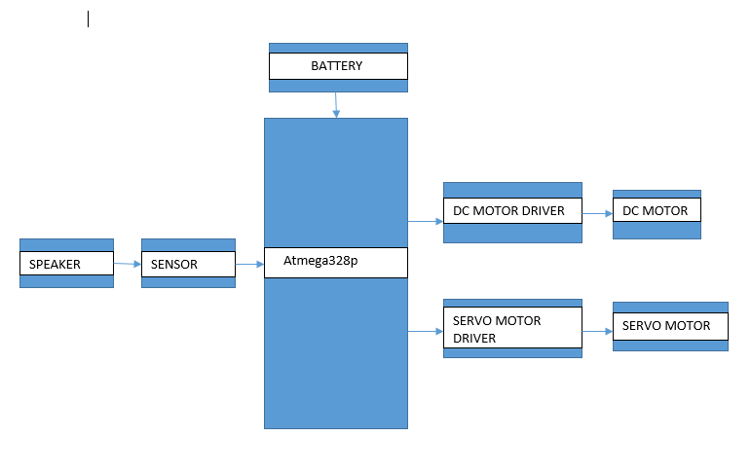

**Elements of block diagram:**

* Atmega 328
* Sound sensor
* Cheerleader
* DC motor
* Servo motor
* Motor drivers

**BLOCK DIAGRAM EXPLANATION:**

**Sound sensor:** Sound Sensor can detect the sound intensity of the environment. The main component of the module is a simple microphone, which is based on the LM386 amplifier and an electret microphone. The output of sound sensor is divided into nine levels and each level is assigned with one dance pattern.

**Cheerleader:** When a dance program stored in a microcontroller is being executed cheerleaders will dance according to the stored program. We have programmed nine dance patterns for each sound level of the music. According to the sound levels it will select one dance pattern out of nine. Each dance pattern has different choreography for which we are rotating some motors with some delays. So, it seems like dancing steps.

**TECHNICAL DETAILS:**

**Microcontroller: ATmega328P**

**Fig Atmega328p board Features:**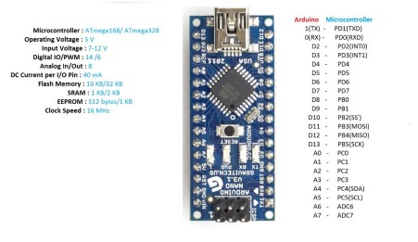

* Operating Voltage (logic level): 5 V
* Input Voltage (Recommended): 7-12 V
* Input Voltage (limits): 6-20 V
* Digital I/O Pins: 14 (of which 6 provide PWM Output)
* Analog Input Pins: 8
* DC Current per I/O Pin: 40 mA
* Flash Memory:16/32 KB (ATmega328) of which 2 KB used by
* bootloader • SRAM: 1/2 KB (ATmega328)

**DC Motor:**

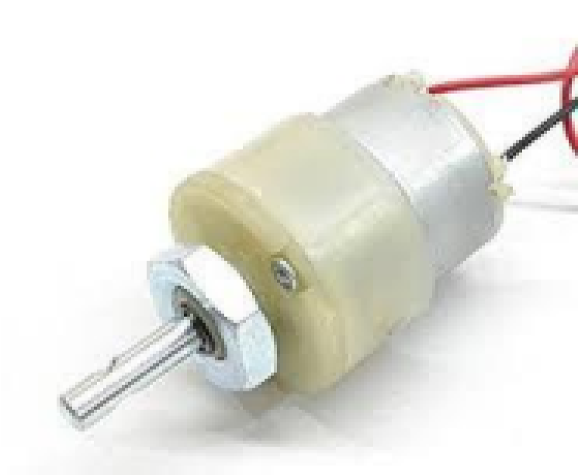

* Torque: 2Kg-cm Rotational speed (No load): 10 rpm
* Operating voltage: 12V • Current: 0.20A (no load), 1.25A (max)

**Servo motor :**

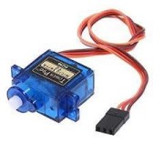

**Specifications:**

* Model no:SG90
* Operating voltage:4.8-7.2 volts
* Speed:0.17-0.14 seconds
* Torque:9.4-11 kg/cm
* Dimensions:41x20x43

**Motor driver (L293D):**

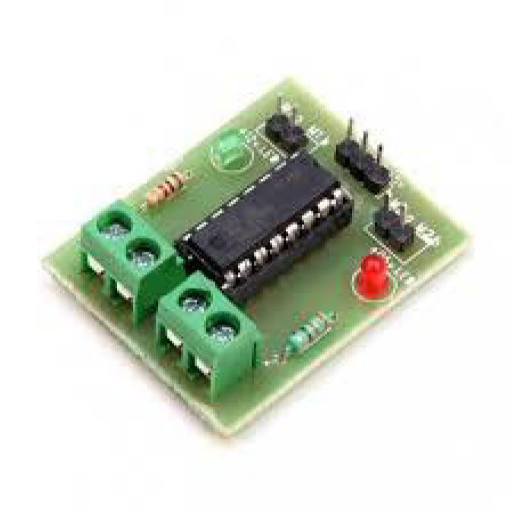

Specifications:

* Supply voltage: 12V
* Peak Output Current: - 600mA
* VCC: 5V

**VMA309 MICROPHONE SOUND SENSOR MODULE:**

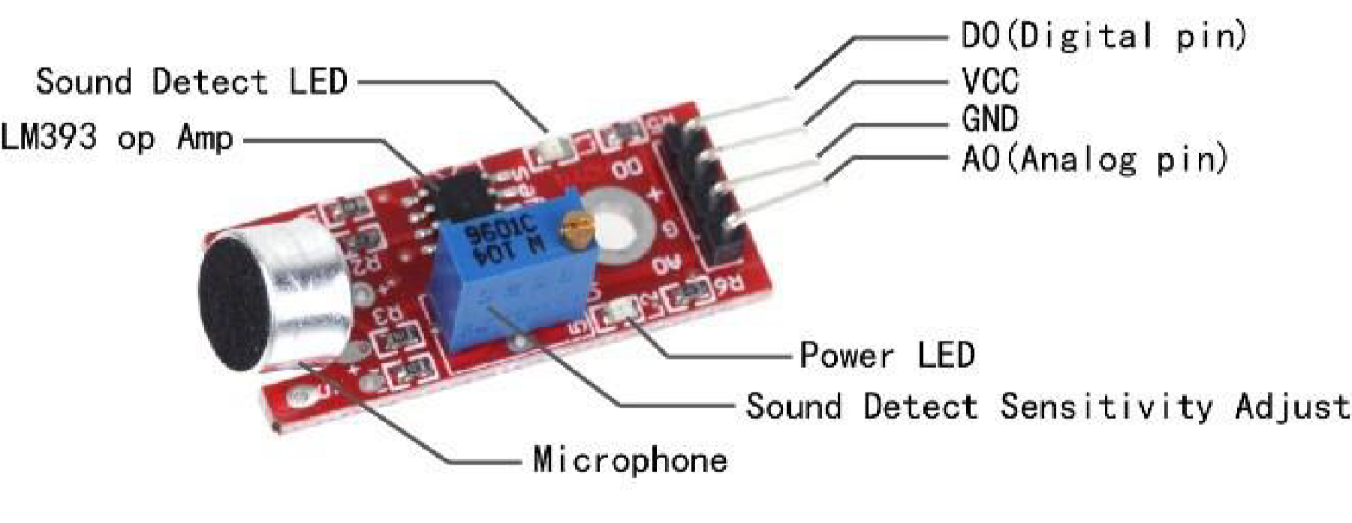

**Specifications:**

* Voltage: 3.3-5V
* 2 indicator LEDs:1 power indicator + 1 comparator output indicator
* Frequency response:50 Hz - 20 KHz
* Impedance :2.2 kΩ
* Sensitivity :48-66 dB
* Operating temperature: -40 °C to +85 °C
* Dimensions :44 x 15 x 10 mm
* Weight: 4 g

**MECANUM WHEEL:**

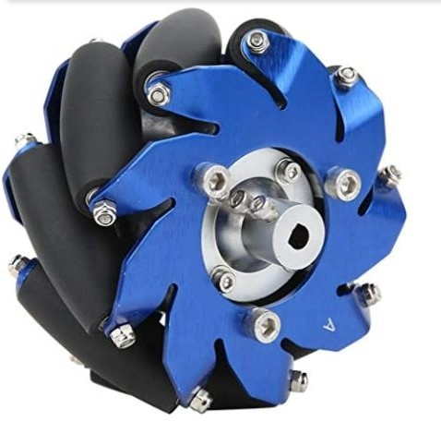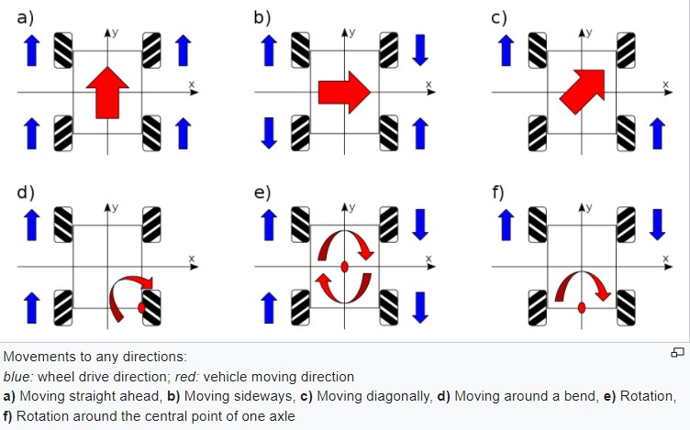

**Working of Mecanum wheel**

The Mecanum wheel is a[n omnidirectional](https://en.wiktionary.org/wiki/omnidirectional) [wheel](https://en.wikipedia.org/wiki/Wheel) design for a land-based [vehicle](https://en.wikipedia.org/wiki/Vehicle) to move in any direction. It is sometimes called the Swedish wheel or Ilon wheel. The Mecanum wheel is based on a [tireless](https://en.wikipedia.org/wiki/Tire) wheel, with a series of [rubberized](https://en.wikipedia.org/wiki/Rubber) external [rollers](https://en.wikipedia.org/wiki/Roller_(disambiguation)) obliquely attached to the whole circumference of its [rim.](https://en.wikipedia.org/wiki/Rim_(wheel)) These rollers typically each have an [axis of rotation](https://en.wikipedia.org/wiki/Axis_of_rotation) at 45° to the

wheel [plane](https://en.wikipedia.org/wiki/Plane_(geometry)) and at 45° to the [axle](https://en.wikipedia.org/wiki/Axle) line.[[3]](https://en.wikipedia.org/wiki/Mecanum_wheel#cite_note-omni-3) Each Mecanum wheel is an independent non-steering [drive](https://en.wikipedia.org/wiki/Drive_wheel) [wheel](https://en.wikipedia.org/wiki/Drive_wheel) with its own [powertrain,](https://en.wikipedia.org/wiki/Powertrain) and when spinning generates a [propelling force](https://en.wikipedia.org/wiki/Ground_propulsion) perpendicular to the roller axle, which can be [vectored](https://en.wikipedia.org/wiki/Vector_(mathematics_and_physics)) into a longitudinal and a transverse component in relation to the vehicle.

**INNOVATIVENESS:**

In this project we are developing dancing robots which will be grabbing attention of kids and adults by their body movements according to the song and lighting on their body. It is creative way to bring in attention of kids to dance with them with innovation and joy.

**USEFULLNESS:**

Entertainment: The main application of our project is for entertainment as our cheerleaders are dancing. Their smooth movement while dancing, captures everyone's heart.It can be used in schools for motivating kids to develop their motor skills. It can be used in homes that would help the parents to engage their kids in entertainment with exercise. It can be also used in smart malls for costumer attraction. It can be used in television shows too.

**EXPECTED CONCLUSION:**

Cheerleaders are synchronously dancing, moving freely and performing dance on the music. Dancing robots are grabbing the attention of people with their ability to dance and aesthetics. These are completely autonomous systems.

**Future applications:**

* Traffic control: Whenever there is huge traffic at signal by proving sensors to system, they could sense the density of the traffic and the lane where traffic is more the robot will turn to that lane and the traffic of that lane will be released first.
* Household purpose: By little modification in the system robots can be used for serving, cleaning etc. There is hotel in china wherein waiters are not human beings but the robots.­­­­­­­­­
* We can use this bot for increasing the awareness need of exercise in our day to day life by adding additional AI features. It motivates the child to dance with it and enjoy their time of playing in a enthusiastic way.

**REFERENCES** *:*

1. Hua Peng, Changle Zhou, Huosheng Hu, Fei Chao, and Jing Li,” Robotic Dance in Social

Robotics—A Taxonomy” IEEE Trans. IEEE TRANSACTIONS ON HUMAN-MACHINE SYSTEMS, VOL. 45, NO. 3, JUNE 2015

1. D. O’Halloran, A. Wolf, Member, IEEE, H. Choset, Member, IEEE,” Design of a

High-Impact Survivable Robot” Proceeding of the 2004 IEEE, Internatonal Conference on Robotics & Automation, New Orleans, LA. April 2004

* Books:

Beginning C for Arduino Second Edition-Jack Purdum,Ph.D

* Related Sites:

https://youtu.be/82rL4xjFC