MKXKLMXShadow sensors are widely used to detect the movement of a person in a confined area. Many circuits published earlier have a serious drawback that only one light dependent resistor (LDR) is used for shadow detection.
Needless to say, this is not a perfect solution! Shadow sensors are widely used to detect the movement of a person in a confined area. Many circuits published earlier have a serious drawback that only one light dependent resistor (LDR) is used for shadow detection.
Needless to say, this is not a perfect solution! Shadow sensors are widely used to detect the movement of a person in a confined area. Many circuits published earlier have a serious drawback that only one light dependent resistor (LDR) is used for shadow detection.
Needless to say, this is not a perfect solution! 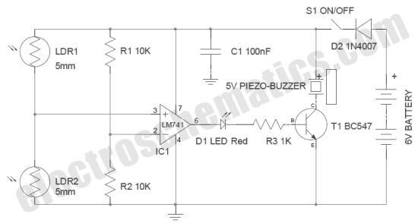


PimpriChinchwad College of Engineering, Pune
Department Of Electronics and Telecommunication

Project Title:CheerBoxite
A.Y.2020-2021
Group ID: C1-05

Manthan Choudhary
TEETC321
Sakshee Kolhe
TEETC317
Bhagya Venu Pillai:
TEETC338

Prof. Prakash Sontake and Prof. Sangita Patil

Guided By:

ABSTRACT

Nowadays, there is increasing need for automation in industries where we need mobile robot to move and it became a major challenge in the field of study. Other project motive is to participate in various robotics competitions

This dancing robot will dance according to the programmed movement along with the chosen music within a specific time frame. This robot will design in hardware and going to operate by interfacing the software to control all robot's movements due to the dancing steps that have been programmed. To fulfill this need, Arduino microcontroller is to be used to apply the software programming on the circuit.

INTRODUCTION
- In beginning, robots were only used for a singular function or purpose that is as an aid to human in industrial applications. Nowadays, the robot is not only assigned to do work but also for entertainment purpose. As a part of it, dancing robots can be created. Dancing robots grab the attention of people with their ability to dance on the floor especially on their own feet. Their smooth movement while dancing captures attention.

OBJECTIVES
SPECIFICATIONS
- Weight:
- Height: 48 cm
- Width: 18 cm
- Area covered: 38 cm
- Forward movement: 10 cm
- Backward movement: 10 cm
- Atmega 328
- Battery
- Motors
- Wheels
- Sound sensors

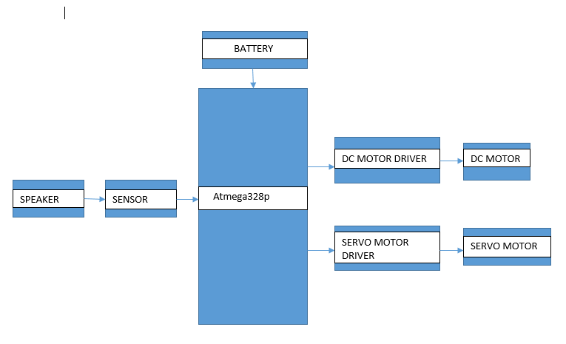
ADVANTAGES &
APPLICATIONS

CONCLUSION
R
- The main objective of this project is to design a Dancing Robot. This dancing robot can be characterized as mobile robot where wheels will be used for its leg's movement. This dancing robot will dance according to the programmed movement along with the chosen music within a specific time frame. This robot will design in hardware and going to operate by interfacing the software to control all robot's movements due to the dancing steps that have been programmed. To fulfill this need, Arduino microcontroller is to be used to apply the software programming on the circuit.

- ADVANTAGES: Cheerboxite can be used for enhancing the motor skills in kids mind.
- It can be used to increase creativity in young minds.
- We can use this bot for increasing the awareness need of exercise in our day to day life by adding additional AI features.
- It motivates the child to dance with it and enjoy their time of playing in a enthusiastic way. It can be used in schools for motivating kids to develop their motor skills.
- It can be used in homes that would help the parents to engage their kids in entertainment with exercise.
- It can be also used in smart malls for costumer attraction.
- It can be used in television shows too.

- Cheerleader should move synchronously.
- Should move freely and perform dance on the music.
- It should grab the attention of people and kids with their aesthetics and dancing ability. This is autonomous system.

REFERENCE
Hua Peng, Changle Zhou, Huosheng Hu, Fei Chao, and Jing Li,” Robotic Dance in Social Robotics—A Taxonomy” IEEE Trans. IEEE TRANSACTIONS ON HUMAN-MACHINE SYSTEMS, VOL. 45, NO. 3, JUNE 2015
[2] D. O’Halloran, A. Wolf, Member, IEEE, H. Choset, Member, IEEE,” Design of a High-Impact Survivable Robot” Proceeding of the 2004 IEEE, Internatonal Conference on Robotics & Automation, New Orleans, LA. April 2004 • Books: Beginning C for Arduino Second Edition-Jack Purdum,Ph.D • Related Sirr

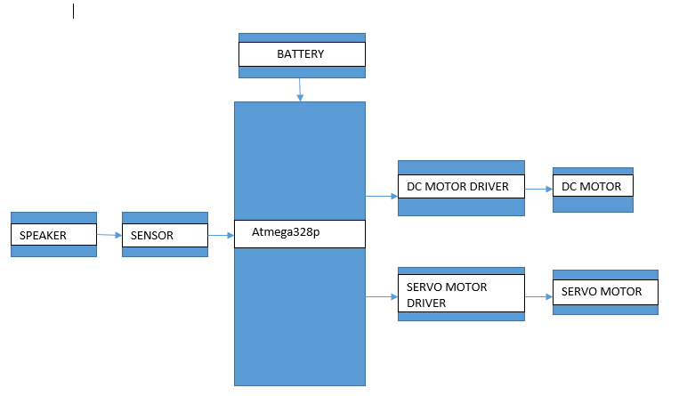
BLOCK DIAGRAM
CIRCUIT DIAGRAM
