**Assignment Name:- 1.2**

**Assignment Title:-**

**Name:- KAWALE ROSHANI VASANT.**

**Roll No:-48**

--------------------------------------------------------------------

* **for loop using range function**x=range(5)  
  **for** i **in** x:  
   print(i)
* **Output:**

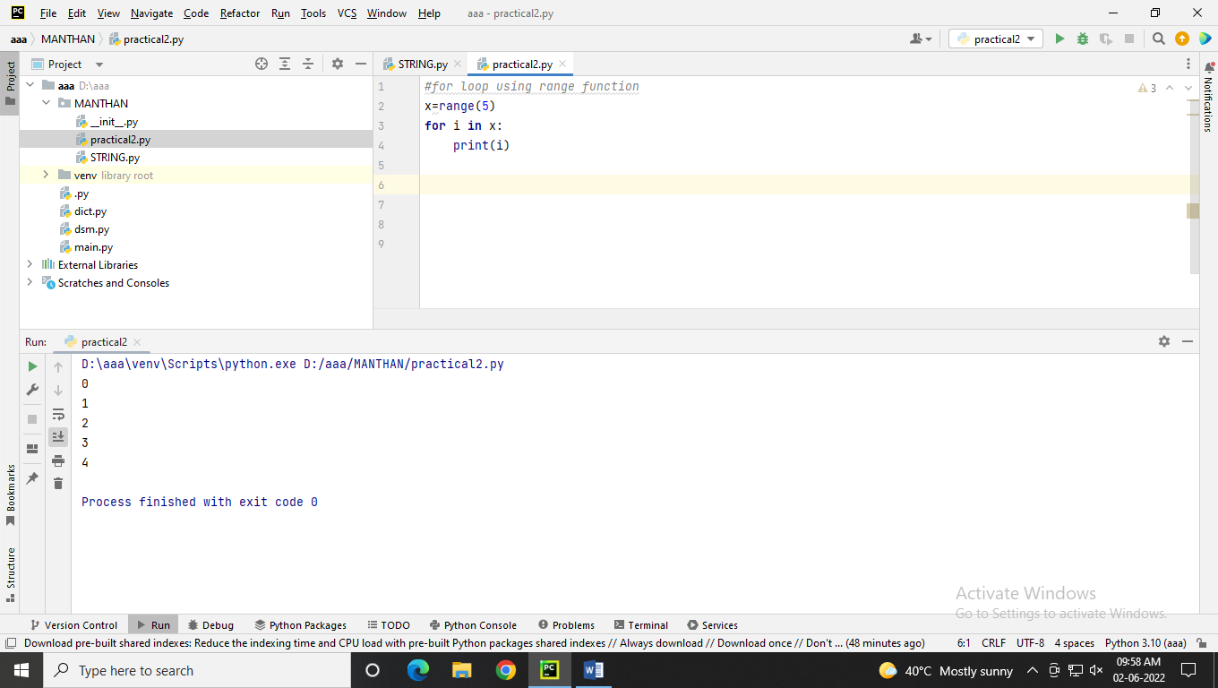

* **for loop using list**studentName=[**"Roshni"**,**"Dipti"**,**"Leena"**]  
  **for** i **in** studentName:  
   print(i)
* **Output:**

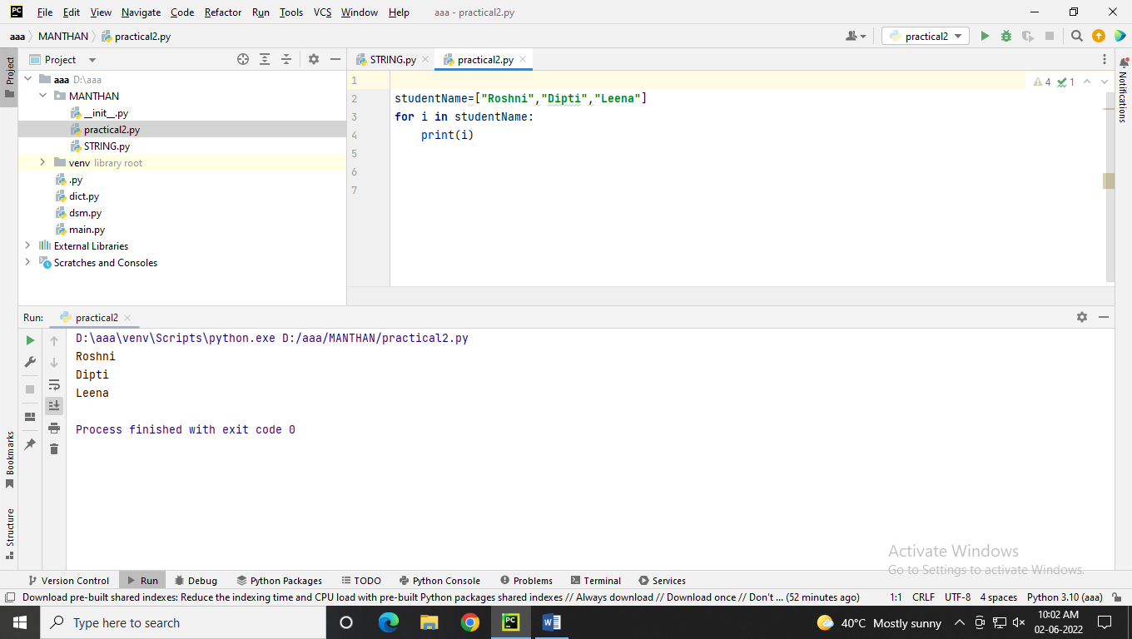

* **for loop using tuple**

fruits=(**"Mango"**,**"Apple"**,**"Banana"**)  
**for** i **in** fruits:  
 print(i)

* **Output :**

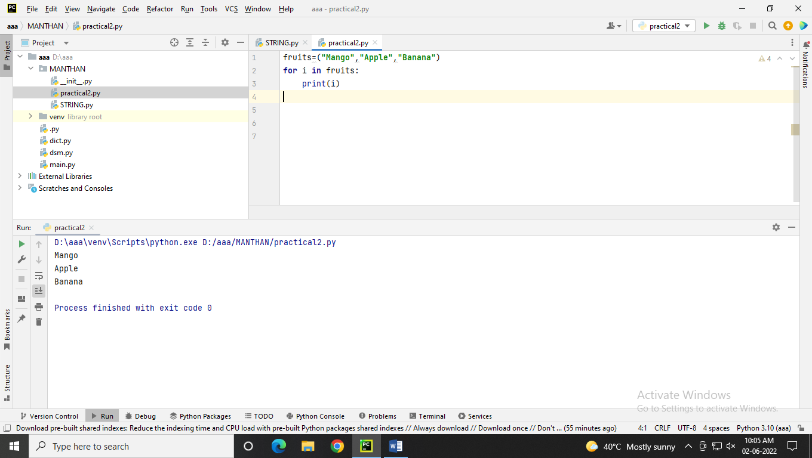

* **for loop using string function**msg = **"Hello World"  
  for** character **in** msg:  
   print(character, end=**' '**)
* **Output :**

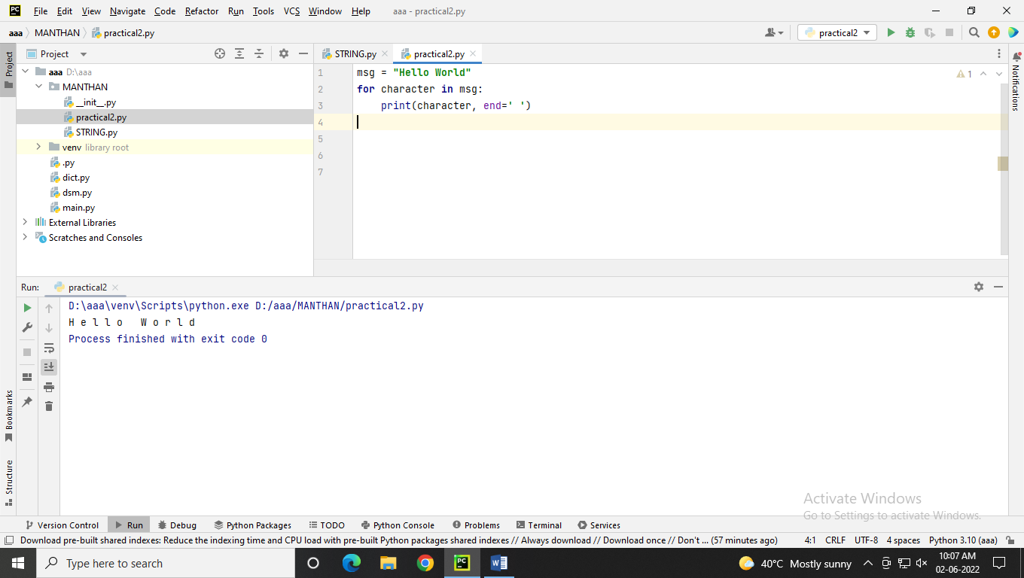

* **for loop using dictionary**studentData = {  
   **"std_Name"** : **"Kamini"**,  
   **"Roll_No"** : 10 ,  
   **"Gender"** : **"female"** }  
  **for** i **in** studentData:  
   print(i)

OUTPUT:

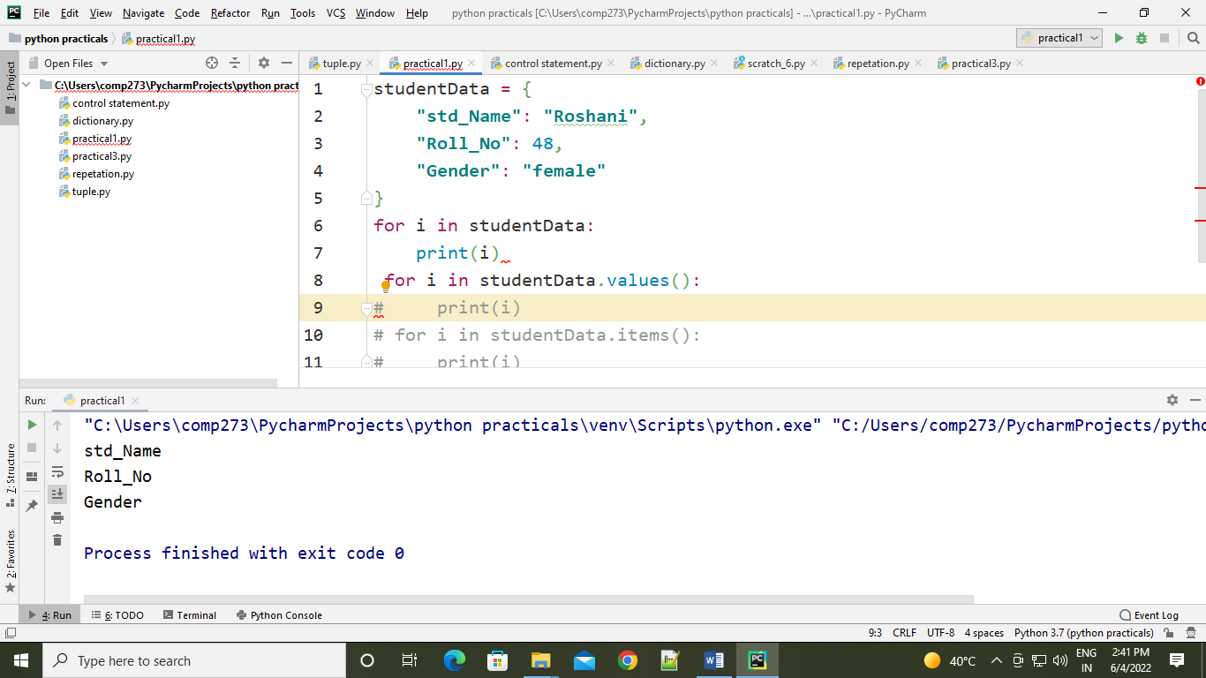

**for** i **in** studentData.values():  
 print(i)

OUTPUT:

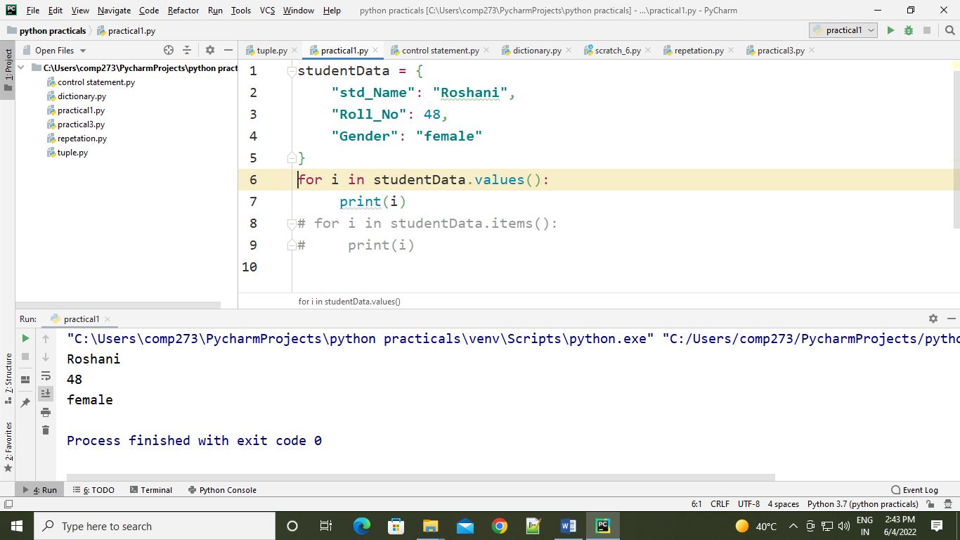

**for** i **in** studentData.items():  
 print(i)

OUTPUT:

