**A**

Project Report

On

**Alarm**

Developed At

Saurashtra University

Department of Computer Science

As a Partial Fulfill of MSc. IT & CA Sem-2

Academic Year 2017-2018

Submitted To

Saurastra University

Department of Computer Science



Under the Guidance Of

Pro. Vaishali Desai

Developed By

Manthankumar Satani

Index

|  |  |  |
| --- | --- | --- |
| **No.** | **Topic Name** | **Page No.** |
| 1. | Project Profile | 1 |
| 2. | Project Definition | 3 |
| 3. | Abstract | 4 |
| 4. | Preface | 5 |
| 5. | Candidate Declaration | 6 |
| 6. | Acknowledgement | 7 |
| 7. | Introduction | 8 |
| 8. | Feasibility Study | 9 |
| 9. | Database Design | 10 |
| 10. | ER Diagram | 12 |
| 11. | Data Dictionary | 13 |
| 12. | Screenshots | 14 |
| 13. | Testing | 18 |
| 14. | Limitations | 20 |
| 15. | Conclusion | 21 |
| 16. | Bibliography | 22 |

Project Definition

* **Project Title:-**

*Alarm*

* **Frontend Tool:-**

*Android*

* **Backend Tool:-**

*SQLite*

* **Project Guide :-**

**Prof. Vaishali Desai**

* **Developed By:-**

**Manthankumar Satani**

* **Submitted to:-**

*Saurashtra University Department of Computer Science Rajkot*

* **Academic Year:-**

*2017-2018*

* **Academic Stream:-**

*2nd Semester of MSc. IT & CA (Master of Science in Information Technology and Computer Application)*

Abstract

***ALARM*** providing a great functionality of alarm with simple math problem so you don’t get late for anything.

In this Project, the main purpose of the application is to set alarm for the user and must wake up them.

In this Application, main one types of users would be there.

1. User

Initially User can use the application for personal use like user can set or delete the Alarm or recreate them.

Preface

* This Application is used to set alarm for the user.
* This Application is used to set, delete or manage the alarms by the user.
* User can see the list of Alarm that already added.
* User can select alarm to active or deselect for inactive alarm.
* This app is developed in Eclipse Android at front end and uses the SQLite as backend.

Candidate Declaration

I declare that 2nd semester report entitled “***ALARM***” is my work conducted under the Master guide, Pro. Vaishali Desai.

I further declare that to the best of my knowledge the report for MSc. IT&CA (SEM-2) semester does not contain part of the work which has been submitted for the award of MSc. IT&CA (SEM-2). Degree either in this or any other university without proper citation.

**Manthankumar Satani**

Acknowledgement

I am student of MSc IT&CA 2nd Sem. in Saurashtra University Department of Computer Science - Rajkot. I thank to the collage for giving me an opportunity to make a project.

And also thanks to the entire person who has landed their support in shaping of this application.

I am very thankful to all those who have helped me in preparing and guiding this Project on “ALARM”. I am feeling a great happiness to present this Documentation.

In particular, I would like to thank our Project guide prof. Vaishali Desai who had spent her precious time for my project and provides me such nice and encouraging environment. It would be impossible for me to complete this project without her important instruction and supervision.

# I would like to express my deepest gratitude to all faculties and our head of the department Mr. C. K. Kumbharana who showed trust in both of us with such a challenging project. So I heartily thanks to him for spending his valuable time and providing better guidance for achieving our goal.

**[Manthankumar Satani]**

Introduction

* In today’s generation we have working wary fast so these Application is provide the facility to set reminder or alarm and prevent not to be late.
* We are a growing, profitable, technically advanced, well-managed for ALARM application. We offer an extremely practical and highly beneficial technology. We have the answer.
* We have deliberately chosen to provide the most effective and responsive service organization. And we deliberately position our company as the most willing and the most able to take total responsibility for the success of your bar code investment.
* We have still a limited knowledge and understanding of the wide number of technologies used by the user, so we hope that it is mostly accurate, complete and that it will help you.
* The Purpose of this application is faster response to queries. Therefore it can show the alarm with a different day and time which will generate the same result set efficiently in less time. The new application of ALARM CLOCK is faster because it will do less work when extracting the result tulles form the database
* Technology Literature:

....A good software is much more than a few lines of code....

Feasibility Study

Measure of how beneficial or practical the development of an information system will be to an organization.

**TYPES OF FEASIBILITY STUDY:-**

* *Technical Feasibility*
* *Economical Feasibility*
* *Operational Feasibility*
* Schedule Feasibility

***Technical Feasibility:***

Technical feasibility is normally under take to find out whether the work can be done with the present equipment, current production, existing software technology and available personal.

***Economical Feasibility:***

Economic feasibility analysis normally determines the cost and expected saving of each alternative that may be have decided.

***Operational Feasibility:***

Will the system be used if it is developed and implemented?

Will there be resistance from users?

***Schedule Feasibility:***

How reasonable is the project timetable?

Database Design

DFD:

A Data Flow Diagram (DFD) is a graphical representation of the "Flow" of data through an information system. DFDs can also be used for the visualization of data processing (structured design).

On a DFD, data items flow from an external data source or an internal data store to an internal data store or an external data sink, via an internal process.

# A DFD provides no information about the timing or ordering of processes, or about whether processes will operate in sequence or in parallel. It is therefore quite different from a flowchart, which shows the flow of control through an algorithm, allowing a reader to determine what operations will be performed, in what order, and under what circumstances, but not what kinds of data will be input to and output from the system, nor where the data will come from and go to, nor where the data will be stored (all of which are shown on a DFD).

# Data Flow Diagrams (DFDs) are one of the three essential perspectives of the Structured-Systems Analysis and Design Method (SSADM). The sponsor of a project and the end users will need to be briefed and consulted throughout all stages of a system's evolution. With a data-flow diagram, users are able to visualize how the system will operate, what the system will accomplish, and how the system will be implemented.

# The old system's dataflow diagrams can be drawn up and compared with the new system's Data Flow Diagrams to draw comparisons to implement a more efficient system. How any system is developed can be determined through a Data Flow Diagram.

* **Level 0 SYSTEM INPUT/OUTPUT LEVEL:-**

# A level-0 DFD describes the system-wide boundaries, dealing inputs to and outputs from the system and major processes. This diagram is similar to the combined user-level context diagram.

* **Level 1 SUBSYSTEM LEVEL DATA FLOW:-**

# A level-1 DFD describes the next level of details within the system, detailing the data flows between subsystems, which make up the whole.

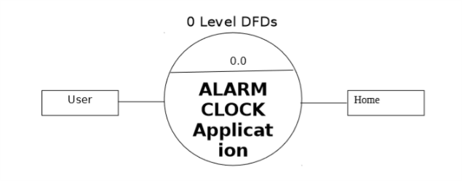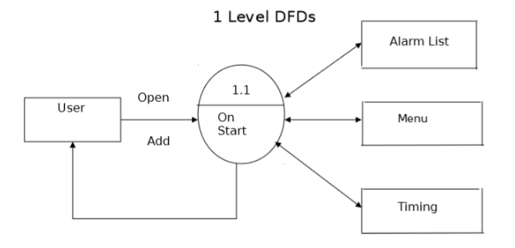

ER Diagram

Entity Relationship Model (ERM) is a technique used to analyze and model the data in organizations using an Entity Relationship (ER) Diagram.

In Software Engineering, an Entity-Relationship Model (ERM) is an abstract and conceptual representation of data. Entity-relationship Modeling is a database modeling method, used to produce a type of conceptual schema or semantic data model of a system, often a relational database, and its requirements in a top-down fashion. Diagrams created by this process are called Entity-Relationship Diagrams, ER Diagrams, or ERDs

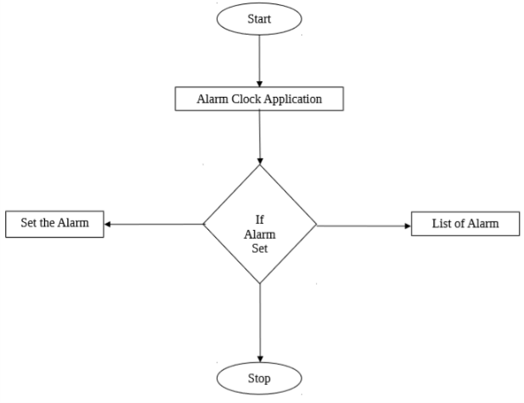

# Data Dictionary

# **Database Name: - DB**

# **Table Name: - alarm**

|  |  |  |  |
| --- | --- | --- | --- |
| **alarm** | | | |
| 1 | _id | String | Alarm Number |
| 2 | alarm_active | String | Alarm is active or not |
| 3 | alarm_time | String | When alarm will ring (time) |
| 4 | alarm_days | String | Which day alarm ring (weekdays) |
| 5 | alarm_difficulty | String | Equation difficulty (easy/medium/hard |
| 6 | alarm_tone | String | Alarm ring tone |
| 7 | alarm_vibrate | String | Alarm will vibrate or not |
| 8 | alarm_name | String | Name of alarm |

Screenshots

Home

When there is no alarm set

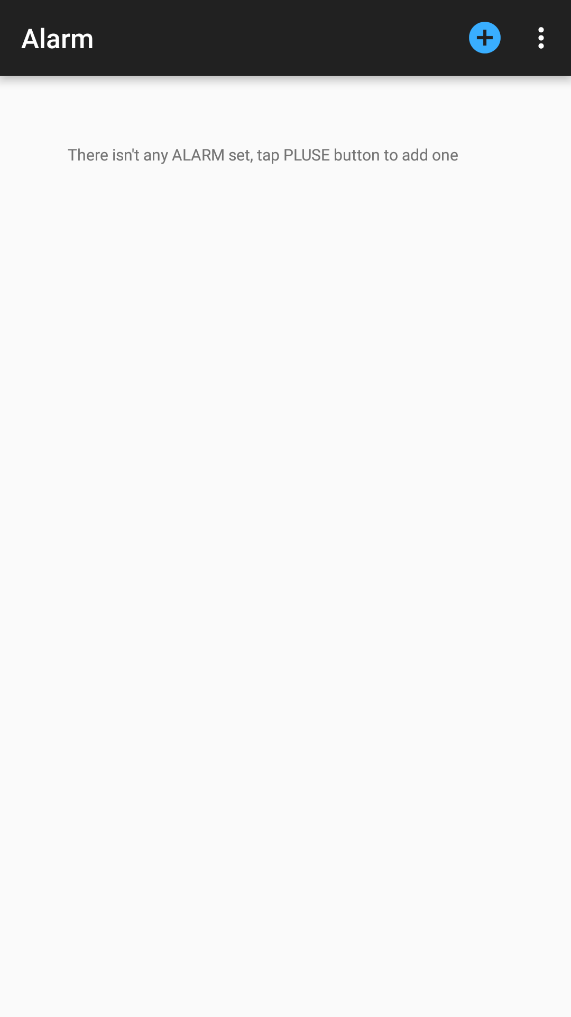

When there is alarms

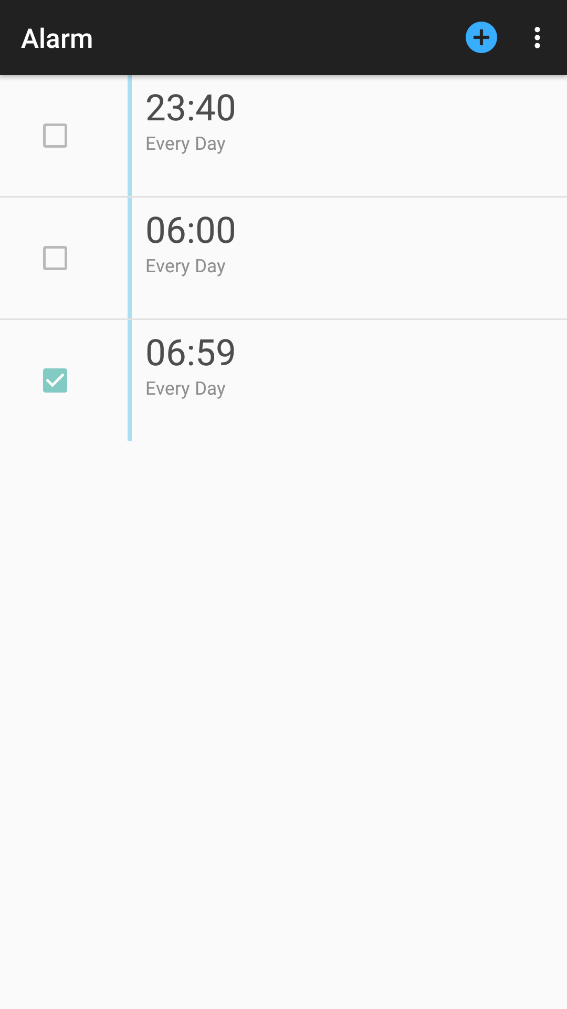

Set or edit alarm

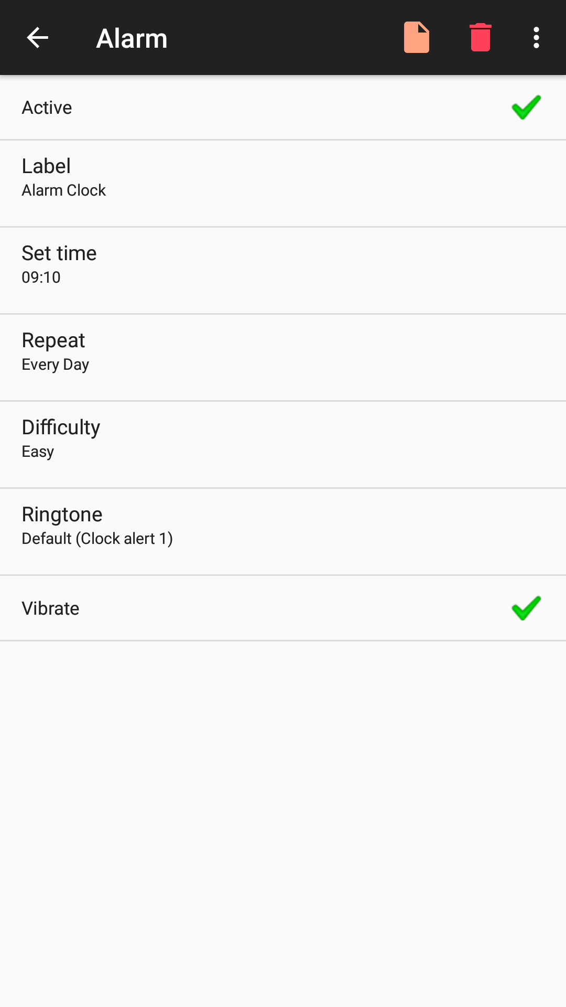

Alarm ringing

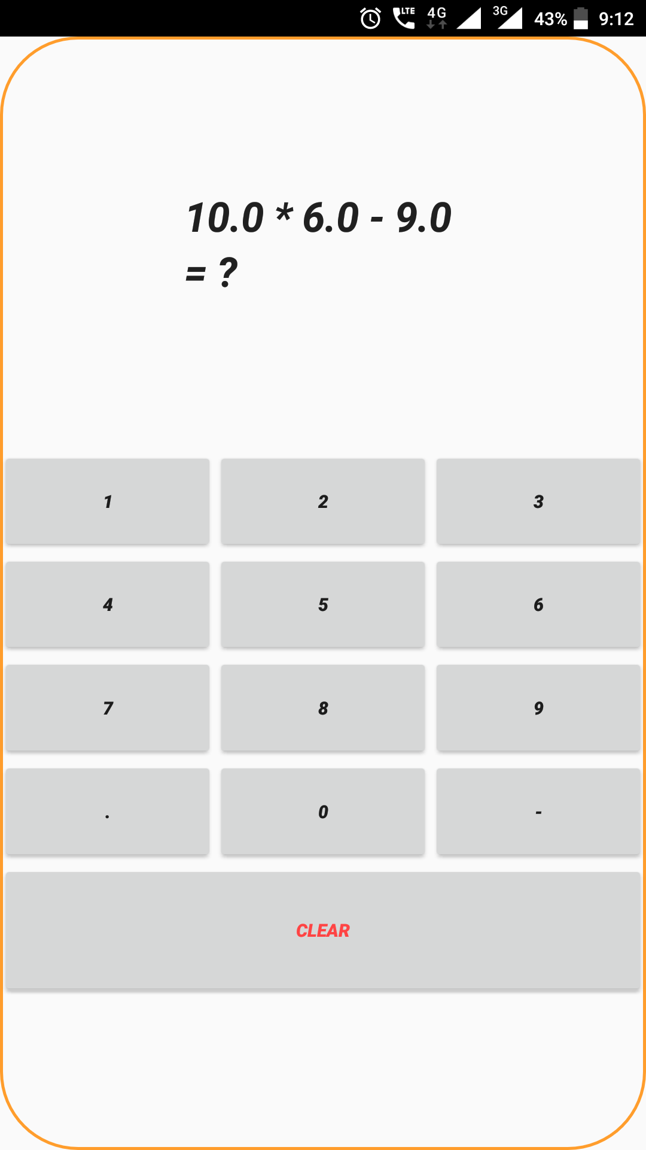

Testing

There are different Models of testing. On the basis of testing methods there are two types of testing:

* White-box testing
* Black-box testing

Black-box tests are used to demonstrate that software functions are operational, that input is properly accepted and output is correctly produced, and that integrity of external information is maintained.

White-box tests are used to examine the procedural details. It checks the logical paths by test case. It can also checks the conditions, loops used in the software coding. It checks that loops are working correctly on defined boundary value.

* 1. **White-box testing:**

White-box testing sometimes called glass-box testing, is a test case design method that users the control structure of the procedural design to drive the test case.

Always we are thinking that there is no necessary to execute or checks the loops and conditions and so large number of errors is uncovered. In our coding we test that all the loops works truly in each module. The one technique of white-box testing is basis path testing. It contains two parts, one is flow graph notation and the second is cyclometer complexity. In flow graph notation we are checking logical control of flow. By using cyclometer complexity we find complexity of our project structure.

* 1. **Black-box testing:**

Black-box testing focuses on the functional requirements of the software. That is black-box testing enables the software engineer to drive sets of input conditions that will fully exercise all functional.

Requirements for the program, Black-box testing is not an alternative to white-box testing techniques. Rather, it is a complementary approach that is likely to uncover a different class of errors than white-box methods.

Limitations

# The first limitation is user cannot customize color or design.

# User must solve math problem.

# User cannot give the feedback.

Conclusion

# ALARM is a useful Application for all kind of peoples for do not be late or forget any time.

# It will bring new dimensions on reminding or getup.

# It’s very easy to use and set alarm through our Application.

# It also gives information about facility which is given by our Application.

Bibliography

**Web Site**

* [https://developer.**android**.com/**studio**/index.html](https://developer.android.com/studio/index.html)
* <http://stackoverflow.com/>
* [https://github.com](https://github.com/)