# Module 12: Building Database Apps with PostgreSQL & Python

Assignment Submission

Name: ________________________

Roll/ID: ________________________

Date: ________________________

## Practical 1: Connect to PostgreSQL

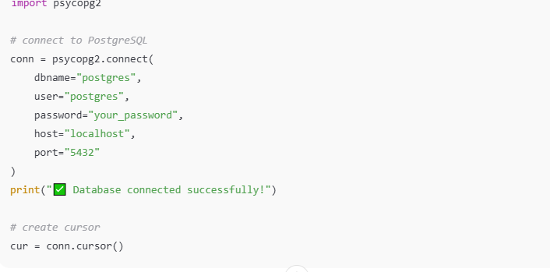

## Practical 2: Create Table

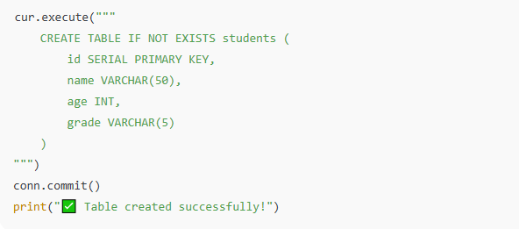

## Practical 3: Insert Data

Paste screenshot here...  
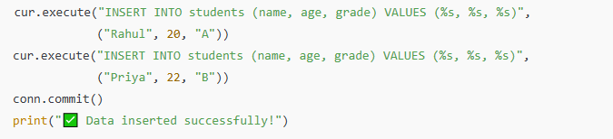

## Practical 4: Deleting content in the table

Paste screenshot here...  
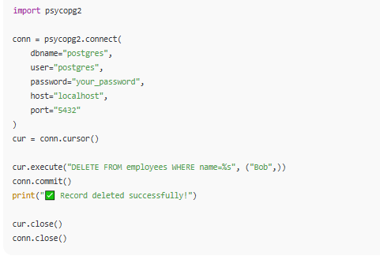

## Practical 5: Retrieving (Extracting) Data from Database

Paste screenshot here...  
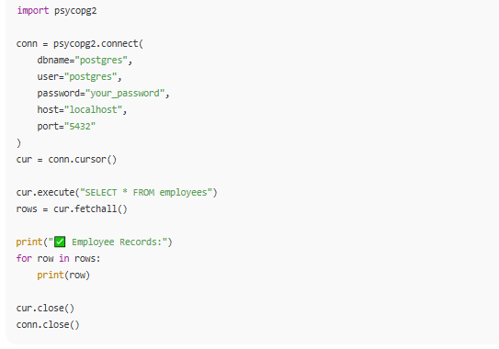

## Practical 6: Delete Data

Paste screenshot here...  
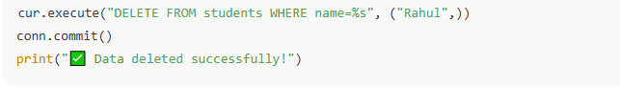

## Practical 7: Creating Table using Python

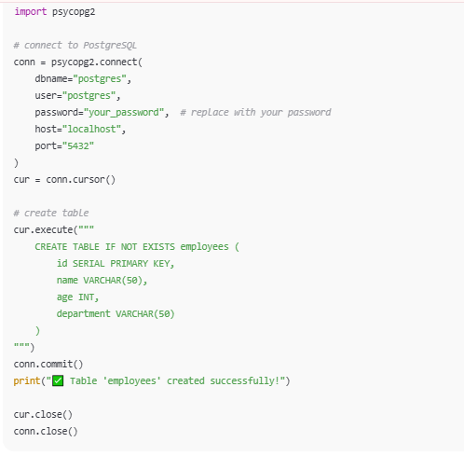

## Practical 8: Deleting content in table

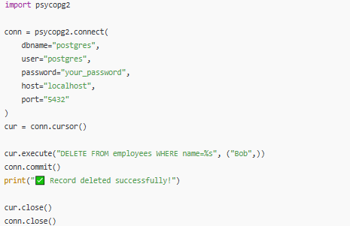

**Practical 9: Inserting Data using Python** 