**WowWeather.com**

**Site Plan**

**Site Description**

The purpose of this site is to show the users the different weather temperatures on different days and hours during the week so they can use this information however and whenever they need to.

**Target Audience**

**Who:** Any person who requires knowledge about the weather and has access to the internet.

**Age:** 15 to 90.

**Income:** Any income that can pay internet connection.

**Technology**: Any device with internet access would work for the web site, laptops, tablets, cellphones, etc.

**Motivation:** Need to get knowledge about the different weather temperatures presented each day for personal, scholar, or professional purposes.

**Personas**

Anna Tindall



**Occupation:** Photography Student.

**Demographics and Education:** 25 years old. Third year photography student and part time worker at a mall.

**Goals and motivation for using the site:** To know what clothes to select for her work depending on the weather of each day.

**Social:** Very active and sociable. Likes to take pictures of everything around her and walk to work every day since that gives her more chances to take beautiful pictures. She lives alone.

**Technology:** Uses mostly her Hp laptop, and her iPhone.

**Quote:** “Everything that tells a story deserves to be photographed.”

Kevin Wilson

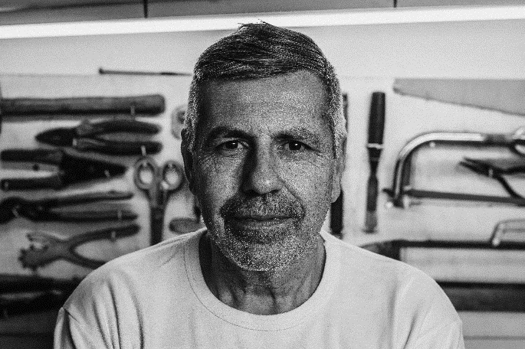

**Occupation:** Carpenter.

**Demographics and Education:** 45 years old. Owns his own joinery in Boston, Massachusetts.

**Goals and motivation for using the site:** To know if its humid, hot, or cold, in order to adequately treat the wood.

**Social:** Good worker and boss. Prefers to be alone but is nice to people and kind in his relations with others. Father of two boys and a good husband.

**Technology:** Uses mostly his cellphone, which is a Sony; and his desk computer.

**Quote:** “I feel good when I know I am being productive and happy at the same time.

George Davis



**Occupation:** Doctor.

**Demographics and Education:** 72 years old. Doctor specialized in heart surgery at a hospital on Illinois. Graduated from the University of Illinois, with his specialization and master done in that same university.

**Goals and motivation for using the site:** To decide whether to walk or use his car in any situation when the destination place is near.

**Social:** Loving father of three children, grandfather of four, and still loves his wife though she passed away four years ago. Kind and attentive with his patients.

**Technology:** Uses mostly his iPhone 6 and his desk computer at work.

**Quote:** “Every human is a soul that deserves attention and love.”

**Scenarios**

1. Will this site bring me the information about weather I need?
2. Can I find the exact information about the temperature or just some blurred content?
3. Can I see when it is going to snow and when not? How?
4. Is there any way for me to provide a day and time and see the weather for that date?
5. What will be the weather like in three days?
6. What time can I go out before it rains?
7. Will the weather be hot or cold today?

**Site Map**

Home

Search Site

Contact

About Us

Opinions

Reports

Questions

Services

Weather

People

Suggestions

History

Requests

This week

**Color Scheme**

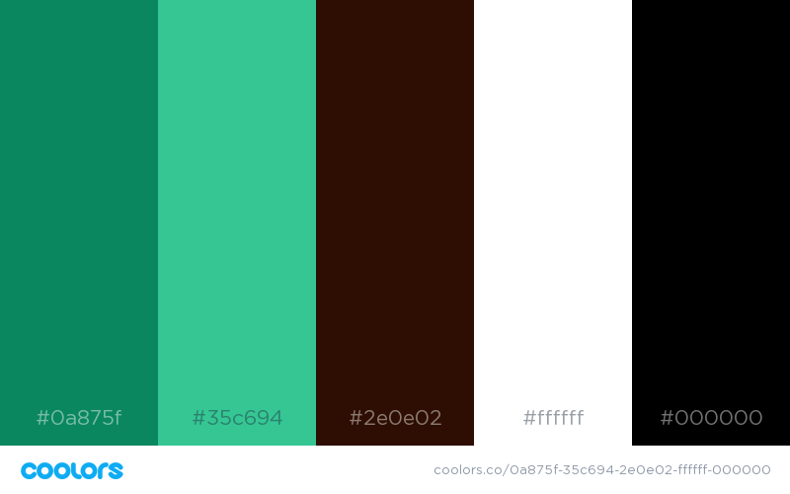

|  |  |
| --- | --- |
| Color | Element/Content |
| DEEP GREEN-CYAN TURQUOISE | Titles and decoration for the site |
| MOUNTAIN MEADOW | Subtitles and decoration for the site |
| ZINNWALDITE BROWN | Navigation bar and footer |
| WHITE | Background and text |
| BLACK | Text |

**Typography**

|  |  |  |  |
| --- | --- | --- | --- |
| Element | Font | Size | Sample |
| Site header | Abadi | 48px | Sample |
| Nav bar | Abadi | 22px | Sample |
| Footer | Abadi | 18px | Sample |
| Heading 1 | Abadi | 36px | Sample |
| Heading 2 | Abadi | 29px | Sample |
| Heading 3 | Abadi | 24px | Sample |
| Paragraph Text | Vani | 16px | Sample |