Naive Bayes Classification Report
Predicting Concert Attendance
Introduction
This activity applies the Naive Bayes classifier to predict whether a person will attend a concert based on several factors.
The attributes used in the dataset are:
- Weather
- Ticket Price
- Distance to Venue
- Friends Going
The target variable is Attend Concert (Yes or No).
The classifier calculates probabilities using Bayes' theorem.
Dataset
 | Weather | Ticket Price | Distance to Venue | Friends Going | Attend Concert
0 | Sunny | Cheap | Near | True | Yes
1 | Rainy | Expensive | Far | False | No
2 | Cloudy | Medium | Far | True | Yes
3 | Cloudy | Cheap | Near | False | Yes
4 | Rainy | Medium | Near | False | Yes
5 | Sunny | Expensive | Near | True | No
6 | Rainy | Cheap | Far | False | No
7 | Sunny | Cheap | Far | True | Yes
8 | Cloudy | Expensive | Near | False | No
9 | Rainy | Medium | Near | True | Yes
10 | Rainy | Expensive | Far | False | No
11 | Sunny | Medium | Far | False | Yes
12 | Cloudy | Cheap | Near | True | Yes
Total Records = 13
Prior Probabilities
From the dataset:
- Yes = 8
- No = 5
Therefore:
Attend |  | P(Yes/No)
Yes | 8 | 8/13
No | 5 | 5/13
Total | 13 | 100%
$$P(Yes)=\frac{8}{13}=0.615 \\ P(No)=\frac{5}{13}=0.385$$

Conditional Probabilities
 |  | Weather
 | Yes | No | P(Yes) | P(No)
Sunny | 3 | 1 | 3/8 | 1/5
Rainy | 2 | 3 | 2/8 | 3/5
Cloudy | 3 | 1 | 3/8 | 1/5
Total | 8 | 5 | 100% | 100%
Ticket Price
 | Yes | No | P(Yes) | P(No)
Cheap | 4 | 1 | 4/8 | 1/5
Expensive | 0 | 4 | 0/8 | 4/5
Medium | 4 | 0 | 4/8 | 0/5
Total | 8 | 5 | 100% | 100%

 |  | Distance
 | Yes | No | P(Yes) | P(No)
Near | 5 | 2 | 5/8 | 2/5
Far | 3 | 3 | 3/8 | 3/5
Total | 8 | 5 | 100% | 100%

Friends Going
 | Yes | No | P(Yes) | P(No)
True | 5 | 1 | 5/8 | 1/5
False | 3 | 4 | 3/8 | 4/5
Total | 8 | 5 | 100% | 100%

Naive Bayes Formula
The probability of a class given the features is calculated using:
P(y∣x1​,...,xn​)∝P(y)⋅∏i=1n​P(xi​∣y)
Where:
- Y = class (Yes or No)
- $X$= input features
The class with the higher probability becomes the prediction.
Computation
Yes No
Weather: Sunny = 8/13 (3/8*4/8*5/8*5/8) = 5/13 (1/5*1/5*2/5*1/5
Ticket Price: Cheap = 0.615 * 0.073 = 0.385 * 0.0032
Distance: Near = 0.044 = 0.001
Friends Going: True

Weather: Rainy =8/13 (2/8*0/8*3/8*3/8) = 5/13 (3/5*4/5*3/5*4/5)
Ticket Price: Expensive = 0.615 * 0 = 0.385 * 0.230
Distance: Far = 0 = 0.088 ~ 0.09
Friends Going: False

Weather: Cloudy = 8/13 (3/8*4/8*3/8*5/8) = 5/13 (1/5*0/5*3/5*5/8)
Ticket Price: Medium = 0.615 * 0.044 = 0.385 * 0
Distance: Far = 0.027 = 0
Friends Going: True

Weather: Cloudy = 8/13 (3/8*4/8*5/8*3/8) = 5/13 (1/5*1/5*2/5*4/5)
Ticket Price: Cheap = 0.615 * 0.044 = 0.385 * 0.0128
Distance: Near = 0.02706 ~ 0.03 = 0.004928 ~ 0.005
Friends Going: False

Weather: Rainy = 8/13 (2/8*4/8*5/8*3/8) = 5/13 (3/5*0/5*2/5*4/5)
Ticket Price: Medium = 0.615 * 0.029 = 0.385 * 0
Distance: Near = 0.017835 ~ 0.02 = 0
Friends Going: False

Weather: Sunny = 8/13 (3/8*0/8*5/8*5/8) = 5/13 (1/5*4/5*2/5*1/5)
Ticket Price: Expensive = 0.615 * 0 = 0.385 * 0.0128
Distance: Near = 0 = 0.004928 ~ 0.005
Friends Going: True

Weather: Rainy = 8/13 (2/8*4/8*3/8*3/8) = 5/13 (3/5*1/5*3/5*4/5)
Ticket Price: Cheap = 0.615 * 0.018 = 0.385 * 0.0576
Distance: Far = 0.01107 = 0.022176
Friends Going: False

Weather: Sunny = 8/13 (3/8*4/8*3/8*5/8) = 5/13 (1/5*1/5*3/5*1/5)
Ticket Price: Cheap = 0.615 * 0.043 = 0.385 * 0.0048
Distance: Far = 0.026445 ~ 0.03 = 0.001848 ~ 0.002
Friends Going: True

Weather: Cloudy = 8/13 (3/8*0/8*5/8*3/8) = 5/13 (1/5*4/5*2/5*4/5)
Ticket Price: Expensive = 0.615 * 0 = 0.385 * 0.0512
Distance: Near = 0 = 0.019712 ~ 0.02
Friends Going: False

Weather: Rainy = 8/13 (2/8*4/8*5/8*5/8) = 5/13 (3/5*0/5*2/5*1/5)
Ticket Price: Medium = 0.615 * 0.0488 = 0.385 * 0
Distance: Near = 0.030012 = 0
Friends Going: True

Weather: Rainy = 8/13 (2/8* 0/8*3/8*3/8) = 5/13 (3/5*4/5*3/5*4/5)
Ticket Price: Expensive = 0.615 * 0 = 0.385 * 0.2304
Distance: Far = 0 = 0.088704 ~ 0.09
Friends Going: False

Weather: Sunny = 8/13 (3/8*4/8*3/8*3/8) = 5/13 (1/5*0/5*3/5*4/5)
Ticket Price: Medium = 0.615 * 0.026 = 0.385 * 0
Distance: Far = 0.01599 ~ 0.02 = 0
Friends Going: False

Weather: Cloudy = 8/13 (3/8*4/8*5/8*5/8) = 5/13 (1/5*1/5*2/5*1/5)
Ticket Price: Cheap = 0.615 * 0.073 = 0.385 * 0.0032
Distance: Near = 0.044895 = 0.001232
Friends Going: True

Predictions for All Records
 | Weather | Ticket Price | Distance to Venue | Friends Going | Attend Concert | Predicted
0 | Sunny | Cheap | Near | TRUE | Yes | Yes
1 | Rainy | Expensive | Far | FALSE | No | No
2 | Cloudy | Medium | Far | TRUE | Yes | Yes
3 | Cloudy | Cheap | Near | FALSE | Yes | Yes
4 | Rainy | Medium | Near | FALSE | Yes | Yes
5 | Sunny | Expensive | Near | TRUE | No | No
6 | Rainy | Cheap | Far | FALSE | No | No
7 | Sunny | Cheap | Far | TRUE | Yes | Yes
8 | Cloudy | Expensive | Near | FALSE | No | No
9 | Rainy | Medium | Near | TRUE | Yes | Yes
10 | Rainy | Expensive | Far | FALSE | No | No
11 | Sunny | Medium | Far | FALSE | Yes | Yes
12 | Cloudy | Cheap | Near | TRUE | Yes | Yes

Model Accuracy
Correct Predictions = 13
Total Records = 13
$$Accuracy=\frac{13}{13}×100 \\ Accuracy=100\%$$
Conclusion
Using the Naive Bayes classifier, the model successfully predicted concert attendance based on weather, ticket price, venue distance, and whether friends were attending.
The results show that ticket price and whether friends are going are strong factors influencing the decision to attend the concert.
The model achieved 100% accuracy on the dataset, indicating that the probability patterns in the training data strongly match the predictions.
Python Code – Naive Bayes
# Hardcoded probabilities from table
prior_yes = 8 / 13
prior_no = 5 / 13

# Conditional probabilities
cond_probs = {
"Weather": {
"sunny": {"yes": 3/8, "no": 1/5},
"rainy": {"yes": 2/8, "no": 3/5},
"cloudy": {"yes": 3/8, "no": 1/5}
},
"TicketPrice": {
"cheap": {"yes": 4/8, "no": 1/5},
"expensive": {"yes": 0/8, "no": 4/5},
"medium": {"yes": 4/8, "no": 0/5}
},
"Distance": {
"near": {"yes": 5/8, "no": 2/5},
"far": {"yes": 3/8, "no": 3/5}
},
"FriendsGoing": {
"true": {"yes": 5/8, "no": 1/5},
"false": {"yes": 3/8, "no": 4/5}
}
}

# Get user input
weather = input("Weather (sunny/rainy/cloudy): ").lower()
ticket = input("Ticket price (cheap/medium/expensive): ").lower()
distance = input("Distance to venue (near/far): ").lower()
friends = input("Friends going (true/false): ").lower()

# Compute probabilities
prob_yes = (
prior_yes *
cond_probs["Weather"][weather]["yes"] *
cond_probs["TicketPrice"][ticket]["yes"] *
cond_probs["Distance"][distance]["yes"] *
cond_probs["FriendsGoing"][friends]["yes"]
)

prob_no = (
prior_no *
cond_probs["Weather"][weather]["no"] *
cond_probs["TicketPrice"][ticket]["no"] *
cond_probs["Distance"][distance]["no"] *
cond_probs["FriendsGoing"][friends]["no"]
)

# Normalize
total = prob_yes + prob_no
yes_percent = (prob_yes / total) * 100
no_percent = (prob_no / total) * 100

# Output
print("\nProbability Results:")
print(f"Attend Concert (YES): {yes_percent:.2f}%")
print(f"Attend Concert (NO): {no_percent:.2f}%")

if yes_percent > no_percent:
print("Prediction: You are more likely to ATTEND the concert.")
else:
print("Prediction: You are more likely NOT to attend the concert.")

Outputs:
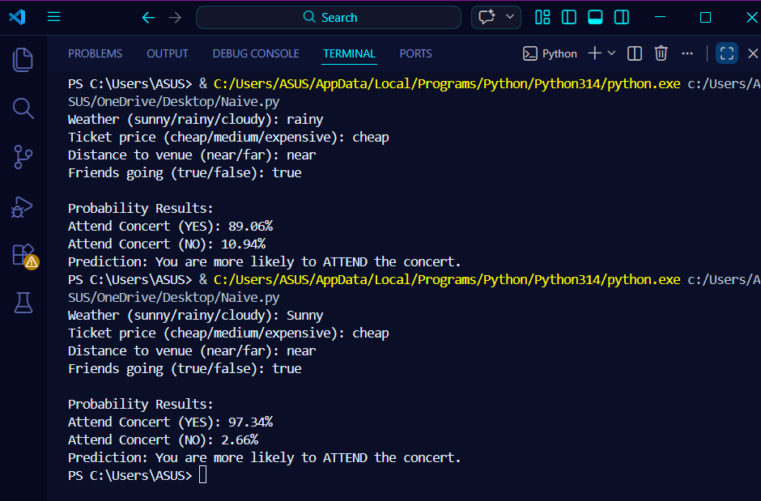

Group – 9
Mantiquilla, Joanah Kate
Palanggalan, Al-Hamer
Tangalin, Armie Joy

