Calories | Sugar (g) | Class
150 | 5 | Healthy
300 | 25 | Unhealthy
350 | 28 | Unhealthy
200 | 10 | Healthy
400 | 30 | Unhealthy
180 | 8 | Healthy
220 | 12 | Healthy
420 | 35 | Unhealthy
250 | 15 | Healthy
Data Set New Point
Calories | Sugar (g) | Class
330 | 20 | ?

Formula:
$$√(X_{2}-X_{1})^{2}+(Y_{2}-Y_{1})^{2}$$
Where:
- $X_{2}$ = New entry’s Calories (330)
- $X_{1}$ = Existing entry’s Calories
- $Y_{2}$ = New entry’s Sugar (20)
- $Y_{1}$ = Existing entry’s Sugar

Compute for Distance:
1.
$$√(330-150)^{2}+(20-5)^{2}$$
$$√32400+225$$
Calories | Sugar (g) | Class | Distance
150 | 5 | Healthy | 180.62
300 | 25 | Unhealthy | ?
350 | 28 | Unhealthy | ?
200 | 10 | Healthy | ?
400 | 30 | Unhealthy | ?
180 | 8 | Healthy | ?
220 | 12 | Healthy | ?
420 | 35 | Unhealthy | ?
250 | 15 | Healthy | ?
$$180.62$$

2.
$$√(330-300)^{2}+(20-25)^{2}$$
$$√900+25$$
$$30.41$$
Calories | Sugar (g) | Class | Distance
150 | 5 | Healthy | 180.62
300 | 25 | Unhealthy | 30.41
350 | 28 | Unhealthy | ?
200 | 10 | Healthy | ?
400 | 30 | Unhealthy | ?
180 | 8 | Healthy | ?
220 | 12 | Healthy | ?
420 | 35 | Unhealthy | ?
250 | 15 | Healthy | ?

3.
$$√(330-350)^{2}+(20-28)^{2}$$
$$√400+64$$
Calories | Sugar (g) | Class | Distance
150 | 5 | Healthy | 180.62
300 | 25 | Unhealthy | 30.41
350 | 28 | Unhealthy | 21.54
200 | 10 | Healthy | ?
400 | 30 | Unhealthy | ?
180 | 8 | Healthy | ?
220 | 12 | Healthy | ?
420 | 35 | Unhealthy | ?
250 | 15 | Healthy | ?
$$21.54$$

4.
$$√(330-200)^{2}+(20-10)^{2}$$
$$√16900+100$$
$$130.38$$
Calories | Sugar (g) | Class | Distance
150 | 5 | Healthy | 180.62
300 | 25 | Unhealthy | 30.41
350 | 28 | Unhealthy | 21.54
200 | 10 | Healthy | 130.38
400 | 30 | Unhealthy | ?
180 | 8 | Healthy | ?
220 | 12 | Healthy | ?
420 | 35 | Unhealthy | ?
250 | 15 | Healthy | ?

5.
$$√(330-400)^{2}+(20-30)^{2}$$
$$√4900+100$$
$$70.71$$
Calories | Sugar (g) | Class | Distance
150 | 5 | Healthy | 180.62
300 | 25 | Unhealthy | 30.41
350 | 28 | Unhealthy | 21.54
200 | 10 | Healthy | 130.38
400 | 30 | Unhealthy | 70.71
180 | 8 | Healthy | ?
220 | 12 | Healthy | ?
420 | 35 | Unhealthy | ?
250 | 15 | Healthy | ?

6.
$$√(330-180)^{2}+(20-8)^{2}$$
$$√22500+144$$
$$150.48$$
Calories | Sugar (g) | Class | Distance
150 | 5 | Healthy | 180.62
300 | 25 | Unhealthy | 30.41
350 | 28 | Unhealthy | 21.54
200 | 10 | Healthy | 130.38
400 | 30 | Unhealthy | 70.71
180 | 8 | Healthy | 150.48
220 | 12 | Healthy | ?
420 | 35 | Unhealthy | ?
250 | 15 | Healthy | ?

7.
$$√(330-220)^{2}+(20-12)^{2}$$
$$√12100+64$$
$$35.69$$
Calories | Sugar (g) | Class | Distance
150 | 5 | Healthy | 180.62
300 | 25 | Unhealthy | 30.41
350 | 28 | Unhealthy | 21.54
200 | 10 | Healthy | 130.38
400 | 30 | Unhealthy | 70.71
180 | 8 | Healthy | 150.48
220 | 12 | Healthy | 35.69
420 | 35 | Unhealthy | ?
250 | 15 | Healthy | ?

8.
$$√(330-420)^{2}+(20-35)^{2}$$
$$√8100+225$$
$$91.24$$
Calories | Sugar (g) | Class | Distance
150 | 5 | Healthy | 180.62
300 | 25 | Unhealthy | 30.41
350 | 28 | Unhealthy | 21.54
200 | 10 | Healthy | 130.38
400 | 30 | Unhealthy | 70.71
180 | 8 | Healthy | 150.48
220 | 12 | Healthy | 35.69
420 | 35 | Unhealthy | 91.24
250 | 15 | Healthy | ?

9.
$$√(330-250)^{2}+(20-15)^{2}$$
$$√6400+25$$
$$80.16$$
Calories | Sugar (g) | Class | Distance
150 | 5 | Healthy | 180.62
300 | 25 | Unhealthy | 30.41
350 | 28 | Unhealthy | 21.54
200 | 10 | Healthy | 130.38
400 | 30 | Unhealthy | 70.71
180 | 8 | Healthy | 150.48
220 | 12 | Healthy | 35.69
420 | 35 | Unhealthy | 91.24
250 | 15 | Healthy | 80.16

Sort in Ascending Order:
Calories | Sugar (g) | Class | Distance
350 | 28 | Unhealthy | 21.54
300 | 25 | Unhealthy | 30.41
220 | 12 | Healthy | 35.69
400 | 30 | Unhealthy | 70.71
250 | 15 | Healthy | 80.16
420 | 35 | Unhealthy | 91.24
200 | 10 | Healthy | 130.38
180 | 8 | Healthy | 150.48
150 | 5 | Healthy | 180.62

Calories | Sugar (g) | Class | Distance
350 | 28 | Unhealthy | 21.54
300 | 25 | Unhealthy | 30.41
220 | 12 | Healthy | 35.69
400 | 30 | Unhealthy | 70.71
250 | 15 | Healthy | 80.16
Choose K:

Updated Dataset:
Calories | Sugar (g) | Class
150 | 5 | Healthy
300 | 25 | Unhealthy
350 | 28 | Unhealthy
200 | 10 | Healthy
400 | 30 | Unhealthy
180 | 8 | Healthy
220 | 12 | Healthy
420 | 35 | Unhealthy
250 | 15 | Healthy
330 | 20 | Unhealthy

Therefore: The new data point is classified as UNHEALTHY.

GRAPH
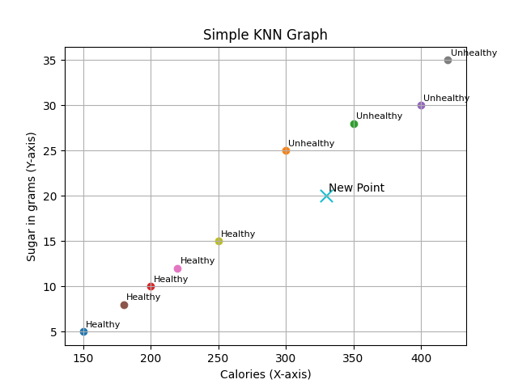

CODE



