CA3 MINI PROJECT 2 | GENERATIVE AI FOUNDATIONS
Course code: CSB312 | Project Report
TalentVerse AI
Career Intelligence Engine
Converts a career goal written in plain English into a validated skill-gap map and a milestone-based learning plan, saved in a database.
Item | Details
Student name | Sukhraj Singh
Roll number | 27
Section | K24BX
Course | CSB312 Generative AI Foundations
Selected project | Option 9: TalentVerse, Skills and Career Intelligence
Selected automation idea | Convert a career goal into a skill-gap map and a milestone-based learning plan
Input type | Text
Deployed frontend URL | [Paste your deployed URL here]

1. Project Title, Objective and Problem Statement

1.1 Project title
TalentVerse AI: Career Intelligence Engine.

1.2 Problem statement
Students usually know the job they want but not the steps that lead to it. A sentence such as "I want to become a data scientist" does not say which skills to learn first, how long each stage takes, or how to track progress. Generic career advice does not help, because every student starts from a different point.
AI models can read a free-text description and propose a plan, but their answer is prose that a program cannot store, count or update. A plan can only be tracked if it is turned into a fixed structure and checked before it is saved.

1.3 Objective
To build a full-stack generative AI application that accepts a career goal written in natural language, extracts a structured plan using schema-guided prompting, validates it, saves it in a database, and shows the saved record to the user. The user can later reopen the plan and update milestone status.
The specific objectives are:
- Accept text input through a validated form.
- Call the Gemini API from the server so the API key is never exposed.
- Make the AI return a defined JSON schema, then validate it with Zod.
- Reject invalid output instead of saving it or inventing missing values.
- Create and update records in an SQLite database through a backend API.
- Display the extracted fields, the validation status and the database confirmation in the frontend.
- Handle missing fields, invalid AI output and failed requests clearly.

2. Selected Project and Automation Idea
Requirement in the brief | Choice made in this project
Project selected (one of ten) | Option 9: TalentVerse, Skills and Career Intelligence
Automation idea implemented | Convert a career goal into a skill-gap map and a milestone-based learning plan
Input type (at least one) | Text
Required workflow | User input, AI extraction, schema-guided output, validation, backend API, database create/update, frontend confirmation
Database operation | Create (insert a plan) and update (change milestone status)

2.1 Example
Stage | Example
User input | I am a final-year student. I want to become a data scientist. I know Python and basic statistics but I am weak at machine learning, SQL and data visualisation.
Structured output | career_goal: Data Scientist; current_skills: Python, Statistics; skill_gaps: Machine Learning, SQL, Data Visualisation; priority: high; milestones: ordered list with title, description, duration and status.
Database record | One row in SQLite with an id and timestamps, shown on the Dashboard and in Saved Plans.

A response that only displays AI text would not meet the brief. Here the AI output is converted to a schema, validated, and written to the database, and the interface shows the stored record.

3. Architecture and Workflow
The application has three tiers: a browser front end, an Express back end that holds the API key and all rules, and an SQLite database. The browser never calls Gemini or the database directly.
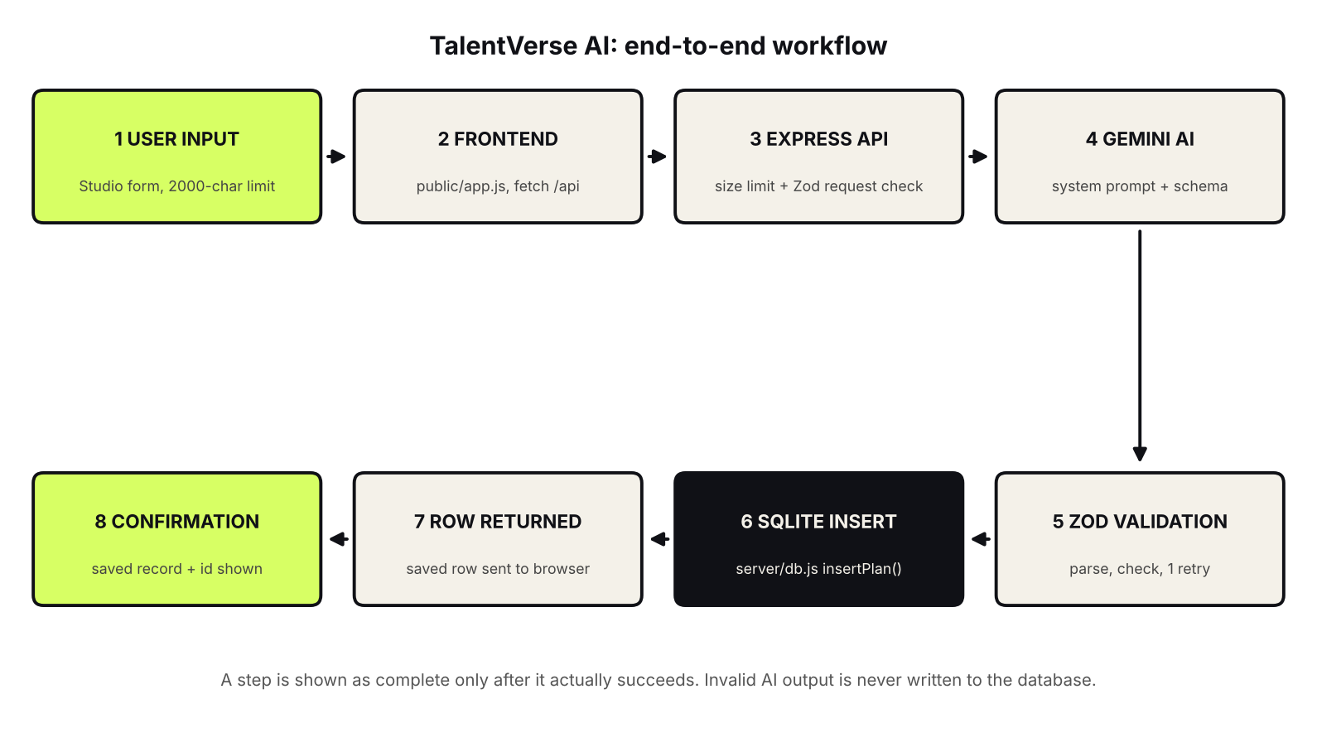
Figure 1. Architecture and workflow diagram

3.1 Mapping to the required workflow
Required stage | What happens in TalentVerse AI | Where it lives
User input | The user fills in the Studio form. The browser checks required fields and length and shows a counter. | public/app.js
AI extraction | The server sends the text to Gemini with a system instruction that fixes the role and the rules. | server/gemini.js, callGemini()
Schema-guided output | A response schema tells Gemini to return JSON with the required fields and types. | server/gemini.js
Validation | The reply is parsed and checked by Zod. If invalid, one controlled retry runs, then an error is returned. | server/schemas.js, generatePlan()
Backend API | Express receives the request, limits its size, validates it, blocks duplicates and returns JSON. | server/index.js
Database create / update | Only a validated plan is inserted. A status change is validated, then updated. | server/db.js, insertPlan()
Frontend confirmation | The saved row, with its id and timestamps, is returned and displayed. | public/app.js, planDetail()

3.2 Create flow
- The user submits the form. The browser sends a JSON POST request to /api/plans/generate.
- Express rejects bodies over 20 KB and checks the request with the request schema. A bad request returns HTTP 400.
- A hash of the request is stored in an in-flight set. A duplicate request while the first is running returns HTTP 409.
- generatePlan() calls Gemini. Network failures, rate limits and timeouts become controlled errors.
- The reply is parsed and validated with Zod. If it fails, the server retries once. If it fails again, an error is returned and nothing is saved.
- insertPlan() writes the valid plan to SQLite and returns the saved row.
- The browser displays the saved record, including its database id.

3.3 Update flow
When the user changes a milestone status, the new status is validated with a status schema, the plan id is checked, the matching row is updated, and the saved record is returned. The page re-renders from that record, and progress is recalculated from stored statuses.

4. Technology Stack
Layer | Technology | Purpose
Frontend | HTML, CSS, plain JavaScript | Input form, pipeline display, dashboard, saved plans. No build step; hash-based routing.
Backend | Node.js with Express | Serves the website and the JSON API. Holds secrets and rules.
AI | Google Gemini API | Extracts the structured plan. Called only from the server.
Validation | Zod | Runtime validation of requests, AI output and status updates.
Database | SQLite | Persistent storage of plans in a SQL database file.
Configuration | dotenv (.env file) | Keeps GEMINI_API_KEY out of the source code and the browser.
Tools | VS Code, Node.js, npm | Development environment.

5. Schema Definition and Sample Structured AI Output
The AI must return one JSON object with this shape. The same shape is stored in the database.

5.1 Sample structured output
{
"career_goal": "Data Scientist",
"current_skills": ["Python", "Statistics"],
"skill_gaps": ["Machine Learning", "SQL", "Data Visualisation"],
"priority": "high",
"milestones": [
{
"title": "Machine Learning Foundations",
"description": "Study core ML concepts and build practice models.",
"duration": "8 weeks",
"status": "not_started"
}
]
}

5.2 Field definitions and validation rules
Field | Type | Rule
career_goal | string | Required. Limited length.
current_skills | array of strings | Only skills the user stated. May be empty.
skill_gaps | array of strings | Skills still to be learned.
priority | string | Must be exactly low, medium or high.
milestones | array of objects | Non-empty, limited number of items.
milestones[].title / description / duration | string | Required for every milestone.
milestones[].status | string | Must be not_started, in_progress or completed.
user input text | string | Required, within the minimum and maximum length (2000 characters at most).

Successful JSON parsing is not treated as proof of validity. A reply can be valid JSON and still have a wrong priority, a missing field or the wrong type. Zod checks the structure, types and allowed values before anything is saved.

6. Prompt Design
The brief requires schema-guided prompting that handles missing or invalid values instead of silently inventing them. The prompt design uses four measures.
- System instruction. A fixed instruction gives the model its role (career planning assistant), the exact output it must return, and the rules it must follow.
- Response schema. The schema is sent with every Gemini request, so the model is guided toward the required fields and types.
- No invention. The model is told to list as current skills only what the user states, and not to invent experience, qualifications or deadlines. Anything missing is left empty and not guessed.
- Validate and retry. The reply is checked by Zod on the server. One retry is allowed. If the result is still invalid, an error is returned and nothing is saved.

The user's text is treated as data to analyse, not as instructions. It is kept separate from the system instruction, which reduces the chance that text typed into the form changes the model's behaviour.

7. Backend API and Validation
All routes are in server/index.js. Responses are JSON, and the HTTP status matches the problem.
Endpoint | Method | Purpose
/api/health | GET | Reports server status, whether a Gemini key is configured, and the number of stored plans.
/api/plans/generate | POST | Validates the request, calls Gemini, validates the reply, saves the plan and returns the saved record.
/api/plans | GET | Returns all saved plans.
/api/plans/:id | GET | Returns one plan with its milestones.
Milestone status route | PATCH / PUT | Validates the new status, updates the row and returns it.

7.1 Create route
app.use(express.json({ limit: "20kb" })); // maximum request size

const inFlight = new Set(); // blocks accidental double submits
app.post("/api/plans/generate", asyncRoute(async (req, res) => {
const parsed = requestSchema.safeParse(req.body);
if (!parsed.success) {
return res.status(400).json({ error: parsed.error.issues[0].message });
}
const key = crypto.createHash("sha1")
.update(JSON.stringify(parsed.data)).digest("hex");
if (inFlight.has(key)) throw new AppError(409,
"This exact request is already being processed. Please wait.");
inFlight.add(key);
// ... call generatePlan(), insert, respond, then inFlight.delete(key)
}));

7.2 Error handling
# | Case | System behaviour | User sees
1 | Missing or empty input | Rejected by the form check and the request schema. No AI call, no save. | Message asking for input
2 | Input too long | Counter in the browser; schema and 20 KB limit on the server. | Length message
3 | Gemini unreachable | Error caught and logged; controlled error returned. | Clear error; input kept
4 | Rate limit or timeout | Mapped to a specific error. | Wait and retry message
5 | Malformed JSON from AI | Parse fails; one retry; then error. Nothing saved. | Clear error
6 | Missing or wrong AI fields | Zod rejects the reply. | Clear error
7 | Invalid priority or status | Zod rejects the reply or the update. | Clear error
8 | Duplicate submission | In-flight set returns HTTP 409. | Please wait message
9 | Invalid plan id | parseId() returns null; route answers 400. | Clear error
10 | Server not reachable | The api() helper catches the failed request. | Cannot reach the server

The server logs technical detail (for example "[gemini] network error: fetch failed"), while the user receives a short, safe message. Stack traces and the API key are never sent to the browser.

8. Database Design and Create / Update Operations
Plans are stored in an SQLite database file in the data folder. SQLite is a relational SQL database that keeps data on disk, so records survive a browser refresh and a server restart.

8.1 Table design
Field | Type | Description
id | Integer, primary key | Unique identifier shown after saving.
career_goal | Text | The target role extracted by the AI.
current_skills | JSON text (array) | Skills the user already has.
skill_gaps | JSON text (array) | Skills the user still needs.
priority | Text | low, medium or high.
milestones | JSON text (array) | Ordered milestones with title, description, duration and status.
created_at / updated_at | Timestamp | Set when a row is created or changed.

8.2 Create operation
insertPlan() runs only after validation succeeds. It returns the saved row, and the interface shows success only from that returned row. If the insert fails, an error is returned and no success message is shown.

8.3 Update operation
A milestone status change is validated by statusSchema, applied to the matching plan and returned. The page re-renders from the saved record, so the screen always reflects what is stored.

8.4 Read operation and persistence
The Dashboard and Saved Plans read plans from the database. Refreshing the browser, or restarting the server, does not remove saved plans. Progress is computed as completed milestones divided by total milestones, from the stored statuses.
Check server/db.js for the exact column names and types before submitting, and adjust the table above if they differ.

9. Frontend: Extracted Fields, Validation Status and Confirmation
The front end is plain JavaScript. public/app.js renders each page into a single container and switches pages with a hash router (for example #/dashboard and #/studio). The brief requires a clear display of the extracted fields, the validation status and the database update confirmation. The interface provides them as follows.
Requirement | Where it is shown
Input interface | Blueprint Studio: career goal, current skills, experience level, optional context, character counter, sample-input button.
Validation status | The processing pipeline beside the form shows each stage as it runs on the server. A stage is marked done only when it succeeds.
Extracted fields | The blueprint shows career goal, priority, skills, skill gaps and milestones.
Database confirmation | The saved record is shown with its database id, then appears on the Dashboard and in Saved Plans.

9.1 One function for every API call
async function api(path, options = {}) {
let res;
try {
res = await fetch("/api" + path,
{ headers: { "Content-Type": "application/json" }, ...options });
} catch {
const e = new Error("Cannot reach the server. Is it running (npm start) and are you online?");
e.network = true;
throw e;
}
const data = await res.json().catch(() => ({}));
if (!res.ok) {
const e = new Error(data.error || `Request failed (${res.status}).`);
e.status = res.status;
throw e;
}
return data;
}

9.2 Screenshots of the interface
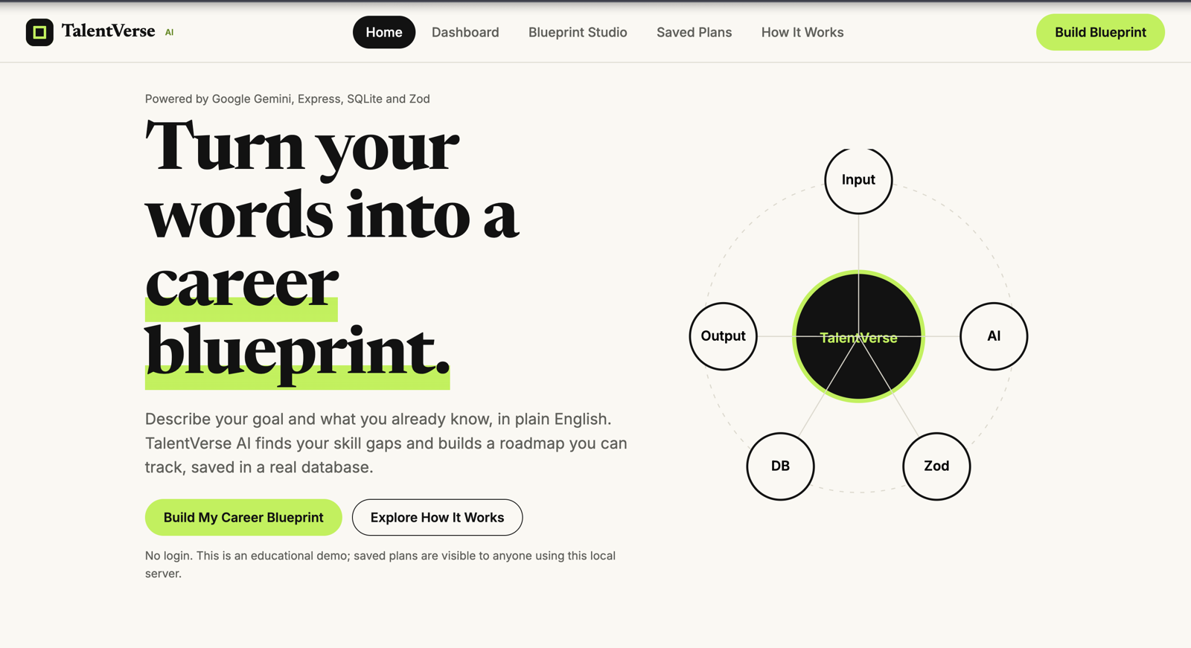
Figure 2. Home page
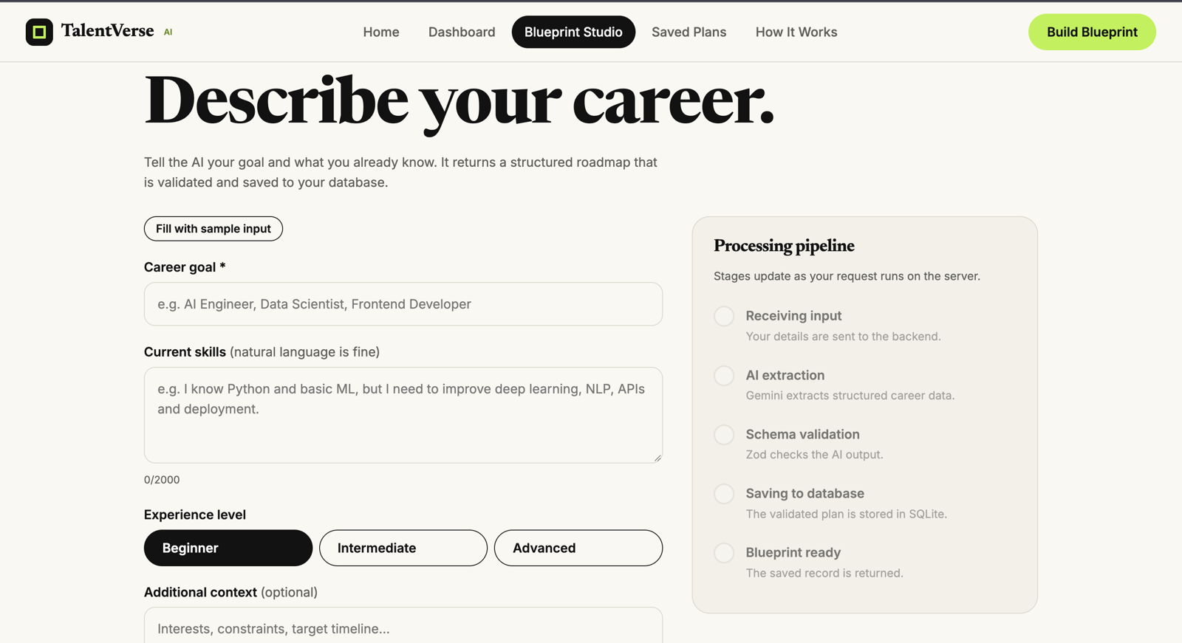
Figure 3. Blueprint Studio: input form and processing pipeline
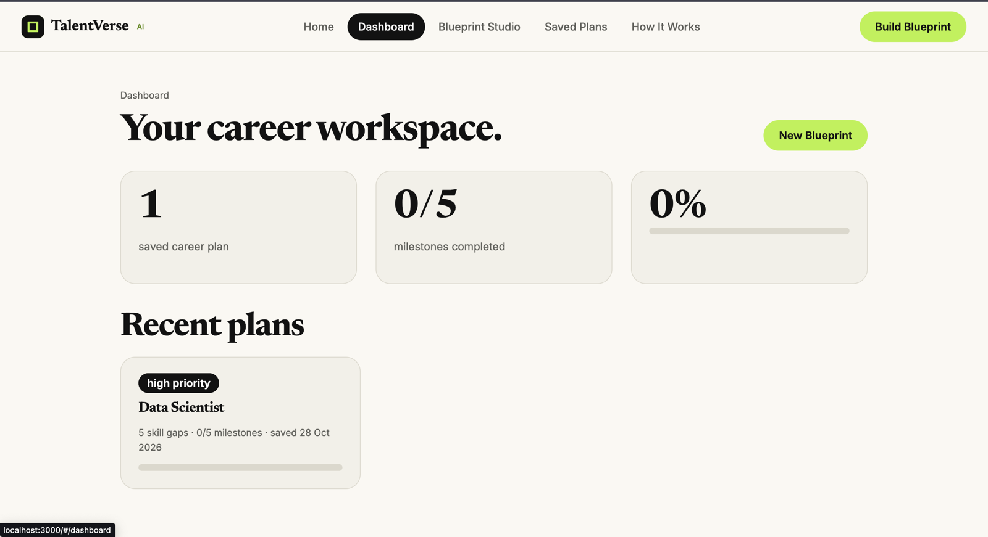
Figure 4. Dashboard: saved plan read from the database
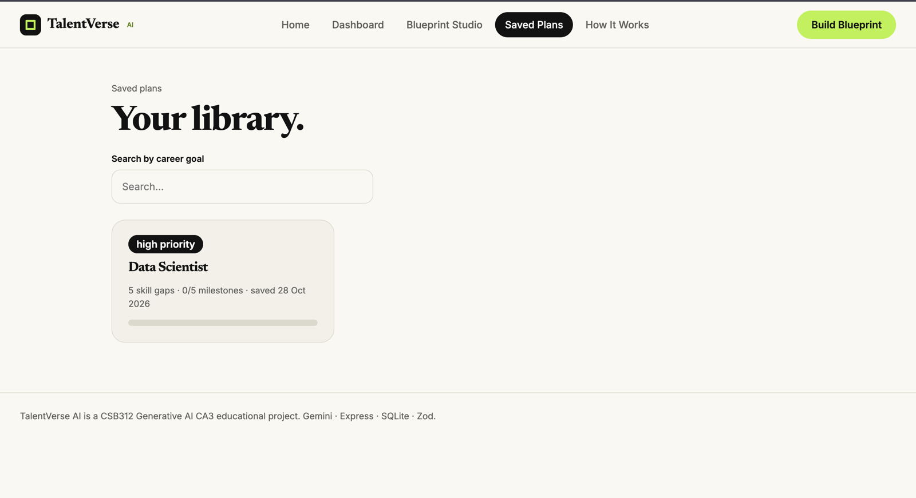
Figure 5. Saved Plans library
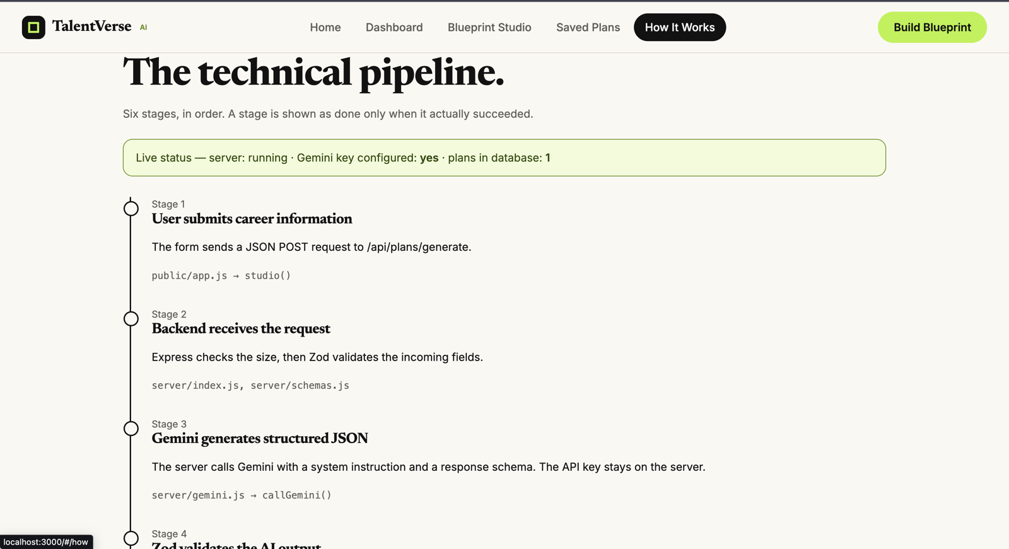
Figure 6. How It Works: live server status (server running, key configured, 1 plan in database)
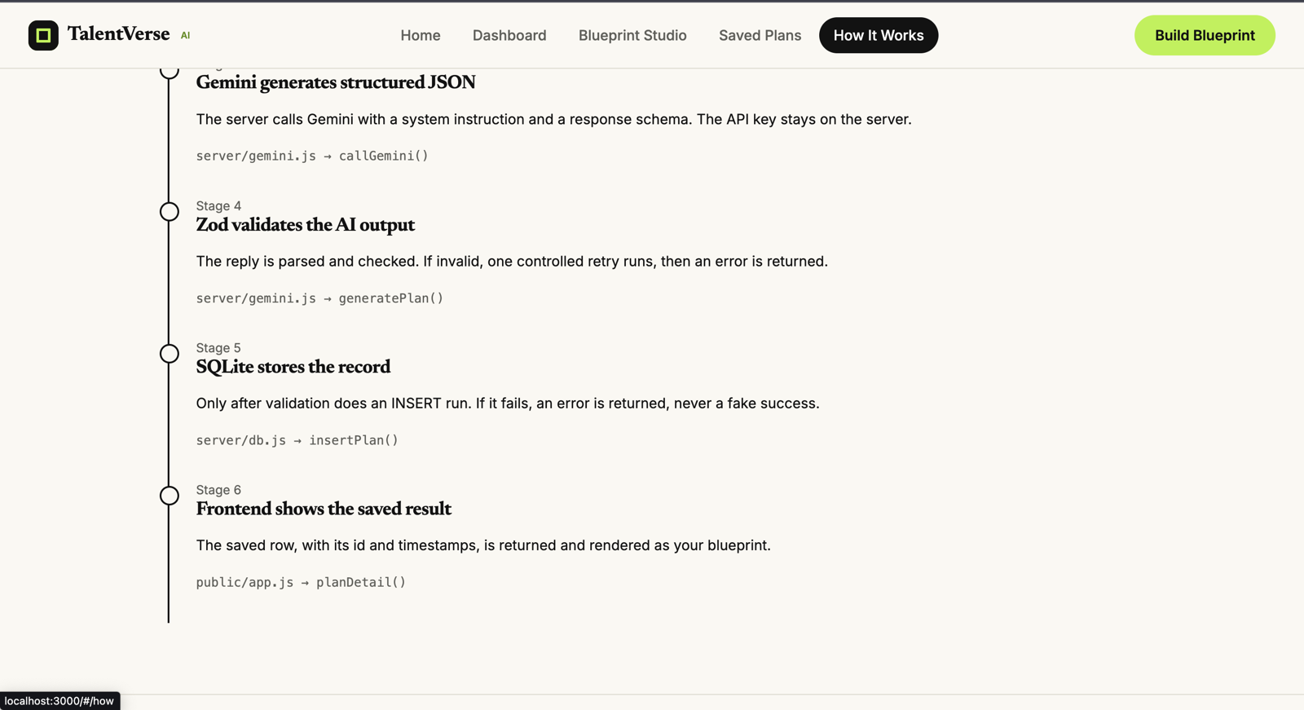
Figure 7. How It Works: validation, storage and confirmation stages

10. Testing
The brief requires one successful flow and at least one invalid-input, missing-field or error case. The table lists the tests. Tests observed during development are recorded with their evidence; the others are completed by following the procedure and writing the result.
# | Test | Procedure and expected result | Result
1 | Successful flow (create) | Fill the Studio form and generate. A plan with milestones is saved and shown with its id. | Passed. A "Data Scientist" plan (high priority, 5 skill gaps, 5 milestones) is stored (Figures 4 and 5).
2 | Persistence | Save a plan, refresh the browser, open Saved Plans. The plan is still there. | Passed. The plan appears on both Dashboard and Saved Plans.
3 | Successful update | Change a milestone status, refresh. The new status and progress remain. | Run and record (Figure 9)
4 | Invalid input | Submit an empty or too-short form. An error appears and no row is added. | Run and record (Figure 10)
5 | Missing field | Leave the career goal empty. The request is rejected before the AI is called. | Run and record
6 | Invalid AI output | Make the schema reject a reply (for example, an invalid priority). The error is shown and nothing is saved. | Run and record
7 | Failed request | Disconnect the network or use a wrong key. A clear error appears with no success message. | Observed. Terminal shows "[gemini] network error: fetch failed" and the server keeps running (Figure 8).
8 | Duplicate submission | Click generate twice quickly. The second request is refused with HTTP 409. | Run and record
9 | Health check | Open /api/health. It shows ok, key configured and the plan count. | Passed (Figure 6).

10.1 Test evidence
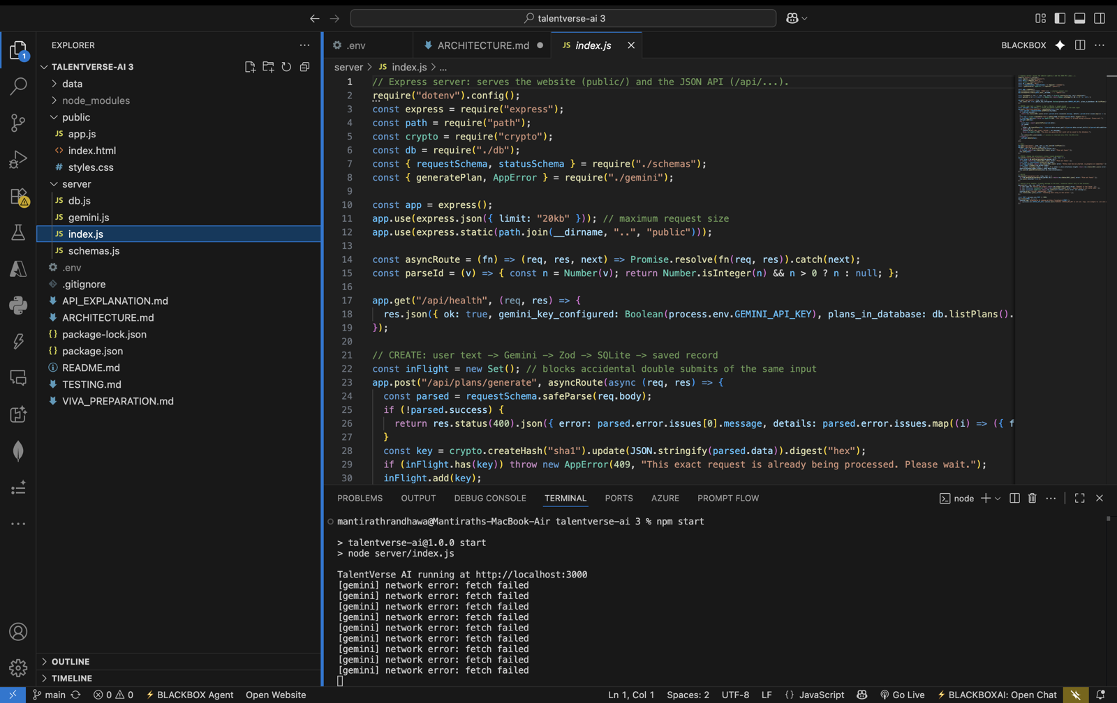
Figure 8. Server terminal: Gemini network failure logged while the server keeps running
[Insert screenshot here: Figure 9. Successful database update: a milestone status changed, then the page refreshed]
Figure 9. Successful database update: a milestone status changed, then the page refreshed.

[Insert screenshot here: Figure 10. Invalid-input test: the error message shown for empty or too-short input]
Figure 10. Invalid-input test: the error message shown for empty or too-short input.

11. Deployment
Item | Details
Deployed frontend URL | [Paste your deployed URL here]
Hosting approach | One Node.js service. Express serves both the frontend (public/) and the API, so the deployed frontend connects to the same backend and database.
Build command | npm install
Start command | npm start (runs node server/index.js)
Environment variable | GEMINI_API_KEY, set in the hosting dashboard (never committed to source control)
Verification | Open the deployed URL, then /api/health, then generate and save a plan.

Deployment is compulsory in the brief. The URL above must be filled in only after the deployed site has been opened and a plan has been generated and saved on it.

12. Safeguards for Sensitive Data
- The Gemini API key is stored in .env on the server and is never sent to the browser. The health endpoint reports only true or false.
- Request size is limited to 20 KB, and text length is limited by schema.
- Both the request and the AI reply are validated before anything reaches the database.
- Dynamic text is escaped before it is placed in the page.
- .env is listed in .gitignore.
- The application asks for career information only. Users are advised not to enter personal identity or financial details.

13. Known Limitations
- No login. Saved plans are visible to anyone using the same server, as stated on the Home page.
- The app has no save-preview step. A valid plan is saved when generated, and the user reviews it afterwards.
- SQLite on a single server suits a demonstration, not many simultaneous users. Some free hosts reset local files on restart.
- Plan generation needs an internet connection, a valid API key and available Gemini quota.
- AI suggestions can contain unrealistic durations or miss niche skills, so the user should review them.
- No job-market data is used, so no demand or salary statistics are claimed.
- Milestone status can be updated, but milestone text cannot be edited after saving.
- Testing is manual; there is no automated test suite.

14. Future Improvements
- Add user accounts and per-user access to plans.
- Add a preview and edit step, with confirmation before saving.
- Move the database to a hosted PostgreSQL service for reliable deployment.
- Add learning resources and project ideas for each milestone.
- Support resume upload to extract current skills automatically.
- Compare skill gaps with real job descriptions (the third TalentVerse idea).
- Add automated tests for schemas and API routes.
- Keep a progress history and allow export to PDF.

15. Conclusion
TalentVerse AI meets the brief's required workflow from text input to a database record shown in the interface. The AI is given a narrow job, its output is forced into a schema and checked by code, and only valid data is saved. Missing or invalid values are rejected rather than invented, and every stage reports its real result, so failures are visible and success is never faked.
The project demonstrates schema-guided prompting, runtime validation, a backend API, and create and update operations on a persistent database. The remaining work is deployment of the frontend URL, user accounts and a preview-and-confirm step before saving.

