Hardware Project
  - Wrist-camera SLAM for manipulation demonstrations and live teleoperation
28 August 2026

What the project is
A person picks up a handheld UMI-style gripper and performs a task by hand. Two things are recorded at once: what the wrist-mounted camera sees, and how far the jaws are open. Both are timestamped on one host clock and matched by nearest timestamp, with the per-frame error written out rather than assumed.
The camera pose is not a nice-to-have. It is the action label — the exported robot0_eef_pos and robot0_eef_rot_axis_angle are the camera trajectory. Bad tracking does not degrade the dataset; it invalidates it.
Component | Part
Camera | Intel RealSense D435i (stereo IR + RGB + IMU)
Actuator | Dynamixel XL330-M077 via ROBOTIS U2D2, driven as a torsional spring
Tracker | ORB-SLAM3 Stereo-Inertial, embedded via a C ABI shim
Arm | UFACTORY xArm over Ethernet, servo mode (teleoperation)
Output | Zarr replay buffer, UMI / Diffusion Policy schema
Code | ~6,700 lines Python plus local ORB-SLAM3 changes
Two branches share one pose estimator: capture → track → export → train for data collection, and capture → track → arm for teleoperation. Anything that improves tracking improves both.

Problems and fixes
# | Problem | Fix | Status
1 | Monocular VIO drifted without bound | Switched to ORB-SLAM3 Stereo-Inertial | Resolved
2 | USB latency made the servo spring unstable | Moved the PID onboard the servo | Resolved
3 | Careful manipulation never cleared the IMU-init gate | Two-stage atlas + translate, don’t rotate | Partly measured
4 | The depth projector was being used as scene texture | Emitter off unless depth is running | Verified on rig
5 | The gripper ate a fifth of the feature budget | Derived polygon mask | Measured
6 | A held object becomes camera-fixed too | Deliberately not fixed in code | Open
7 | Resets move the map origin mid-recording | map_epoch counter, export splits on it | Handled
8 | A SLAM pose is not a controller pose | Clutch + three independent guards | Handled
9 | Camera frame is not 90° from the robot frame | Full rotation fitted by Kabsch/SVD | Resolved

1–2. Fixed early
Monocular visual-inertial odometry had no absolute scale and drifted without bound. Stereo-inertial fixed it: the baseline supplies metric scale directly.
The servo was originally driven as a spring by a host-side PID loop over USB, where jitter in the control interval made the restoring force inconsistent. The loop now runs on the servo’s own microcontroller; the host only sets the target.

3. Careful manipulation never cleared the IMU-init gate
Tracking failed during exactly the task the rig exists for: small-motion pick-and-place. Near-constant resets, ~33% of frames tracked, tracked runs about three frames long.
The cause is in ORB-SLAM3’s LocalMapping.cc: IMU initialization demands at least 2 cm of accumulated translation within roughly ten seconds, or it resets. Precise manipulation has small net displacement by nature.
Fix — build the map once. A deliberate expansive scan is saved as atlas.osa; every demo loads it and localizes against it. This removes the reset rather than reducing it: the saved atlas serializes mbIMU_BA2, and the gate tests !GetIniertialBA2(), so an already-initialized map can never re-trigger it.
python3 output_script/build_atlas_map.py --output-dir maps/kitchen_table
python3 output_script/synced_capture.py --orbslam-map-dir maps/kitchen_table
What the rig then showed. A live session still reset 18 times. Texture was ruled out on the spot — median 800 features per frame, only 4% of frames below 300. The IMU log gave the real answer:
Quantity | Median | p90
Angular rate | 8.4 °/s | 35 °/s
Linear acceleration, gravity removed | 0.18 m/s² | 1.03 m/s²
The camera was being rotated, not translated. The gate measures distance between camera centres; pivoting in place changes the image enormously and contributes nothing. At this camera’s intrinsics, 8.4 °/s of rotation produces ~79 px/s of image motion while 5 cm/s of translation produces only ~21 px/s — so roughly four fifths of the apparent motion carried no translation information.
The operating instruction: carry the camera bodily sideways and back and forth, 20–30 cm, pointed at roughly the same scene. Not standing still and sweeping it around like a torch. The same applies to the mapping pass.

4. The depth projector was being used as scene texture
The D435i’s IR projector paints dots so stereo depth has something to match on blank surfaces. But the pattern is projected from the camera: the dots slide across surfaces as the camera moves, and they are near-identical to one another, so their descriptors are ambiguous. As landmarks they are worse than useless. The option had never been set, so it defaulted on, and a code comment had come to describe the dots as “the only texture a plain surface had to offer”.
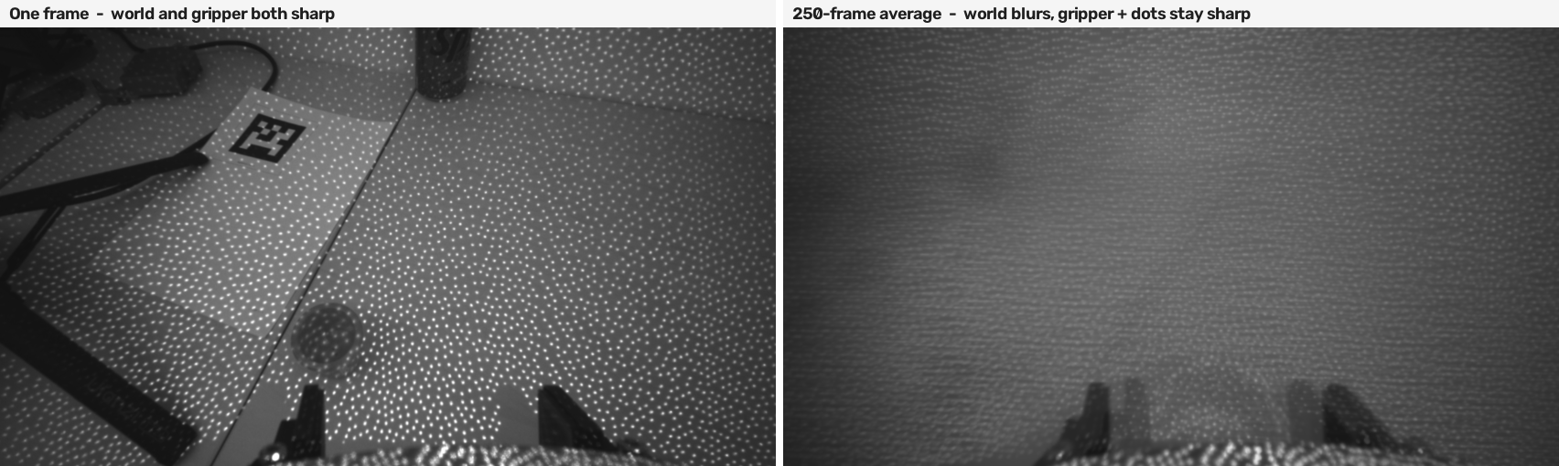
Figure 1. Left: one IR frame — dots, gripper and world all equally sharp. Right: 250 frames of the same recording averaged. Everything attached to the world smears into a gradient; the gripper silhouette and the dot pattern survive intact, because both are attached to the camera. This one image is the evidence behind problems 4 and 5.
Fix. Emitter on only when the depth stream is actually running. Derived from the depth stream rather than exposed as its own flag — no configuration wants a third answer. Upstream draws the same line: ORB-SLAM3’s Stereo, Stereo-Inertial, Monocular and Calibration RealSense examples all switch it off; only the RGB-D ones, which consume the depth map rather than IR features, leave it on. Confirmed running on the rig.

5. The gripper ate a fifth of the feature budget
The camera is wrist-mounted, so the gripper is rigidly attached and permanently in frame. A feature that never moves in the image is, geometrically, evidence that the camera never moved — so gripper features bias translation downward, in the one regime already closest to the 2 cm threshold. They also triangulate into bogus map points that get baked into the atlas.
Recording | Features / frame | On the gripper | Share
scan_0006 | 779 | 130 | 16.7%
scan_0007 | 795 | 146 | 18.3%
scan_0009 | 767 | 163 | 21.3%
The gripper occupies 8.4% of the frame but takes 17–21% of the features: a dark, hard-edged silhouette is exactly what ORB looks for, in a scene otherwise dominated by plain white surfaces.
Fix. A polygon mask flattened into the frames before tracking sees them. Gripper features drop to zero, the total is unchanged (779 → 778), so the budget goes to real scene content. The saved IR PNGs stay raw.
The polygon was derived, not hand-drawn: camera-fixed structure stays sharp in a long temporal average, so gradient magnitude of that average isolates it. Fitted by voting across twelve samples from three recordings, keeping only blobs touching the bottom edge, then dilated for finger travel. Extent came out stable to ±0.1% of frame area. Validated on a recording held out of the fit.
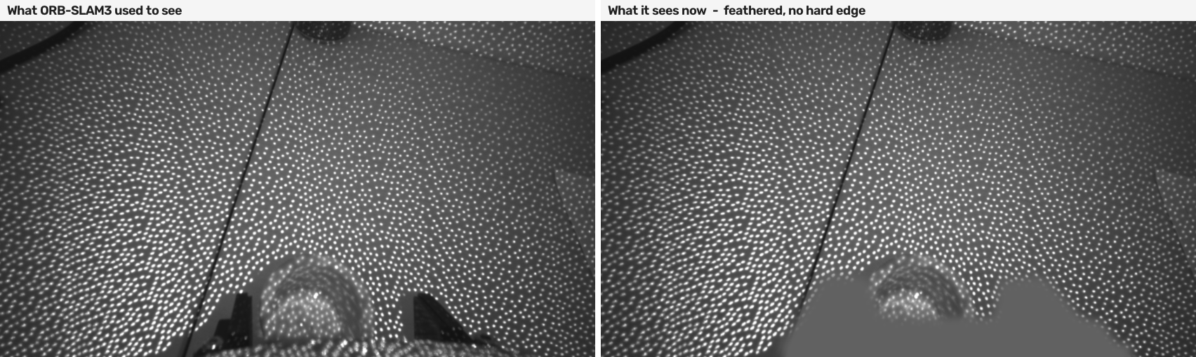
Figure 2. The same frame before and after masking. The fill is feathered rather than hard-edged, so the mask’s own border does not become a new set of camera-fixed corners; measured, the boundary band ends up with 12–20% fewer features after masking, not more.
Masking happens in Python because upstream cannot do it: ORBextractor::operator() takes a mask argument and ignores it, and TrackStereo has no mask parameter at all.

6. A held object becomes camera-fixed too — open
The moment an object is grasped it is rigidly attached to the camera, exactly like the gripper. A static mask cannot cover it, because where it lands depends on how it was grasped.
Recording | Grasp window | Object area | Share of post-mask features
scan_0009 | 12–20 s | 2.8% | 13.2%
scan_0007 | 6–12 s | 2.3% | 11.4%
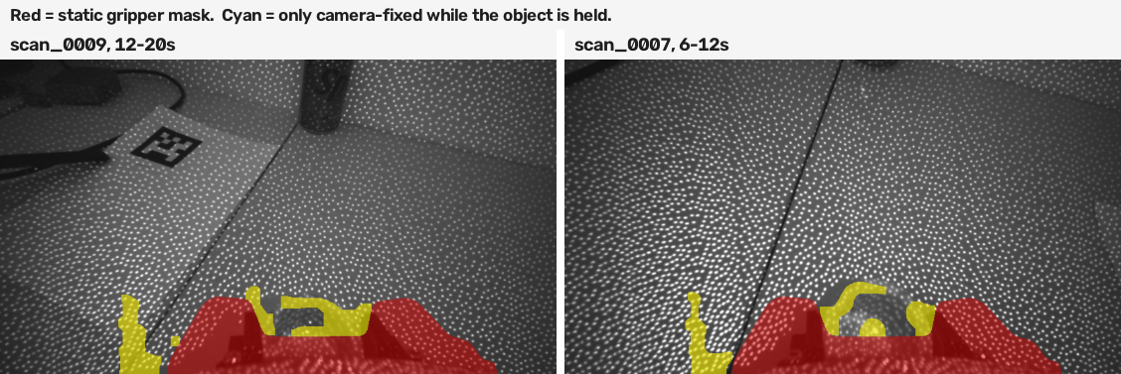
Figure 3. The camera-fixed detector run over short sliding windows instead of a whole recording. Red is the static gripper mask. Cyan is the region that is camera-fixed only while the object is held — it appears above the mask boundary, disappears on release, and no static mask can predict where it will land.
Position taken — deliberately not fixed in code. PoseOptimization already uses a Huber kernel and four rounds of chi-squared outlier rejection, which is exactly the mechanism for a minority of points that disagree with the rest, and 11–13% is a clear minority. Per-frame dynamic rejection would re-implement that with more ways to get it wrong.
Three reasons it is not settled: the share could multiply with a larger object or a blanker background; the object was mapped in its pre-grasp position, so its stale map points pollute the atlas, which outlives any single frame; and it happens precisely during the phase already nearest the IMU-init gate. The real lever is the denominator — more world-fixed texture around the workspace dilutes the object’s share. Extending the mask upward by 40–60 px is documented and deferred until there is live grasp-phase data to decide against.

7. Resets move the map origin mid-recording
Each reset can move the active map’s pose origin, silently breaking any trajectory spanning it. A map-ID check does not catch it: the common reset path clears and re-initializes the same Map object in place, so its ID never changes. One recording showed two real resets that an ID check reported as zero.
Fix. A counter in Atlas, incremented on both CreateNewMap() and clearMap() so it catches every path, surfaced as System::GetMapEpoch() and written per row as map_epoch. Export splits on it: an episode is one contiguous map epoch, not one recorded folder.

Teleoperation
output_script/umi_teleop.py sends the same live pose to a UFACTORY xArm at 50 Hz through set_servo_cartesian in servo mode. Nothing on the arm is sensed; the hand is the input device. Anchor, clutch, deadzone, smoothing and delta clamp are copied from an existing Quest-controller script already tuned against this arm, so the one thing changed is the pose source. Dry run is the default — without --execute nothing reaches the arm.
This is also the harshest test of tracking quality available. Data collection judges a pose offline, where a bad trajectory is a bad label found later. Teleoperation judges it while it is being produced, and a bad pose is a moving arm.
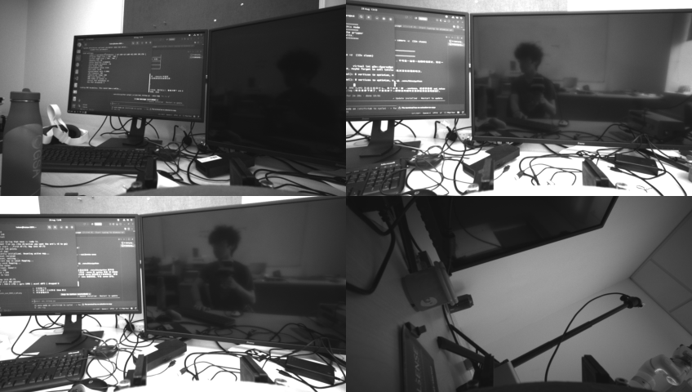
Figure 4. Four IR frames from a teleoperation session — the world the tracker actually had to work with: a black monitor, a white wall, cabling. No projected dot pattern anywhere, the emitter change running live. The gripper sits at the bottom of every frame, the reason the mask exists.

8. A SLAM pose is not a controller pose
A Quest controller never loses tracking, reports at a fixed rate, and never redefines its own origin. ORB-SLAM3 does all three.
The SLAM worker is throttled to 10 Hz — 20 Hz reproduced a crash — while servo mode wants 50 Hz, so the control loop runs at 50 Hz and reads whatever the latest pose is. The arm is always chasing a target up to ~100 ms old. That is inherent, not a tuning defect.
A reset moves the map origin: the same pose value suddenly means somewhere else, which reaches a real arm as a jump. Tracking lost, a changed map_epoch, or no fresh pose within 0.5 s all disengage the clutch and demand a re-anchor. Three further guards bound what can get through:
Guard | Value | Reasoning
MAX_CART_DELTA_MM | 80 mm | bounds distance from the anchor
POSE_JUMP_MPS | 2.0 m/s | a hand carrying a camera never exceeds this; a SLAM jump is metres instantly
MAX_STEP_MM | 8 mm / cycle | caps the arm at ~0.4 m/s whatever the cause
The distance clamp alone is not enough: at TARGET_ALPHA 0.55 an 80 mm step in the target still puts 44 mm into the very next 20 ms command, about 2.2 m/s of commanded motion.
Scale is 300 mm of arm per metre of hand, half the Quest script’s 600. A SLAM pose carries tracking noise a controller pose does not, and scaling down attenuates it by the same factor. The extra hand travel is absorbed by the clutch — disengage, reposition, re-engage, like lifting a mouse.
Servo mode also does no reachability check; it accepts or rejects. Rejections are now named rather than printed as a bare return code, and recovered from automatically, so one rejection disengages the clutch instead of ending the session. Error 23, joint angle exceeds limit, is not something software can tune away — it means starting nearer the middle of the joints’ range.

9. The camera frame is not a 90° rotation from the robot frame
How the camera frame relates to the arm’s base frame depends on how the gripper is held and how the arm is mounted, so it is calibrated once by moving along each robot axis and reading which camera axis responded. The result is sanity-checked by determinant: a real rigid mounting can only give a proper rotation, so a single flipped sign gives −1 and is rejected on the spot rather than at --execute time.
An axis map was enough for translation. Rotation broke immediately:
ORB-SLAM3’s world frame has its Z aligned to gravity by the IMU, but its yaw is set by wherever the camera pointed when the map initialized — arbitrary, and different every session.
An axis permutation only expresses multiples of 90°, so snapping an arbitrary yaw to the nearest axis leaves up to 45° of residual. Translation survives that as a cosine factor, which is why position-only teleoperation felt correct. Rotation does not: the whole rotation axis ends up tilted, and the wrist turns about a visibly wrong axis.
Fix. The three calibration directions already over-determine the full rotation; snapping them to axes threw that away. They are now fitted with Kabsch/SVD, determinant forced to +1. Against a synthetic 33° yaw offset with hand noise included:
Method | Angular error
Axis-map permutation | 33.00°
Full fitted rotation | 0.75°
This has a consequence for the atlas. Because the world yaw is chosen afresh whenever a map cold-starts, a fitted frame is only valid for the session that produced it. Loading a saved atlas fixes the world frame and makes the calibration reusable — a third distinct job for the atlas:
 | What the atlas buys
1 | Bypasses the 2 cm IMU-initialization gate
2 | Relocalization instead of restarting when tracking is lost
3 | Fixes the world yaw, so a frame calibration survives across sessions
Rotation stays behind --rotation, damped by a 0.5 scale, a 2° deadzone (subtracted rather than thresholded, so crossing it is continuous) and heavier smoothing than translation. The camera is held in the hand, where wrist articulation produces far more rotation per unit of effort than whole-arm translation does, and 1:1 feels twitchy. The arm’s Euler convention was measured rather than read from the docs: only Rz(yaw)·Ry(pitch)·Rx(roll) reproduced the axis-angle rotation, to 0.000°.

Design note: the added texture is not a marker system
Stickers go around the manipulation region, and are never detected as markers. With the projector off, the workspace has to supply its own world-fixed texture, and printed patterns do that — but they are consumed as ordinary ORB features. There is deliberately no fiducial-detection code in the repository.
Deriving pose from marker geometry would tie the recorded trajectories to an instrumented environment, and a policy trained on those poses would depend on markers existing at deployment. Implicit use keeps the pose coming from natural features — the same estimator that runs when the markers are gone.
Two practical constraints: tracking happens in near-infrared, where many coloured dyes are transparent, so patterns must be black-on-white laser print and non-repeating; and whatever texture is present during mapping is baked into the atlas as map points, so it must stay physically put afterwards.

Where it stands
Item | Evidence | Status
OpenVINS to ORB-SLAM3 | Live, 50+ s continuous motion | Verified
Onboard servo PID | Live, including hard nudges | Verified
Emitter switches off on the rig | Live session log and frames | Verified
Axis calibration | Live, determinant check passed | Verified
Teleoperation, translation only | Live, arm driven from SLAM pose | Verified
Rotation, not translation, caused the resets | Live IMU log | Measured
Gripper feature share | Offline, three recordings | Measured
Held-object feature share | Offline, two grasp windows | Measured
Fitted frame beats the axis map | Synthetic 33° yaw | Measured
Two-stage atlas removes resets | Source-level reasoning only | Needs rig
Mask improves tracking | Feature counts only, not tracking | Needs rig
Teleoperation with rotation | Written, not yet driven | Needs rig
Jump and rate guards fire correctly | Never triggered live | Needs rig
Translation-only teleoperation runs on the real arm. Everything in the SLAM-quality column — atlas, mask, feathering — is still unvalidated on the rig.
Order to test in. The changes are coupled, so the order matters: the projector is off, so the texture has to exist before mapping is worth running; the atlas has to exist before localization can be judged; and the atlas has to exist before a frame calibration is worth saving.
- Put the scene texture up — around the manipulation region, not in it.
- Run the mapping pass, translating 20–30 cm rather than sweeping.
- Record a demo against that map; count resets via map_epoch.
- Record a control with --no-gripper-mask and compare.
- Re-run the frame calibration against that atlas, then teleoperate with --rotation — dry run first, --execute with a reduced --max-delta-mm second.
Still open. Whether to mask inside ORB-SLAM3 rather than in Python — its octree extractor actively redistributes features toward sparse regions, which the cv2.ORB proxy used for the boundary measurement does not. And whether to extend the mask upward over where held objects sit, at the cost of the manipulation region’s own pixels, which SLAM wants nothing from anyway.

