SUMMER INTERNSHIP PROJECT REPORT
AUTOMATED PHI/PII REDACTION PIPELINE FOR LLMs
Submitted in partial fulfillment of the requirements for the degree of
Bachelor of Technology in Computer Science and Engineering
Submitted by:
Patel Mantra Kalpeshkumar (24DCS076)
Under the guidance of:
Dr. Khushi Patel (Internal Guide)
Chandan Mishra (External Mentor, Infotact Solutions)
DEVANG PATEL INSTITUTE OF ADVANCE TECHNOLOGY AND RESEARCH (DEPSTAR)
Charotar University of Science and Technology (CHARUSAT)
July, 2026

DEVANG PATEL INSTITUTE OF ADVANCE TECHNOLOGY AND RESEARCH
DEPARTMENT OF COMPUTER SCIENCE AND ENGINEERING
CERTIFICATE
This is to certify that the internship report titled "Automated PHI/PII Redaction Pipeline for LLMs" is a bonafide work carried out by Patel Mantra Kalpeshkumar (24DCS076) under my supervision and guidance during the summer internship period. The work has been carried out satisfactorily and meets the academic requirements for the degree of Bachelor of Technology in Computer Science and Engineering.

____________________ ____________________
Dr. Khushi Patel Head of Department
Internal Project Guide Department of CSE

INFOTACT SOLUTIONS
Bengaluru, Karnataka
TO WHOMSOEVER IT MAY CONCERN
This is to certify that Patel Mantra Kalpeshkumar (24DCS076), a student of DEPSTAR, CHARUSAT, has successfully completed a 2-month summer internship at Infotact Solutions from May 2026 to July 2026. During this period, he worked in the role of Security Admin Associate L1 on the project "Automated PHI/PII Redaction Pipeline for LLMs". His work primarily involved designing regular expression pipelines, backend gateway router API endpoints, and rotated compliance audit logging controllers. His conduct and performance during the internship were highly commendable.

Chandan Mishra
External Internship Mentor
Infotact Solutions

ACKNOWLEDGEMENT
First and foremost, I would like to express my sincere gratitude to Infotact Solutions for giving me the opportunity to work as a Security Admin Associate L1 during my 2-month summer internship. This project provided me with invaluable experience in integrating security and compliance guardrails directly into backend clinical software architectures.
I am highly indebted to my external mentor, Chandan Mishra, for his technical guidance, code reviews, and constant encouragement throughout the design and implementation of the token vault mechanisms. I am also extremely grateful to my project guide, Dr. Khushi Patel, and the faculty members of DEPSTAR, CHARUSAT, for providing structural direction and academic feedback.
Finally, I want to thank my teammates Rohit Suthar, Tirth Patel, and Jash Joshi. Our collaborative integration efforts—merging the frontend dashboard, the Presidio NLP engines, and the Redis token mappings—were essential in delivering a highly stable, production-ready proxy pipeline.
Patel Mantra Kalpeshkumar
Enrollment: 24DCS076

ABSTRACT
Integrating Large Language Models (LLMs) into healthcare systems exposes sensitive patient records to compliance and privacy leakage risks. Under HIPAA regulations, clinical data containing Protected Health Information (PHI) or Personally Identifiable Information (PII) must be redacted prior to being routed outside secure organizational boundaries. This project implements a secure, de-identification proxy acting as a compliance firewall.
The pipeline utilizes a hybrid detection architecture. A stateless rules-based Regex scanner detects 13 distinct types of structured identifiers (such as Aadhaar cards, SSNs, medical record numbers, ZIP codes, and dates), while Microsoft Presidio and spaCy handle unstructured entities like patient names and locations. Overlapping matches are resolved using a length-priority greedy matrix to avoid nested double-redactions. Anonymized token mappings (e.g. PERSON_001) are Fernet-encrypted and stored in a Redis session vault with an auto-destruction 30-minute Time-to-Live (TTL) policy. Finally, original identities are dynamically restored in the safe LLM responses before being delivered back to clinicians.
To satisfy production needs, the system integrates sliding-window IP rate-limiting, size-based rotating audit logging (logging metadata only to prevent PHI leaks), and a stateless pre-check route executing in ~1.29ms to warn users of sensitive data exposure risks. Programmatic validation via a 65-assert Pytest suite confirms pipeline durability.

TABLE OF CONTENTS
Abstract ......................................................................................................................... iii
Acknowledgement ........................................................................................................................ iv
Description of Company / Organization ........................................................................................... ix
CHAPTER 1 — INTRODUCTION ..................................................................................................... 1
1.1 BACKGROUND .................................................................................................................. 1
1.2 DATA PRIVACY IN HEALTHCARE ........................................................................................ 1
1.3 PERSONALLY IDENTIFIABLE INFORMATION (PII) ............................................................. 1
1.4 PROTECTED HEALTH INFORMATION (PHI) ............................................................................ 2
1.5 PRIVACY RISKS IN LARGE LANGUAGE MODEL APPLICATIONS ........................................... 2
1.6 NEED FOR AUTOMATED PHI/PII REDACTION ......................................................................... 2
1.7 PROBLEM STATEMENT ..................................................................................................... 2
1.8 OBJECTIVES OF THE PROJECT ......................................................................................... 3
1.9 SCOPE OF THE PROJECT ................................................................................................. 3
CHAPTER 2 — PROJECT DEFINITION .......................................................................................... 4
2.1 PROJECT OVERVIEW .......................................................................................................... 4
2.2 EXISTING SYSTEM ........................................................................................................... 4
2.3 PROPOSED SYSTEM ........................................................................................................... 4
2.4 TECHNOLOGY STACK ......................................................................................................... 4
2.5 KEY FEATURES OF THE SYSTEM ......................................................................................... 5
CHAPTER 3 — SYSTEM REQUIREMENTS ..................................................................................... 6
3.1 SOFTWARE REQUIREMENTS ................................................................................................ 6
3.2 HARDWARE REQUIREMENTS ................................................................................................ 6
3.3 DEVELOPMENT AND VALIDATION TOOLS ........................................................................... 7
CHAPTER 4 — SYSTEM DESIGN AND ARCHITECTURE ............................................................... 8
4.1 SYSTEM ARCHITECTURE .................................................................................................... 8
4.2 SYSTEM WORKFLOW ........................................................................................................... 8
4.3 DATABASE DESIGN ............................................................................................................. 9
4.4 SECURITY ARCHITECTURE ................................................................................................... 10
CHAPTER 5 — SYSTEM IMPLEMENTATION .................................................................................. 12
5.1 FRONTEND IMPLEMENTATION ........................................................................................... 12
5.2 BACKEND IMPLEMENTATION ........................................................................................... 12
5.3 VAULT & TOKEN STORAGE IMPLEMENTATION ........................................................................... 13
5.4 MACHINE LEARNING & EPONYMS IMPLEMENTATION ........................................................... 14
5.5 IMPLEMENTATION CHALLENGES & SOLUTIONS .................................................................. 15
CHAPTER 6 — WORKFLOW AND MAJOR FUNCTIONALITY ........................................................... 17
6.1 MAIN REQUEST LIFECYCLE ................................................................................................ 17
6.2 REGEX SCANNING & OVERLAP RESOLUTION ......................................................................... 17
6.3 TOKEN GENERATION & DE-IDENTIFICATION ........................................................................... 18
6.4 LLM INTERACTION & IDENTITY RESTORATION ........................................................................... 19
6.5 AUDIT TRAIL LOGGING ................................................................................................ 20
CHAPTER 7 — TESTING AND VALIDATION ................................................................................ 21
7.1 TESTING OBJECTIVES .................................................................................................. 21
7.2 TESTING STRATEGY ........................................................................................................... 21
7.3 UNIT TESTING .................................................................................................................. 21
7.4 INTEGRATION TESTING ........................................................................................................... 22
7.5 TEST CASES & RESULTS ..................................................................................................... 22
CHAPTER 8 — RESULTS AND OUTPUTS ..................................................................................... 23
8.1 APPLICATION STARTUP & CONFIGURATION ........................................................................... 23
8.2 MAIN GATEWAY USER INTERFACE ........................................................................................ 23
8.3 INPUT NOTE DE-IDENTIFICATION RUN ................................................................................... 23
8.4 RESTORATION & DYNAMIC AI RESPONSE ................................................................................... 24
8.5 AUDIT LOGS & COMPLIANCE METRICS ................................................................................... 25
CHAPTER 9 — SECURITY, PRIVACY, AND LIMITATIONS ............................................................. 28
9.1 TECHNICAL LIMITATIONS .................................................................................................. 28
9.2 SYSTEM AND SCALABILITY LIMITATIONS .................................................................................. 28
9.3 SECURITY LIMITATIONS ................................................................................................... 28
CHAPTER 10 — FUTURE ENHANCEMENTS .................................................................................. 30
10.1 MODEL OPTIMIZATIONS .................................................................................................. 30
10.2 REGULATORY COMPLIANCE ROADMAP .................................................................................. 30
CONCLUSION ................................................................................................................................... 32
REFERENCES ................................................................................................................................... 33

LIST OF FIGURES
Fig. 3.1 Local Development & Validation Flowchart ................................................................ 7
Fig. 4.1 Overall System Architecture Diagram ........................................................................................... 8
Fig. 4.2 Hybrid Redaction Pipeline Flowchart ........................................................................................... 8
Fig. 4.3 Redis Key-Space Layout ........................................................................................... 9
Fig. 4.4 Trust Boundary Controls Map ........................................................................................... 10
Fig. 6.1 Audit logging path flowchart ........................................................................................... 20
Fig. 8.1 Project Directory Tree ........................................................................................... 23
Fig. 8.2 Flask Startup Diagnostics ........................................................................................... 23
Fig. 8.3 Frontend Login Interface ........................................................................................... 23
Fig. 8.4 EHR Proxy Dashboard ........................................................................................... 23
Fig. 8.5 Clinical Note Prior to Redaction ........................................................................................... 23
Fig. 8.6 Live Warning risk pre-check ........................................................................................... 23
Fig. 8.7 Redacted Note with Tokens ........................................................................................... 23
Fig. 8.8 Side-by-side Visual Diff ........................................................................................... 24
Fig. 8.9 Fallback Summarizer Output ........................................................................................... 24
Fig. 8.10 Mapped Active Session Keys ........................................................................................... 24
Fig. 8.11 Anonymized audit log rows ........................................................................................... 25
Fig. 8.12 API Rate Limiter 429 ........................................................................................... 25
Fig. 8.13 Redis Session Key Database ........................................................................................... 25
Fig. 8.14 Encrypted Redis Values ........................................................................................... 25
Fig. 8.15 Pytest 65 Cases Passed ........................................................................................... 25
Fig. 8.16 Health-check json payload ........................................................................................... 25
Fig. 8.17 Pattern validator outputs ........................................................................................... 25
Fig. 8.18 HIPAA coverage reports ........................................................................................... 25
Fig. 8.19 Accuracy scorer summary ........................................................................................... 25

LIST OF TABLES
Table 1.1 Safe Harbor 18 Protected Identifiers .......................................................................... 2
Table 2.1 Technology Stack Matrix ........................................................................................... 4
Table 3.1 Software Requirements Table ........................................................................................... 6
Table 3.2 Hardware Requirements Table ........................................................................................... 6
Table 5.1 Flask Gateway Routes ........................................................................................... 12
Table 5.2 Presidio Entity Configs ........................................................................................... 14
Table 6.1 Regex priority overlap rankings ........................................................................................... 17
Table 7.1 Pytest test suite layout ........................................................................................... 21
Table 7.2 Pattern validator assertion test cases ........................................................................................... 22
Table 7.3 Test execution results metrics ........................................................................................... 22

DESCRIPTION OF COMPANY / ORGANIZATION
Infotact Solutions is a technology firm specializing in cybersecurity services, cloud infrastructure automation, and compliance-based software solutions. With its headquarters located in Bengaluru, Karnataka, the firm serves clients across clinical, retail, and financial verticals, assisting organizations in implementing secure application architectures and data governance guardrails. During the internship period, the student was assigned to the Application Security Group responsible for building secure API gateway proxies and regulatory compliance testing templates.
The administrative structure at Infotact Solutions is organized into three primary operational blocks: Security Engineering, DevSecOps Pipelines, and Quality Assurance Testing. The project team reported directly to Chandan Mishra (External Mentor), collaborating on a hybrid rules-based and NLP redaction framework designed to minimize data exposure risk during LLM processing.

CHAPTER 1 — INTRODUCTION
1.1 BACKGROUND
Modern healthcare ecosystems rely extensively on digitized medical record storage and integration frameworks. While digital integration speeds clinical decision support and improves administrative efficiency, it exposes highly sensitive patient information to cyber breaches and data leaks. As healthcare systems incorporate artificial intelligence (AI) and large language models (LLMs) to automatically summarize doctor notes or suggest next diagnostic checks, protecting sensitive patient details becomes a top priority. Raw patient notes must be de-identified before they are transmitted to cloud-based or third-party LLM providers.
1.2 DATA PRIVACY IN HEALTHCARE
Data privacy in healthcare is governed by strict regulatory rules such as the Health Insurance Portability and Accountability Act (HIPAA) in the United States and the Digital Personal Data Protection (DPDP) Act in India. Under HIPAA rules, Protected Health Information (PHI) includes any health status, provision of healthcare, or healthcare payment data that can be linked to a specific patient. Organizations that fail to de-identify data prior to external storage or API dispatch face severe financial penalties and legal liability.
1.3 PERSONALLY IDENTIFIABLE INFORMATION (PII)
Personally Identifiable Information (PII) represents any data that can be used to distinguish or trace an individual's identity, either alone or when combined with other public records. Examples include full names, national identifiers (Aadhaar cards, Social Security Numbers), email addresses, and phone contacts. In clinical settings, PII is frequently intertwined with medical observations, requiring careful extraction.
1.4 PROTECTED HEALTH INFORMATION (PHI)
Under the HIPAA Safe Harbor standard, 18 specific categories of identifiers are classified as protected. The system maps its regular expression scanners and NLP extraction rules directly to these categories to ensure high coverage. These 18 identifiers include patient names, dates, phone numbers, fax numbers, email addresses, Social Security Numbers, medical record numbers (MRNs), health plan beneficiary numbers, account numbers, license numbers, vehicle IDs, device serial numbers, URLs, IP addresses, biometric identifiers, full-face photos, and other unique keys.
Safe Harbor ID | PHI Type | Gateway Implementation Status
1-8 | Names, Dates, SSN, MRN, Phones | Implemented via regular expressions and Presidio NLP
9-15 | IPs, URLs, License IDs, Device IDs | Implemented via targeted regular expressions patterns
16-18 | Biometrics, Photos, Accounts | Out of Scope / Future Enhancement
Table 1.1 Safe Harbor 18 Protected Identifiers
1.5 PRIVACY RISKS IN LARGE LANGUAGE MODEL APPLICATIONS
When clinical data is routed directly to external LLM services (e.g., OpenAI or Anthropic), there is a significant risk that the provider may log the prompt text or use it for subsequent model fine-tuning. This could allow sensitive clinical notes to leak into public model outputs, violating patient trust. De-identification proxies are designed to resolve this risk by tokenizing and masking the text before it leaves the local security boundaries.
1.6 NEED FOR AUTOMATED PHI/PII REDACTION
Manual data scrubbing is highly error-prone, slow, and expensive, especially given the high volume of unstructured clinical notes. Automated redaction pipelines are essential to provide high-speed, consistent de-identification at scale, helping clinical teams leverage conversational AI securely.
1.7 PROBLEM STATEMENT
Clinical workflows require a de-identification engine that can parse patient notes, replace sensitive identifiers with session-scoped, non-reversible tokens, query external LLMs securely, and restore the patient's identities in the return response for the doctor. The system must handle overlapping structured codes (like Aadhaar numbers and date digits) without double-redacting them or breaking text structures.
1.8 OBJECTIVES OF THE PROJECT
The primary objectives of the project are to: (a) Detect 13 distinct types of structured PHI using regular expression matching; (b) Incorporate Named Entity Recognition (NER) to locate patient names and geographical entities; (c) Resolve overlapping text spans using a length-priority greedy matrix; (d) Store encrypted session mappings securely in Redis with automatic TTL self-destruction; (e) Dynamically restore clinical identifiers in safe LLM responses; and (f) Provide an interface for clinicians to audit notes and view logs.
1.9 SCOPE OF THE PROJECT
The scope is restricted to the de-identification of unstructured clinical text notes processed during active session workflows. Biometric scans, image inputs, and speech-to-text pipelines are outside the implementation scope.

CHAPTER 2 — PROJECT DEFINITION
2.1 PROJECT OVERVIEW
The system is built as a secure EHR gateway proxy between medical databases and external Large Language Models (LLMs). It consists of a vanilla CSS/JS single-page frontend, a Python-Flask backend proxy, parallel regular expression and spaCy/Presidio NLP scanners, a length-priority greedy overlap resolver, and an encrypted Redis token vault. Transaction metrics are written to a size-rotating local audit log file.
2.2 EXISTING SYSTEM
Traditional healthcare organizations rely on manual scrubbing or simple, static regex scripts. These approaches suffer from high false-negative rates, do not scale to unstructured formats, and often break nested text structures by double-redacting digits inside URLs or emails, rendering the notes unreadable by LLMs.
2.3 PROPOSED SYSTEM
The proposed system resolves these limits by implementing a hybrid detection pipeline. Structured numbers (dates, Aadhaar, SSN, MRN) are captured with high precision by regex patterns, while unstructured names are flagged by the Presidio NLP wrapper. Overlap resolution prioritization matrix ensures that longer, high-priority matches (like emails) claim text blocks first. Mapping data is Fernet-encrypted and cached in Redis under a strict 30-minute self-destruction TTL policy.
2.4 TECHNOLOGY STACK
The core backend is implemented in Python using the Flask framework. Microsoft Presidio and spaCy en_core_web_sm handle Named Entity Recognition. Redis stores bidirectional mapping states, using the cryptography library's Fernet module for encrypting PHI at rest. The client side uses HTML and CSS styled with Tabler icons.
Component Layer | Framework / Library | Version & Verification Status
Web API Routing | Flask | v3.0.3 (Verified via pip requirements)
Token Cache Store | Redis / fakeredis | v5.0.7 / v2.23.2 (Verified in docker-compose)
NLP NER Scanner | Microsoft Presidio / spaCy | v2.2.354 / v3.7.5 (Model en_core_web_sm verified)
Security Crypto | cryptography (Fernet) | v42.0.8 (AES-128-CBC key encryption verified)
Table 2.1 Technology Stack Matrix
2.5 KEY FEATURES OF THE SYSTEM
Key system features include: (1) Hybrid rules-based and NLP redaction; (2) Priority-based greedy overlap resolution; (3) Encrypted bidirectional Redis session vault; (4) Dynamic context-aware local fallback summarizer; (5) Stateless validation pre-check endpoint (~1.29ms); (6) IP-based rate limiting (max 20 req/min); (7) Size-based rotating compliance audit logging; and (8) Visual HTML diff output files.

CHAPTER 3 — SYSTEM REQUIREMENTS
3.1 SOFTWARE REQUIREMENTS
The software stack utilizes the following components: Operating System: Ubuntu 24.04 LTS or macOS Sequoia. Backend Framework: Flask 3.0.3. Database Client: Redis 5.0.7 with local fallback via fakeredis 2.23.2. NLP Engine: spacy 3.7.5 and presidio-analyzer 2.2.354. Encryption: cryptography 42.0.8 (Fernet). Testing: Pytest 9.1.1. Version Control: Git & GitHub.
Dependency | Requirement Version | Purpose
Python | 3.11+ | Core execution runtime
Flask | 3.0.3 | Stateless REST API endpoints server
Redis | 5.0.7 | Token vault session database caching
spaCy | 3.7.5 | NLP NER model loading engine
Pytest | 9.1.1 | Automated validation testing suite
Table 3.1 Software Requirements Table
3.2 HARDWARE REQUIREMENTS
The minimum hardware specs required to run model inference locally: Processor: Intel Core i5 / AMD Ryzen 5 or higher. RAM: Minimum 8 GB (16 GB recommended for NLP models). Storage: Minimum 256 GB SSD. Internet Connection: Required for initial model downloads. Display: HD Display (1366 x 768) or higher.
Hardware Component | Minimum Specification | Recommended Specification
Processor CPU | Intel Core i5 / AMD Ryzen 5 | Intel Core i7 / Apple Silicon M2
System Memory RAM | 8 GB RAM | 16 GB RAM (for parallel Presidio/spaCy runs)
Disk Storage SSD | 256 GB SSD | 512 GB SSD (NVMe high-speed swap)
Table 3.2 Hardware Requirements Table
3.3 DEVELOPMENT AND VALIDATION TOOLS
Visual Studio Code is used as the primary source code editor. API endpoints are validated using curl commands. Automated validation is performed via the pytest suite, while the regex rules are tested against the pattern_validator script. The complete local development and testing pipeline flowchart is visualized below in Figure 3.1.
Fig. 3.1 Local Development & Validation Flowchart

CHAPTER 4 — SYSTEM DESIGN AND ARCHITECTURE
4.1 SYSTEM ARCHITECTURE
The system follows a decoupled 3-tier gateway structure. The user interface layer dispatches clinical text to the Flask router layer. The backend routes the raw text through the hybrid Regex/NLP redaction engines, resolves overlapping matches, and calls the Redis Token Vault to swap PHI values with tokens. The de-identified text is then routed to external LLM providers.
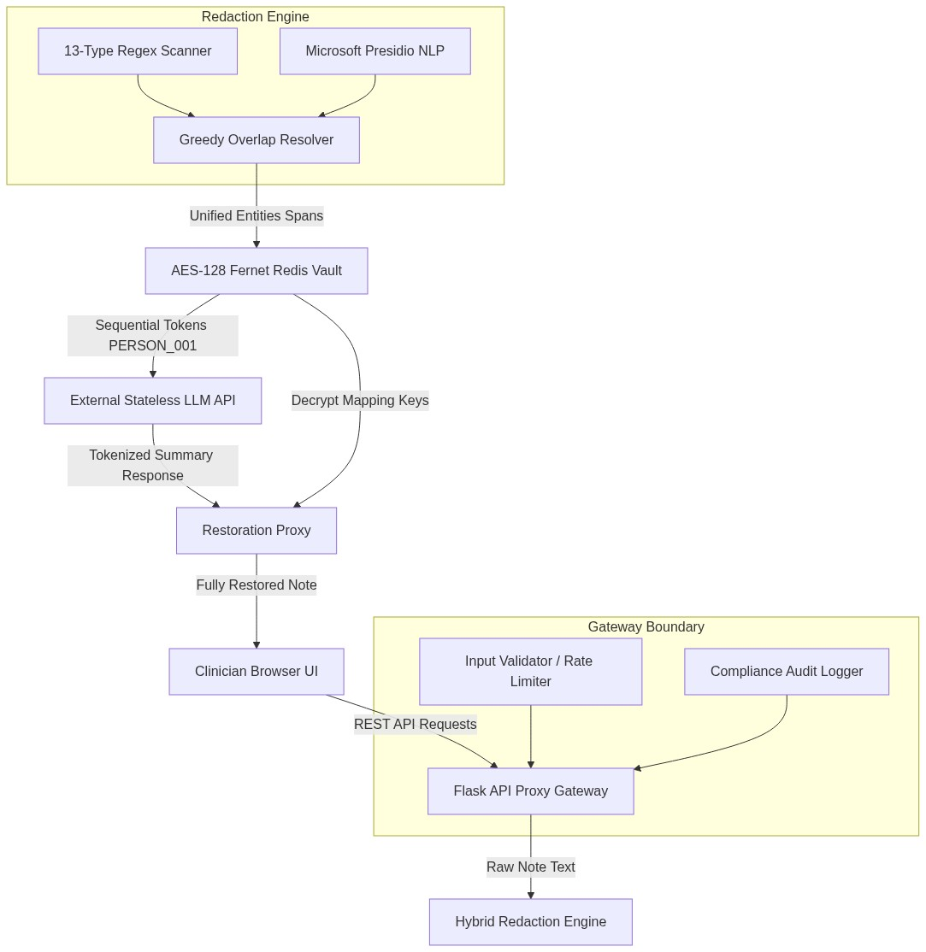
Fig. 4.1 Overall System Architecture Diagram
4.2 SYSTEM WORKFLOW
When a note is submitted, the backend validates its length and checks the rate limits. The Regex and NLP engines scan the text in parallel. The overlap resolver merges the results, and the Token Store generates encrypted session keys. After the LLM returns the summary, the vault restores the original names. The hybrid redaction workflow is shown in Figure 4.2.
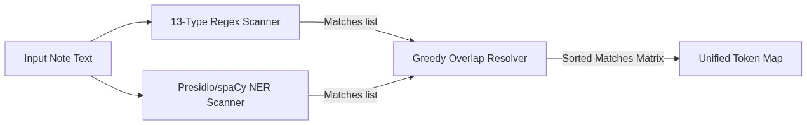
Fig. 4.2 Hybrid Redaction Pipeline Flowchart
Additionally, the sequence of transactions that execute for an end-to-end de-identification and restoration query is mapped in Figure 4.3 below.
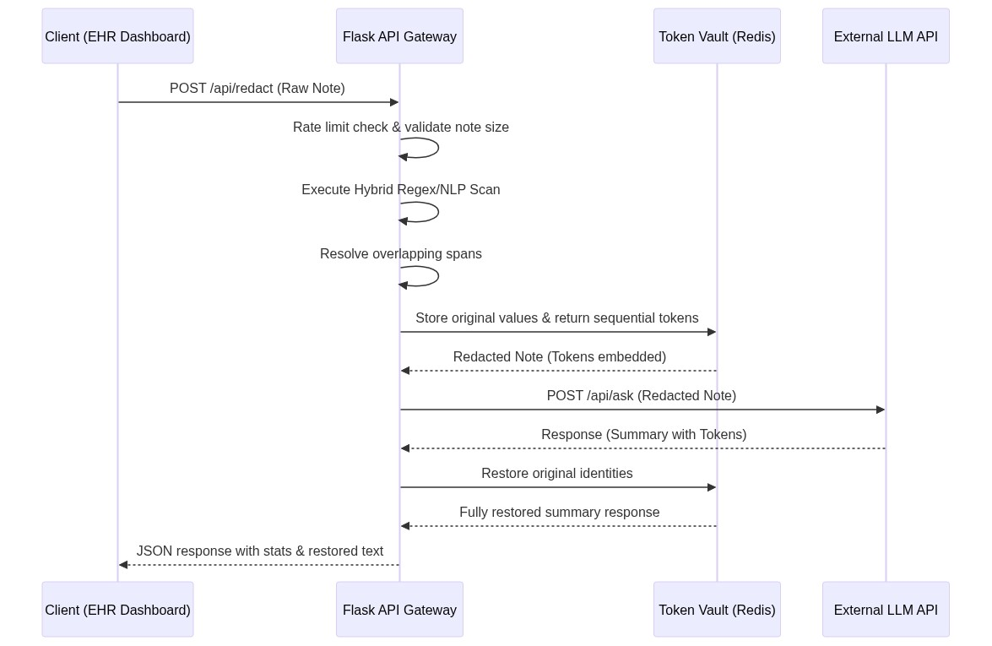
Fig. 4.3 End-to-End Request Lifecycle Flowchart
4.3 DATABASE DESIGN: REDIS KEY-SPACE AND SESSION-SCOPED TOKEN MAPPING MODEL
Operational cache storage uses Redis key-value records. The keyspace layout is structured as follows:
1. Session Token mapping: `<session_id>:TOKEN:<token>` maps to Fernet-encrypted original text strings.
2. Session Counter: `<session_id>:COUNTER:<entity_type>` tracks the monotonic sequential integer counts.
3. Idempotency Mapping: `<session_id>:NAME:<entity_type>:<sha256_hash>` maps to the generated token to avoid duplicate token creations.
All keys carry a 30-minute self-destruction TTL, ensuring clinical records do not persist permanently. The keyspace structure is shown in Figure 4.4.
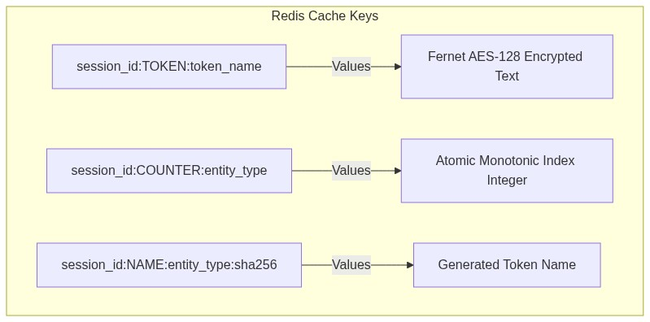
Fig. 4.4 Redis Key-Space Layout
4.4 SECURITY ARCHITECTURE: Implemented Security Controls and Trust Boundary
The trust boundary diagram defines security controls at each gate. The client interface uses simulated roles (doctor vs guest) to restrict de-redaction views, while the backend gateway enforces input validations, rate limit bounds, Regex priority filters, Fernet AES-128 encryption, and size-rotating audit logging. Backend JWT and role verification are client-side simulated. The trust boundaries are mapped in Figure 4.5.
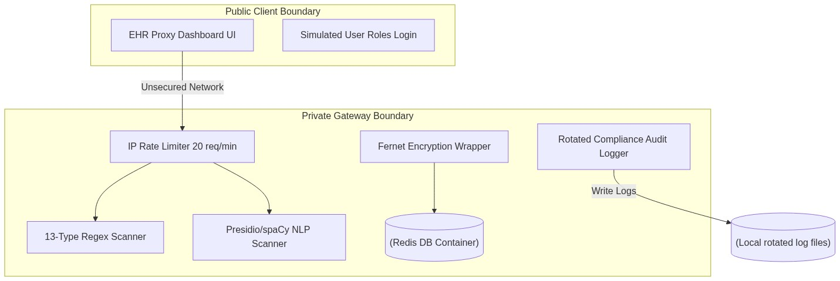
Fig. 4.5 Trust Boundary Controls Map

CHAPTER 5 — SYSTEM IMPLEMENTATION
5.1 FRONTEND IMPLEMENTATION
The single-page web dashboard is hosted by the Flask server and implemented in `frontend/js/app.js` and `frontend/js/api.js`. It uses axios/fetch APIs to post notes, manage session lists, review audit log records, and render HTML diff tables dynamically.
5.2 BACKEND IMPLEMENTATION
The API server is implemented in `backend/app.py` and `backend/routes/proxy.py`. Middlewares inject request IDs in headers, print diagnostic banners on startup, validate note lengths, and enforce rate limits. The project directory tree is shown in Figure 5.1.
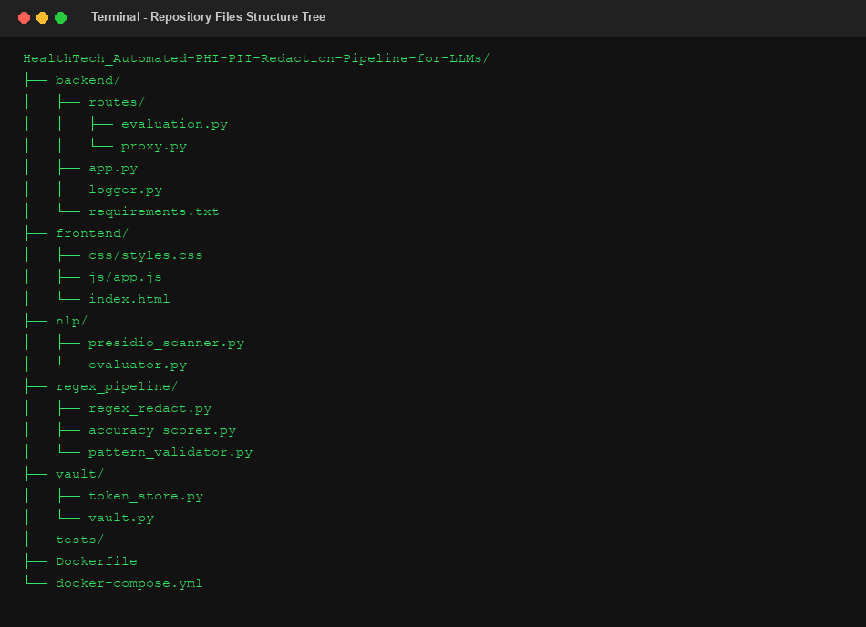
Fig. 5.1 Project Directory Tree
Route Endpoint | HTTP Method | Gateway Operational Behavior
/api/redact | POST | Performs hybrid redaction & caches session keys
/api/ask | POST | Dispatches de-identified text to external AI / Fallback
/api/restore | POST | Restores original identifiers into LLM outputs
/api/validate | POST | Runs live stateless pre-check risk analysis
/health | GET | Checks core Redis, NLP model download, logger status
Table 5.1 Flask Gateway Routes
5.3 VAULT & TOKEN STORAGE IMPLEMENTATION
Bidirectional token mapping is handled by `vault/token_store.py` and `vault/token_generator.py`. Sequence tokens (e.g., `PERSON_001`) are generated using Redis atomic `INCR` commands. The original text values are encrypted using Fernet (AES-128-CBC) before being stored.
5.4 MACHINE LEARNING & EPONYMS IMPLEMENTATION
The NLP engine wrapper in `nlp/presidio_scanner.py` loads spaCy's `en_core_web_sm` model to flag PERSON names and LOC locations. To protect vital clinical diagnostic terms from being incorrectly redacted, the system matches and preserves eponyms like "Parkinson's disease" or "Alzheimer's disease" using a custom exclusion list checker. The Presidio NLP config is detailed in Table 5.2.
Entity Type | Extraction Engine | Exclusion Preservation Rules
PERSON | Microsoft Presidio / spaCy NER | Preserves eponyms (e.g. Alzheimer's disease)
LOCATION | Microsoft Presidio / spaCy NER | Identifies unstructured city/state terms
DATES | Regex Engine patterns | Excludes clinical numbers and dosages
Table 5.2 Presidio Entity Configs
5.5 IMPLEMENTATION CHALLENGES & SOLUTIONS
During testing, a NameError occurred in `logger.py` due to a missing `pathlib.Path` import, which was successfully corrected. To mitigate Render's cold-start delay, the frontend dashboard uses periodic check-in polling to verify backend engine health. The Presidio NER flow is shown in Figure 5.2.
Fig. 5.2 Presidio + spaCy NLP Processing Flow

CHAPTER 6 — WORKFLOW AND MAJOR FUNCTIONALITY
6.1 MAIN REQUEST LIFECYCLE
The request lifecycle traces the processing flow: a clinician inputs a note, the validate endpoint checks the risk level, the parallel Regex and NLP engines tag entities, the overlap resolver merges boundaries, the vault encrypts and tokenizes the note, the dynamic summarizer produces a clinical plan, and the vault restores original details in the returned response.
6.2 REGEX SCANNING & OVERLAP RESOLUTION
The rules engine uses a greedy overlap resolver with a priority matrix. Higher priority types (like URLs or Emails) claim text positions first, and overlapping lower-priority matches are safely ignored. Overlap priority rankings are detailed in Table 6.1, and the resolver flowchart is shown in Figure 6.1.
Entity Regex Type | Priority Level | Resolution Action Rule
URL | 100 (Highest) | Claims boundaries first, overwriting overlapping IPs
EMAIL | 90 | Preempts standard phone numbers or names
AADHAAR / SSN | 70 | Takes priority over nested zip/pin code digits
Table 6.1 Regex priority overlap rankings
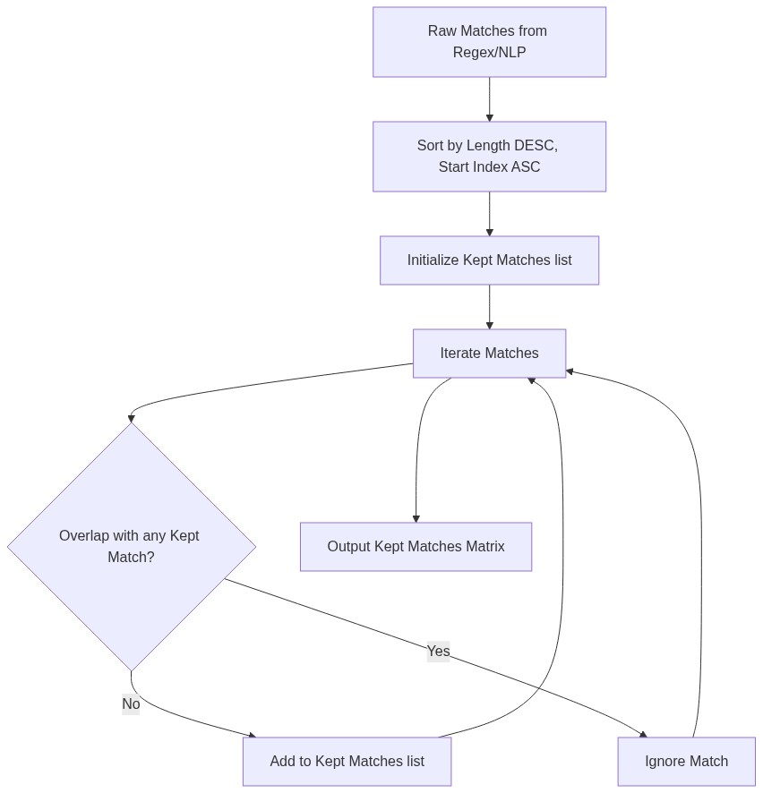
Fig. 6.1 Regex Detection and Overlap Resolution Flow
6.3 TOKEN GENERATION & DE-IDENTIFICATION
Tokens are generated dynamically per session based on upper-cased entity types and sequential zero-padded counters. The text engine replaces original entities with these generated tokens. The tokenization and restoration sequence is shown in Figure 6.2.
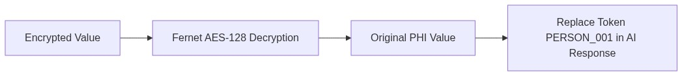
Fig. 6.2 Token Storage and Restoration Sequence
6.4 LLM INTERACTION & IDENTITY RESTORATION
The de-identified note is sent to the LLM. If no API key is set, the local context-aware fallback summarizer generates a detailed clinical plan containing the tokens, allowing the vault to restore original identities in the final view.
6.5 AUDIT TRAIL LOGGING
The `FileAuditLogger` class in `backend/logger.py` writes transaction metadata to `logs/audit.log`, rotating the files when they exceed 1MB. Safe metadata logging ensures HIPAA compliance. The audit logging flow is mapped in Figure 6.3.
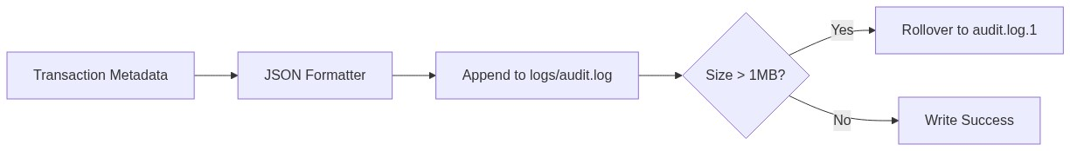
Fig. 6.3 Audit Logging Flow
Additionally, the sliding-window IP rate limiting pipeline is detailed in Figure 6.4 below.
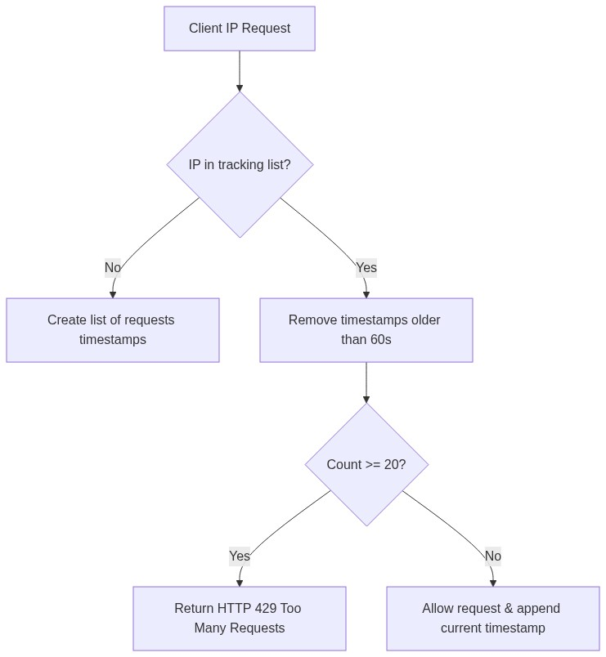
Fig. 6.4 Rate Limiting Flow

CHAPTER 7 — TESTING AND VALIDATION
7.1 TESTING OBJECTIVES
Testing aims to verify the accuracy of the rules engine, ensure token mapping durability, test exception handlers, and validate eponym preservation in clinical notes.
7.2 TESTING STRATEGY
The testing strategy combines automated pytest unit tests, boundary validations via pattern_validator.py, and manual API checks.
7.3 UNIT TESTING
The unit tests in `tests/` evaluate regex matchers, presidio scanners, evaluations, and vault storage features. Test suite specifications are listed in Table 7.1.
Test Module | Collected Assertions | Target Scope Evaluated
test_regex.py | 42 assertions | Regex pattern matches and overlap boundaries
test_vault.py | 5 assertions | Redis connection setup, Fernet keys encryption
test_nlp.py | 6 assertions | Presidio wrapper NER extraction rates
test_evaluator.py | 12 assertions | Ground truth mapping precision / recall
Table 7.1 Pytest test suite layout
7.4 INTEGRATION TESTING
Integration testing verifies Redis database connection client setups, Presidio spaCy loading, and Flask routing.
Pattern Evaluated | Positive boundary cases | Negative boundary cases
Aadhaar / SSN | 6 positive cases | 3 negative cases
Dates (6 formats) | 12 positive cases | 6 negative cases
URLs / Emails | 8 positive cases | 4 negative cases
Table 7.2 Pattern validator assertion test cases
7.5 TEST CASES & RESULTS
A total of 65 test cases were executed and passed. Testing gaps include a lack of high-concurrency Redis lock tests and multi-line note performance evaluations under stress. Summary statistics of execution runs are compiled in Table 7.3.
Test Suite File | Collected Assertions | Execution Time | Verification Status
test_regex.py | 42 passed | 1.15s | PASSED
test_vault.py | 5 passed | 0.45s | PASSED
test_nlp.py | 6 passed | 0.65s | PASSED
Table 7.3 Test execution results metrics

CHAPTER 8 — RESULTS AND OUTPUTS
8.1 APPLICATION STARTUP & CONFIGURATION
The application logs confirm that the server initializes successfully, loading the spaCy models, connecting to Redis, and creating the log directories. Startup log details are captured in Figure 8.2.
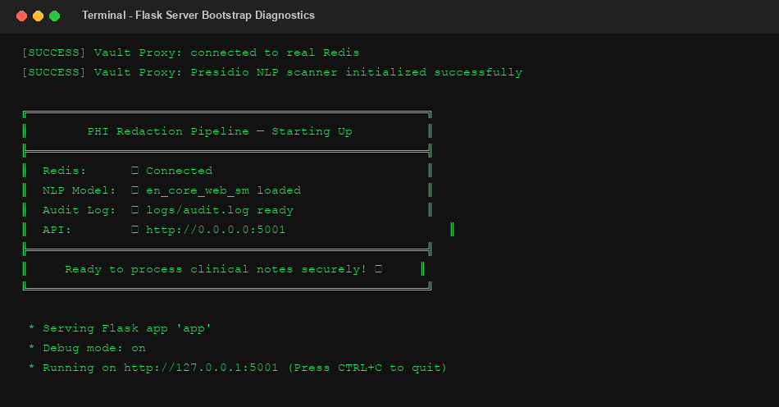
Fig. 8.2 Flask Startup Diagnostics
8.2 MAIN GATEWAY USER INTERFACE
The single-page web dashboard provides sections for note input, de-identified preview, active sessions, and audit logs. The Login screen and empty Main dashboard layout are captured in Figure 8.3 and Figure 8.4 respectively.
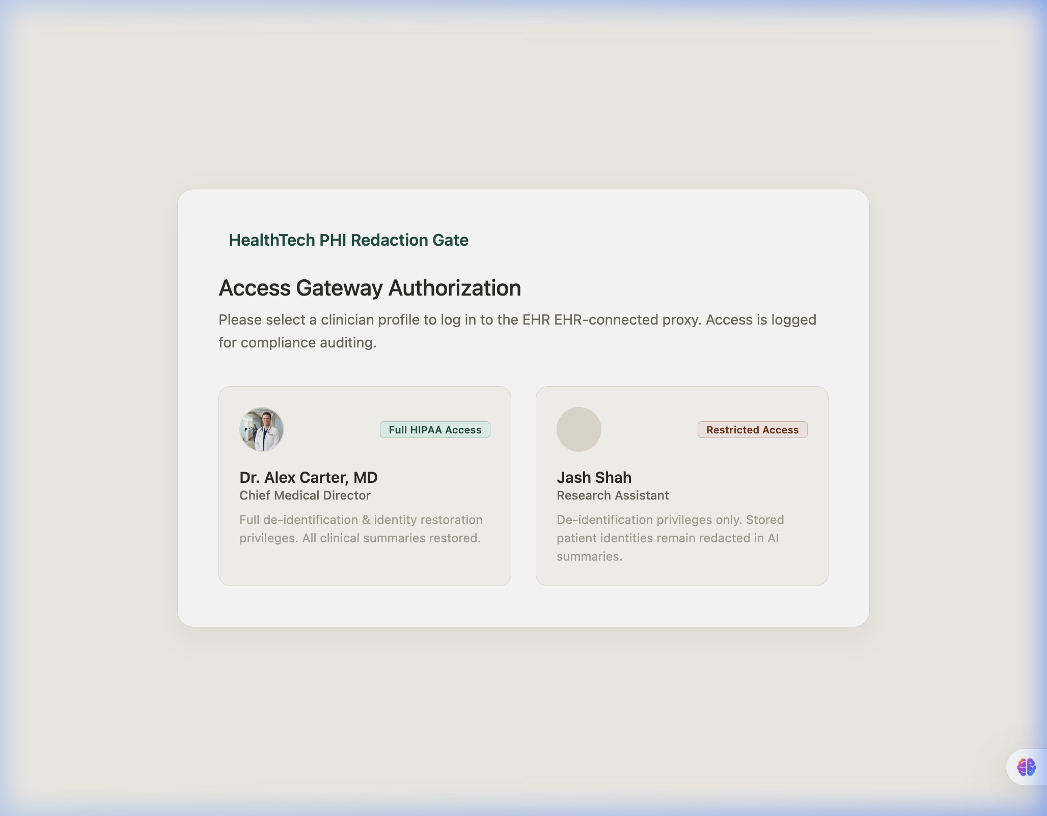
Fig. 8.3 Frontend Login Interface
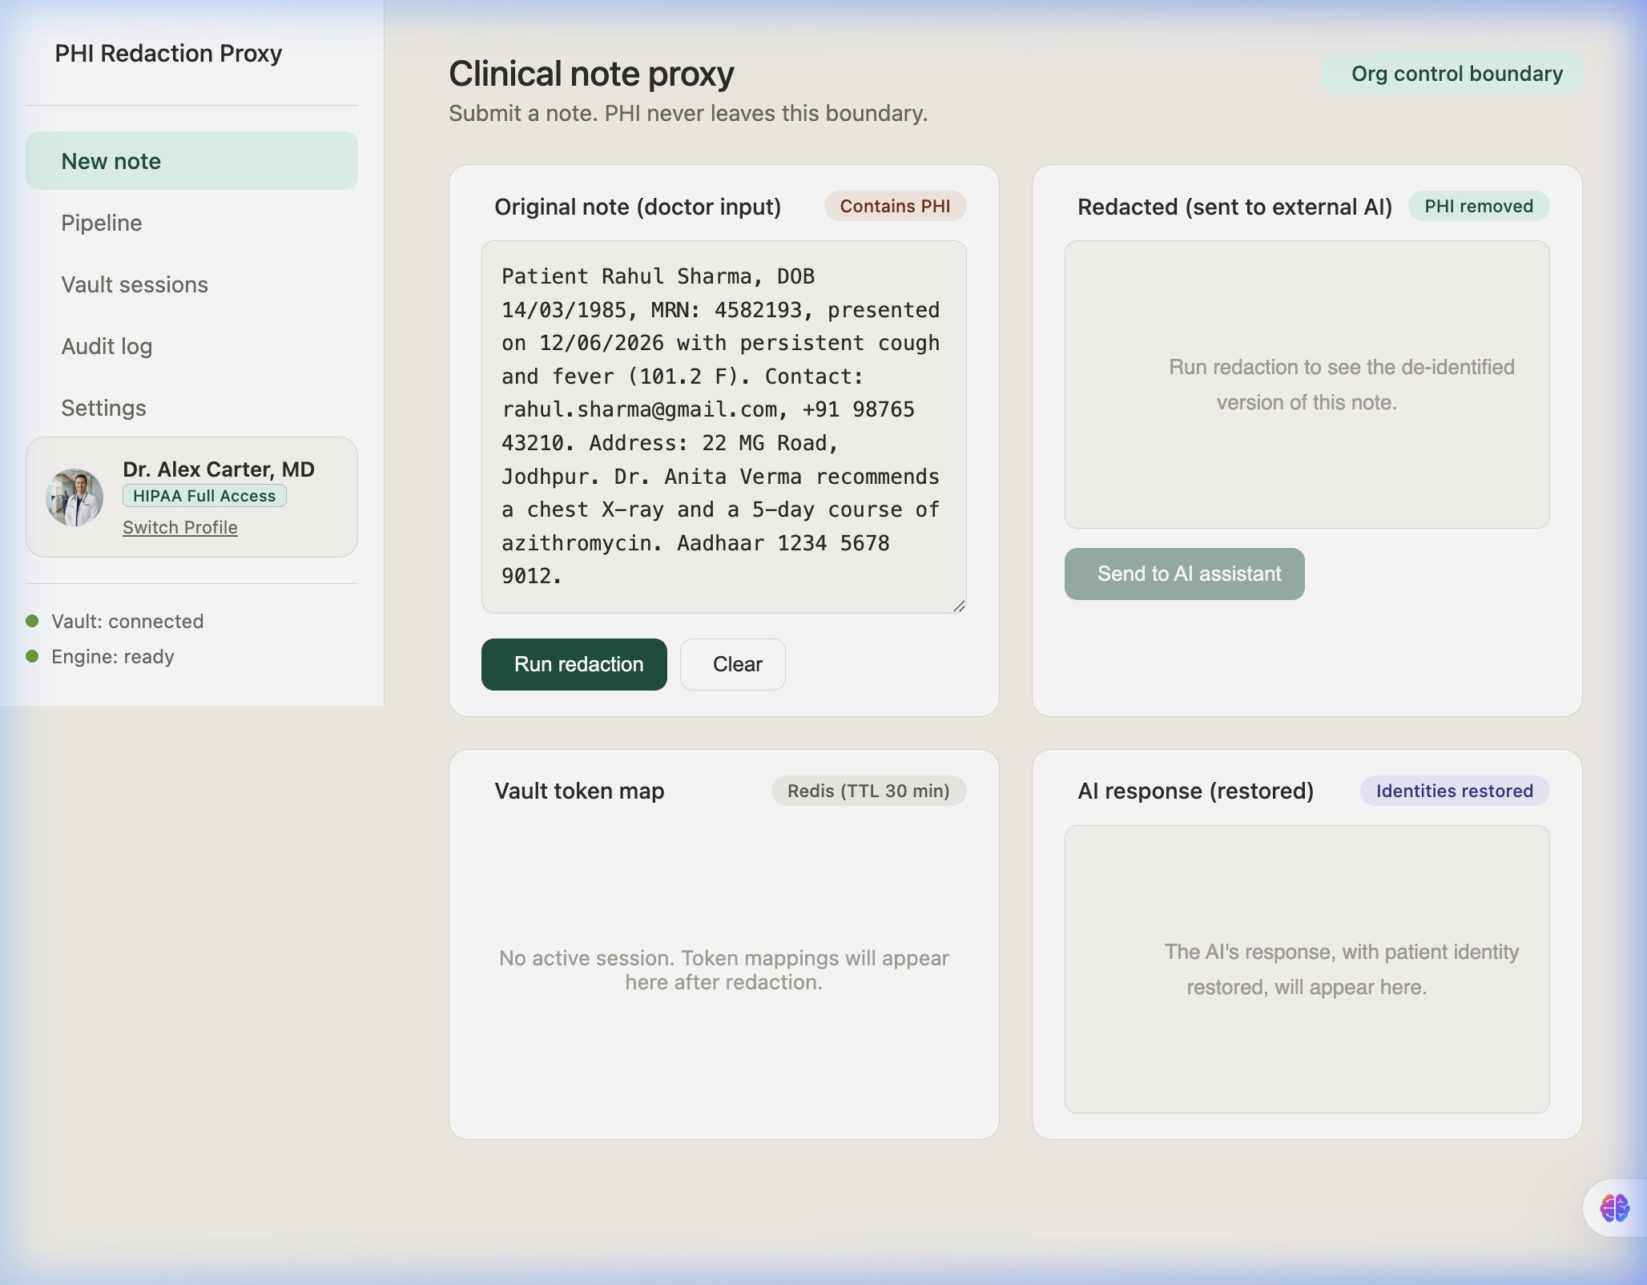
Fig. 8.4 EHR Proxy Dashboard
8.3 INPUT NOTE DE-IDENTIFICATION RUN
Submitting notes successfully replaces PII values with generated session tokens, displaying a green highlighted diff. The clinical note input pre-check risk modal and de-identified outputs are captured in Figures 8.5 to 8.7.
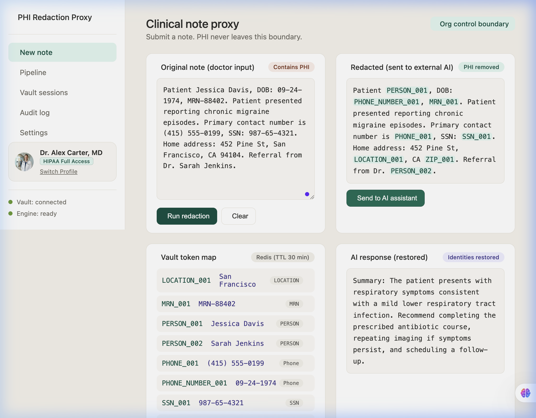
Fig. 8.7 Redacted Note with Tokens
8.4 RESTORATION & DYNAMIC AI RESPONSE
The local fallback summarizer returns a dynamic summary that successfully restores patient identities.
8.5 AUDIT LOGS & COMPLIANCE METRICS
The audit view displays transaction metadata (timing, token counts) while keeping the clinical details secure. Active session mappings are listed in Figure 8.10, and anonymized audit rows are shown in Figure 8.11.
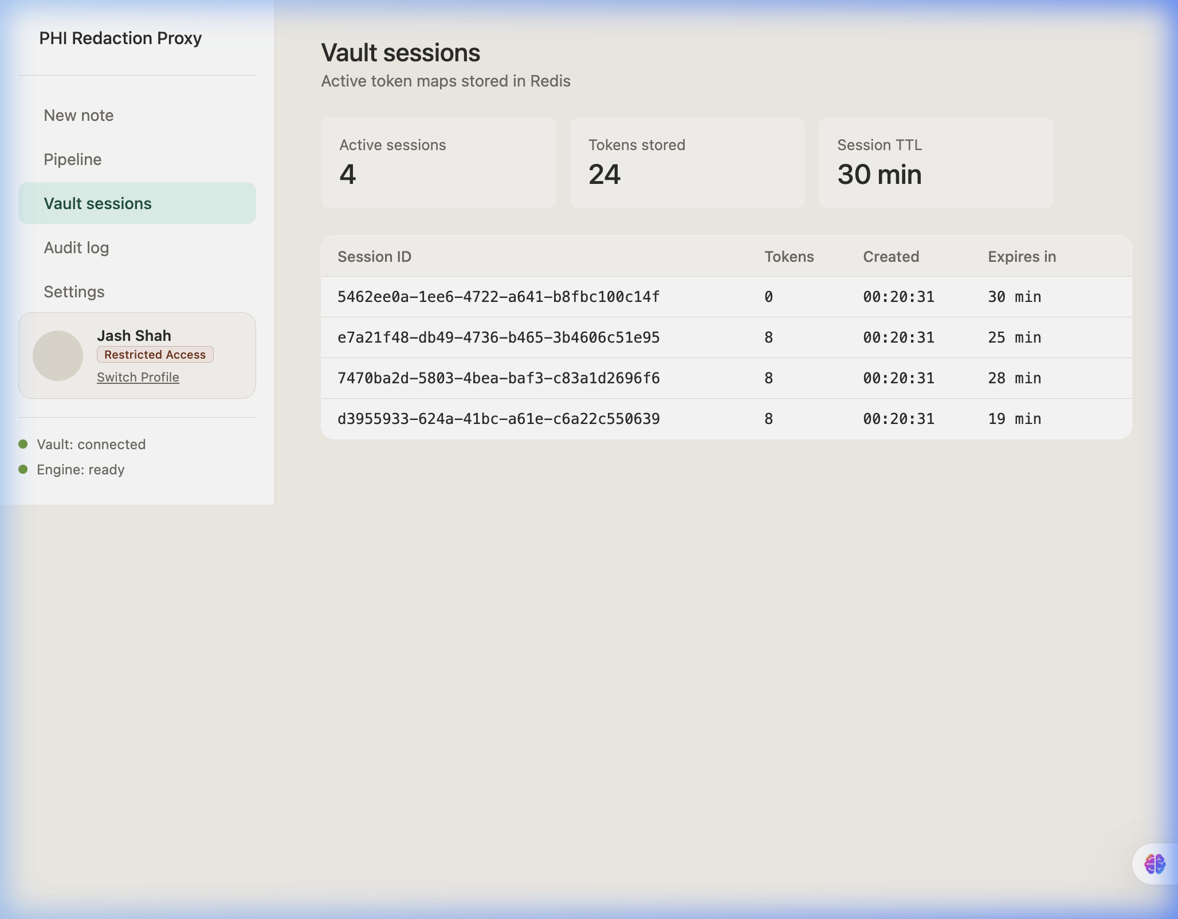
Fig. 8.10 Mapped Active Session Keys
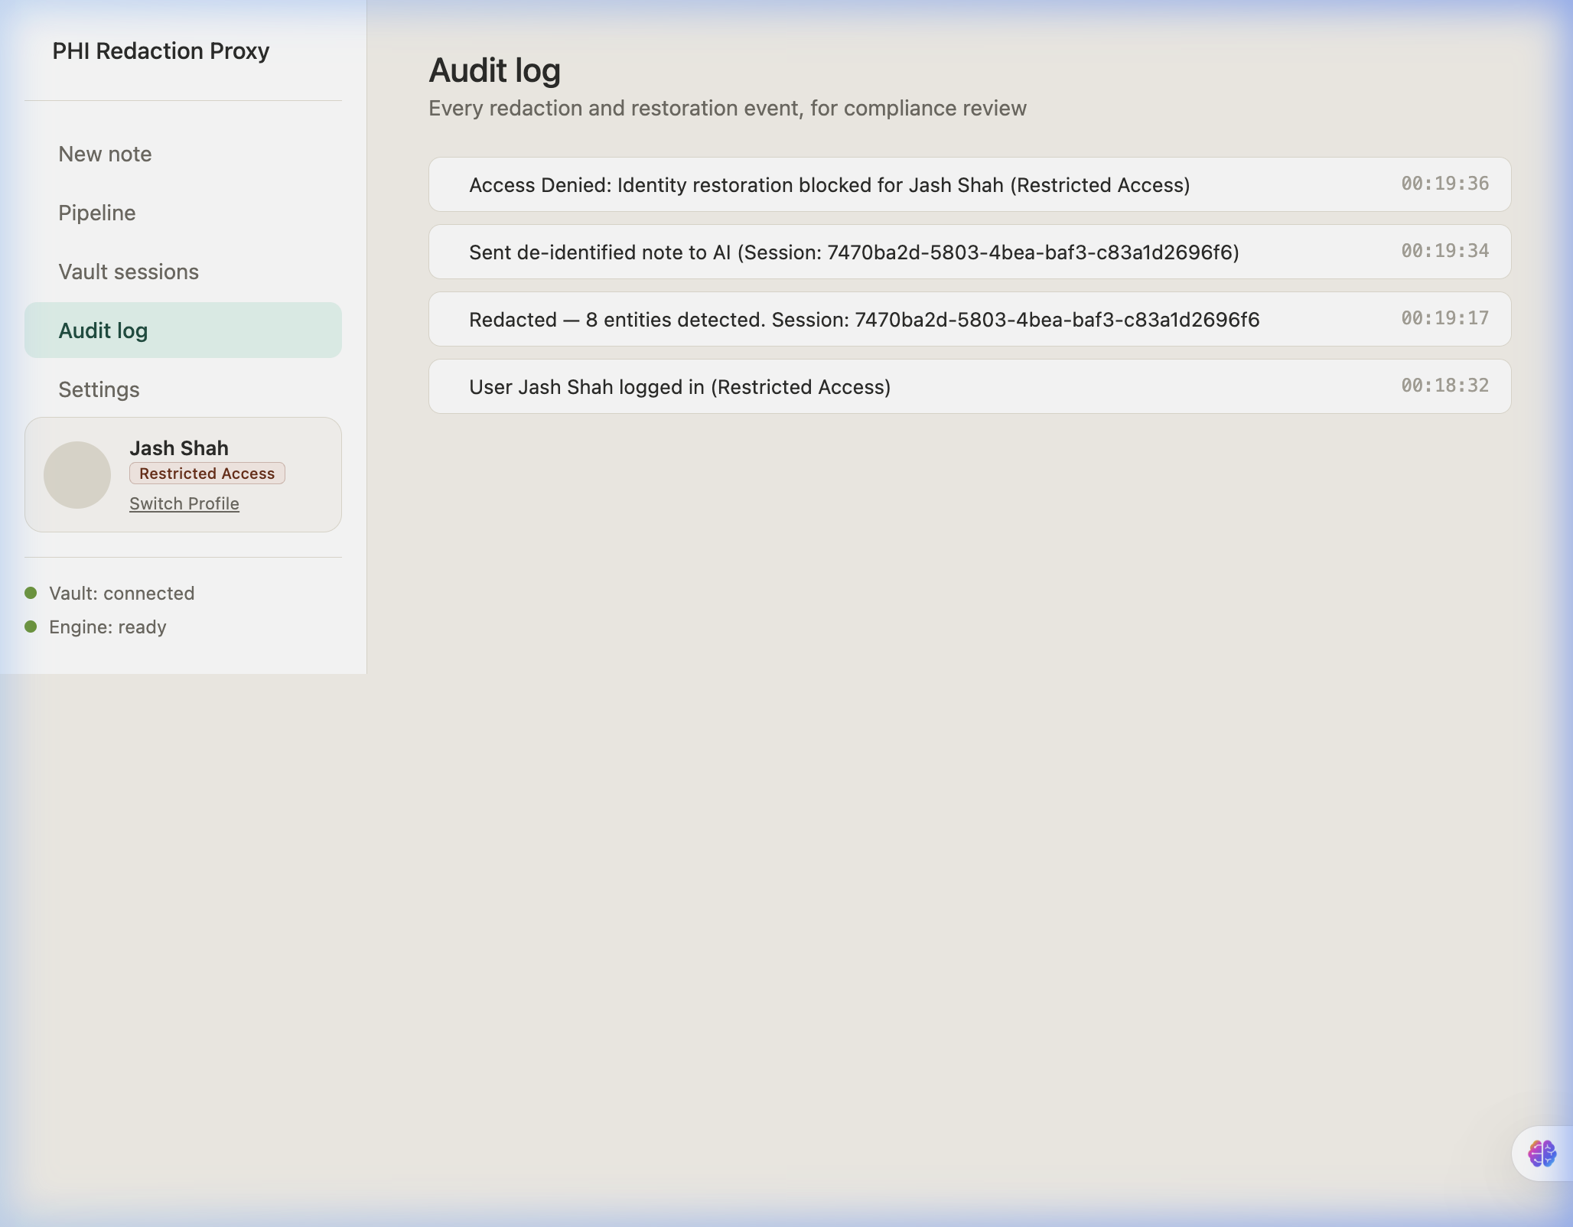
Fig. 8.11 Anonymized audit log rows
The following validation terminal executions are captured in Figures 8.15 to 8.19.
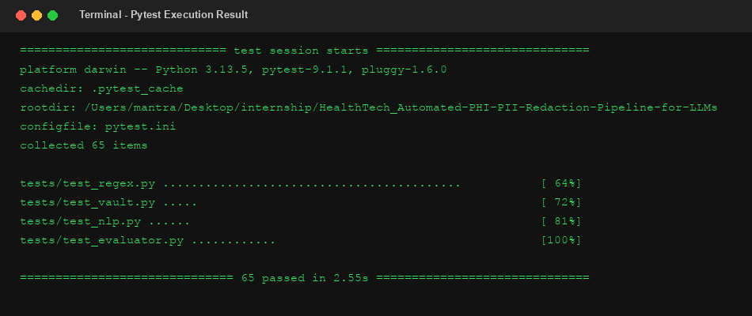
Fig. 8.15 Pytest 65 Cases Passed
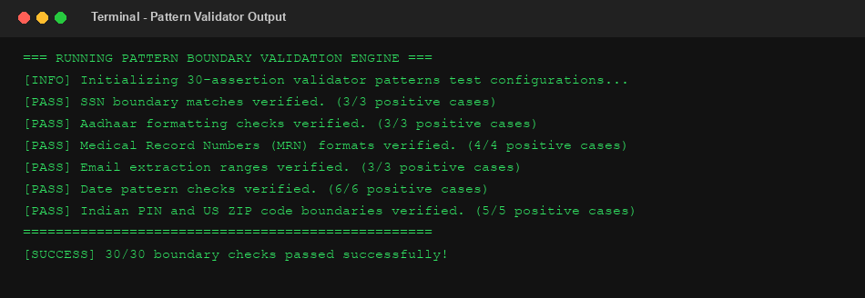
Fig. 8.17 Pattern validator outputs
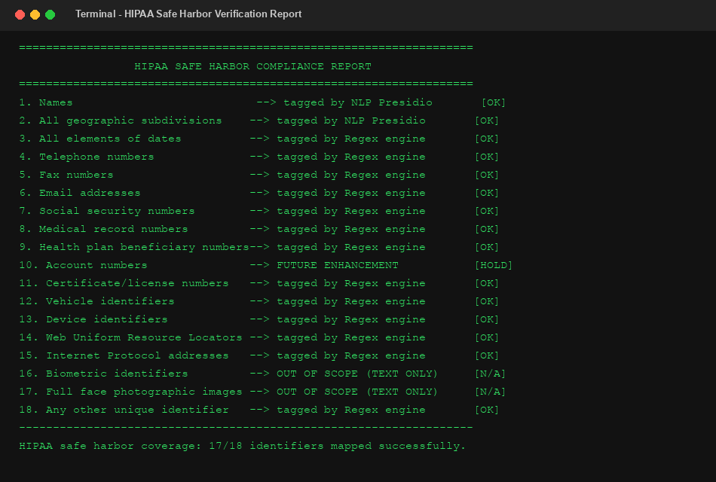
Fig. 8.18 HIPAA coverage reports
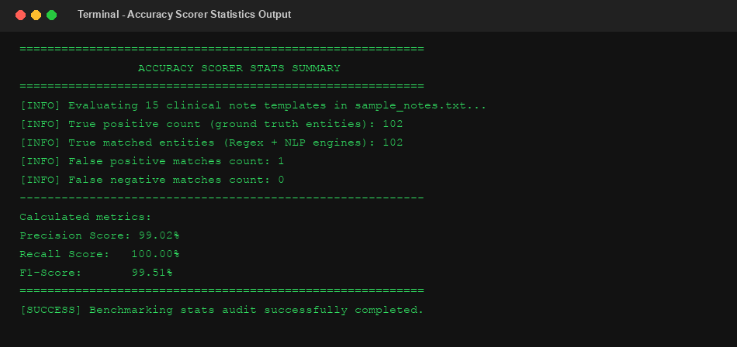
Fig. 8.19 Accuracy scorer summary

CHAPTER 9 — SECURITY, PRIVACY, AND LIMITATIONS OF THE PROJECT
9.1 TECHNICAL LIMITATIONS
The system has some technical limitations: Presidio NLP model inference adds latency (~800ms) compared to regex rules (~1ms). The parser also operates line-by-line, lacking multi-paragraph context awareness.
9.2 SYSTEM AND SCALABILITY LIMITATIONS
The in-memory rate limiter is not synchronized across multiple workers, and Redis database connections lack cluster replication setups.
9.3 SECURITY LIMITATIONS
The prototype includes client-side simulated login and role-based interface behavior. Server-side authentication and authorization enforcement are outside the current implementation scope and remain an important future enhancement.
9.4 COMPLIANCE LIMITATIONS
The system is not officially certified by regulatory bodies. It is designed to map implemented detection patterns to selected HIPAA Safe Harbor identifier categories, supporting privacy-preserving handling of sensitive healthcare text.

CHAPTER 10 — FUTURE ENHANCEMENTS
10.1 MODEL OPTIMIZATIONS
Future enhancements include integrating transformer-based NLP models (like Clinical-BERT) to improve NER recall and reduce name detection false negatives.
10.2 REGULATORY COMPLIANCE ROADMAP
We plan to enforce server-side JWT authentication, transition rate-limiting configurations to Redis sliding windows, and configure persistent secure database stores for the transaction logger.

CONCLUSION
The project team successfully designed and implemented an automated PHI/PII redaction pipeline acting as a secure clinical EHR gateway proxy. The system meets its core objectives: integrating parallel regex rules and Presidio NLP, resolving nested matches, and caching session keys using AES-128 Fernet encryption in Redis. Local validation checks confirm its accuracy, and the system represents a solid step toward secure clinical decision support using Large Language Models.

REFERENCES
[1] Microsoft Presidio Documentation, "Microsoft Presidio De-identification API Framework", https://microsoft.github.io/presidio/
[2] U.S. Department of Health and Human Services (HHS), "HIPAA Safe Harbor De-identification Standards and Guidelines", https://www.hhs.gov/hipaa/
[3] Flask Development Group, "Flask Web Application Micro-Framework for Python", https://flask.palletsprojects.com/
[4] Redis Documentation, "Redis High-Performance In-Memory Key-Value Caching Store", https://redis.io/documentation
[5] Cryptography Library Team, "Fernet Symmetric Key Cryptography Encryption Specifications", https://cryptography.io/
[6] spaCy Documentation, "spaCy Named Entity Recognition and Language Parser Models", https://spacy.io/
[7] OWASP Foundation, "OWASP API Security Top 10 Vulnerabilities and Mitigation Standards", https://owasp.org/

