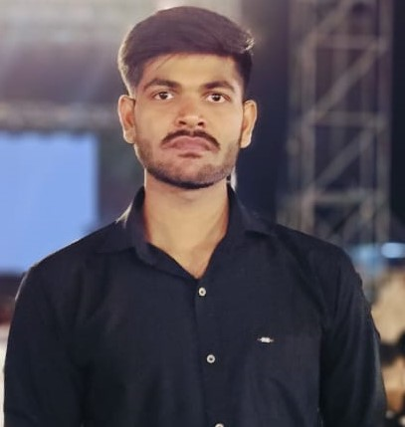SAHIL KUMAR

An enthusiastic learner looking for an opportunity to work with a leading software company preferably as a SDE/SWE or any other relevant role that allows me to utilize my skills in programming, problem-solving, and software design to develop software.

# CONTACT

 9162231102

 [sahilkumar952558@gmail.com](mailto:sahilkumar952558@gmail.com)

 [sahilkumar.118969@marwadieduc ation.edu.in](mailto:sahilkumar.118969@marwadieduc%20ation.edu.in)

 [www.linkedin.com/in/sahil-kumar-a7873a259](http://www.linkedin.com/in/sahil-kumar-a7873a259)

* <https://github.com/Swartz9525>

 Rajkot, Gujarat

# SKILLS

C,Java, JavaScript

Data Structure & Algorithm Problem solving skills

HTML , CSS , ReactJs , Nodejs

MongoDB, Sql

# CERTIFICATE

**NDG Linux Essentials**

Platfrom- Cisco Networking Academy

#### CCNAv7: Switching, Routing, and Wireless Essentialst

Platfrom- Cisco Networking Academy

**Oracle Academy - (SQL)**

**Hackathon Participate**

**Internpedia -** Internship Certificate

# CP PROFILE

# [Leetcode](https://leetcode.com/pankaj7464049/)EDUCATION

**Bihar School Examination Board(10th)**

2019-2020

Percentage : 73%

**Bihar School Examination Board(12th)**

2020-2022

Percentage : 80%

#### Marwadi University, Gujarat

2022-Present

Bachelor of Technology (Computer Engineering)

8.71/10 CPI

# Key Strengths

## Strong Technical Proficiency: "Proficient in full-stack development with expertise in the MERN

* Passion for Learning
* Adaptability and Flexibility
* Effective Team Player and Communication Skills

# PROJECT

## E-commerce Website

Developed an e-commerce web app using **HTML**,**CSS** and **Javascript**, demonstrating proficiency in Front-End Development.



Created responsive and user-friendly interfaces, ensuring optimal user experience across devices.

Implemented essential features such as product listing, shopping cart to enable seamless shopping experiences.

## Seamless Appoinment and Digital Health Cards for Personalized Healthcare Access

Develop a user-friendly website for patients to find and book appointments with hospitals based on specific needs..



Implement hospital categorization and filtering options (e.g., price, distance) for easy navigation

Integrate a digital health card creation feature upon user account setup. Enhance user experience by eliminating the need for paper records and promoting environmental sustainability. Utilized MERN Stack Development

## Travel and Tourism Website with Advance Java Technology

Designed and developed a comprehensive travel and tourism website using Java and Swing GUI..



I. Implemented a robust SQL database management system to efficiently handle user data, bookings, and transactions.

Integrated advanced Java technologies to enhance user experience and provide seamless navigation. User - friendly interface, ensuring a high level of customer satisfaction