Hello {USERNAME},

Please see below your login details. Could you please confirm that you were able to login successfully and update your password?

URL: {URL}
Username: {USERNAME}
Password: {PASSWORD}

To update your password

- Click on your username menu on the top right corner of your browser and select Profile.
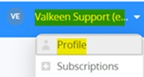

- Enter and confirm your new password in the highlighted fields.
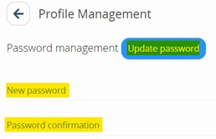
- Click Update password.

Following our Tempus PoC discussion, Akash listed you in the Google Sheet as the point of contact for the API topic.

The API documentation you can find in the help center in Tempus. This covers both inbound and outbound integration scenarios.
URL: https://roche.tempus-resource.com/sg/apidoc/index.html

If you are the right contact for this topic, I would suggest a short call (mid-end) next week to walk through the setup and align on the next steps. Please let me know what works best for you.

Many thanks,

Manuel Weiss

__________________________
Implementation Specialist

VALKEEN
Valkeen GmbH
Bahnhofstrasse 64
8001-Zurich
Switzerland
weiss@valkeen.com
www.valkeen.com
Strategic Partner for Tempus Resource by ProSymmetry
www.valkeen.com
www.tempus-resource.eu



