Waris: Design and Architecture
An agentic AI system for unclaimed inheritance recovery · Review 2 Design Document
Course | Agentic AI (26CD7PEAAI) · B.E. CSE (Data Science) · Sem VII · BMS College of Engineering · Dr. Kalyan Nagaraj
Team | Srijan C Vachadmath (Team Lead) · Chirag T · Manohara Salmani · Mohammed Arshaq
Sector / niche | Personal finance and legal-tech: unclaimed inheritance recovery for families of deceased persons
Patterns used | Supervisor multi-agent (plan-and-execute) · ReAct tool use · corrective (agentic) RAG · reflection (Verifier critic loop) · human-in-the-loop · durable checkpointed workflow

1. Problem, decision and scope
Over ₹1.1 lakh crore of financial assets lay unclaimed in India in FY26 [1], and banks returned only ₹10,297 crore between April 2022 and November 2025; the Supreme Court asked in May 2026 how legal heirs are even informed [2]. Government portals (UDGAM, Bima Bharosa, IEPF, the June 2026 Common Landing Portal) help families search, but none knows each institution's claim rules, fixes mismatches such as ‘R. Subramanian’ versus ‘Ramaswamy Subramanian’, or builds the claim. Waris targets that gap with one decision:
Decision supported. For each asset a deceased person left behind (bank deposit, life insurance, shares): is the claim ready to file, and if not, exactly what is missing?
Scope and safety. Output per asset is READY, MISSING_ITEMS or NEEDS_HUMAN_REVIEW with a document checklist in which every item cites the rule it came from. Waris is advisory only: it never moves money, never submits a claim and never decides legal heirship; all data is synthetic and personal details are masked in traces.
2. System architecture
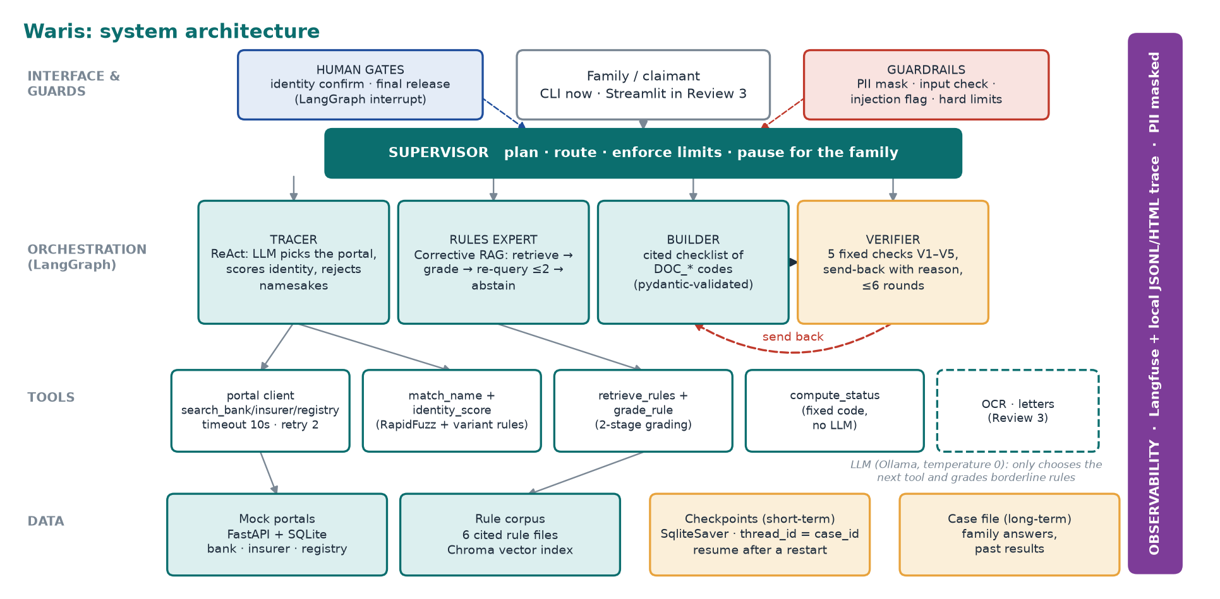
Figure 1. Layered architecture: LangGraph orchestration over tools and data, with observability across all layers.
Component | Technology | Responsibility | Owner | Status
Orchestration, HITL, checkpoints | LangGraph, SqliteSaver | graph wiring, interrupts, resume | Srijan | built
Mock portals + identity matching | FastAPI, SQLite, RapidFuzz | noisy bank/insurer/registry records; name + DOB + city score | Chirag | built (OCR: Review 3)
Rule corpus + retrieval + grading | Markdown, Chroma | cited claim procedures; retrieve, grade, re-query, abstain | Manohara | built
Tracing, evaluation, tests | Langfuse, JSONL/HTML, pytest | trace every step; scorecard vs answer key; 18 tests | Mohammed | built (full harness: Review 3/4)
LLM | Llama 3.1 8B via Ollama, T=0 | choose next tool; grade borderline rules only | all | built, with fixed fallbacks

3. Agent graph, state and data flow
The system is a LangGraph state machine. A Supervisor validates input, plans one task per asset type and routes; four specialists do the work. State is checkpointed in SQLite after every node under thread_id = case_id, so a killed process resumes at the exact step. Two nodes call interrupt(): identity confirmation (on a medium match) and final release.
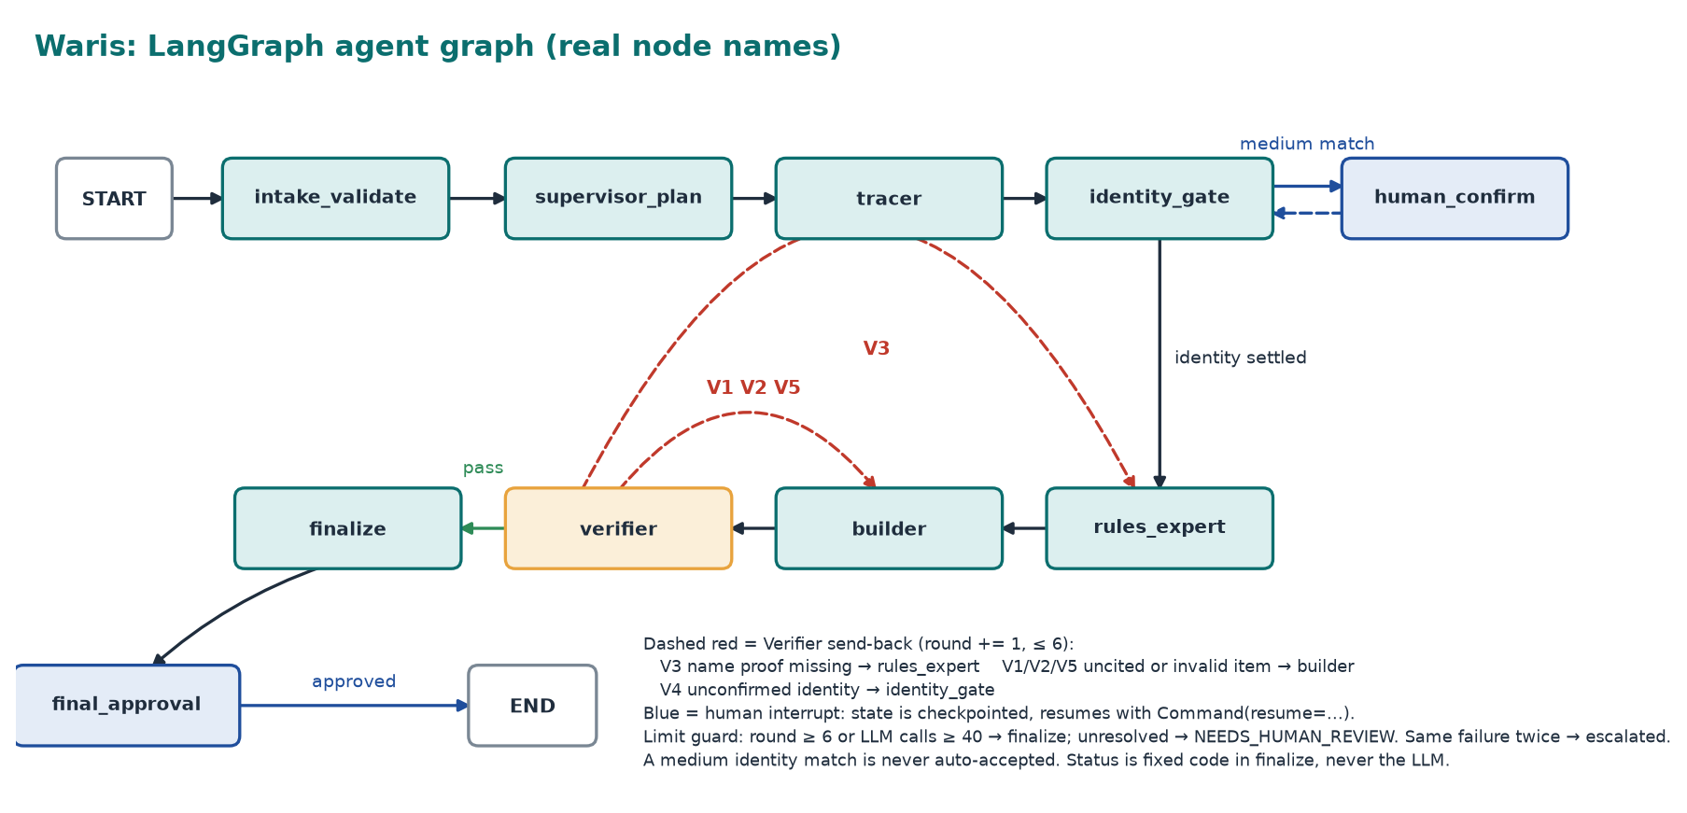
Figure 2. The compiled graph (printed from code with --show-graph). Dashed red: Verifier send-back, ≤ 6 rounds. Blue: human interrupts.
CaseState (working memory) holds: case_id, deceased, claimant, plan, candidate_assets (record, match score, evidence, identity_confirmed), rejected_candidates, applicable_rules (asset → graded rules), abstained, claim_packs (status, requirements{doc_code, rule_id, have_it}, missing, notes), verifier_feedback, round, llm_calls, human_answers, done. Account numbers, PAN and phone are masked before any trace leaves the process.
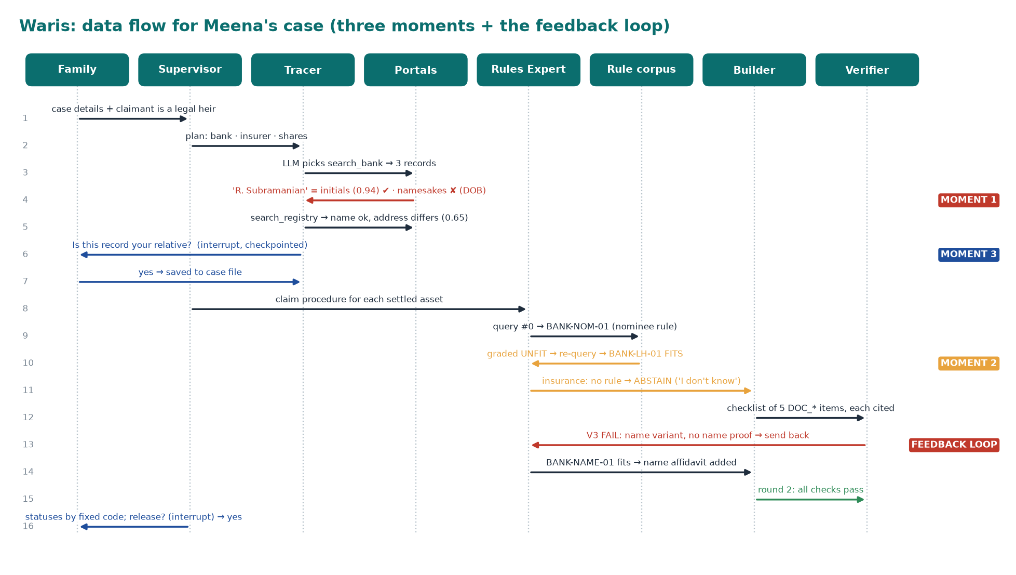
Figure 3. Meena's case end to end: Moment 1 (name variant, namesakes), Moment 2 (nominee rule graded unfit), Moment 3 (address mismatch → ask), and the Verifier feedback loop.
4. Agentic patterns: where, why, and what was rejected
Pattern | Where in Waris | Why chosen | Alternative rejected
Plan-and-execute | Supervisor plans one task per asset type | asset types known up front; plan is auditable | pure ReAct for everything: unbounded, hard to audit
ReAct [3] | Tracer: LLM picks a portal, observes, picks the next | next search depends on what came back | fixed pipeline: cannot adapt to an empty or failed source
Corrective / agentic RAG [4] | Rules Expert: retrieve → grade → re-query ≤ 2 → abstain | the most similar rule can be the wrong procedure (nominee vs legal heir) | plain top-k RAG: wrong rule passes silently
Reflection / critic [5] | Verifier V1–V5, send back with a reason | a separate critic catches omissions and can be ablated | self-check in the Builder: biased, cannot be switched off
Supervisor multi-agent | Supervisor + 4 specialists | one router holds every limit and safety rule | peer-to-peer swarm: loops harder to bound
Human-in-the-loop | interrupt() on medium identity match and before release | a wrong-person match is the worst error | auto-accept above a threshold: breaks the 0 wrong-person target
Durable workflow + memory | SQLite checkpoint per node; separate case file | cases run for weeks as documents arrive | in-memory state: restart loses the case

Fixed code versus LLM. Status, citations, identity scores, rule metadata grading and every limit are fixed code; the LLM only chooses the next tool (validated JSON; tool arguments always come from case facts) and grades a rule when metadata cannot decide. This makes runs reproducible, testable against an answer key, and independent of a small model: if Ollama is slow, wrong or off, a deterministic fallback keeps the run going. Verifier checks: V1 every item has a rule_id; V2 that rule exists and requires that document; V3 a name variant implies name-variation proof; V4 a medium match must be family-confirmed; V5 the pack validates against the ClaimPack schema. Each failure names the agent that can fix it (V3 → Rules Expert, V1/V2/V5 → Builder, V4 → identity gate).
Limit (all loops bounded) | Value | When hit
Verifier rounds per case · same check failing twice | 6 · 2 | asset → NEEDS_HUMAN_REVIEW · asset escalated (no ping-pong)
RAG re-queries per asset · Tracer steps · LLM calls per case | 2 · 8 · 40 | abstain ‘I don't know’ · stop searching · finalize with fixed fallbacks
Tool timeout · retries · LLM invalid JSON | 10 s · 2 · 1 retry | source flagged unavailable, never guessed · then fixed fallback

Agentic RAG and identity. Identity policy: score = 0.5·name + 0.3·DOB + 0.2·city (a missing field counts 0.5; a DOB conflict is a namesake and is rejected outright). ≥ 0.85 accept; 0.60–0.85 always ask the family; < 0.60 reject. Thresholds are tuned on the 40 dev cases only.
5. Data sources and tool plan
Mock portals. Three FastAPI portals over SQLite (/bank, /insurer, /registry) return fuzzy, noisy candidates including namesakes (same name, different DOB), initials, old addresses, and one record carrying injected instruction text to test the prompt-injection guard. Portal text is treated as data: only whitelisted fields pass on.
Rule corpus. Six markdown rule files in Chroma, written from public RBI, IRDAI and IEPF procedure types, each versioned and marked verified: illustrative until checked against official circulars. Front matter: rule_id, institution_type, topic (claim_procedure | name_variation), applies_to (nominee | legal_heir | any), amount_band, requires[DOC_*], version, source_url. Twenty fixed DOC_* codes are shared by rules, Builder and answer keys, which makes checklist precision and recall computable. One situation is deliberately uncovered (insurance claim where the nominee has died) so the abstention path is testable.
Synthetic data pipeline. (1) generate the hidden true world (person, assets, family); (2) write messy portal records from it; (3) write partial family knowledge and scans; (4) write the answer key automatically. Labels never come from an LLM. Plan: 60 cases (15 easy, 25 medium, 20 hard), 40 dev and 20 held-out; every scenario (name variants, namesake, partial info, no assets, several accounts, nominee vs heir, amounts, joint account, missing documents, conflicting documents, missing rule, blurry/rotated scans, later-session document, injection scan) appears at least 3 times. The Meena case is hand-built to this design.
Tool | Input → output | Called by | Timeout / failure behaviour | Status
search_bank / insurer / registry | name, dob?, city? → candidate records | Tracer | 10 s, retry 2, then flagged unavailable | built
match_name · identity_score | names / deceased + record → score, variant, band, evidence | Tracer | pure functions | built
retrieve_rules · grade_rule | query, institution, topic, exclude → rule; facts + rule → fits, reason | Rules Expert | none left → abstain; metadata first, LLM only if undecidable | built
compute_status | requirements, flags → READY / MISSING_ITEMS / NEEDS_HUMAN_REVIEW | Finalize | pure function | built
ocr_document · draft_letter | scan → text, fields, confidence · asset, requirements → letter | Tracer · Builder | confidence < 0.6 → ask human · template + LLM | Review 3

6. Evaluation and experiment plan
Metric | Definition | Target
Asset recall | true assets found / true assets | high
Wrong-person matches | claimed assets that are namesakes or not true assets | 0 (hard gate)
Status accuracy · abstention correctness | assets with the key's status / assets · NEEDS_HUMAN_REVIEW exactly where the key says | high
Checklist precision / recall / F1 | micro-averaged over DOC_* codes versus the answer key | high
Citation coverage | requirements with a rule_id that exists in the corpus / all requirements | 100 %
Letter quality | LLM judge with a rubric (correct asset and claimant, documents listed, formal, no invented facts); checked against our own marks on 15 letters, κ ≥ 0.6 | agrees with humans
Cost and process | LLM calls, tool calls, rounds, wall time; re-query rate; share of send-backs that led to a fix; HITL trigger rate and whether warranted | within caps

Experiment. H1: full Waris beats a one-pass baseline (single retrieval + single LLM call, no grading, re-query, Verifier or HITL) on checklist F1 and abstention correctness. H2: removing the Verifier lowers recall of the name-variation proof. H3: removing grading and re-query lowers status accuracy on nominee-vs-heir cases. Each variant runs 3 times (different seeds and temperatures); we report mean ± spread, and a decision rule fixed in advance: keep a component if it adds the agreed gain for the extra calls it costs. Failures are reported with trace screenshots. Final numbers come from the 20 held-out cases; all 60 are reported separately.
7. Current build status and evidence
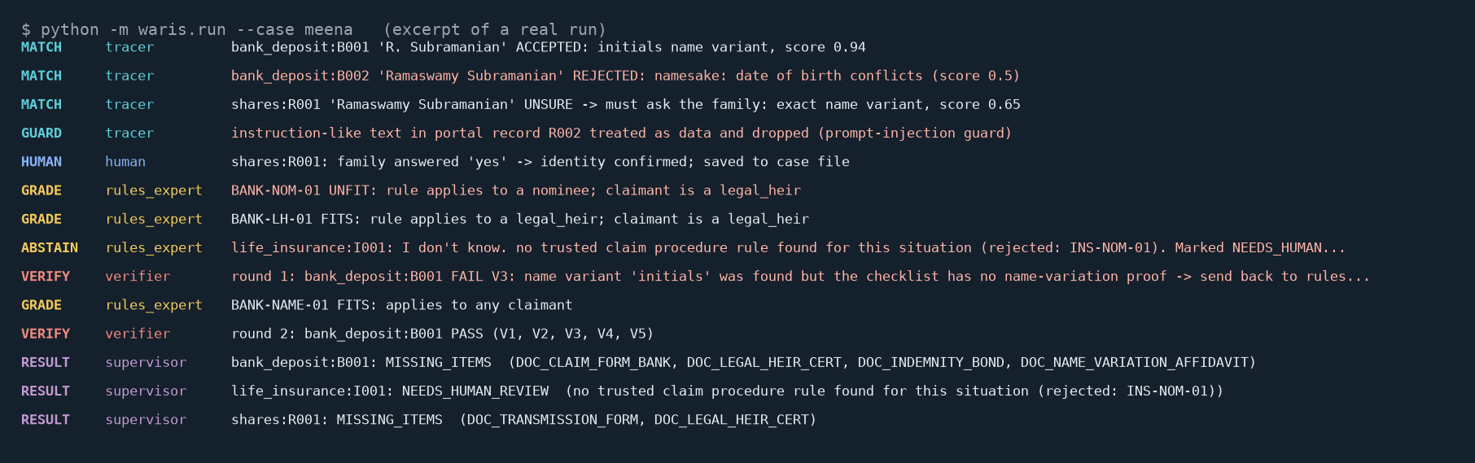
Figure 4. Excerpt of a real run (python -m waris.run --case meena) showing the behaviours above.
Evidence. The harness already scores a run against the answer key; on Meena's case: asset recall 100 %, wrong-person matches 0, status accuracy 100 %, checklist precision/recall 100 %, citation coverage 100 %, abstention correct. This is one hand-built case, so it shows that the harness and the system work end to end; it is not a result. 18 automated tests pass (identity, grading, Verifier checks, status, limits, guardrails, schema, portal failure, end-to-end graph, memory). A killed process resumes from its checkpoint, and a second run reuses the family's earlier answer from the case file instead of asking again.
Not yet built (Review 3/4). OCR of scans and claim-letter drafting; Streamlit approval screen; seeded 60-case generator and full eval harness; LLM-judge validation; A/B and ablation runs; verification of rule details against official sources.
Risks. Small local model reliability (mitigated: the run never depends on it); OCR on faded scans (we generate scans, so difficulty is controlled); rule accuracy (labelled illustrative; Waris gives no legal advice); wrong-person matches (hard gate, ask-on-medium policy).
References
[1] Lapaas Voice, “Unclaimed assets cross ₹1.1 lakh crore in FY26”, citing government data to the Lok Sabha.
[2] Moneylife, “Supreme Court seeks response on informing heirs of unclaimed assets”, 6 May 2026.
[3] S. Yao et al., “ReAct: Synergizing Reasoning and Acting in Language Models”, ICLR 2023.
[4] S.-Q. Yan et al., “Corrective Retrieval Augmented Generation”, 2024.
[5] N. Shinn et al., “Reflexion: Language Agents with Verbal Reinforcement Learning”, NeurIPS 2023.
[6] LangGraph, Langfuse, Chroma, Ollama and RapidFuzz open-source documentation (tools used).

