Ideation Phase
Empathize & Discover

Date | 28 June 2025
Team ID | LTVIP2025TMID28557
Project Name | Laptop Request Catalog Item
Maximum Marks | 4 Marks

Empathy Map Canvas:
An empathy map is a simple, easy-to-digest visual that captures knowledge about a user’s behaviours and attitudes.

It is a useful tool to helps teams better understand their users.
Creating an effective solution requires understanding the true problem and the person who is experiencing it. The exercise of creating the map helps participants consider things from the user’s perspective along with his or her goals and challenges.
Example:
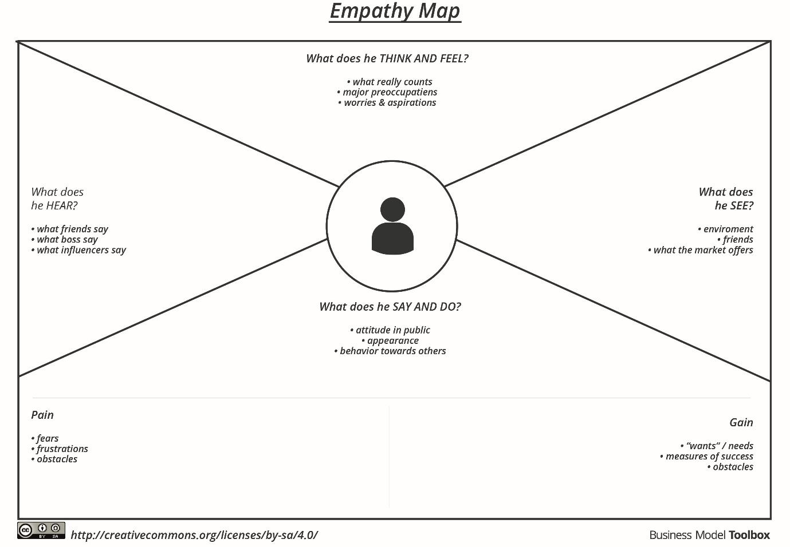

Reference: https://www.mural.co/templates/empathy-map-canvas

Example: Food Ordering & Delivery Application
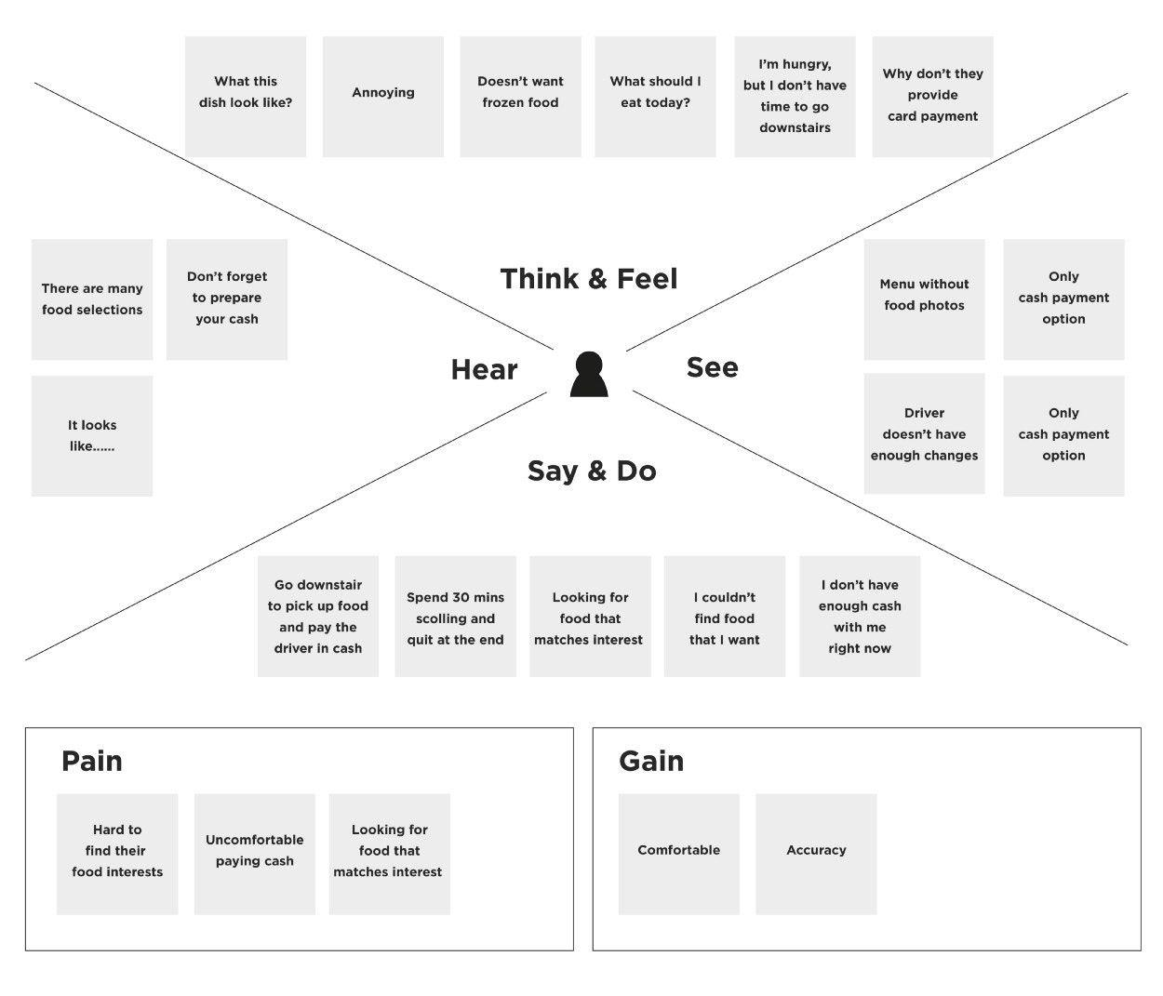

Empathy Map Canvas for Laptop Request Catalog Item
User: Company Employee (new or existing)

SAYS
• I need a laptop that meets my work requirements.
• I don’t know which model to choose.
• How long will this take to get approved?
• Why is the catalog so unclear?

THINKS
• Will I get the right laptop for my role?
• What if the laptop doesn't have the specs I need?
• I hope I don’t have to go through a long approval process.

DOES
• Navigates the IT portal to find the laptop request form
• Searches for model specifications online
• Asks colleagues or HR for help
• Submits the request with uncertainty

FEELS
• Confused by lack of guidance
• Frustrated by unclear choices and vague process
• Anxious about delays affecting work start or productivity

