Project Development Phase
Model Performance Test

Date | 28 June 2025
Team ID | LTVIP2025TMID28557
Project Name | Laptop Request Catalog Item
Maximum Marks

Model Performance Testing:
Project team shall fill the following information in model performance testing template.
S.No. | Parameter | Values | Screenshot
 | Model Summary | Salesforce automation setup for Data management using Object, Fields and Reports.  Note: Import Records if data Match Correctly then Records will Created or Else it will Show Error | 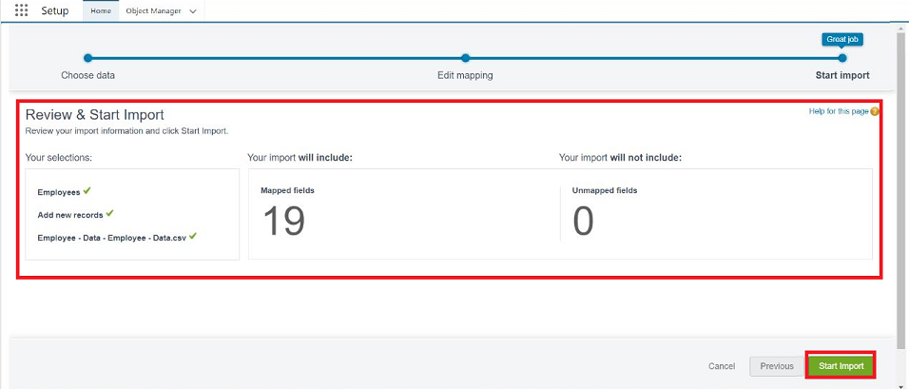
 | Accuracy | Training Accuracy - 98%  Validation Accuracy - 98% | - 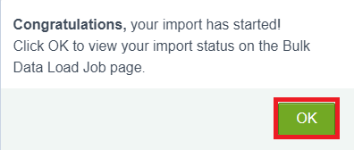
3. | Confidence Score (Only Yolo Projects) | Class Detected - If detecting Object and fields name if wrong and other activity  Confidence Score - If the model is 92% sure the object is correctly detected | 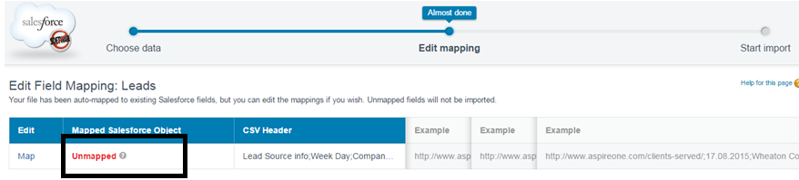  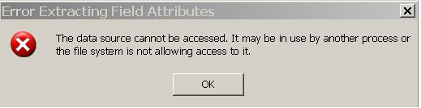

Catalog Item: Laptop Request

Item Name
Laptop Request

Catalog Category
IT Hardware & Devices

Description
This catalog item allows employees to request a standard-issue laptop for official use. Laptops are provided based on job role requirements and availability, subject to approval by the reporting manager and IT department.

Request Type
New Hardware Provision

Available To
All employees with active corporate accounts

Approval Workflow
1. Employee submits laptop request via the service portal.
2. Request is routed to Reporting Manager for approval.
3. Upon manager approval, the request is reviewed by IT Admin for inventory and configuration.
4. Final approval and dispatch from IT.

Delivery Time
3–7 business days after final approval, depending on stock availability.

Laptop Specifications (Standard Model)
- Model: Dell Latitude / HP ProBook (subject to availability)
- Processor: Intel i5 or higher
- RAM: 16GB
- Storage: 512GB SSD
- Operating System: Windows 11 Pro
- Software Pre-installed: MS Office, Endpoint Protection, VPN Client

Attachments Required (if applicable)
- Business Justification (for roles not pre-approved)
- Previous laptop return confirmation (if requesting replacement)

Contact for Support
IT Helpdesk – it.support@company.com | Extension: 1234

Notes
- Lost or damaged laptops must be reported immediately.
- Replacement for damaged laptops will follow asset damage assessment protocol.
- This item is not intended for contractors or interns without prior IT approval.

