
Dr. Abir Chandan Barai
PhD in chemistry
Research Associate
Promea Therapeutics
Personal Details
Date of Birth: 08/05/1992
e-mail: abirbarai@gmail.com,
Mobile : 9593002886

Present address
Kukatpally, Opposite of JNTU, Hyderabad, Telangana
Permanent address
Gobradan, Moyna,
Purba Medinipur, West Bengal, India
721642
Curriculum Vitae

Education:
- PhD (Organic and supramolecular Chemistry): Thesis Title: “Chemical Investigation on Astavarga Plants and Self-assembly Study of Stigmasterol andCrotocembraneic acid.” Under guidance of Professor Braja Gopal Bag, Department of Chemistry, Vidyasagar University, Medinipur, West Bengal
- M.Sc. (Chemistry) degree in 2014 (81.25 %, 1st Class) from Vidyasagar University, Midnapore, West Bengal.
- B.Sc. (Chemistry Hons) degree in 2012 (54 %, 2nd Class) from Midnapore College, Vidyasagar University, West Bengal.
- Higher Secondary in 2009 (72.00 %, 1st Division) under W.B.C.H.S.E.
Experience
- Research associate, Resin synthesis, Promea Therapeutics
- Research Associate, Virchow Biotech Pvt. Ltd.
- Trainer for “Four Day training programme of eleven mandatory test of drinking water for NABL recognition”, organized by Utsab Agency, 28 September, 2021 to 1st October 2021.
Equipment handled
Affinity Chromatography, HPLC, Column Chromatography, Polarizing Optical microscopy, IR, UV-Vis spectroscopy, Fluorescence spectroscopy, Fluorescence life time, DLS-Zeta potential analyzer, Rheometer etc.
Technical skill:
- Synthesis of resin for protein purification
- Synthesis, purification and characterisation of organic compounds.
- Extraction, purification and characterization of terpenoid, steroid and fatty acid based natural product from plants.
- Extraction of plant primary and secondary metabolites for formulation of different supplementary of nutraceuticals product.
- Interpretation of 1H and 13C NMR signals (by 2D NMR) of organic compount, MS, IR, UV-VIS, Fluorescence, XRD, Rheology.
- Microscopic techniques Optical microscopy, SEM, TEM and AFM.
- Experience in working with Basic Chemistry Software (ChemOffice, Microcal Origin, Endnote etc) and Photographic software like Corel draw and Adobe Photoshop.
Awards/Scholarship:
- UGC-RGNF for Research Fellowship in the year 2015.
- Qualified All INDIA-GATE in chemistry (Graduate Aptitude Test in Engineering),
GATE - 2015 Rank- 1270Selected
- Best Poster award: SCBFM-2018, IISER Kolkata
List of Publications:
- B. G. Bag*, A. C. Barai, Self-assembly of naturally occurring stigmasterol in liquids yielding a fibrillar network and gel, RSC Adv., 2020, 10, 4755
- B. G. Bag*, A. C. Barai, S. N. Hasan, S. K. Panja, S. Ghorai, S. Patra, Terpenoids, nano-entities and molecular self-assembly, Pure and Applied Chemistry, 2019, doi.org/10.1515/pac-2019-0812.
- A. C. Barai, K. Paul, A. Dey, S. Manna, S Roy, B. G. Bag*, C. Mukhopadhyay Green synthesis of Nerium oleander-conjugated gold nanoparticles and study of its in vitro anticancer activity on MCF-7 cell lines and catalytic activity, Nano Convergence, 2018, 5,10.
- B.G. Bag*, A.C. Barai, K. Wijesekera, P. Kittakoop, First Vesicular Self-Assembly of Crotocembraneic Acid, a Nano-Sized Fourteen Membered Macrocyclic Diterpenic Acid, Chemistry Select, 2017, 2, 4969 – 4973.
- B. G. Bag*, S. Das, S. N. Hasan, A. C. Barai, Nanoarchitectures by hierarchical self-assembly of ursolic acid: entrapment and release of fluorophores including anticancer drug doxorubicin, RSC Adv., 2017, 7, 18136-181343.
- K. Chaudhuri, S. N. Hasan, A. C. Barai, S. Das, T. Seal, B. G. Bag*, Green synthesis and characterization of gold nanoparticles using Bursera serrata fruit extract, Asian Journal of Pharmacy and Pharmacology, 2019; 5:332-343.
- C. Garai, S. N. Hasan, A. C. Barai, S. Ghorai, S. K. Panja, B. G. Bag*, Green synthesis of Terminalia arjuna-conjugated palladium nanoparticles (TA-PdNPs) and its catalytic applications, J. Nanostruct. Chem., 2018, 8, 465.
- K. Chaudhuri, S. N. Hasan, A. C. Barai, S. Das, T. Seal, B. G. Bag*, Nutraceutical Evaluation of Rhynchotechum ellipticum, a potent wild edible plant consumed by the tribal of North-Eastern region in India and Green Synthesis of Gold Nanoparticles using its leaf extract, Journal of Pharmacognosy and Phytochemistry, 2018, 7, 1434-1442.
- K. Chaudhuri, S. N. Hasan, A. C. Barai, S. Das, T. Seal, B. G. Bag*, Green synthesis of gold nanoparticles using Wendlandia wallichii, a potent wild edible plant consumed by the tribal of north-eastern region in India, The Pharma Innovation Journal, 2018, 6, 437-446.
List of conference presentations:

- Abir C. Barai, S. Ghorai, Sk N. Hasan, S.K. Panja, B. G. Bag*. SCBFM 2018, IISER Kolkata. (Best Poster Prize)
- Abir C. Barai and B. G. Bag*, IISF, Young Scientist Conference 2018, Govt. Of India, Indira Gandhi Pratisthan, Lucknow, International, poster presentation.

Research summary
Synthesis of Binol derivatives form 2- amino-6-picolin
6-hydroxy-N-(6-methylpyridin-2-yl) naphthalene-2-carboxamide and its alkoxy analogues bearing long alkyl chains have been synthesized using 6-hydroxy-2-naphthoic acid and 2amino-6-picoline. The facile synthetic scheme of binol derivatives from 6-hydroxy-N-(6methylpyridin-2-yl) naphthalene-20-carboxamide derivatives are reported here.
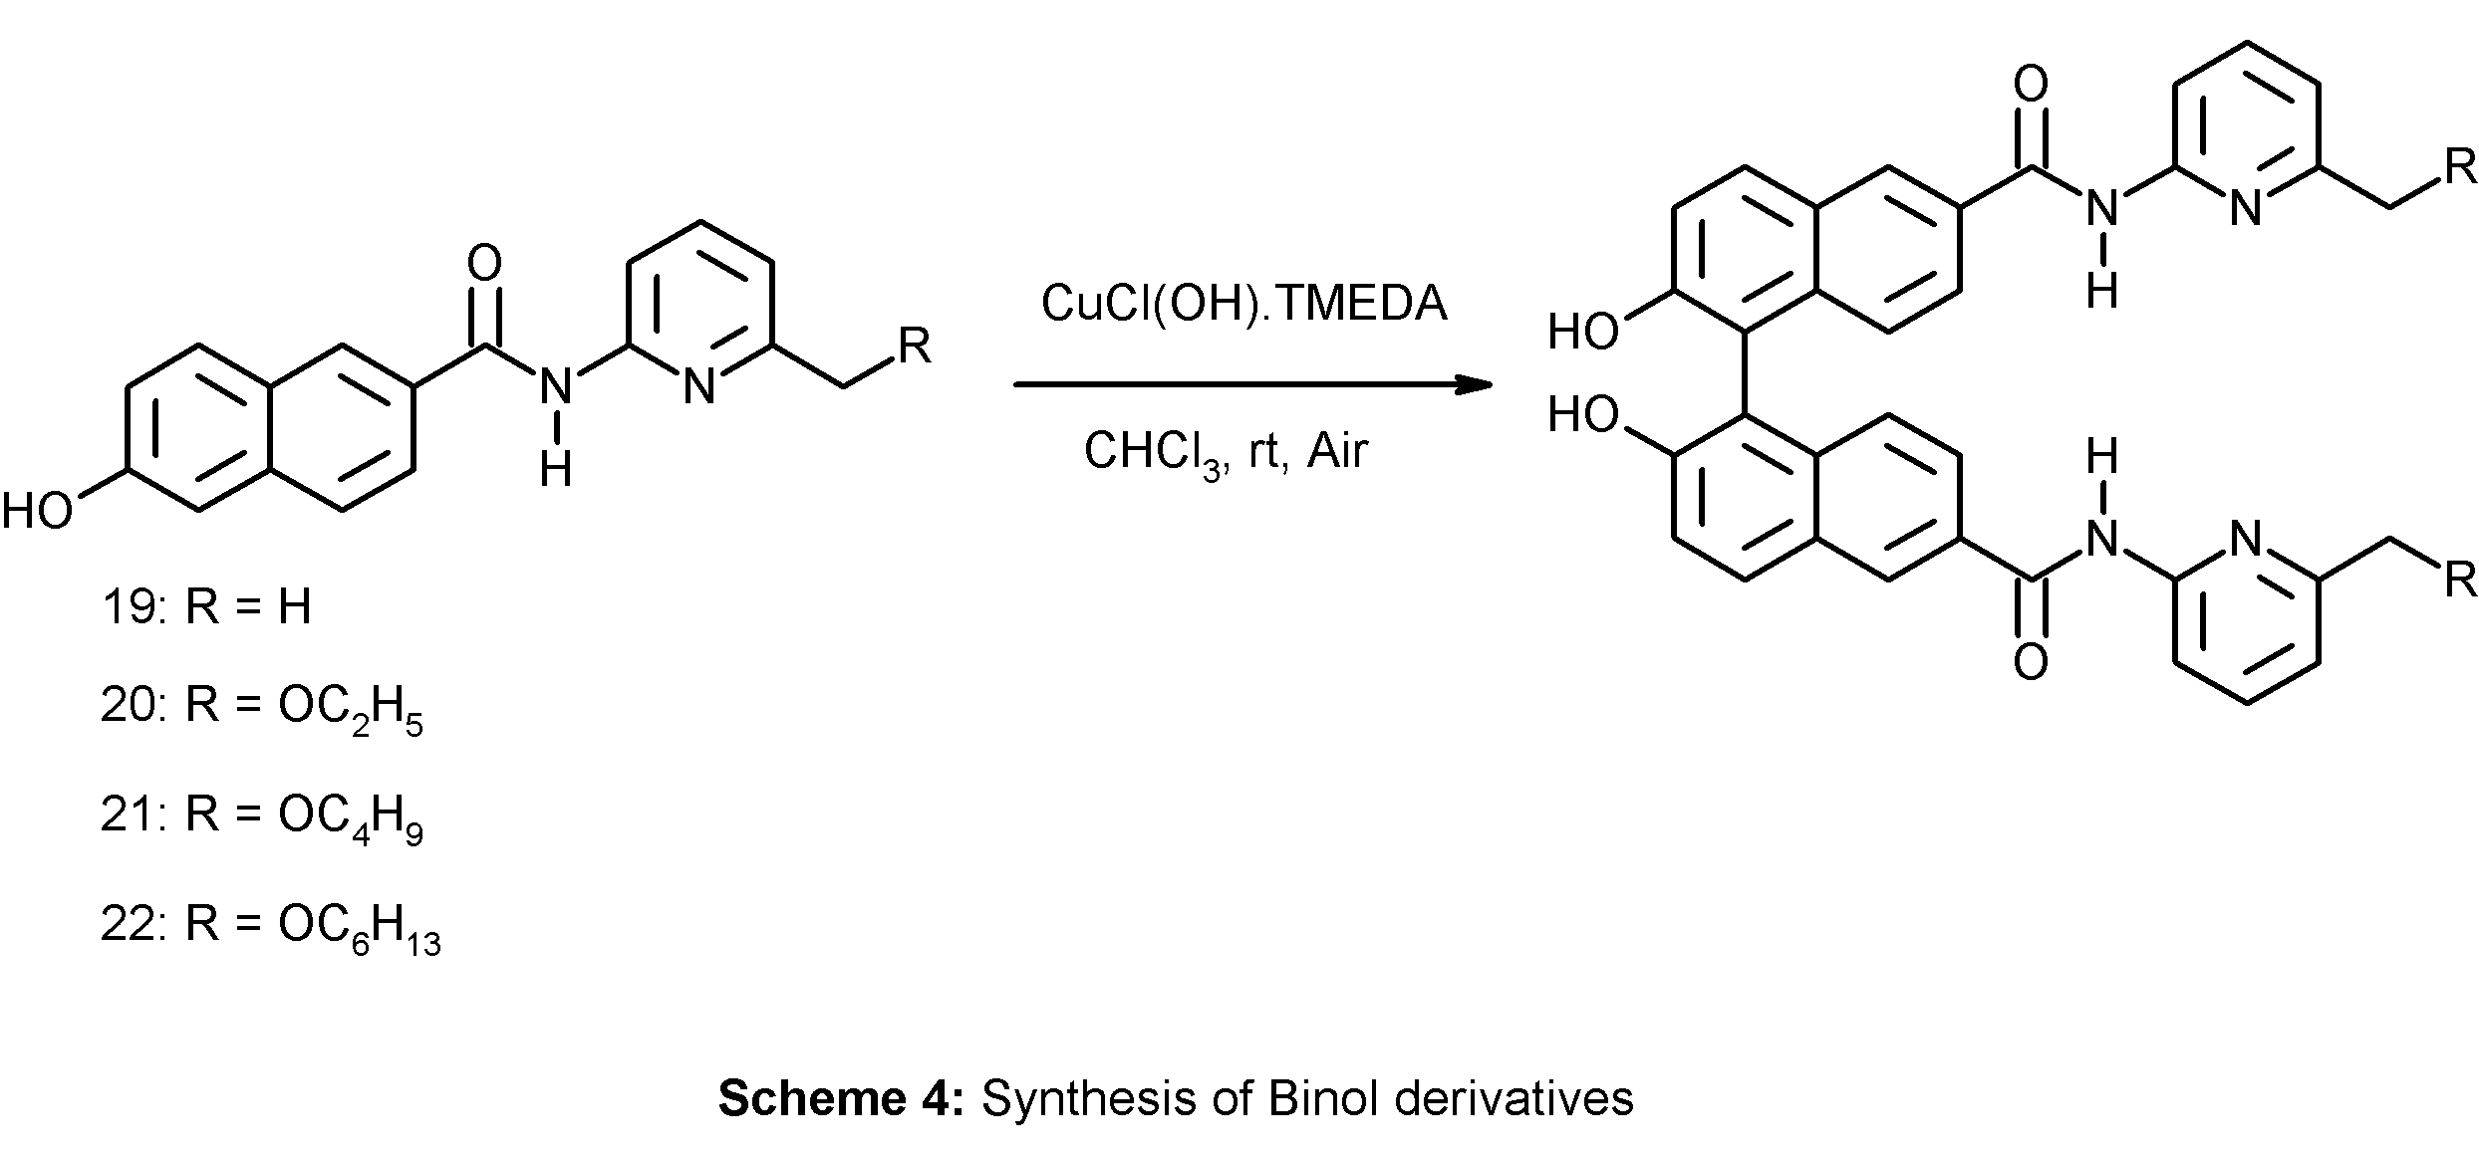
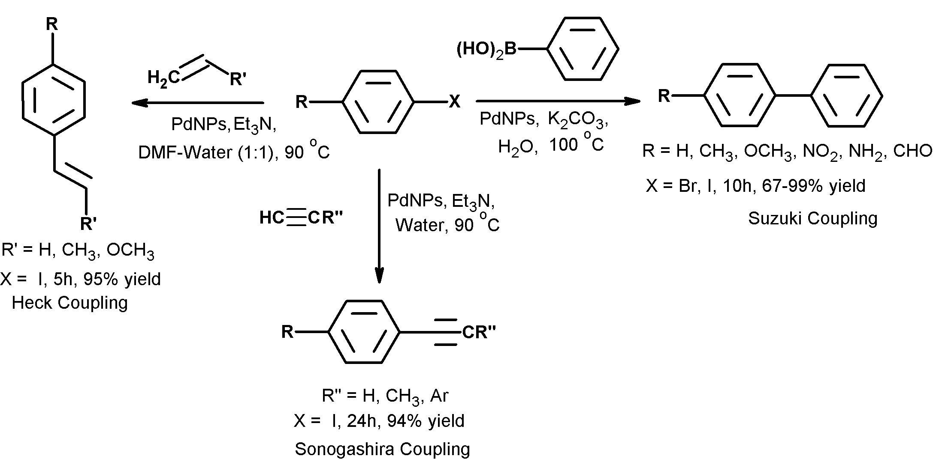
Easily prepared metal nanoparticles catalyst for C-C coupling and reduction reaction and anticancer activity

Synthesis of metal nanoparticles from the metal salts by reduction with plant extracts in water, without any additional stabilizing or capping agents is a green and eco-friendly method. AuNPs, AgNPs and PdNPs are used catalyst for photocatalytic reduction of toxic pollutants, PdNPs (palladium nanoparticles) were utilized as efficient catalyst for Sonogashira, Heck and Suzuki type C–C coupling reactions and reduction of 3-nitrophenol and 4-nitrophenol and organic dyes in aqueous medium at room temperature. Anticancer activity of the stabilized AuNPs studied against MCF-7 breast cancer cell line revealed that the stabilized AuNPs were highly effective for the apoptosis of cancer cells selectively.
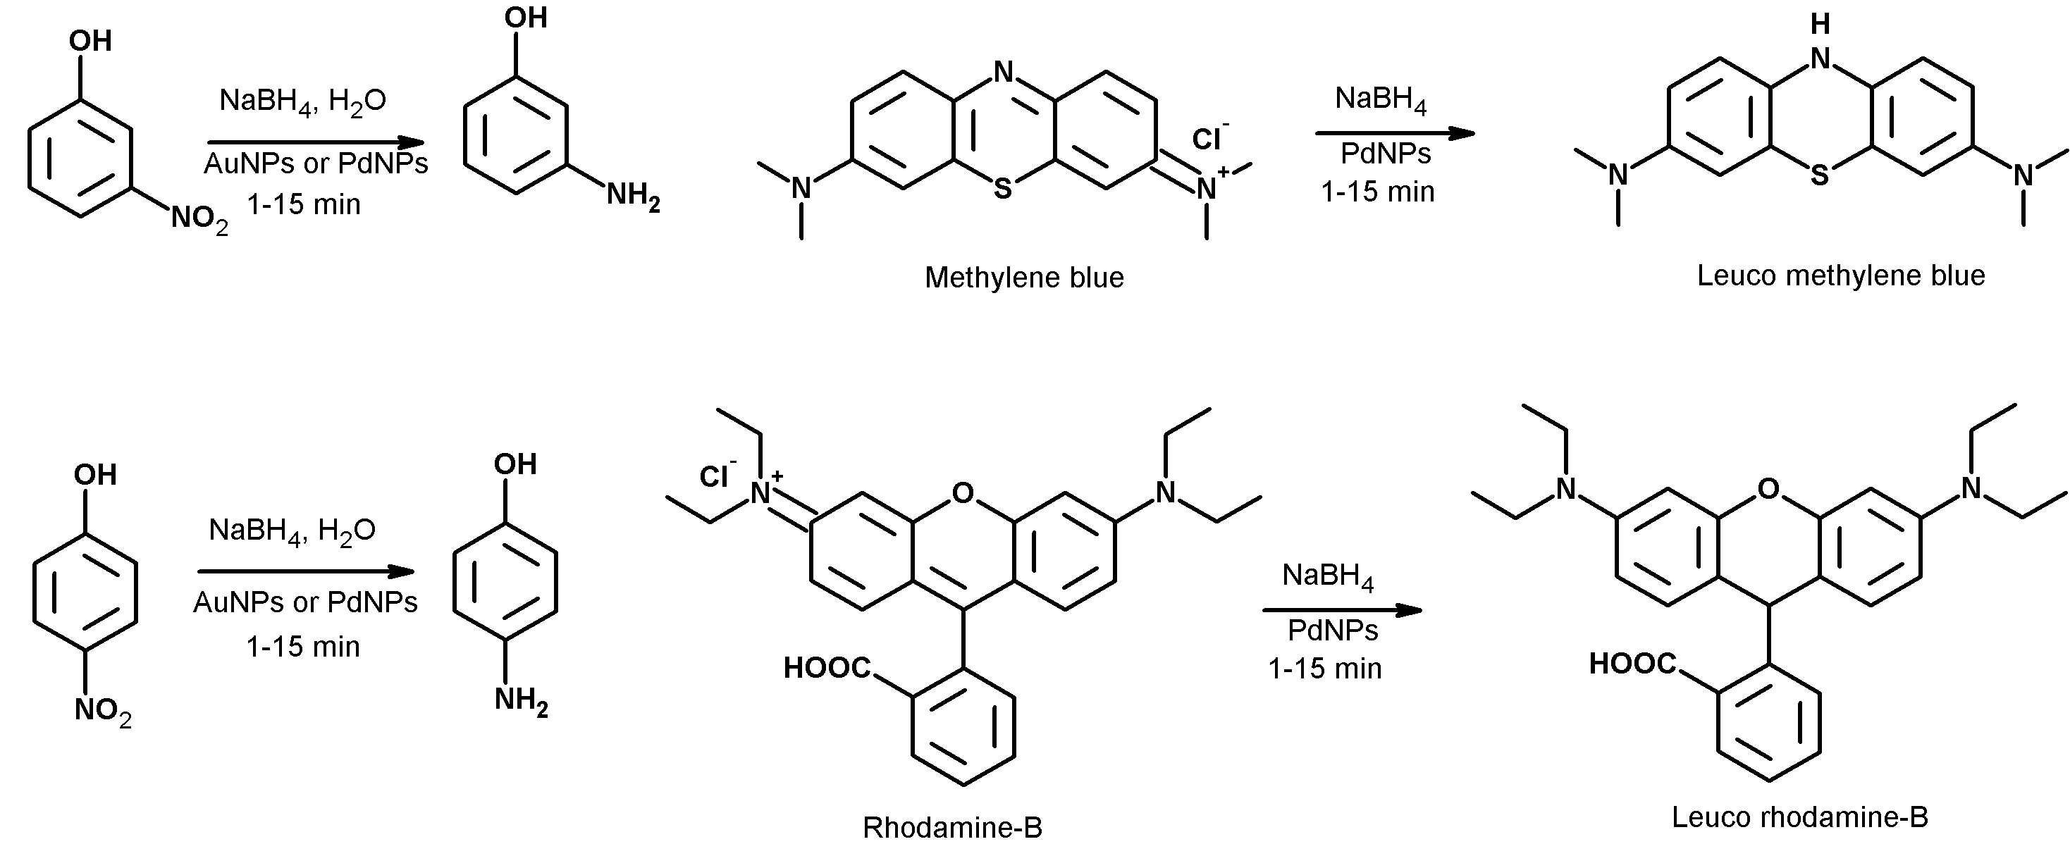

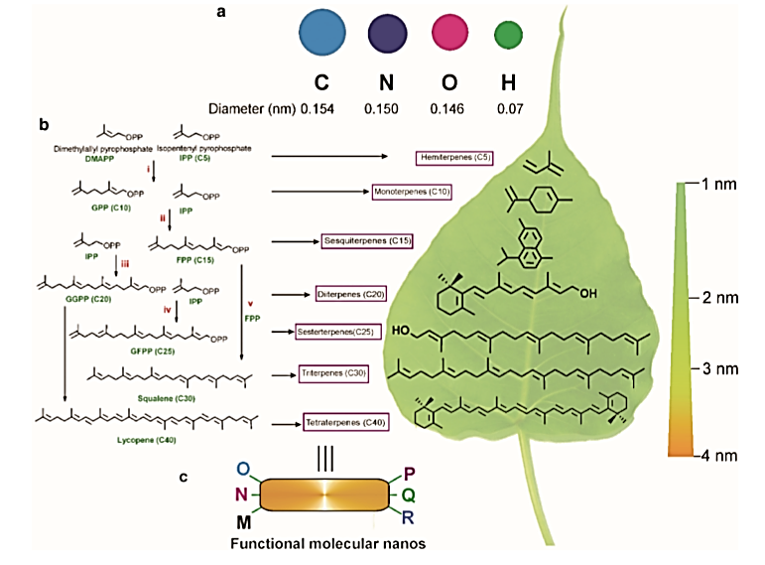
Terpenoids, nano-entities and molecular self-assembly
Terpenoids having nanometric lengths, commonly having several functional groups and several centers of chirality, can be utilized as renewable Molecular Functional Nanos (MFNs). The terpenoids spontaneously self-assembled in liquids yielding different morphologies such as vesicles, tubes, flowers, petals and fibers of nano- to micro-meter dimensions and supramolecular gels. The self-assemblies were utilized for the entrapment and release of fluorophores including anticancer drug, pollutant capture, generation of hybrid materials and catalysis.

Self-assembly study of Stigmasterol in organic liquids
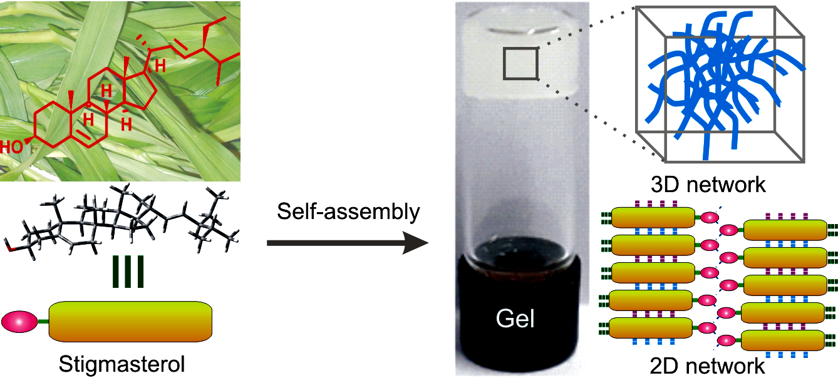
Stigmasterol, a naturally occurring 6-6-6-5 monohydroxy phytosterol, was extracted from the leaves of Indian medicinal plant Roscoea purpurea, commonly known as Kakoli. The molecule self-assembled in organic liquids yielding supramolecular gels in most of the liquids studied via the formation of fibers and belt-like architectures of nano-to micrometer diameter. Characterization of the self-assemblies were carried out by optical, electron and atomic force microscopic techniques and X-ray diffraction studies.
Schematic representation of self-assembly of stigmasterol
Declaration:

I, hereby declare that the above-furnished particulars are true to the best of my knowledge and belief. If given a chance, I will prove my efficiency, my loyalty and willingness to work.
Abir Chandan Barai

