Prashanth Golanukonda 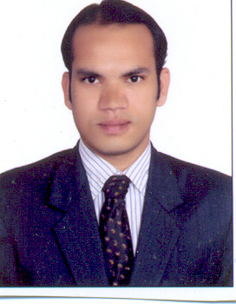
Cell: +91 9701431201 | H. No 3-118/10  Jalalpur(V), Bommala Ramaram(M)  Yadadri (D) 508126
Email: prashanth123g@gmail.com

CAREER OBJECTIVE:

To work with an organization that enhances my professional skills and utilizes it for achieving organizational goal.

EDUCATIONAL QUALIFICATION:

COURSE DETAILS | INSTITUTE | PERCENTAGE
MBA (Finance) | Vishnu Shree institute of technology, Jalalpur under JNTU | 65%
B. Com (Comp) | Silver Jubilee Degree college,  ECIL, under Osmania University | 52%

ASSOCIATE WITH:
Present associated with Suri Engineers Pvt Ltd. Working as Accounts Executive.
Address: Plot No.4/4, IDA Nacharam, Hyderabad – 500 076.
Period: 18-Feb-2019 to Till Now.

Previously associated with Parekh Integrated Services Pvt Ltd. Worked as Statutory Executive.
Address: Plot No.5/C, IDA Nacharam, Baba Nagar Road, Hyd – 500 076.
Period: 21-Dec-2016 to 11-Feb-2019.

Previously associated with Kwality Photonics Pvt Ltd. Worked as Accounts Executive.
Address: D-28,2nd Floor, Electronic Complex, Kushaiguda, Hyderabad- 500062.
Period: 20-Apr-2012 to 10-Dec-2016.

Duties and Responsibilities
- Vendor bill verifying processing and make them ready for payment of all vendor bills.
- tax invoice (GST) billing, purchase debit note & sales Credit Note preparations.
- Prepare and Maintain the Payment Vouchers and filing properly.
- Petty Cash Maintenance and Cash handling in branch.
- GST Tax Working preparation and GSTR 1 & GSTR 3B Online Return monthly filing.
- Bank Reconciliation statements And Other bank related works.
- Payment Collection and Payment Follow-up.
- Salary preparation and PF & ESI Calculation online filing.
- TDS & TCS Calculation online Returns filing & Professional Tax online Payment.
- Prepare and Maintain the MIS Report and share to HO.
- Accounts Finalization and auditing work, and reconciliation.

COMPUTER SKILLS:
- Associated companies which have ERP package such as Tally ERP.9, SAP B1, Open bravo ERP.
- Good exposure in Microsoft Office Excel (V Look up, Pivot table & Advanced Filtering, Data Validation), MS Word and PowerPoint.
- Typing Speed 35 WPM

Personal Information:

Date of Birth | 19th July, 1985
Marital Status | Married
Father’s Name | Mr. Brahma Chary
Hobbies | Photography, Listening music
Languages Known | Telugu, English, Hindi

Place: Hyderabad Prashanth Golanukonda

