Dear Respected sir/madam,
I, Dr. Nageswara Reddy B wish to introduce myself as a highly energetic individual aiming to better my expertise in the field of synthetic organic chemistry. I earned Ph.D. in synthetic organic and medicinal chemistry under supervision of Prof. Madhvesh pathak from chemistry department, VIT University, Vellore, India and master degree in medicinal chemistry from S.V. University, Thirupathi, India. In addition to that, I have 8 years industrial experience in synthesis of organic compounds milligram to kilogram scale, CRO, Drug discovery and their interpretation using NMR, Mass Spectroscopy, LC-MS, HPLC, and IR. I worked for various international clients.
At VIT University Vellore campus, I worked as a research scholar and I have published 10 papers. My thesis title is, “’Synthesis of New Heterocyclic Compounds by Employing Catalytic Microwave Methods and Bio Evaluation.” During my PhD, I explored on various small heterocyclic molecules such as tiazole and oxazole and pyrazole derivatives and its catalytic screening, Am very enthusiastic about design of new molecules and synthesis of novel compounds, its activity, by using chemical tools to find out the molecular targets. My success in the past has stemmed from a strong commitment to hard work; sense of professionalism, dedication to responsibility.
Thank you for taking time to review my application and I am thankful for your consideration and look forward to hearing from you shortly. Please find attached CV for additional information.
Thanking you
Yours sincerely,
B.Nageswara Reddy, Ph.D
91-9740865652

CURRICULUM VITAE
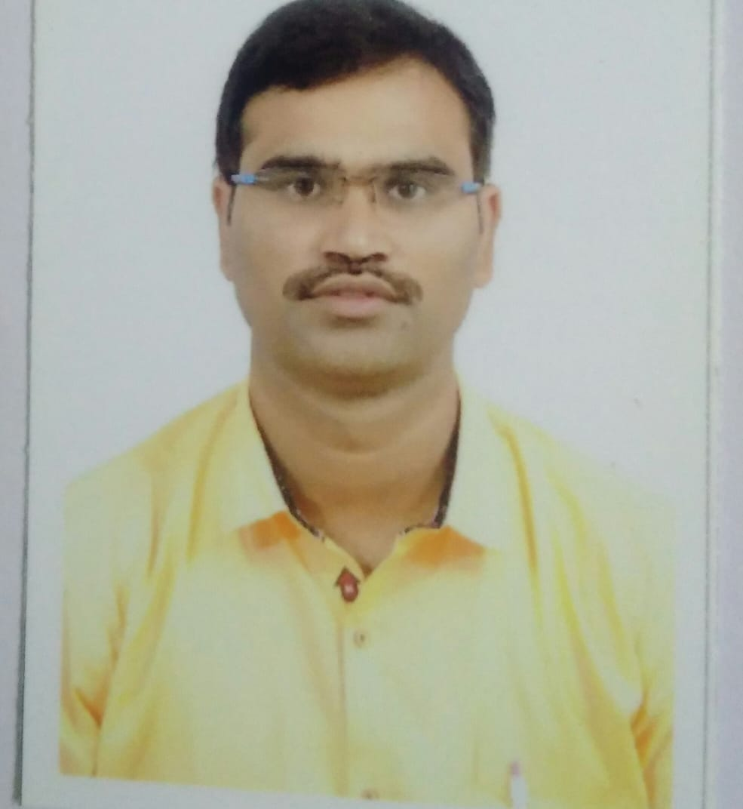
Dr. Nageswarareddy Bijivemula
Passport No: T9302982
E-mail: dr.bnreddy2018@gmail.com
Mobile no: +91- 9740865652

Objective:
To obtain a Post Doctoral Position in your esteemed group with an opportunity to pursue research in the area of organic chemistry/ medicinal chemistry to hone my skills and knowledge.

Brief Academic Profile
- Ph.D - Completed Ph. D thesis work under the supervision of Prof. Madhvesh Pathak Dept of chemistry, School of Advanced Science, VIT University, Vellore, India Period of Study: July, 2013 to Sep, 2019.
- M. Sc- Organic Chemistry (1st Class), April, 2005, Sri Venkateswara University, Tirupati, A.P. India.
- B. Sc- Mathes, Physics & Chemistry (Distinction), April, 2002, Sri Venkateswara University, Tirupati, A.P. India

Employment History:
- Presently working as a Research scientist in chemistry laboratory, Pharmaffiliates, India, from Dec 2020 to till date.
- Worked as a Associate scientist in Medicinal chemistry laboratory, GVK Biosciences private Ltd, Bangalore India, from March 2018 to Oct 2019.
- Worked as a Senior Research Associate in Medicinal chemistry laboratory, GVK Biosciences private Ltd, Hyderabad, India, from March 2010 to Jun 2013.
- Worked as a Senior Research Associate at Jubilant chemsys Noida, India from October 2008 to March 2010.
- Worked as a Research chemist at Chembiotek (A Division of TCG Life Sciences), Kolkata, India from Jan 2007 to Oct 2008.
- Worked as a chemist at Noel pharma, Baddi, Himachal Pradesh, India from April 2006 to Jan 2007.
- Worked as a Lecturer in Chaithnyna junior & Degree College, Badvel Kadapa, A.P, India, From June 2005 to April 2006.

Reserch Related Skill
- Handling reactions from mg scale to g scale
- Manuscript writing, project reports & final experimental protocols
- Projects design, synthesis, development and execution of multistep organic synthesis
- Estimation of new molecule, establishment and standardization of the reactions
- Laboratory management, strategic planning and complex problem solving
- Team building, group instruction, supervising and mentoring
- Synthesized and shipped projects as per requirement
- Interpreting of organic compounds by ¹H-NMR, ¹³C-NMR, FTIR, LCMS, GCMS & HPLC

Conferences
- Medicinal Chemistry and Drug Discovery & Development (India 2019) in March 2019, at Biocon Academy, Bangalore.
- UGC Sponsored National Seminar on New Frontiers in Chemical Science (NFCS-2014) in March 2014, at YV University, Kadapa.

Awards
- Outstanding scientific contribution (Takeda Pharmaceutical Company Limited).
- Outstanding chemist (Pfizer)

List of Publications.

- Bijivemula.N.Reddy, Peddiahgari Vasu Govardhana Reddy, Pogula Sreekanth Reddy, S. M. Reddy, Sirigi Reddy Sudharsan Reddy, and Madhvesh Pathak. Synthesis of New 4, 5-Dihydro-1-methyl-[1, 2, 4] triazolo [4, 3-a] quinolin-7-amine–Derived Urea’s and Their Anticancer Activity, Synthetic communications, Volume 45, Issue 7, 2015, pp.831-837.

- Bijivemula.N.Reddy, Peddiahgari Vasugovardhan Reddy, Bhoomireddy Rajendra Prasad Reddy, Sirigi Reddy Sudharsan Reddy, S. M., Reddy and Madhvesh Pathak. Novel7-Nitro-1-(piperidin-4-yl)-4,5-dihydro-[1,2,4]triazolo[4,3-a]quinoline-Sulphonamide Derivatives as Antimicrobial Agents: Design, Synthesis and Biology Analysis, Journal of Heterocyclic Chemistry, Volume 53, Issue 5, 2016, pp.1416-1423.

- Bijivemula.N.Reddy, Chinthaparthi Radha Rani, S.M. Reddy and Madhvesh Pathak. An efficient and green La(OTf)₃ catalyzed Petasis borono–Mannich reaction for the synthesis of tertiary amines. Res Chem Intermed, Volume 42, Issue 10, 2016, pp.7533-7549.
- Bijivemula. N. Reddy, S.M. Reddy & Madhvesh Pathak, Design, synthesis, molecular docking and biological evaluation of pyrazolo [3,4-d] pyrimidine containing amide derivatives as α-amylase, Chemistry Select, Issue 4, 2019, pp.1-8. (DOI: 10.1002/slct.201900208).

- Bijivemula.N.Reddy, S.M. Reddy & Madhvesh Pathak. Highly Efficient Ruphos Pd Catalysts for the formation of Carbon-Carbon Bond via Suzuki Reaction, Pharma Chemica, Volume 9, Issue 9, 2017, pp.102-108.
- Mallikarjuna Reddy Sura, N. Reddy Bijivemula, Sreekanth Reddy Pogula, Krishna Reddy, Peddiahgari Vasugovardhan Reddy and Madhvesh Pathak. Highly efficient Pd-PEPPSI-IPr catalyst for N-(4-pyridazinyl)-bridged bicyclic sulfonamides via Suzuki-Miyaura coupling reaction. Applied Organo metallic Chemistry, Volume 32, issue 2, 2017, pp.4068 (DOI10.1002/aoc.4068).
- Sura Mallikarjuna Reddy, Bijivemula N. Reddy, Venkata Krishna Reddy Motakatla, Anusha Gokanapalli, Madhvesh Pathak, Peddiahgari Vasu Govardhana Reddy. Pd-NHC catalyzed Suzuki – Miyaura couplings on 3-bromo-9H- pyrido [2,3-b] indole -6-sulfonamide. Synthetic communications, Volume 49, Issue 16, 2019, pp.1987-1996
- Sirigireddy Sudharsan Reddy, Bijivemula.N.Reddy, Peddiahgari Vasugovardhan Reddy and Gajulapalli Vishwakshan Reddy. A convenient synthesis of novel 5-(2, 2-difluoro-1-phenylcyclopropyl)-N-substituted-1, 3, 4-oxadiazol-2-amines using graphene oxide and ionic liquids under ultrasonic irradiation conditions, Chemistry Select, 2017, 2 (1) 356-363.

- Bhoomireddy Rajendra Prasad Reddy, Peddiahgari Vasugovardhan Reddy and Bijivemula.N.Reddy. Efficient solvent free synthesis of tertiary α-aminophosphonates using H₂Ti₃O₇ nanotubes as a reusable solid -acid catalyst, New Journal of Chemistry, 2015, 39, pp.9605-9610.

- Bhoomireddy Rajendra Prasad Reddy, Peddiahgari Vasugovardhan Reddy, Dharani Praveen Kumar & Bijivemula.N.Reddy. Rapid synthesis of alkylaminophenols via Petasis Borono-Mannich reaction using protonated trititanate nanotubes as robust solid-acid catalyst, RSC Adv. 2016, 6(18), 14682-14691.

- Reactions Handled:
Appel Reaction, Baeyer villager oxidation Reaction, Beckmann rearrangement reaction, Birch reduction, Buchwald coupling, Curtius Reaction, Chan-Lam Coupling, Clemmensen Reducion, Dess - Martin Oxidaion, Epoxidaion Reaction, Esterification Reaction, Friedel - Craft Alkylation, Grignard Reaction, Heck Reaction, Hydroboraion, Kumada Coupling, Mannich Reaction, Mitsunobu Reaction, Negishi Coupling, Petasis Reaction, Sandmeyer Reaction, Sonogashira Coupling Reactions, Stille Coupling, Suzuki Coupling, Swern Oxidaion Reaction, Ullman Reaction, Van Leusen Reaction, Vilsmeier - Heck Reaction, Wittig Reaction, Bromination Reaction, Nitration Reaction Alkylation Reactions, Reductive alkylation, Amide coupling Reactions and Cyanide Reactions, Group protection reactions, Oxidation Reactions Reductions Reactions and cyclization Reactions.
- Reagents & Catalysts Handled:
- LDA, n-BuLi, NaH, KH, LIHMDS, KHMDS, NaOEt, DBU, Red-Al, Pd/C, Raney Ni, DDQ, SeO_{2,}OsO_{4,} PCC, MnO₂, m-CPBA, Oxone, H₂O_{2,} NBS, NCS, NIS, Br₂, POCl_{3,}SOCl_{2,} SOBr_{2,}, POBr_{3,} SnCl_{2.}2H₂O , Fe/ HCl, Zn/CH₃COOH, AlCl_{3,} NaCN, KCN, CuCN, Zn(CN)_{2,} DEAD, DIAD, NaBH_{4,} LiBH₄, LiAlBH_{4,} Li(OEt)₃ BH, BH₃-THF, BH₃ - DMSO, DIBAl-H, Amide coupling reagents, Pd Catalysts, Cu catalyst, Ru catalyst, Rh catalyst
- Drugs and its impurities handled:

Riboflavin and its impurities C and D, Acyclovir and its impurities A, C, F, G, L, M and P, L- Valacyclovir Hydrochloride and its impurities Q, & R, Donopezil impuriy-D, Desfluoro Citalopram Oxalate, D -Valganciclovir Hydrochloride, Rizatriptan and its impurities G, H and I

Reserch Interest
- Synthetic organic chemistry, Medicinal chemistry and Process development
- Transition metal catalysis and its applications in synthesis
- Design, synthesis structural characterization of lead molecules for the development of organic synthesis that find use in various fields
- Development and synthesis of chiral reagents, metal catalysts in asymmetric synthesis to synthesize novel bioactive compounds
- Instruments Handled:
- CEM, and ANTON microwave synthesizers
  - FT-IR Spectrophotometer
  - Autoclave Hydrogenation instrument.
  - Parallel synthesizer
  - Combiflash Chromatography
  - Grace Chromatography
  - Biotage

- Computing Skills:
Experience in extensively using Microsoft Office, Chemdraw (14 & 16), ACD software (2017), Search Engines (Scifinder, Beilstein cross fire, MDL Database, Reaxys, Pub med, patent lens, espacenet etc.)
- Personal details:
Date of Birth : 6th June, 1982.
Gender : Male.
Languages known : English, Hindi and Telugu.
Marital Status : Married.
Nationality : Indian.
Address for Communication : Thummalapalli Village (near school)
Badvel (Taluk) - 516502
Kadapa (DT), A.P, India

- Declaration:
I hereby declare that the information furnished above is true to the best of my knowledge and belief.
Place: Kadapa, A.P
Date: sincerely
B. Nageswara Reddy, Ph.D Associate scientist.

Research Summary
Newly synthesized compounds (12 a-j) have been subjected for anticancer activity in vitro against human neuroblastoma cell lines (SK N SH) and human colon carcinoma cell lines (COLO 205) by using the MTT cell viability method. Few compounds have exhibited the greatest activity against SK N SH and COLO 205 cell lines with IC₅₀ 43 and 48 μL, respectively. The remaining compounds exhibited comparable cytotoxicity against both cell lines
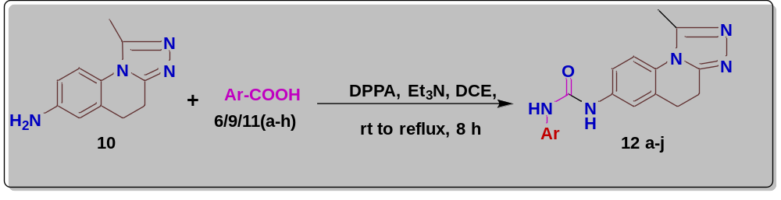

All synthesized compounds (17a-j) were examined for antimicrobial activity, in which 7-nitro-1-(1-(pyridin-2-ylmethylsulfonyl) piperidin-4-yl)-4,5-dihydro-[1,2,4]-triazolo-[4,3-a] quinoline (17i) was the most potent against both bacteria and fungi. Compound (17a) also showed most effective inhibition towards gram positive bacteria.
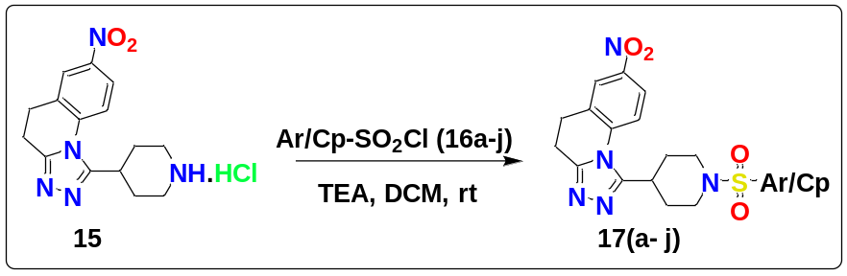

We developed a simple and efficient microwave assisted method for a series of tertiary amine derivatives from synthesized compounds and commercially available compounds by employing reusable La(OTf)₃ as an efficient catalyst.
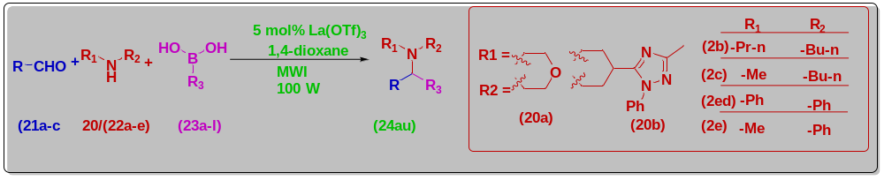
A series of new 1-(methylsulfonylmethyl)-4-aryl -1H pyrazoles was synthesized by Suzuki cross-coupling reaction under microwave irradiation conditions using Ruphos-Pd G2 as an effective catalyst. The synthesized title compounds most of them have shown promising antibacterial activity against the standard penicillin drug
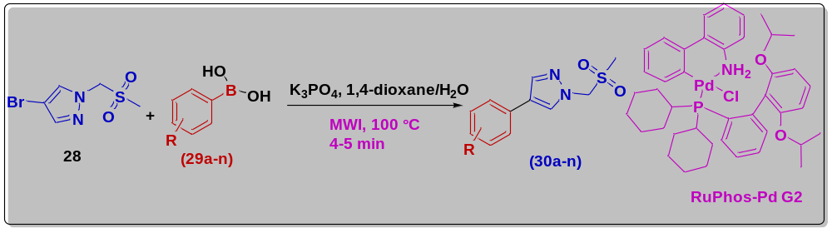

Novel antidiabetic analogs, different pyrazolo [3,4-d]pyrimidine containing amide derivatives (40a-l) were designed and synthesized. All derivatives have showed remarkable α-amylase inhibitory activity, among which seven compounds namely 40d, 40f, 40g, 40h, 40i, 40j and 40k showed a potential α-amylase activity, among them four compounds 40i, 40k, 8f and 40g were showed more potent than reference inhibitor acarbose. In addition, In vivo antidiabetic activity examination evaluated that the 40d and 40k compound produced remarkable activity that is approximately equipotent to that gained by thereference drug Glibenclamide. Further, molecular docking studies have revealed that all the analogs have shown good interactions with α-amylase protein (1HNY) and also showed good correlation between the docking scores, the a-amylase inhibition activity and the in vivo antidiabetic activity. A further related optimization of these pyrazolo [3,4-d]pyrimidine containing amide derivatives could develop these analogs as oral hypoglycemic agents.
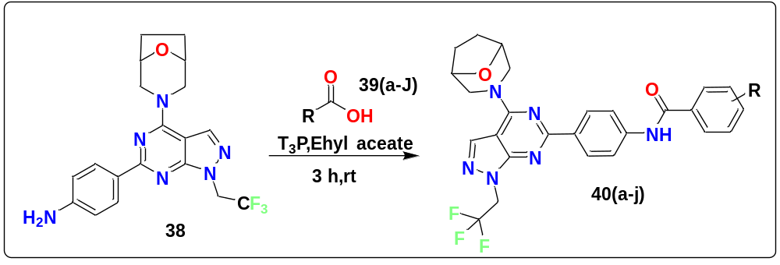

Reference: 1

Dr.Madhvesh pathak

Associate Professor,

Vellore Institute of Technology (VIT),

Vellore, Tamilnadu, India -63201
Telephone: +91-9786841123; Email: madhveshpathak@vit.ac.in

Reference: 2
Dr. Krishna Reddy
Director, Chemistry services
GVK Biosciences Private Limited
Hyderabad-500076
Mobile: + (91) 8008478994, Email: krishna.valluru@gvkbio.com

