**CURRICULUM VITAE**

| **PROFILE** |  |  | **CONTACT** |
| --- | --- | --- | --- |

 **Mr. AMOL BALU KALE**  **Mobile No : 9373395133, 7350549612** 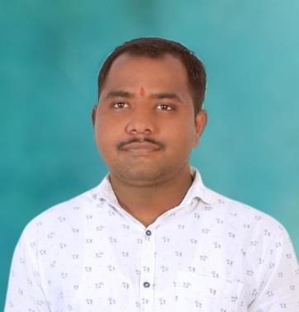

M.sc (Drug Chemistry)

 **Email id : amol.balukale@aragen.com**

kaleamol1997@gmail.com

 **Functional Area :**  **Present :**

**Anlayatical Research Jay Bhavani Apartment,**

**&Development Street no 4, HMT Nagar,**

**Nacharam, Hyderabad – 500076**

 **Industry Type:**  **Permanent :**

**API/CRO At : Dongargan, Po : Jeur (ba), Tal : Nagar**

**Dist : Ahmednagar,**

**Maharashtra : 414601**

 **Industrial Experience : 1 Year 8 Months**

# PROFESSIONAL EXPERIENCE

Wockhardt Research Center , Aurangabad ( 10 Aug 2020 to 14 Jan 2021 )

Aragen Life Scienses,Hyderabad (15 MARCH 2021 to Till date )

# SKILLS

* Analytical method development, and calibration of HPLC.
* Performed analytical method development of TLC.
* Performed calibration of Prep HPLC, UPLC, HPLC and LCMS.
* Analytical method development, and calibration of Prep HPLC.

# RESPONSIBILITIES

* Lead analytical HPLC team of method development .
* To plan and organize routine online sample analysis support to synthesis laboratories for new product development.
* Document Review: Lab notebook, method development, reports, and calibrations.
* Handling customer Queries
* Troubleshooting of the analytical problems during analysis.

# EDUCATIONAL QUALIFICATION

**NAL QUALIFICATIONS**

 Jun 2018 To May 2020 M.Sc (Drug Chemistry)

First Class (72.66%)

Ahmednagar College, Ahmednagar

 Jun 2015 To May 2018 B.Sc (Chemistry)

Higher Second Class (64.16%)

Ahmednagar College, Ahmednagar

 Jun 2013 To May 2015 HSC (Science)

Second Class (51.08%)

Ahmednagar College, Ahmednagar

Jun 2012 To May 2013 SSC 

First Class With Distinction (83.64)

Kai. Ganpatrao Mate Patil Vidyalaya

Dongargan

**CAREER OBJECTIVES**

• To be associated with a progressive organization that gives me scope to apply knowledge, experience and skill in the area of Pharmaceutical Quality and be in tone with the latest trends and be a part of the team that dynamically works towards the growth of organization and thereby attain satisfaction in all aspects.

# INSTRUMENT OPERATION KNOWLEDGE

* **HPLC** : Waters Alliance e2695 system, Software: Empower 3
* **UPLC:** Waters ACQUITY H-Class, Software: Empower 3
* **LCMS :** Water Aliance e2695 System , Softwere: masslynx
* **Prep HPLC :** Water Aliance e2695 System , Softwere: 1) Empower 3 2) Cromoscope

**COMPUTER SKILLS**

* Proficient in Microsoft Office: Word, Excel, PowerPoint etc.,
* Familiar with chemistry software‟s such as Reaxys, SciFinder, Chem. draw, ISIS Draw, MestReNova etc.,
* *Maharashtra State Certificate in Information Technology (MS-CIT)* (Computer Certification Course).

| **PERSONAL DETAILS** |  |
| --- | --- |
| Nationality | : Indian |
| Marital Status | : Married |
| Sex | : Male |
| Languages Known | : English, Hindi and Marathi. |
| Date of Birth | : 02 November 1997 |
| Permanent Address | : At : Dongargan, Po : Jeur (ba), Tal : Nagar Dist : Ahmednagar, Maharashtra : 414601 |



* **Dr. Srikant Daggula**

M. Sc.(Chemistry)

SRA(Analytical R&D)

Aragen Life Science, Hyderabad

Phone: +91 9505846630

* **Dr. A.V. Nagawade**

HOD Chemistry Department

Ahmednagar College Ahmednagar

Phone: +91 9822266883