**CURRICULAM VITAE**

|  |  |  |  |
| --- | --- | --- | --- |
| Karthik M  Contact Numbers: 9497418010,7907785411  E mail: karthikm1995.km@gmail.com |  |  |  |
|  | | |

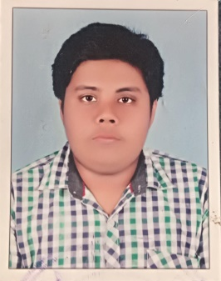

**JOB OBJECTIVE:**

Seeking Junior level position in a Pharmaceutical company of high repute.

**PROFILE SUMMARY:**

Completed Pharm D (Full time 6 year regular course) from Nehru College of Pharmacy, affiliated to Kerala University Of Health Sciences. (KUHS).Trichur Dt, Kerala State.

Completed Internship from PKDIMS (PK Das Institute of Medical Sciences). Hospital. Palghat District Kerala State.

Completed Clinical Pharmacist training from Aster MIMS. (Malabar Institute of Medical Sciences,Kottackal,Malappuram District Kerala State.

**EDUCATION:**

|  |  |  |  |  |  |
| --- | --- | --- | --- | --- | --- |
| SlNo | Name Of Qualification | Name of Institution | University | Year of Passing | CGPA/Percentage |
| 1 | Pharm D | Nehru College Of Pharmacy | Kerala University Of Health Sciences. (KUHS) | 2020 | 65% |
| 2 | HSC | Bhavans Vidya Mandir Engilish Medium School | CBSE | 2014 | 86% |
| 3 | SSLC | Bhavans Vidya Mandir Engilish Medium School | CBSE | 2012 | 8.6 |

PROJECTS COMPLETED:

* Completed a project on Medication Administration Errors in a tertiary care hospital.

**IT SKILL:**

Well versed with:

* MS Office (Word, Excel & PowerPoint).
* Internet Applications

**PERSONAL DETAILS:**

|  |  |
| --- | --- |
| Name | KARTHIK M |
| Address | Karthik Bhavan,Shathri Road Thiruvamkulam P O ,Ernakulam. |
| Pin Code | 682305 |
| State | Kerala |
| Nationality | Indian |
| Fathers Name | Mohanan K N |
| Date of Birth | 22/12/1995 |
| Sex | Male |
| Marital Status | Unmarried |

DECLARATION:

I hereby declare that the above furnished details are true to the best of my knowledge and belief.

 Karthik M

Place:Ernakulam

Date   : 14/09/2020.