**RESUME**

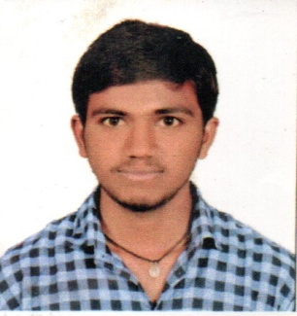

**MADASU VINOD**

**Email ID: vinodmadasu95@gmail.com**

## Contact No: 9505662413

**CAREER OBJECTIVE**

To work with a leading company and to use my analytical thinking to the best of my ability combined with perseverance, so as to contribute to organization’s growth and goal, as well as to attain my professional goal.

**EDUCATION QUALIFICATIONS**

|  |  |  |  |  |
| --- | --- | --- | --- | --- |
| **Course Completed** | **University / Board** | **Name of the Institution** | **Year of Completion** | **Percentage** |
| Msc (chemistry) | Kakatiya University | New Science PG college | 2019 | 68% |
| Degree(B.SC) | Kakatiya University | Lal Bahadur college | 2016 | 65.5% |
| Inter (M.P.C) | Board Of Inter Mediate Education | Hindu Junior college | 2013 | 73.3% |
| SSC | Board of Secondary Education, Andhra Pradesh | Sri Aravinda Vidya Mandir High School | 2011 | 81.3% |

**TECHNICAL SKILLS**

* MS-Office
* Internet Concepts.

**PERSONAL STRENGHTS**

* Communication skills
* Quick learner
* Team work
* Ability to interact with New People

**PERSONAL INFORMATION**

Name : M.VINOD

Father Name : M.RAJENDER

Date of Birth : 15-07-1995

Languages Known : English and Telugu

Nationality : Indian

Marital Status : Single

Hobbies : Reading academic books, Playing Cricket

Address : H. No: 2-60/B,(Villege)kothapally,(Mdl)regonda

(Dist) jayashankar bhupalapally

**DECLARATION**

I here by declare that the details furnished above are true to the best of my knowledge.

Place:

Date:

**(**M.VINOD**)**