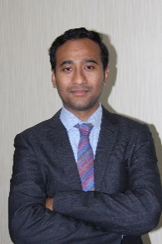**Dr. Sandip Sengupta**

**Research Professor, Yonsei University**

Severance Biomedical Science Institute, Graduate School of Medical Science, Brain Korea 21 Project, Yonsei University

University College of Medicine, 50 Yonsei-ro, Seodaemun-gu, Seoul, 03722, Republic of Korea, Mobile: +82-1029009762

E-mail: [sengsandip@gmail.com](mailto:sengsandip@gmail.com), SENGSANDIP@yuhs.ac

**Objective:**

Looking ahead to work as an organic/medicinal research scientist in a growth-oriented organization wherein I can make a significant contribution to the organization's success. Seeking a position involving creativity challenges and an opportunity to constantly strive to explore, innovate & excel in attaining organizational and individual goals.

**Research Experience**

* >10 years’ experience on synthetic organic chemistry/medicinal chemistry, Drug discovery and development projects with interdisciplinary team.
* Experience includes progression towards the candidate drug discovery journey.
* Total synthesis of biologically active complex natural products and synthesis of their derivatives for SAR study
* Development of novel methodology and their application
* Design, Synthesis and Development of various small molecule kinase inhibitors as targeted cancer drug
* Design and Synthesis of heterocyclic compounds related to medicinal chemistry and drug discovery
* Design and Synthesis of novel Protein Degrader such as PROTAC, AUTAC, HEMTACs.

etc. for drug discovery program and to treat the disease related problems.

* Design and Synthesis of novel MRI contrast agent and its application for imaging

**Technical Skill**

* Good knowledge and good problem-solving skills in designing synthetic routes to potential small molecule probes, hetero bifunctional degraders, macrocyclic kinase inhibitors.
* Regorously maintaining laboratory notebook and related records with confidentiality.
* Synthetic route scouting, cost effective chemical ordering, effective scheme design and guidance to masters and PhD students for their projects.
* Basic knowledge in molecular docking study by using PyMOL software, and biological experiments like CYP inhibition, microsomal stability, hERG study, in vitro DMPK study, In vivo PK experiment.
* Involved in various drug discovery program in collaboration with reputed pharmaceutical companies for making small molecule kinase inhibitor and in time compound delivery for proof-of-concept animal studies.
* Hand in experience in designing and synthesizing hit compound which enter into animal (monkey) PK studies and currently in the preclinical phase.
* Leading the group of 6~10 master and PhD students of lab for successful completion of various crucial projects within time line
* Assisting in the preparation of laboratory reports, project proposal writing, year-end report submission etc.
* Adhering strictly to safety protocols and maintaining high standards of experimental practice.

**Personal information Residential Address**

Date of birth: 2nd September 1984 Basudevpur, Khanjanchalk,

Nationality: Indian East Medinipur, Haldia,

Status: Married West Bengal, India, 721602

Language Known: English, Bengali, Hindi

Mobile: +82-1029009762

**Research Periods:**

**Research Professor March 2020-Current**

Yonsei University, Severance Biomedical Science Institute, Graduate School of Medical science, Seoul, South Korea

**Key Activities:**

* Independently design drug related small molecule inhibitor and propose idea on various new protein degraders, like AUTAC, PROTAC, HEMTAC.
* Designing synthetic routes and propose innovative research idea to lab members to achieve potential small molecule probes for lab goal and individual success.
* Synthesizing, purifying, and characterizing target molecule with high efficiency.
* Collecting, compiling, and analysing chemistry and biology data for optimising.
* Molecular Docking (preliminary knowledge) and Quantitative structure-activity relationships (QSAR) and Cheminformatics
* Aggressively participating in the preparation of laboratory reports, manuscripts, and patents.
* Prioritization of compounds and in time compound delivery for proof-of-concept animal studies

**KRF Post-doctoral fellow October 2015-Feb 2020**

Korea Institute of Science and Technology (KIST), Seoul, South Korea.

**Key Activities:**

* Total synthesis of biologically active natural products, like Baulamycin A, Mupirocin H. (Troubleshooting & synthetic routes)
* Design and synthesis of analogues of natural product L-783277 for effective inhibitor for angiogenesis and lymphangiogenesis.
* Preparation of different derivative of natural products like Baulamycin A for their biological screening. (Synthesis library of compounds for their SAR study)
* Synthesis of small molecule heterocyclic scaffold for various kinases.

**Visiting Scientist** **November 2012-September 2015**

Korea Institute of Science and Technology (KIST), Seoul, South Korea.

**Key Activities:**

* Total synthesis of biologically active natural products, like Mupirocin H, Militarinone D

L-783277 etc.

* Design, synthesis and identification of ROS inducer.
* Design and Synthesis of MRI contrast agent and its application for imaging.
* Synthesis of various heterocyclic scaffolds related to medicinal chemistry and drug discovery.

**Research skills**

* Total synthesis of biologically active compounds
* Optimization of synthetic reactions/routes
* Multi-step synthesis, asymmetric synthesis, and all aspects of general synthetic organic

transformations

* Work experience with various organic reagents and reaction conditions.
* Knowledge of the modern & classical methods in synthetic and medicinal chemistry.
* Strong track record of synthesizing and delivering novel drug lead/candidates
* Purification of organic molecules using separation and purification techniques such as

recrystallization methods and column chromatography, Combi-flash including reverse phase column chromatography

* Experienced with analytical methods and instruments (HPLC, Prep-HPLC, LCMS, HRMS, NMR, IR and UV-Vis.)
* Considerable expertise and extensive knowledge in scientific literature; capable of doing

independent and collaborative research.

**Educational Background**

**PhD in Organic Chemistry**. **November 2006 - September 2012**

(Advisor: Dr. J. S. Yadav, FNA)

Indian Institute of Chemical Technology (IICT), Hyderabad, Vidyasagar University (India).

Title of the thesis: “Towards the Total Syntheses of Biologically Active Natural Products: FR252921, Amaminol B, (-)-Lardolure and (2R,4R,6R,8R)-2,4,6,8-Tetramethylundecanoic Acid”

**Master Degree in Organic Chemistry**  **October 2004 - November 2006**

(1st class) (Advisor: Prof. Sirajul Islam).

Vidyasagar University, West Bengal (India).

**B.S Degree in Chemistry September 2001 - October 2004**

(1st class). Haldia College,

Vidyasagar University, West Bengal (India).

***List of papers published in peer-reviewed journals***

1. “Mapping the Degradable Kinome Provides a Resource for Expedited Degrader Development” ..., **Sengupta, S,** Katherine A. Donovan, Fleur M. Ferguson, Jonathan W. Bushman, ..., Taebo Sim, Nathanael S. Gray, Eric S. Fischer.; **Cell, 2020,** 183, 1714–1731. IF2022 = 41.582. number of citations = 47

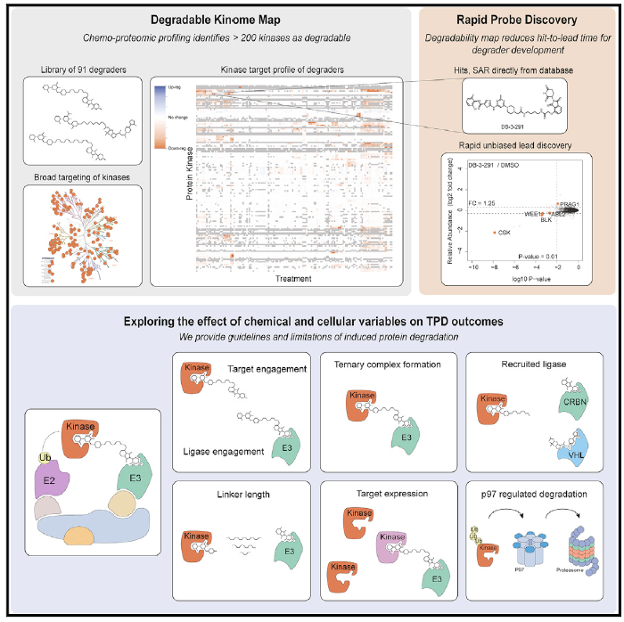

1. “Natural and Synthetic Lactones Possessing Antitumor Activities” Younghoon Kim, **Sengupta, S,** Taebo Sim, ***Int. J. Mol. Sci*. 2020.** IF2022 = 5.542. number of citations = 4.
2. “Identification of a unique L-783277 derivative that targets both lymphangiogenesis and angiogenesis” **Sengupta, S (first author);** Han, Y.; Lee, B. J.; Choi, H. G.; Cho, H.; Dash, U.; Kim, J. H.; Kim, J. H.; Sim, T.; ***J. Med. Chem*. 2019,** 62(20), 9141-9160 **(Cover Article)**. IF2018 = 6.054. number of citations = 8.

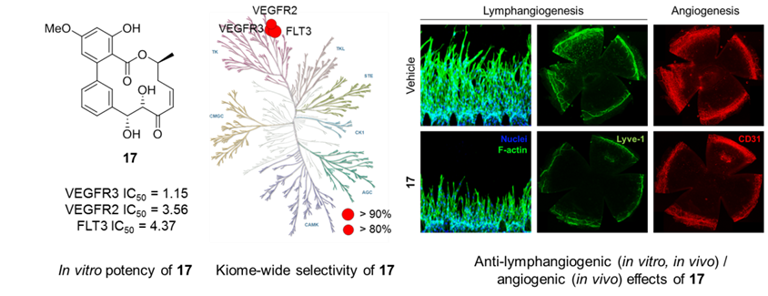

1. “Structural revision of baulamycin A and structure-activity relationships of baulamycin A derivatives” **Sengupta, S. (first author)**; Bae, M.; Oh, D-C.; Dash, U.; Kim, H. J.; Song, W. Y.; Shin, I.; Sim, T.; ***J. Org. Chem*. 2017,** 82(24), 12947-12966 **(Featured Article and Cover Article)**. IF2018 = 4.745. number of citations = 6.

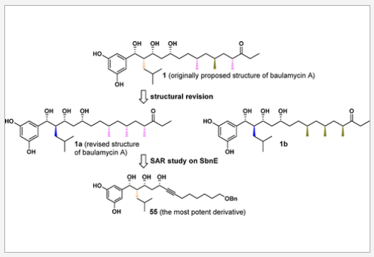

1. “Highly stereoselective synthesis of mupirocin H” **Sengupta, S. (first author)**; Kim, H. J.; Cho, K. S.; Song, W. Y.; Sim, T.; ***Tetrahedron* 2017,** 73(8), 1182-1189, IF2012 = 2.651. number of citations = 6.

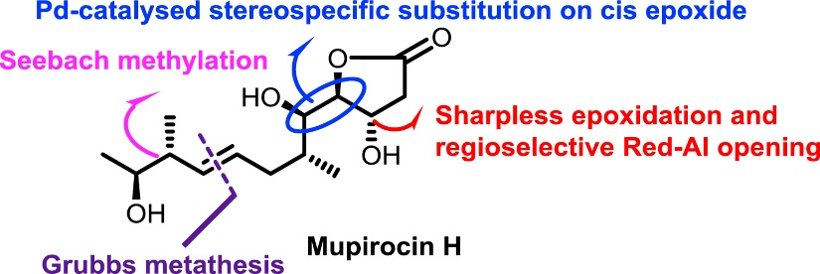

1. “Identification of the First Selective Activin Receptor-Like Kinase 1 Inhibitor, a Reversible Version of L-783277” **Sengupta, S. (first author)**; Cho, H.; Jeon, S. H. S.; Hur, W.; Choi, H. G.; Seo, H-S.; Lee, B. J.; Kim, J. H.; Chung, M.; Jeon, N. L.; Kim, N. D.; Sim, T.; ***J. Med. Chem*. 2017,** 60(4), 1495-1508, IF2015 = 6.259. number of citations = 5.

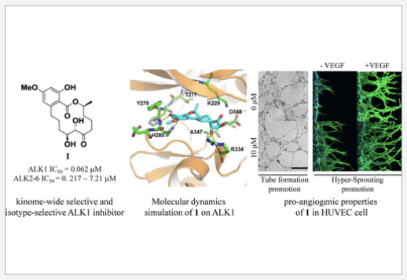

1. “A Concise and Efficient Total Synthesis of Militarinone D” **Sengupta, S (first author)**; Dash U.; Sim, T.; ***Eur. J. Org. Chem*. 2015,** 3963–3970, IF2015 = 3.065. number of citations = 12.

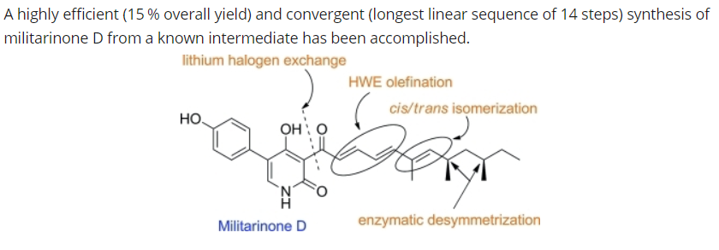

1. “Identification of Novel ROS Inducers, Quinone Derivatives Tethered with Long Hydrocarbon Chains” **Sengupta, S. (first author)**; Hong, Y.; Hur, W.; Sim, T.; ***J. Med. Chem*. 2015,** 58(9), 3739–3750, IF2015 = 5.447. Number of citations = 29.

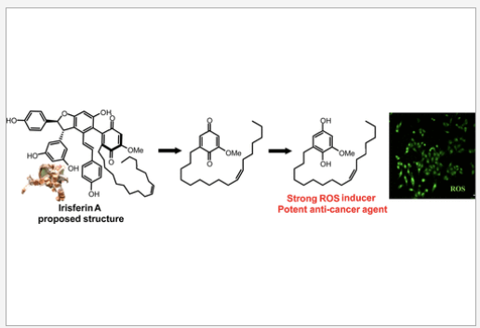

1. “A Concise Synthesis of Mupirocin H by Using a Cross Metathesis Based Strategy” **Sengupta, S. (first author)**; Sim. T.; ***Eur. J. Org. Chem.* 2014,** 5063–5070, IF2015 = 3.065, Number of citations = 3.

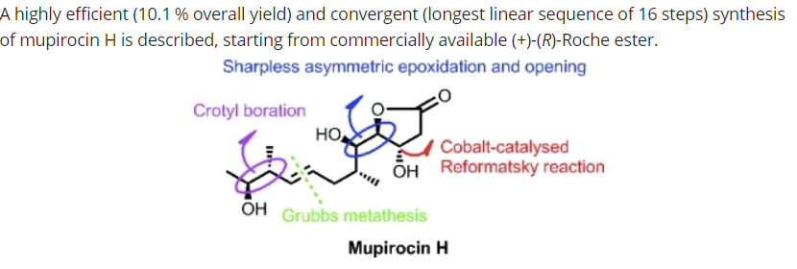

1. “Formal total synthesis of immunosupresive agent FR252921” Yadav, J. S.; **Sengupta, S. (first author)**; ***Eur. J. Org. Chem*. 2013,** 376–388, IF2012 = 3.344, number of citations = 13.

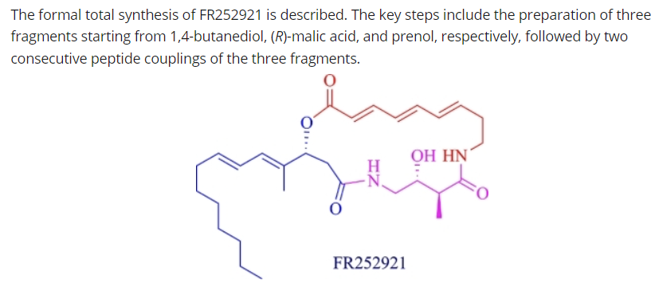

1. “Stereoselective Synthesis of Methyl Branched Chiral Deoxypropionate units: a new route for synthesis of Insect Pheromone (−)-Lardolure and (2R,4R,6R,8R)-2,4,6,8-Tetramethyl undecanoic acid” Yadav, J. S.; **Sengupta, S. (first author)**;Yadav, N. N.; Chary, D. N.; ***Tetrahedron Lett.* 2012,**53(44), 5952-5954, IF2012 = 2.397, number of citations = 13.

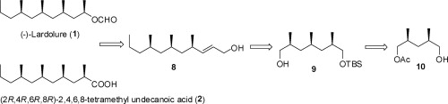

1. “Enantioselective Total Synthesis of Siphonarienal, Siphonarienone, and Pectinatone” Yadav,J. S.;Chary, D. N.; Yadav, N. N.; **Sengupta**, **S.**; ***Helvetica Chimica Acta* 2013,** 96, 1968-1977, IF2013 = 1.394, number of citations = 12.

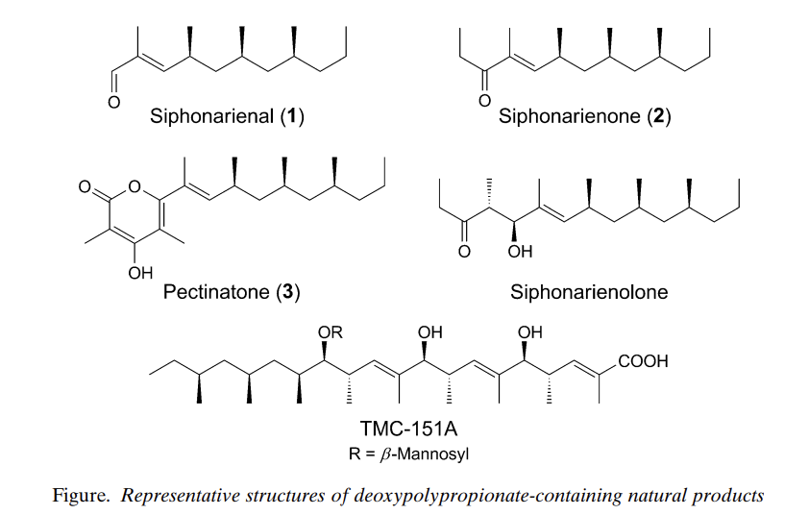

1. “Progress towards the total synthesis of 2,3-dihydroxytrinervitanes” J. S. Yadav, Biswas, S. K.; **Sengupta, S.**; ***Tetrahedron Lett*. 2010,** *51*, 4014-4016, IF2010 = 2.618, number of citations = 7.

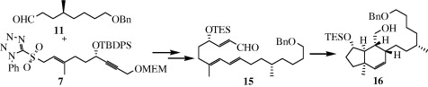

1. “Gallium(III) Chloride catalysed three component coupling of napthol, alkyne and aldehydes: a novel synthesis of 1,3 disubstituted-3H-benzo[f]chromenes” (original research article), Yadav, J. S.; Reddy, B. V. S.; Biswas, S. K.; **Sengupta**, **S**; ***Tetrahedron Lett*. 2009,** *50*, 5798-5801, IF2009 = 2.66, number of citations = 25.

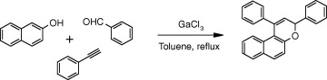

1. “Gallium(III) Chloride catalysed hydroarylation of aryl acetylenes with naphthols and phenols: a facile synthesis of vinyl arenes” Yadav, J. S.; Reddy, B. V. S.; **Sengupta**, **S**. (first author); Biswas, S. K.; ***Synthesis* 2009,** *8*, 1301-1304, IF2009 = 2.572. number of citations = 25.

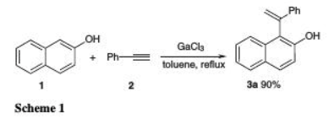

1. “Iodine as a mild, efficient, and cost-effective catalyst for the synthesis of thiirane from oxiranes” Yadav, J. S.; Reddy, B. V. S.; **Sengupta, S. (first author)**;Gupta, M. K.; Baishya, G.; Harshavardhana, S. J.; Dash, U.; ***Monatshefte fur Chemie/ Chemical Monthly* 2008**, *139*, 1363-1367, IF2008 = 1.426, number of citations = 18.

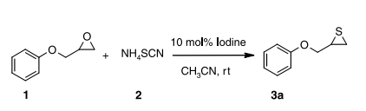

1. “Indium-mediated vic-diallylation/propargylation of phenacyl bromides: a facile synthesis of 4-arylocta-1,7-diene-4-ol derivatives” (original research article), Yadav, J. S.; Reddy, B. V. S.; Biswas, S. K.; **Sengupta, S.**;Vishnumurthy, P.; ***Tetrahedron Lett*. 2008,** *49*, 1034-1036, IF2008 = 2.538, number of citations = 5.

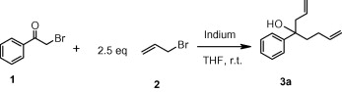

**List of patents**

1. “Novel pyrido[3,4-d]pyrimidin-8-one derivatives as protein kinase inhibitors and compositions for preventing, improving or treating cancer containing the same” Application No. 1020190018704, Application Date: 2019.02.18. (Korea Institute of Science and Technology)

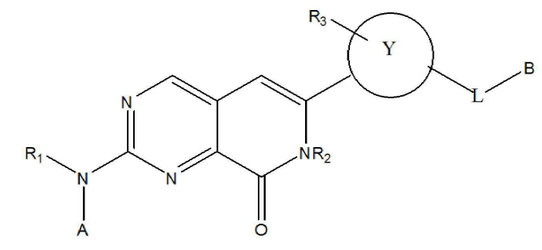

1. “Pyrido[3,4-d]pyrimidin derivatives and pharmaceutical compositions containing the same” Application No. 1020200005292, Application Date: 2020.01.15. (Korea Institute of Science and Technology)

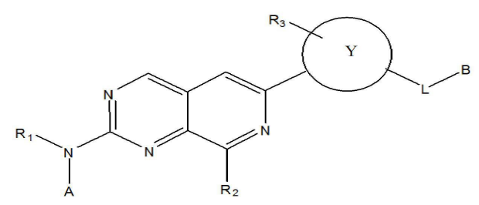

1. “A pharmaceutical composition for promoting intracellular ATP production” Application No. 1020190176032, Application date: 2019.12.27. (Korea Institute of Science and Technology)



1. “Novel α1- adrenergic receptor agonists” Application No. 1020160166759, Application date: 2016.12.08. (Korea Institute of Science and Technology)



1. 3 more patents are under application process (Yonsei University)

**List of manuscript under preparation**

1. “Synthesis and Antimicrobial Evaluation of Baulamycin A-inspired Compounds in Methicillin-Resistant Staphylococcus aureus (MRSA)” Namkyoung Kim; Sandip Sengupta **(first author)**; Jiwon Lee; Uttam Dash; Chiman Song; and Taebo Sim (**manuscript under preparation for *J. Med. Chem*.)**
2. “Total Synthesis of (±) Amaminol A and (±) Amaminol B and Biological Evaluation of their Derivatives” Sandip Sengupta **(first author)**; Debabrata Bhunia; Park Chanjung; Taebo Sim (**manuscript under preparation for *E.* *J. Med. Chem*.)**

**Due to Confidential issues part of my work which includes AUTAC, PROTAC, HEMTAC, small molecule kinase inhibitors or macrocyclic Kinase Inhibitors are not disclosed here.**



**Some Invited lectures**

1. Participated as an oral speaker and presented the work tittle as “Identification of the First Selective Activin Receptor-Like Kinase 1 Inhibitor, a Reversible Version of L-783277” in the **“2016-KOCS Fall and 31st Anniversary International Conference”** held at Seoul, South Korea.
2. Participated as an oral speaker and presented the work tittle as “A Concise Synthesis of Mupirocin H by Using a Cross Metathesis Based Strategy” in the **“2014-KOCS Fall and 30th Anniversary International Conference”** held at Seoul, South Korea (6th-7th November, 2014).

**Some Poster communications**

1. Presented poster in the “**12th CRSI National Symposium in Chemistry & 4TH CRSI-RSC Symposium in Chemistry**” held at IICT, Hyderabad, India (4th -7th February, 2010).
2. Presented poster in the “**2014 Fall International Convention of The Pharmaceutical Society of Korea**” held at gyeongju, South Korea (23rd -24th October, 2014).

**Some of Conferences attended**

1. Participated in International conference on ‘**Asian Symposium on Medicinal Plants, Spices and Other Natural Products (ASOMPS) XIII**-2008, Hyderabad, India (3rd-6th November, 2008).
2. Participated in the **“Organic Synthesis and Human Well-Being: Emerging Opportunities and Challenges”** held at IICT, Hyderabad, India (1st-4th August, 2010).
3. Participated in the **“Korean Chemical Society Symposium”** held at KINTEX, South korea (June 2013).

**Prizes/Awards**

* Korea Research Fellowship award in 2015 for 4.5 years of fellowship.
* Awarded Senior Research Fellowship **(SRF**) from the Council for Scientific and Industrial Research **(CSIR**), New Delhi, India (2009**)**.
* Awarded Junior Research Fellowship **(JRF**) from the Council for Scientific and Industrial Research **(CSIR**), New Delhi, India (2006).

**Supervising and mentoring activities**

* Mentoring graduate student for their Ph.D research, Ph.D level coursework and supervision of junior students.
* Completion of various projects with the group of graduates and under graduate student within timeline (Depends on projects number of students allotted)
* Lab management including arrangements of chemicals lab equipment’s and cost-effective Chemicals search for cutting edge synthesis.

**REFERENCES**

**Dr. J. S. Yadav Dr.A.Bhaskar Rao**

FNA, Ex-Director, & CSIR Bhatnagar Fellow Ex-chief scientist, MCP division

Indian Institute of Chemical Technology Indian Institute of Chemical Technology

Hyderabad 500607, Andhra Pradesh, India Hyderabad 500607, Andhra Pradesh, India

Email: [yadav@iict.res.in](mailto:yadav@iict.res.in) E mail: [adarirao2002@yahoo.co.in](mailto:adarirao2002@yahoo.co.in)

**Dr. Debendra Kumar Mohapatra**

Scientist, Organic-I-Division,

Indian Institute of Chemical Technology

Hyderabad 500007, Andhra Pradesh, India

E-mail: mohapatra@iict.res.in; [dkm_77@yahoo.com](mailto:dkm_77@yahoo.com)