CURRICULUM VITAE

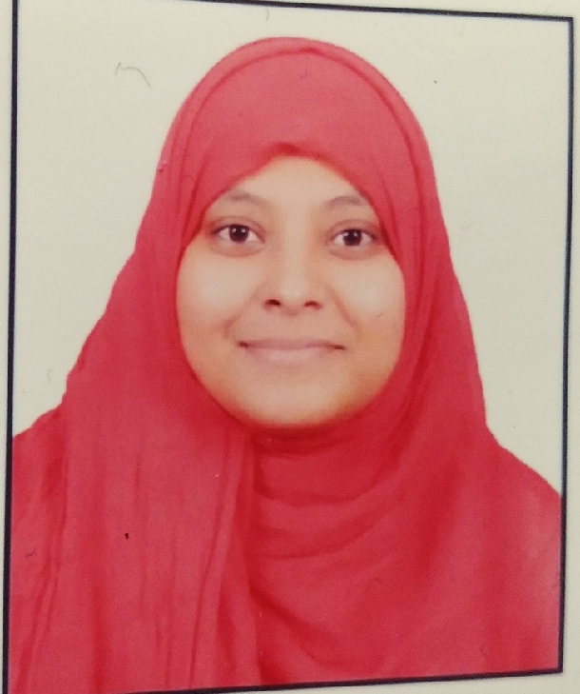

|  |
| --- |
| **Personal Information:** |

**Name** Shaikh Shabnam Murtujalim

**Date of birth** 11 january,1996

**Marital status** Unmarried

**Nationality** Indian

|  |
| --- |
| **Career Objective:** |

To be a part of a distinguished organization where I can utilize my skills & knowledge in the best possible manner, which can provide me ample opportunity for both individual contribution and teamwork for the benefit of the organization

|  |
| --- |
| **Address:** |

**Present:** At. Mamdapur (Patoda), Tq-Ambajogai, Dist-Beed, Maharashtra, India

**Permanent Address:** At. Mamdapur (Patoda), Tq-Ambajogai, Dist-Beed, Maharashtra, India

|  |
| --- |
| **Contact Details:** |

**Phone:** **+**919890808912

**Secondary: +**919403743011

**E-mail:** [shabnamms040@gmail.com](mailto:shabnamms040@gmail.com)

|  |
| --- |
| **Academic details** |

**Masters (2017-2019): MSc Chemistry** **(CGPA-8.51):** Dr. Babasaheb Ambedkar Marathavada University Aurangabad, Maharashtra, India 431001.

**Bachelors (2014-2017):** **BSc** (Chemistry, Biology, Zoology),(**77.89**%) Dr. Babasaheb Ambedkar Marathavada University, Aurangabad, Maharashtra, India, 431001.

**Higher Secondary (2014):** **(61.83%)** Chemistry, Mathematics, Physics, Biology. Aurangabad Divisional Board.

**Secondary (2011):** **(83.00%)** Aurangabad divisional board

|  |
| --- |
| **Awards & Honors:** |

1.Graduate Aptitude Test in Engineering (GATE) 2022**: (Score -371)**

|  |
| --- |
| **Experience:** |

**MSc Project:** DIPEAc Catalyzed Efficient One Pot Multicomponent Synthesis of Dihydrofuran Derivatives under the guidance of Dr. G.M Bondle & Dr. B.B. Shingte Dr Babasaheb Ambedkar Marathavada University Aurangabad Maharashtra, India, 431001.

**Publication :** on 27th October 2022 in ROYAL SOCIETY OF CHEMISTRY journal

|  |
| --- |
| **Languages Known:** |

English

Hindi

Marathi

|  |
| --- |
| **Skills & Highlights:** |

Knowledge of chemistry, handling instruments, Active listener, time management, self and fast learner, optimistic, fluent speaker. Proven Strength in problem solving and coordination.

|  |
| --- |
| **Computer Literature:** |

Completed Course on Computer Concept (CCC) in 2011.

Soundly work on Microsoft Excel, word, PPT.

I hereby declare that the above written particulars are true to the best of my knowledge and belief.

Date: 20/09/2022

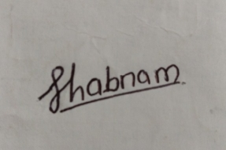

Yours Faithfully

Shaikh Shabnam Murtujalim.