7)c program to implement operations such as insert,delete and display:

INSERTION OPERATION:

#include <stdio.h>

int main()

{

int array[50], position, c, n, value;

printf("Enter number of elements in the array\n");

scanf("%d", &n);

printf("Enter %d elements\n", n);

for (c = 0; c < n; c++)

scanf("%d", &array[c]);

printf("Please enter the location where you want to insert an new element\n");

scanf("%d", &position);

printf("Please enter the value\n");

scanf("%d", &value);

for (c = n - 1; c >= position - 1; c--)

array[c+1] = array[c];

array[position-1] = value;

printf("Resultant array is\n");

for (c = 0; c <= n; c++)

printf("%d\n", array[c]);

return 0;

}

OUTPUT:

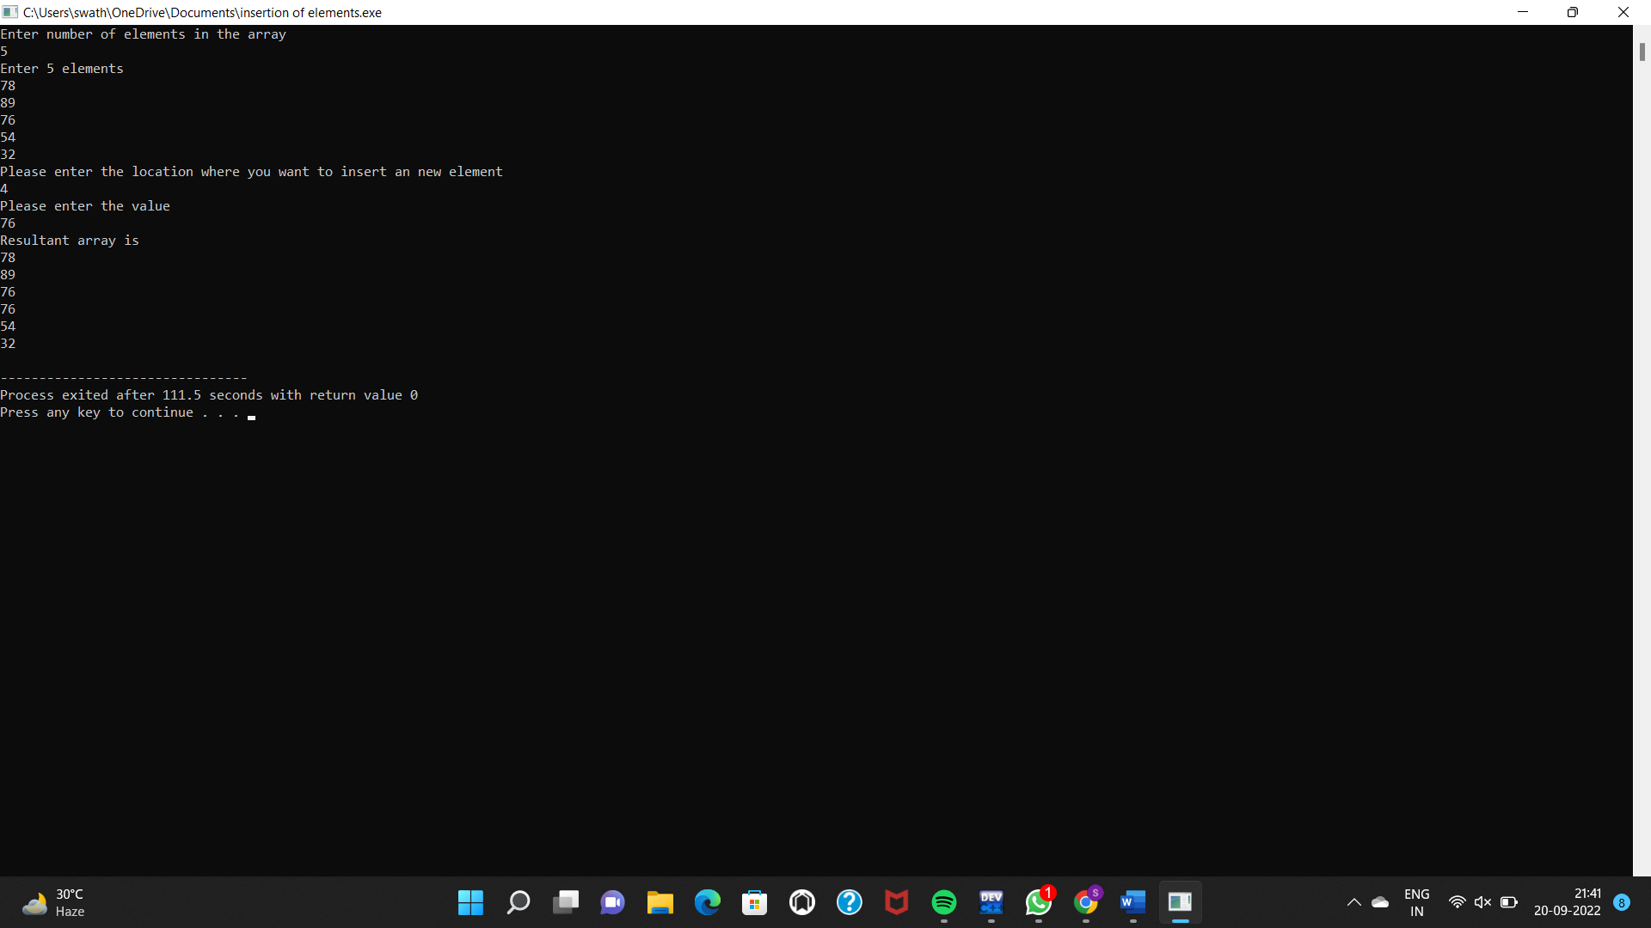

DELETION OPERATION:

#include <stdio.h>

int main()

{

int array[100], position, c, n;

printf("Enter number of elements in array\n");

scanf("%d", &n);

printf("Enter %d elements\n", n);

for ( c = 0 ; c < n ; c++ )

scanf("%d", &array[c]);

printf("Enter the location where you wish to delete element\n");

scanf("%d", &position);

if ( position >= n+1 )

printf("Deletion not possible.\n");

else

{

for ( c = position - 1 ; c < n - 1 ; c++ )

array[c] = array[c+1];

printf("Resultant array is\n");

for( c = 0 ; c < n - 1 ; c++ )

printf("%d\n", array[c]);

}

return 0;

}

OUTPUT:

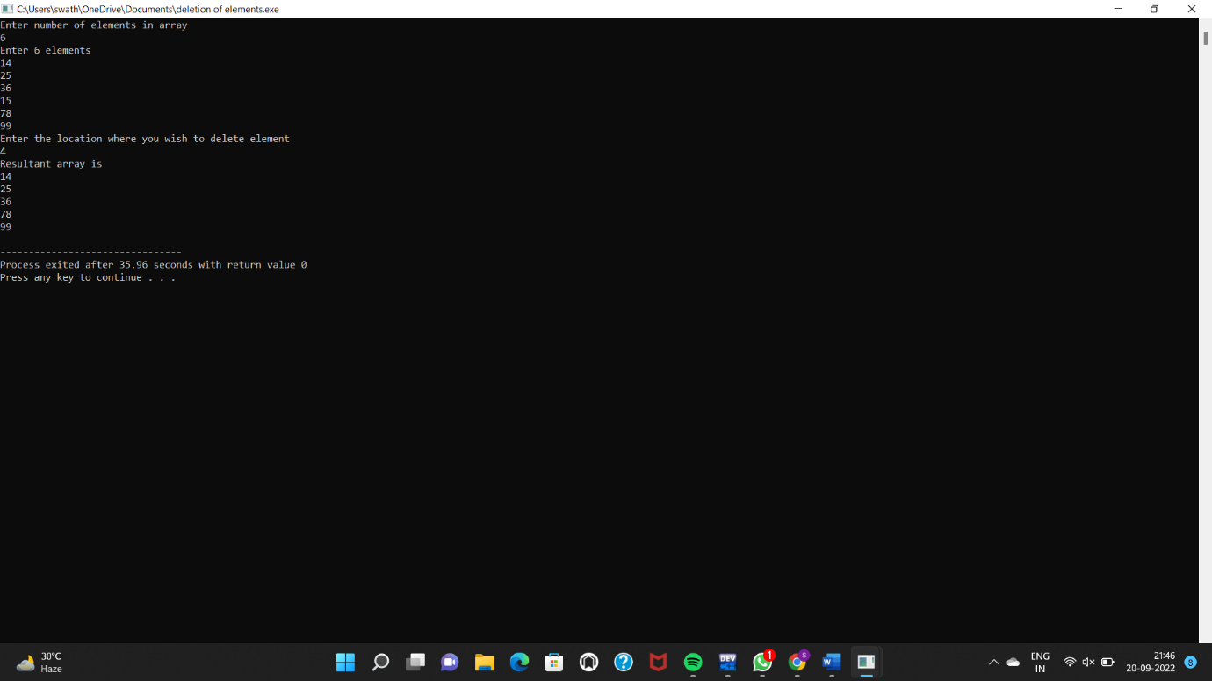

DISPLAY OPERATION:

#include<stdio.h>

int main()

{

int i,t,a[10],n,m,s,j=0,b[10];

printf("enter the limit");

scanf("%d",&n);

printf("enter the values");

for (i=0;i<n;i++)

{

scanf("%d",&a[i]);

}

printf("given values are");

for (i=0;i<n;i++)

{

printf("a[%d]=%d",i,a[i]);

}

printf("enter the position to be update");

scanf("%d",&t);

printf("enter the value to be update");

scanf("%d",&s);

for (i=0;i<n;i++)

{

if (i==t)

{

a[i]=s;

}

}

printf("updated value is ");

for (i=0;i<n;i++)

{

printf("a[%d]=%d",i,a[i]);

}

return 0;

}

OUTPUT:

